Topic: Test Cross, Back Cross and Dominance.
Test Cross and Back Cross
Test Cross Definition
The test cross is an experiment first employed by Gregor Mendel in his studies of genetics of traits in pea plants. Mendel's theory which holds true today was that each organism carried two copies of each trait. One was dominant trait while one could be known as recessive trait . The dominant trait if present could be determine by outward appearance of the organism or the phenotype. Thus Mendel become interested in the question of determining which organisms with the dominant phenotype had two dominant alleles and which have one dominant allele and one recessive allele his answer came in the form of test cross
The purpose of test Cross is to determine the genetic make up of the dominant organism. Mendel wanted to do this so that he could be sure he was working with the dominant organism which was homozygous or contain only dominant alleles however the phenotype alone does not tell you the genotype of an organism . The organism may be hiding a recessive non expressed allele . To find out what this unknown allele was Mendel developed the technique of breeding this individual with a homozygous recessive individual for the same trait .
The phenotypic results of the offspring then tell you the genetic make up of the original parents. The recessive parent is known to have two recessive alleles for the trait otherwise the dominant trait would show. If the dominant phenotype present has a recessive allele this will be given to approximately half of offspring. These offspring would receive a recessive allele from the other parents and therefore be homozygous recessive. Thus if any of the offspring from the test cross have the recessive trait. The dominant phenotype present was actually heterozygous having both dominant and recessive allele.
If on the other hand the offspring all show the same dominant phenotype has the unknown parents then the second allele the dominant phenotype parent has is also dominant. Recessive parent had to donate a recessive allele either way thus every offspring has at least one recessive allele . If none of the offspring show a recessive phenotype it means that the dominant parent passed only dominant alleles to the offspring. This would make the unknown parent a homozygous dominant individual for that trait. In other words the test Cross is a genetic test which reveals the unknown genotype of dominant individual . The test is interpreted through the number and type of offspring
Test Cross Example
Monohybrid Cross
The typical example of test cross is the origin experiment Mendel conducted himself to determine the genotype of a yellow pea. As seen in the image below the alleles Y and small y are used for by are used for yellow and green versions of the allele respectively. Yellow allele Y is dominant over the small y allele . Therefore in an organism with the genotype Yy only the yellow allele is seen in the phenotype. Mendel had a yellow pea and he wanted to know whether it is YY or Yy .
This was important to Mendel as it is to many seed producer and farmers today . The quality of a seed is determined by a plant it produces . A YY if self fertilized would produce only yellow peas in all of its offspring there are many traits which are desirable to reproduce and a homozygous plant is the obvious choice to do reproduce it with . However in a dominant/recessive relationship it is impossible to distinguish between a homozygous dominant plant(YY) and a hybrid or heterozygous plant (Yy) . Both will produce yellow seeds however, if the Yy plant cell fertilizes chance of an offspring with the yy which would make green peas . Mendel sought to sort this out once and for all ,so he devised the following test cross .
Mendel breed the unknown yellow pea with a green pea ,being homozygous recessive (yy). The chart below shows the two possible outcomes of the test

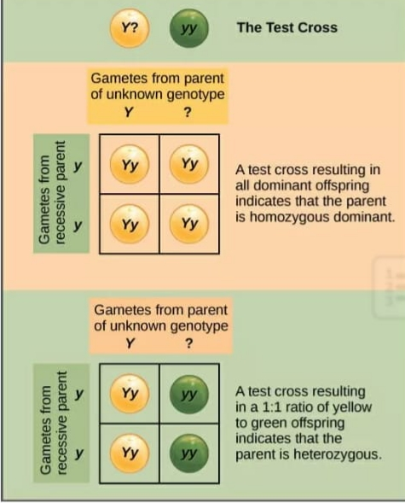
Dihybrid Test Cross
This simple model works well for single trait but it can easily be expanded to encompass more traits. The dihybrid Cross is a cross which look at the cross of two separate traits with different alleles . Sticking the pea colour example we will add a trait to the cross let’s say shape . Peas can either be round and plump or wrinkly . Round peas are dominant created by the (R) allele Wrinkled peas are only found in homozygous recessive individuals (rr).The following charts shows how to calculate the results of test cross . (Note that Wrinkled seeds should have the r allele)

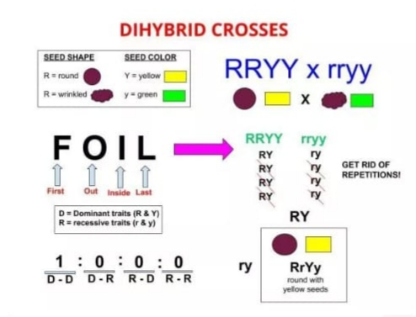
In this case shown this is a test cross involving an individual which is homozygous dominant for both traits with the all recessive test cross individual . This test Cross individual will always have all recessive traits as it allows for immediate detection of the genotype based on the offspring ratio. The image describes using the FOIL method of determining all the possible outcomes. On the first genotype you would pair the first allele of each gene (RY) then the outside pair also (RY) after carrying out this procedure we have all the possible gametes formed from each parent .Eliminate the repetitive pairs and we have the only relevant pairs. In this case all of the offspring are going to be RrYy . This would tell us that parent was homozygous dominant for both traits if the first parent was heterozygous for both traits the ratio of phenotype would look much different. In this case the first parent would be RrYy. Using the Foil method we arrive at four possible gametes from the heterozygous parents : RY, Ry, rY, ry . 4 possible genetic combination formed RrYy, Rryy, rrYy, rryy. Ratio would be 1:1:1:1.
Back Cross
When individual of f1 generation are crossed with one of the two parents either dominant or recessive one the cross is called back cross.
When individual of f1 generation are crossed with the parents having dominant characters in the next generation all individual are produced with dominant characters no recessive individual are produced
Plants of F1 generation. X Homozygous Parent Plants
(Hybrid tall) ( Homozygous tall)
Tt. TT
T .t. X T
After cross
TT. Tt. ( All Tall Plants)
Difference between Test Cross and Back Cross
Test Cross. Back Cross
●Test Cross is the breeding of dominant. ●Back cross is the breeding of F1
Phenotype with its recessive phenotype. Hybrid with one of the parents
●All test crosses are back crosses. ● Back cross of F1 hybrid with the
Recessive phenotype can
be considered as test cross
●The F1 hybrid is crossed with recessive ● F1 hybrid is crossed with either
genotype in test cross. Homozygous dominant or.
Heterozygous genotype
●Test cross identity the zygosity of the dominant. ● Back cross recovers elite
Phenotype. Genotype.

Dominance and Incomplete Dominance
Dominance:
The phenomenon whereby in an individual containing two allelic f are forms of a gene one is expressed to the exclusion of the other .
Dominance is a physiological effect of an allele over its partner allele on the same locus. The state of having two different variants of the same gene on each chromosome is originally caused by a mutation in one of the genes either new or inherited. The term of autosomal dominant or autosomal recessive are used to describe gene variants or non sex chromosomes and their associated traits while those on sex chromosomes are termed as X-linked dominant , X-linked recessive or Y-linked ;these have an inheritance and presentation pattern that depends on sex of the both parents and the child. Since there is only one copy of Y chromosomes, Y linked traits can not be dominant or nor recessive
Types of Dominance
●Complete Dominance
●Codominance
●Incomplete Dominance
●Over Dominance
Incomplete Dominance:
●Mendel’s Principles:
Inheritance of biological characteristics is determined by individual units known as genes.
During sexual reproduction genes are passed from parents to offspring.
Two or more forms of a gene for a single trait exist some forms of the gene may be dominant or recessive.
What is incomplete Dominance?
•Incomplete Dominance is a type of inheritance in which one allele for a specific trait is not completely dominant over the other allele. This result in a combined phenotype.
(Expressed physical trait)
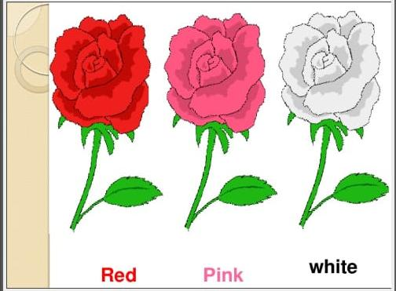
In 1899 Carl Correns was working on a flowering plant named 4 o'clock. When he crossed a true breeding red flower plant with a true breeding white flower 4 o’clock rF1 had pink flowers. This new phenotype had a shade intermediate between those of the parents due to an intermediate amount of pigment in petals. When he self-fertilized F1 pink F2 showed all the three phenotypes of the flowers in the ratio of 1 red: 2 pink : 1white red was homozygous for red alleles and white was homozygous for white alleles. But when alleles for red and alleles for white were present together in the same plant neither of them masked the effect of other rather these alleles showed incomplete dominance in the form of pink colour. When the phenotype of the heterozygote is intermediate between the phenotypes of the two homozygotes. It is called incomplete all partial dominant.
As there is no truly dominant allele the usual capital and small letters distinction for dominant and recessive trait is not necessary. Both the alleles are represented by the same letter R but are numbered differently to distinguish white from red. Allele for red is designed as R and the allele for white is W.
Punnett square indicates that the phenotypic ratio is the same as the genotypic ratio. There is absolutely no need of test crops. The flower colours show blending at phenotypic level in F1 which is quite contrary what Mendel observed. But the reappearance of red and white flowers in F2 confirms that blending does not occur at genetic level.
In incomplete Dominance neither allele is dominant so there is a blending of traits when two different alleles for the same traits occur together heterozygous individuals=3rd phenotype.
Incomplete dominance is when a dominant allele is form of a gene, does not completely mask defects of recessive alleles and the organisms resulting physical appearance shows a blending of both alleles.
Incomplete Dominance may occur because neither of the two alleles is fully dominant over the other or because the dominant allele does not fully dominate recessive allele.
This result in a phenotype that is different from both dominant and recessive alleles and appears to be a mixture of both.
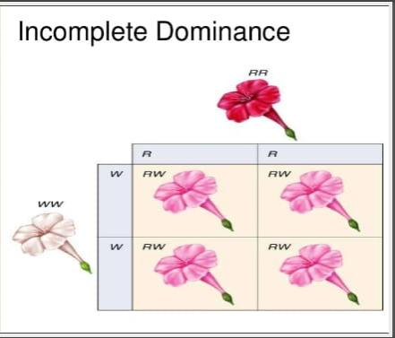
°When a single gene has multiple phenotypic effects the phenomenon is called
a)Codominanc b)Epistasis. c)pleiotropy. d)Sex linkage
○Heterozygous individual has allele
a)both dominant b)both recessive c)one dominant one recessive d)one allele missing
○Zygosity can be
a)Heterozygous b)Homozygous c)both A and B
○Word gene was used by
a)Sutten b)Mendel c)Bateson d)Devaries
○Experiment on plants hybridization was written by
a)Sutten b)Mendel c)Darwin. D)Devaries
○Pea plants were used in Mendel's experiment because
a)they were cheap b)had contrasting characters c)they were available easily d)all of them
○The tendency of offspring to resemble its parents is known as
a)hereditary b)inheritance. c)resemblace
○What happen when both allele of a gene pair independently Express in a heterozygous
a)Dominance b)incomplete Dominance c)Over dominance d)Codominance

