EXPERIMENT NO.1
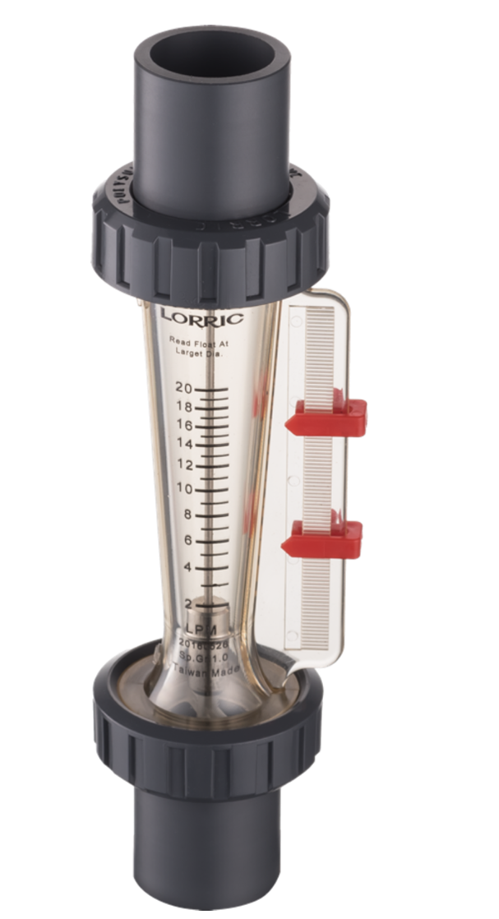
Flow measurement with the help of rotameter.
Theory:
Definition of Rotameter:
A rotameter is a device that measures the volumetric flow rate of fluid in a closed tube.
It belongs to a class of meters called variable area meters, which measure flow rate by allowing the cross-sectional area the fluid travels through to vary, causing a measurable effect.

Advantage:
- A rotameter requires no external power or fuel; it uses only the inherent properties of the fluid, along with gravity, to measure flow rate.
- A rotameter is also a relatively simple device that can be mass manufactured out of cheap materials, allowing for its widespread use.
- Since the area of the flow passage increases as the float moves up the tube, the scale is approximately linear.^{[1]}
- Clear glass is used which is highly resistant to thermal shock and chemical action.
Disadvantage:
- Because operation of a rotameter depends on the force of gravity for operation, a rotameter must be oriented vertically. Significant error can result if the orientation deviates significantly from the vertical.
- Due to the direct flow indication the resolution is relatively poor compared to other measurement principles. Readout uncertainty gets worse near the bottom of the scale.
- Since the float must be read through the flowing medium, some fluids may obscure the reading. A transducer may be required for electronically measuring the position of the float.
- Rotameters are not easily adapted for reading by machine; although magnetic floats that drive a follower outside the tube are available.
Apparatus:
Rotameter measurement tube
Procedure:

Calculation table:
Sr.no | H1(mm) | H2(mm) | Qact(lpm) | Qthr(lpm) | %Error
1
2
3
4

Conclusions:

