Citizenship Education and Community Engagement
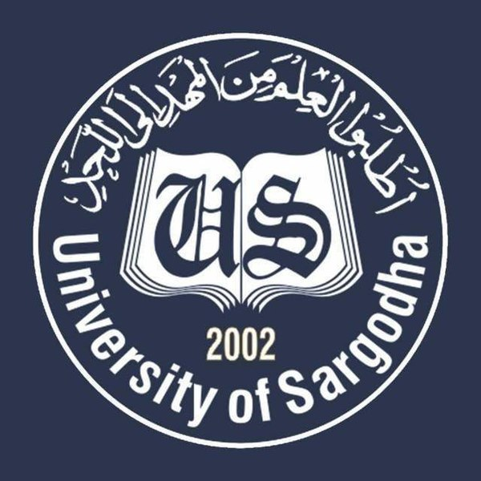

Program: BS Botany COVID-19 Awareness Session: 2019-2023
Submitted To:
Ma’am Mehlah Jabeen
Submitted By: Submission Date: 07-06-2020
Javed Abbas Roll No: BBTF19BM020
Hira Roll No: BBTF19BM006
Rawish Munir Roll No: BBTF19BM022
Sana Saleem Roll No: BBTF19BM026
Fatima Asad Roll No: BBTF19BM053
Riffat Rani Roll No: BBTF19BM004
Department of Biological Sciences,
UOS Bhakkar Campus
Contents
1.Title of the Project: 3
2. Introduction: 3
2.1 Background of the problem: 3
2.2 Present situation: 3
3. Justification of the Project: 3
3.1. Importance of the Project Activity: 3
3.2. Practical implications (Who will get benefits of the activity?) 3
5. Plan of Action: 4
5.1 How will you do this project activity? 4
5.2 Needed resources & the source of generation (financial, human resources etc.) 4
5.5 Proposed duration of the project: 9
6 How will you evaluate your project for possible outcomes? 9
7 References: 9

1.Title of the Project:
Awareness regarding COVID-19 and Rashaan distribution

2. Introduction:

2.1 Background of the problem:
COVID-19 is transmissible disease caused by a family of viruses called ‘corona virus’. Most people infected with COVID-19 will face mild to moderate respiratory illness and recover without requiring special treatment. Older people and those with underlying medical problems like cardiovascular disease, and cancer are more likely to develop serious illness. The best way to prevent and slow down transmission is be well informed about infectious disease, the disease it causes and how it spreads. Protect yourself and other from infection by washing your hands and using sanitizers and not touching your face. This disease primarily spreads through droplets of saliva from the nose when an infected person coughs and sneezes. So, it is important that you also practice respiratory etiquette. (www.cov.gov.pk)
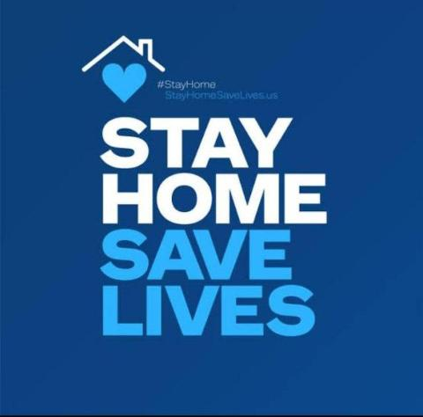

Present situation:
The asperity of corona virus in Pakistan is increasing day by day. Today on 5th of June 2020, according to GEO news more than 89249 people have been infected throughout the country. In Bhakkar, there are 32 confirmed corona cases. Government of Pakistan has suggested some precautionary measures to the nation. There are no specific vaccines or treatments for corona patients. It is the need of time to come forward to give awareness regarding COVID-19 to the people of our areas. That’s why we decided to give awareness to the people of our areas. We have decided to give masks and sanitizers to the people of our areas. (Engr. Zahid abbas UET Lahore)
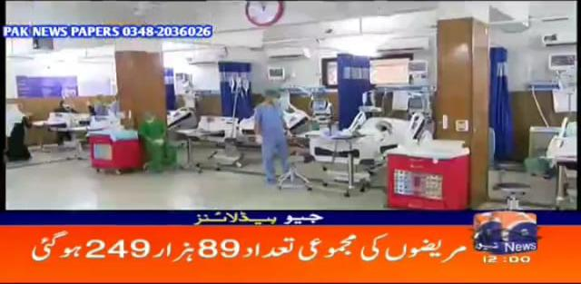

3. Justification of the Project:
We are doing this project because present situation is very dangerous and critical due to spread of Corona Virus. People need masks and sanitizers to protect themselves from this pandemic People also need food in this critical situation. Poor people have no resource to get food masks and sanitizers. We are doing this project to give awareness through charts because prevention is better than cure. (Javed Abbas BBTF19BM020)

3.1. Importance of the Project Activity:
The main purpose of this project is to save or protect our country. Keeping in view the present situation of our country as well as our district Bhakkar, it is very important to give awareness to the people. Being the citizen of Pakistan and district Bhakkar it is our duty to come forward to fight against corona virus. To beat covid-19 our contribution is necessary. (Javed Abbas BBTF19BM020)

3.2. Practical implications (Who will get benefits of the activity?)

People of respective areas:
There are two main stakeholders who will get benefits from this project.

First, awareness regarding corona virus provided to the residents of targeted areas. In this project our focus was to tell about the advantages of social distancing and use of protective measures. By acting upon these precautionary measures residents of targeted areas got benefits from this project. The people of the respective areas got benefits and knew the way that how to use the masks, sanitizers and got awareness about corona virus. They became able to protect themselves from corona virus by acting upon the preventive measures given by WHO and ministry of health.
- Group members of this project:
- Students who are directly involved in this project became able to manage any hazardous situation
- Interaction with society increased. (Javed Abbas BBTF19BM020)
4. Objectives of the Project:
- Give awareness to the people
- Impacts of COVID-19 on human health
- Maintain Social distancing
- Wash hands frequently
- Avoid touching eyes, nose and mouth
- If you have fever, cough and difficulty breathing, seek medical care early.
- Mask distribution
- Sanitization. (Hira BBTF19BM006)

5. Plan of Action:

5.1 How did we do this project activity?

  - Javed Abbas
- First, I made a team of four people that helped me in making this project successfully.
- Secondly, I collected money from my family and friends.
- Thirdly, I purchased masks, gloves and all the required items (methylated spirit, glycerin, lemon etc.) for making sanitizers.
- I made charts and give awareness to the people.
- I captured all the activities and presented it in the form of a report to my teacher Madam Mehlah jabeen. (Javed abbas BBTF19BM020)

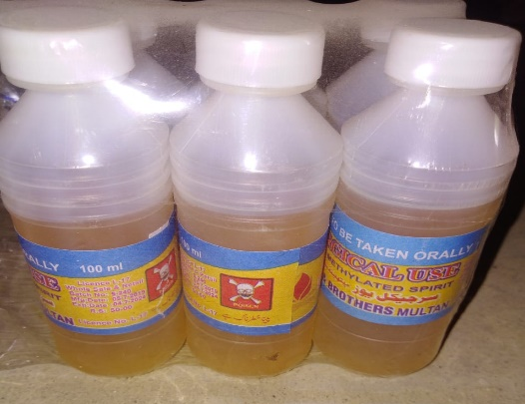
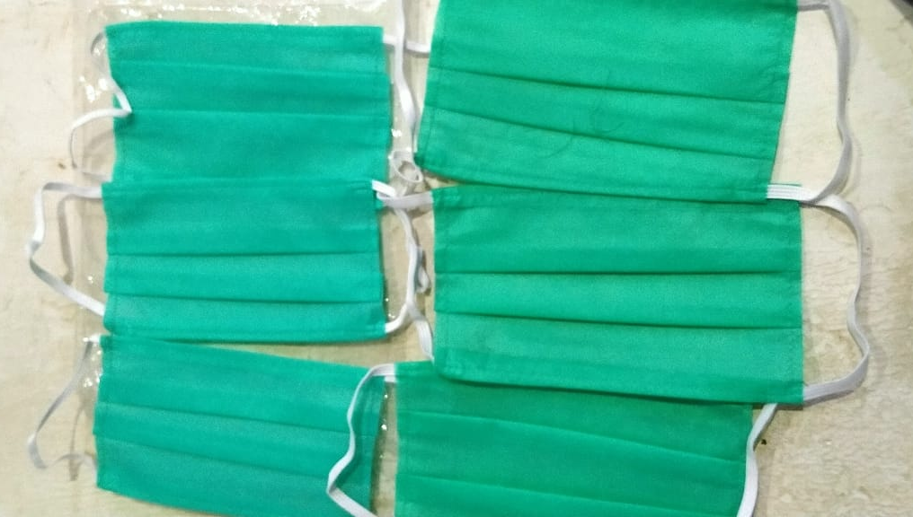

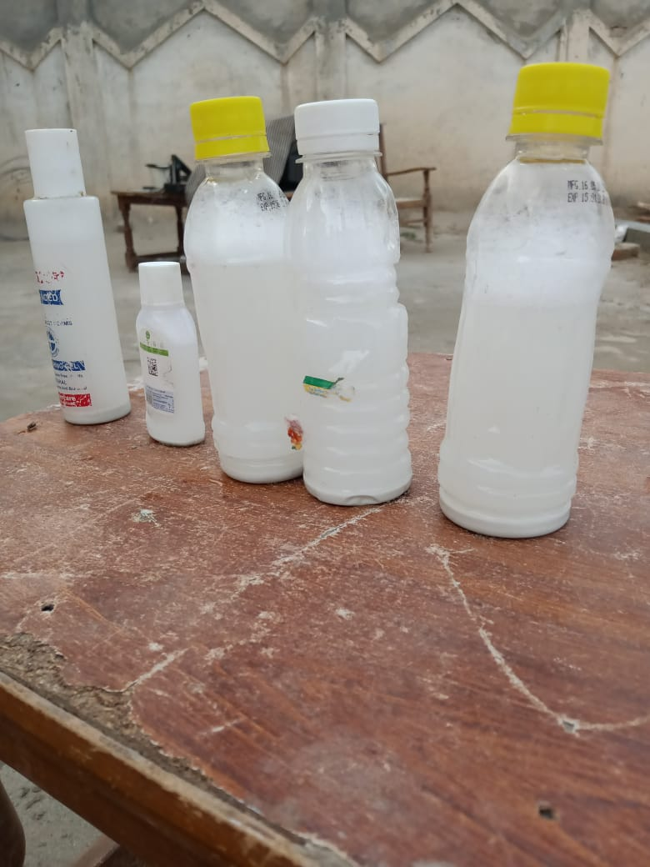

  - Hira
- First, I agreed my family who helped me and supported me financially and throughout supported me in this project.
- I collected contribution from my parents and my brother, and I also contributed in this project.
- I purchased ration with the help of my parents and I also contributed in this work.
- I purchased masks with my own contributions and my brother contributions.
- I also purchased simple charts and I prepared those charts on which precautionary measures was written about COVID-19. (Hira BBTF19BM006)

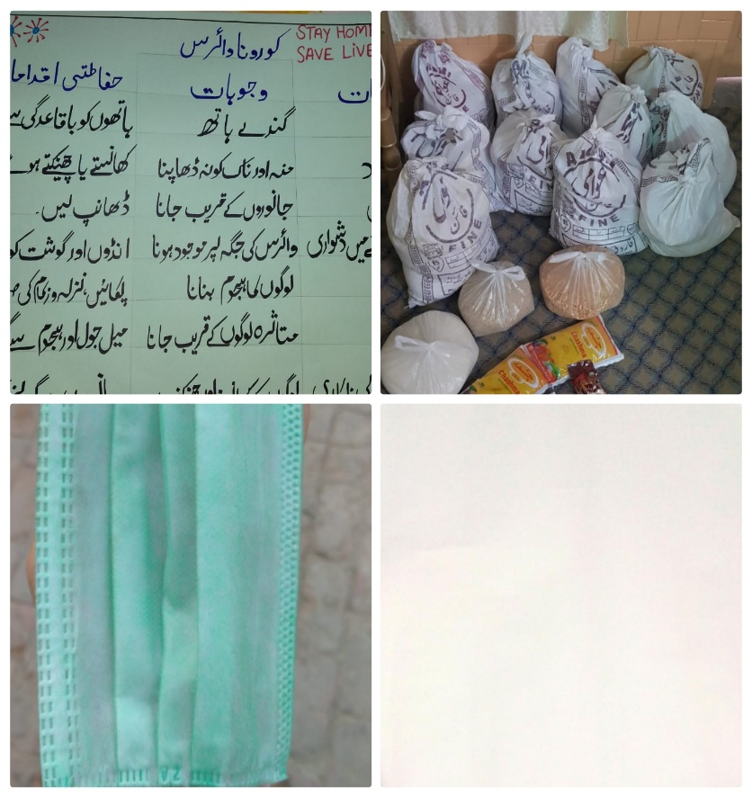

  - Rawish Munir

- First of all, we made a group of six members including Javed Abbas, Hira, Rawish Munir (Myself), Fatima Asad and Riffat Rani.
- We collected the collection from our family and circle that’s I purchased personal gloves masks for my own safety.
- I prepared charts on which precautionary measures were written and then hanged charts on public places such as Bank, mosque and roads etc.
- We made a documentary of our project proofs and submitted it to our teacher Mam Mehlah Jabeen. (Rawish Munir BBTF19BM022)

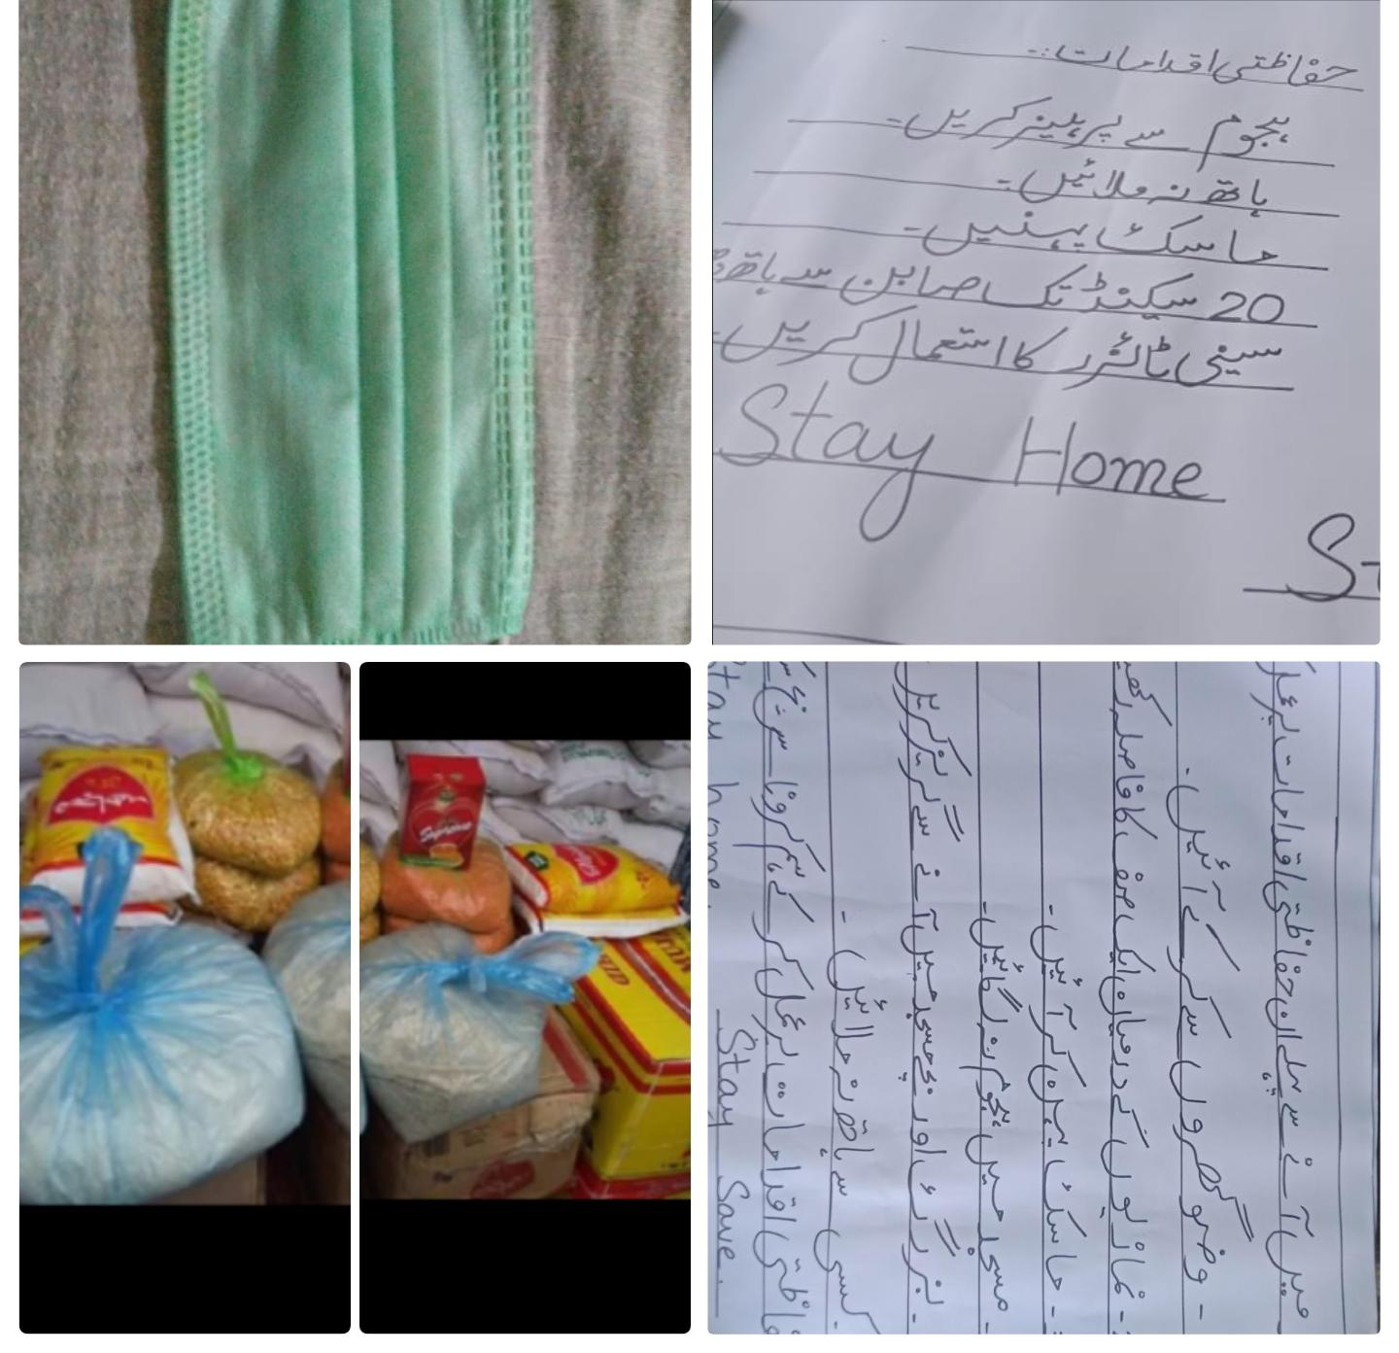

  - Sana Saleem

- First of all, I talked with my parents to help me financially. They agreed and supported me in this project.I collected information about those people that were needy than I gave them ration like oil, flour, matches, tea, rice and sugar.
- I collected this information by visiting their homes and also with the help of my brother Hamza Saleem.
- I also made charts with the help of my sister Sherbano. I made almost 10 charts on which precautionary measures about COVID-19 were written.
- I also made sanitizer at home with the help of my sister and Doctor Tahira. (Sana Saleem BBTF19BM026)

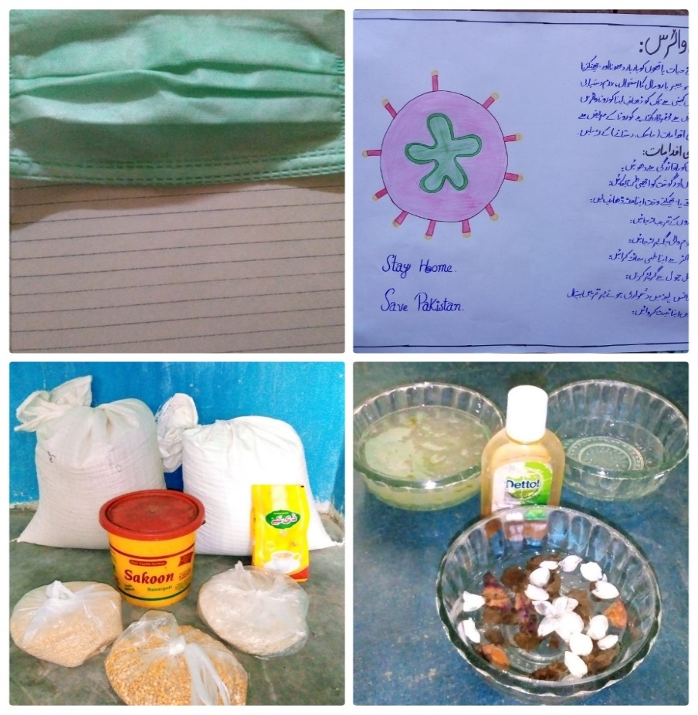

  - Fatima Asad

- The COVID-19 pandemic in Pakistan is a part of ongoing pandemic of Corona virus disease 2019 caused by acute respiratory syndrome Corona Virus 2. This virus was reached in Pakistan on 26 February 2020. By 18 March Corona virus cases had been registered in all four provinces of Pakistan. The number of Corona virus patients was increased day by day. Then, I decided to help the people about this problem.
- It was the time to give awareness about regarding COVID-19 to the people of our areas.
- First of all, I agreed my family who helped me financially and supported me in COVID-19 project.
- I collected contribution from parents and myself pocket money.
- I purchased masks with my own contributions.
- I purchased almost 10 hard charts and then prepared those charts on which precautionary measures was written about COVID-19 with the help of my sister Najma Batool.
- My mother helped me to give awareness about Corona Virus. (Fatima Asad BBTF19BM053)

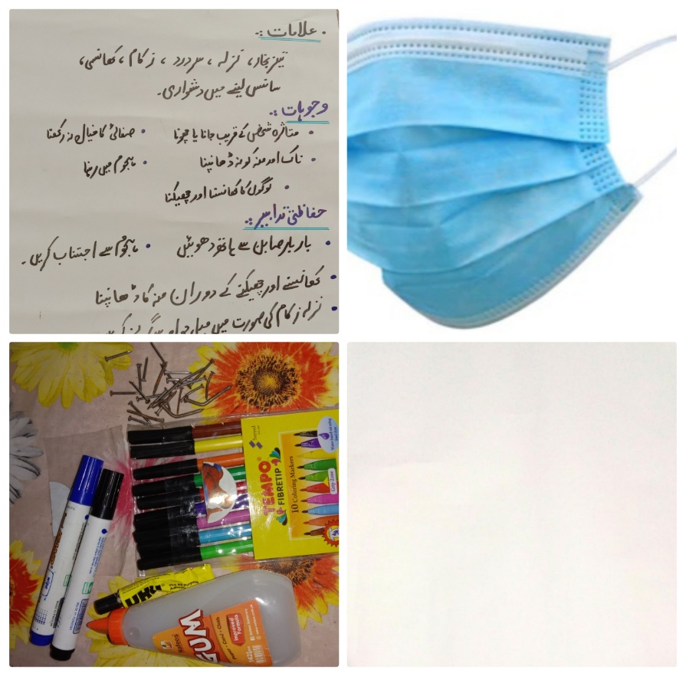

  - Riffat Rani
- First of all,I selected team members to do this project activity.
- I collected contribution each person.
- I purchased lime for draw the circles to maintain social distance at public places.
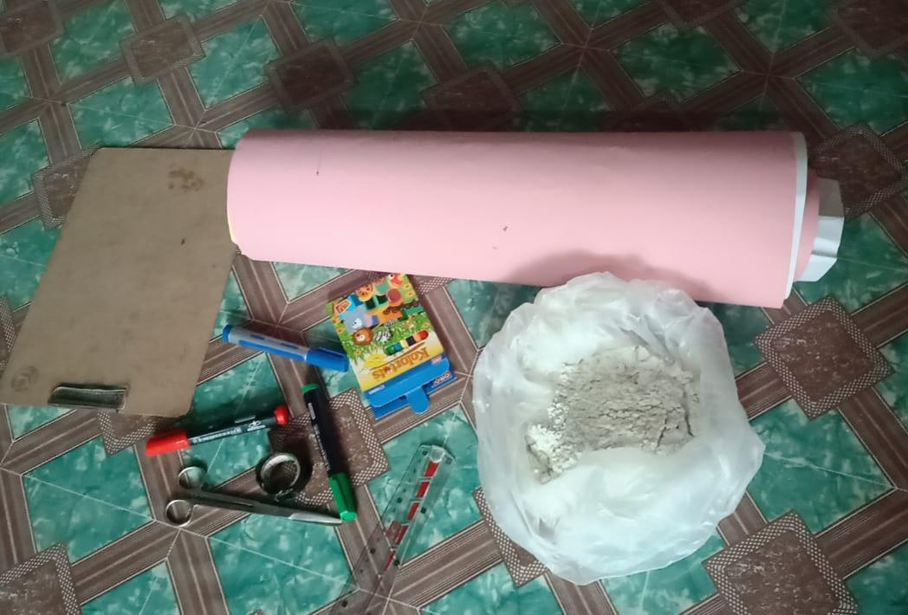
- I used colour pencils to make charts and gum used to stick these charts on walls.
- I made charts on which precautionary measures were written about COVID-19. (Riffat Rani BBTF19BM004)

5.2 Needed resources & the source of generation (financial, human resources etc.)
- Javed Abbas
- Mask (my brother Mujahid Abbas provided masks)
- I donated Dettol, Soap and bleach for sanitization
- My brother Engineer Zahid Abbas provided gloves, plastic bottles, googles
- Mobile and laptop used for editing
- My friend Dr. Shoaib worked as an instructor for making this project. (Javed Abbas BBTF19BM020)
2.Hira:
- My father Ghulam Abbas provided me a ration and include some cereals, oils, wheat, flour, rice and tea.
- My brother M.Naeem and myself purchased masks.
- I prepared charts on which precautionary measures was written for example wash your hands, eat cooked food. Don’t contact more with animals, cover your nose, mouth and use sanitizer for germs protection.
- I gave awareness through charts and my brother helped me and giving awareness about COVID-19. (Hira BBTF19BM006)

3.Rawish Munir
- I had done three different projects for the welfare of needy people regarding Corona virus.
- First, I wrote charts on which precaution measures and symptoms described. In this my sister helped me.
- Second, In the distribution of masks my brother M. Shahraiz helped me a lot. He hanged charts on different public places for awareness of people. I purchased these from my own pocket money.
- Third, I distributed ration to needy people. In this case, my father helped me financially for ration. I also contributed in ration distribution. Rawish Munir (BBTF19BM022)
4.Sana Saleem
- Firstly, I talked to my family about my project. They helped me financially.
- First of all, I tried to find out which is the most visited place like Mosque, bank, market, bazaar etc. My brother came and told me that people were not taking precaution there.so, we put up charts there so people could read them and follow the precautionary measures.
- After that, I decided to help people out of my own pocket money. My parents also helped me financially. We distributed rations to the poor. It included the rice, flour, soap, tea, matches, sugar, oils etc.
- We saw the people that were not wearing the masks than I decided to help them giving masks. My mother also helped me financially. We distributed almost 200 masks. We kept them in Mosques and also clinic near the house.
- Me and my sister made sanitizers at home with the help of lady doctor. She gave awareness about sanitizers that were used to control COVID-19. We used allovera jell, Dettol and rubbing alcohols (that was given by Dr. Tahira).
- My brother Hamza Saleem helped me in hanging charts on public places. These charts had all precautionary measures like don’t touch the patients, eat cooked food, Don’t contact with animals, don’t touch nose, mouth.
- My brother helped me by giving awareness about COVID-19 with his own. (Sana Saleem BBTF19BM026)
5.Fatima Asad
- I prepared charts with the help of my brother M. Ali and sister Najma Batool on which precautionary measures was written such as Don’t touch your eyes ,nose or mouth, don’t shake hands, cover your nose, mouth with your bent a tissue when your cough , maintain a safe distance from anyone who is coughing, clean your hands often, if you have fever, cough, flu and difficulty in breathing than these would be the symptoms od corona so the person having these symptoms should contact with the doctor.
- I gave awareness about COVID-19 with the help of my mother (Balkees Fatima). I went different houses and gave awareness and welfare for the people and told them about symptoms and precautionary measures with my mother help.
- I gave awareness about social distances and prescriptive measures about Corona virus.
- I distributed masks in people for germs protection of Corona virus. (Fatima Asad BBTF19BM053)
6.Riffat Rani
- I made charts for awareness in my village. I also drawn the circle with my brother.
- I wrote the preventive measures to avoid Corona disease.
- I also gave awareness to un- educated people in my village about COVID-19.
- My brother Zeeshan Ali helped me a lot in this project.
- My all family members helped me throughout the whole project.
- My brother brought lime for drawing circles. He bought me the charts, markers, gums.
- He helped in hanging charts and drawing circles. (Riffat Rani BBTF19BM004)
5.3 Each person’s role in the project:
- Javed Abbas
- First of all, I decided to collect money from my family and friends
- Secondly, I chose to spread awareness in two villages (Nawan khho and Gudara khho)
- I made a team of four people (including me)
- Then assigned duties to each member of the team
- I purchased masks, gloves, charts, markers, scales, Dettol, spirit, bottles, lemon and gracline.
- I prepared charts and hanged at nawan khho infront of general stores, mosques and other public places where congregational are held.
- I gave awareness regarding use of masks and sanitizers and gloves ang explained their advantages.
- I explained the symptoms and causes of corona virus
- I distributed masks and sanitizers among needy and poor people.
- I explained the advantages of social distancing
- I drew circle Infront of shops
- I asked people to wash their hand for thirty second by using sanitizers or any soap available.
- I asked people to stay at home and don’t go outside without and compulsion.
- I asked people to avoid handshaking.
- I captured each and every activity by using my own cell phone and edited video. (Javed Abbas BBTF19BM020)

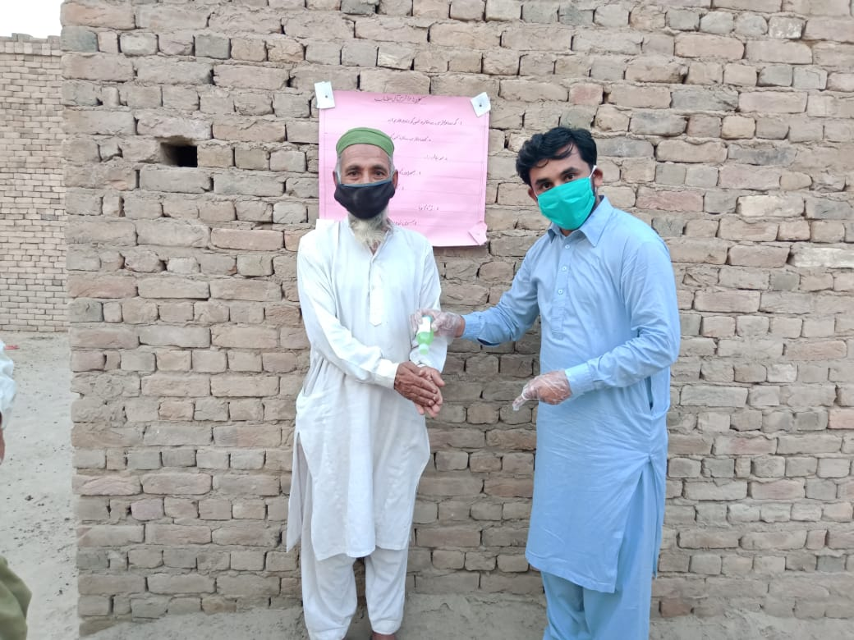
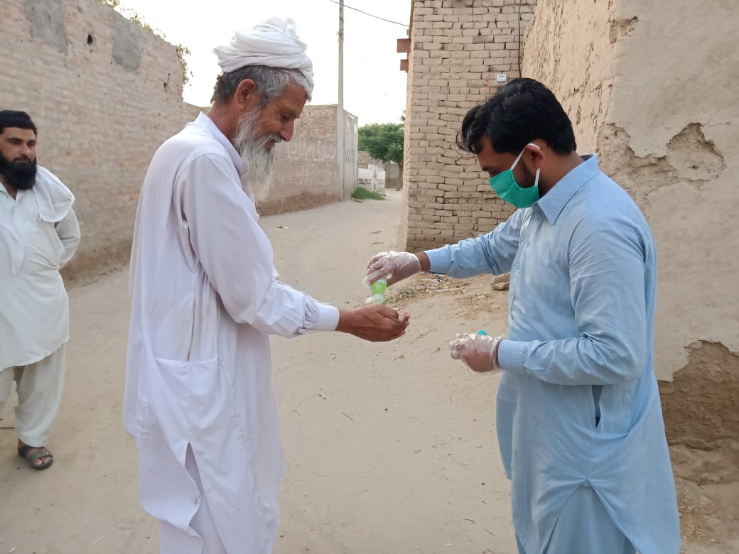

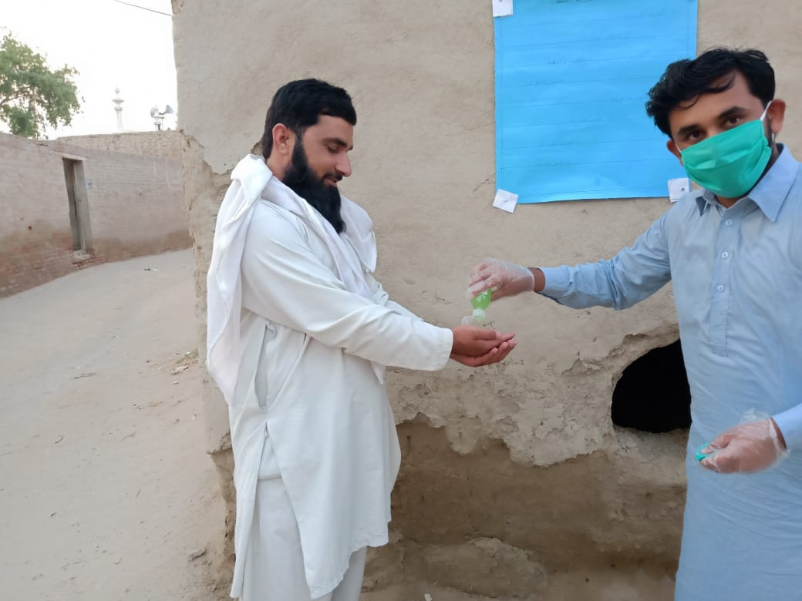
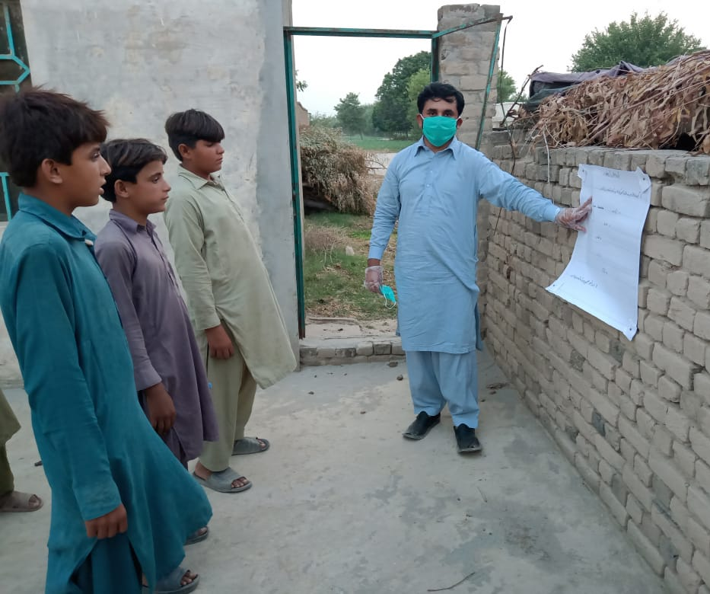

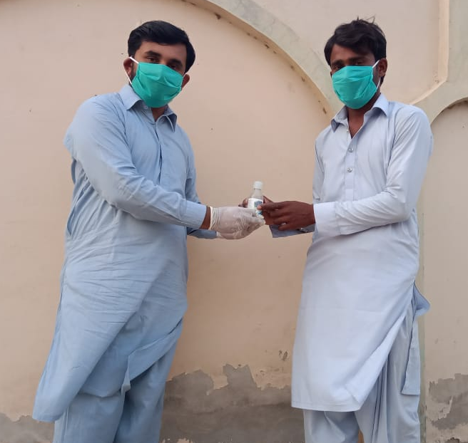

  - Engineer Zahid Abbas (Brother)
- His duty was to spread awareness to the people of Gudara khho
- He purchased masks, gloves, charts, markers, scales, Dettol, spirit, bottles, lemon and gracline.
- He prepared charts and hanged at Gudara khho Infront of general stores, mosques and other public places where congregational are held.
- He gave awareness regarding use of masks and sanitizers and gloves ang explained their advantages.
- He explained the symptoms and causes of corona virus
- He distributed masks and sanitizers among needy and poor people of Gudara khho.
- He explained the advantages of social distancing
- He drew circle Infront of shops to avoid unnecessary gathering.
- He asked people of Gudara khho to wash their hand for thirty second by using sanitizers or any soap available.
- He asked people to stay at home and don’t go outside without any compulsion.
- He asked people to avoid handshaking.
- He captured each activity by using his own cell phone and edited video.

Zeeshan Haider (Brother)
- He helped me in preparing charts
- He worked as a camera man in this project
- He helped us in transporting material from home to target place.
Dr. Shoaib Shah (friend)
- He helped us in purchasing masks, gloves and all required ingredients for making sanitizers.
- He helped us in delivering awareness to the people
- He maintained social distancing and implemented all required SOPs suggested by ministry of health at his clinic.

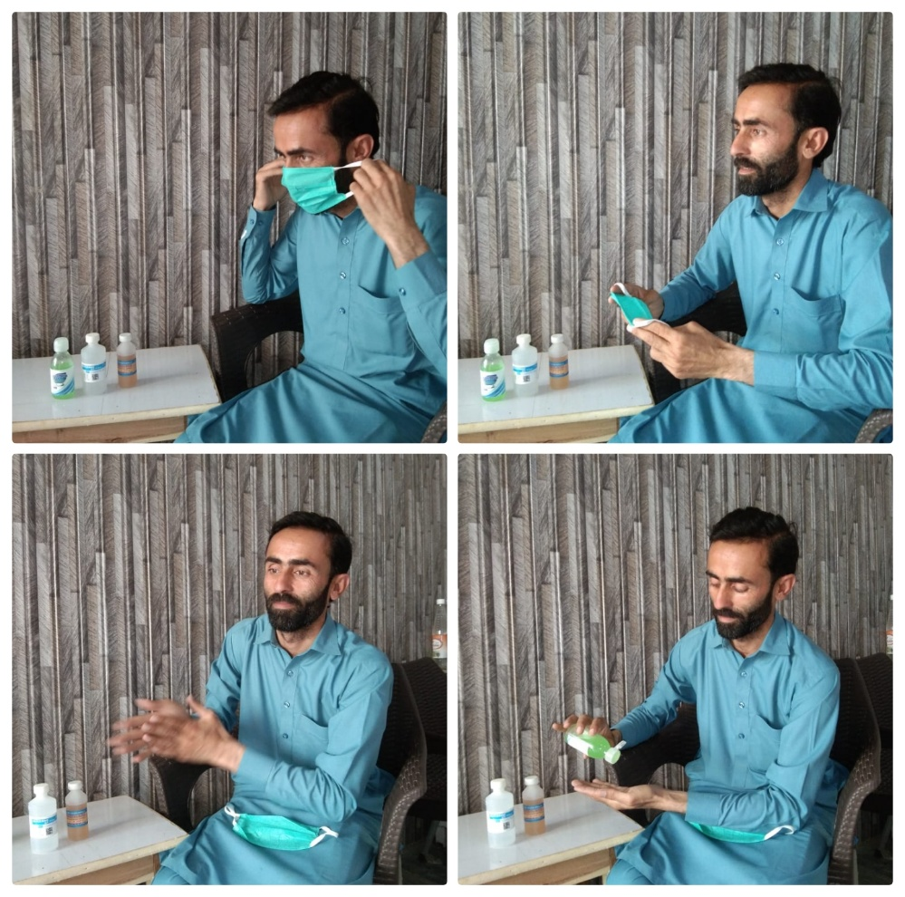

2-Hira
- I purchased masks from my pocket money and distributed them to people because they used these masks and protect themselves from germs.
- I prepared charts on which precautionary measures were written and through this and gave awareness about COVID-19.
- I also contributed ration and it distributed among poor people, it included cereals, flour, tea, rice, soap, oils etc. (Hira BBTF19BM006)
2.1-Ghulam Abbas(father)
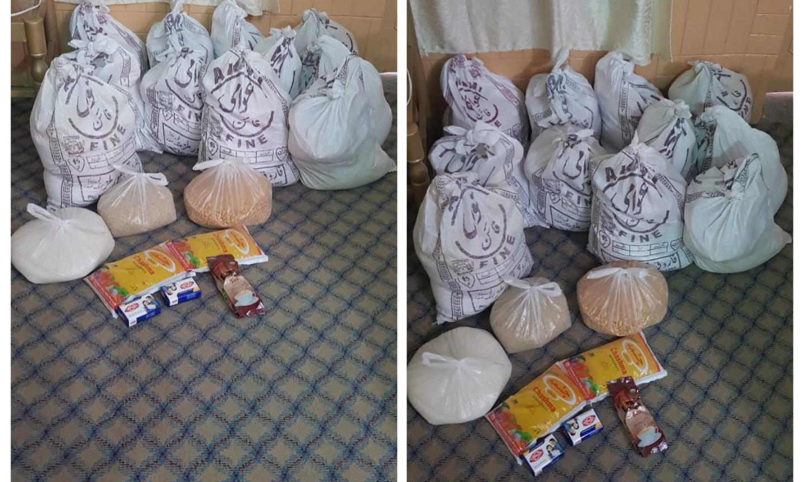
- My father also contributed financially to provide ration to needy people and he also supported me throughout project financially and physically.
2.2-Muhammad Naeem(brother)
- My brother M. Naeem provided masks me and financially helped me.
- He also distributed masks to people and gave awareness about COVID-19.
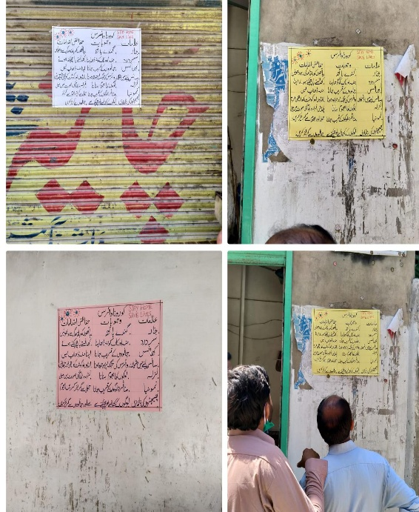
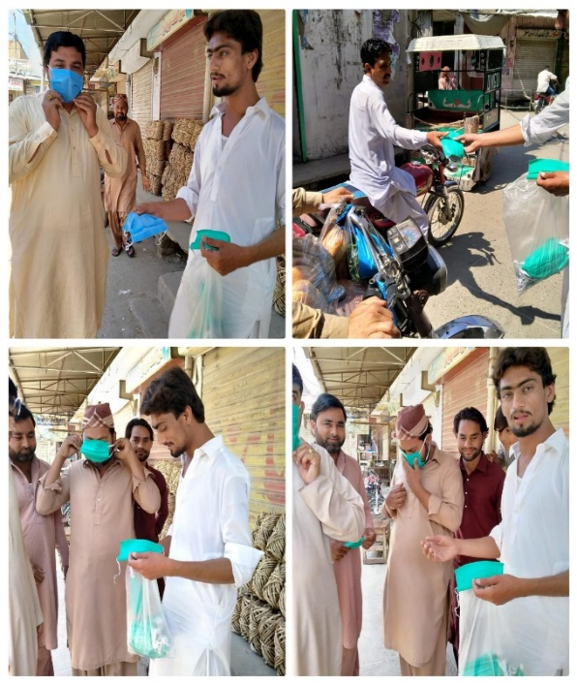
- He also hanged charts on public places like bazaar, roads , petrol pump , Mosque on which preventive measures were written and he also gave awareness through these charts.

3-Rawish Munir
- I made the charts for the welfare and awareness of people. On these charts precaution measures about COVID-19 were written. On these charts, I also wrote symptoms and causes of Corona virus.
- I gave hand made sanitizer to different areas of many houses, these hand made sanitizer were very effective against Corona Virus. I added dettols and bleach to make sanitizer, doctor approved sanitizer.
- I gave awareness about Corona virus, I went to different houses and told them about Corona virus symptoms and preventive measures. My mother helped me in this act. (Rawish Munir BBTF19BM020)

3.1-Shahraiz(brother)
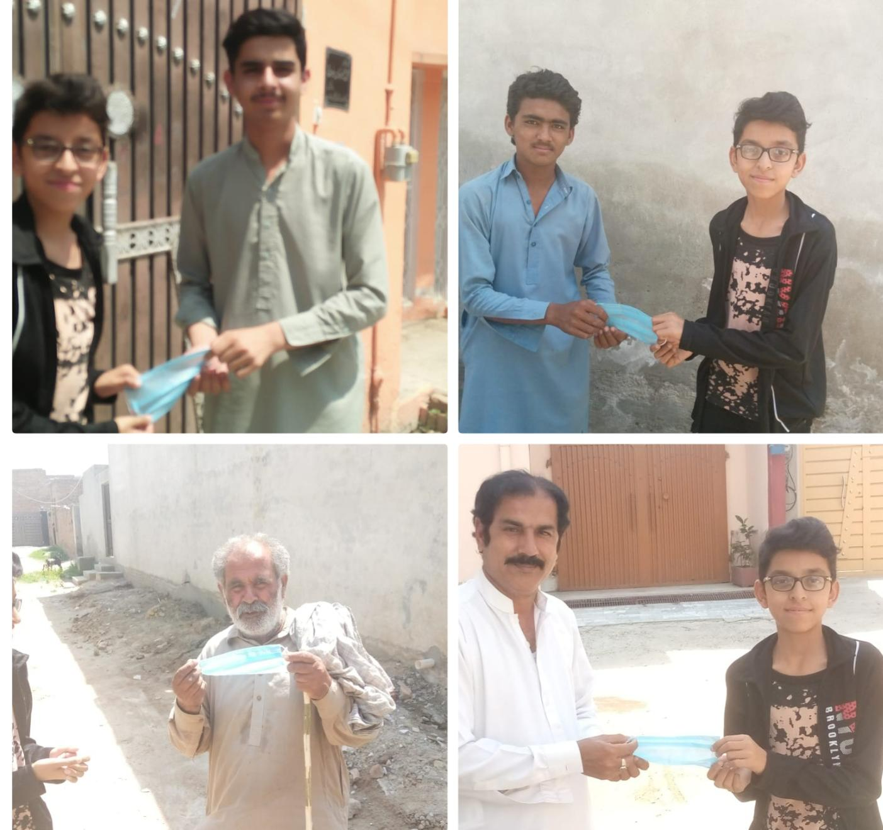
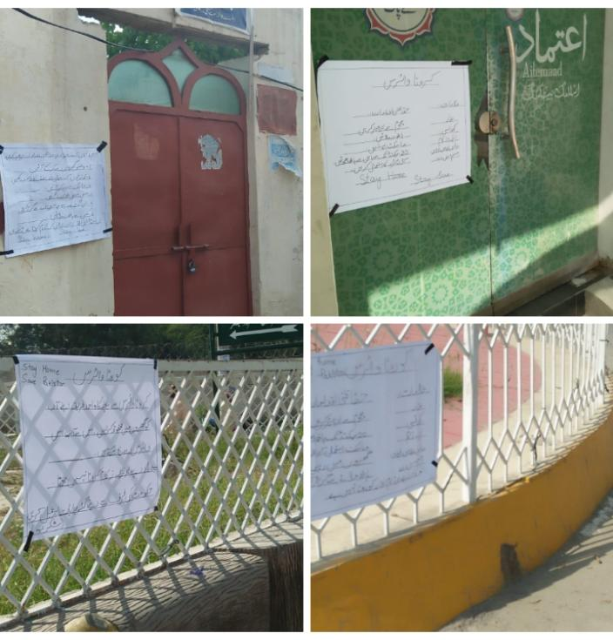
- My brother helped me in this project. He hanged charts on different public places as bank, mosque etc. He hanged these charts with the help of nails. He hanged charts on khansar road, Abbas chock, Sultania mosque etc. my brother purchased these charts from his own pocket money.

3.2- Ushna (sister)
- My sister helped me in making charts and gave me advises about chart making.
3.3- M. Munir khan (father)
- My father helped me financially and gave me some money for ration. I contributed myself for distribute the people by adding my own pocket money. I gave the ration to needy people of my area and helped them. My father is a professor. He also helped me in giving awareness to the people.
- I gave ration to the 4 houses.
- I tried my best to complete their needs.
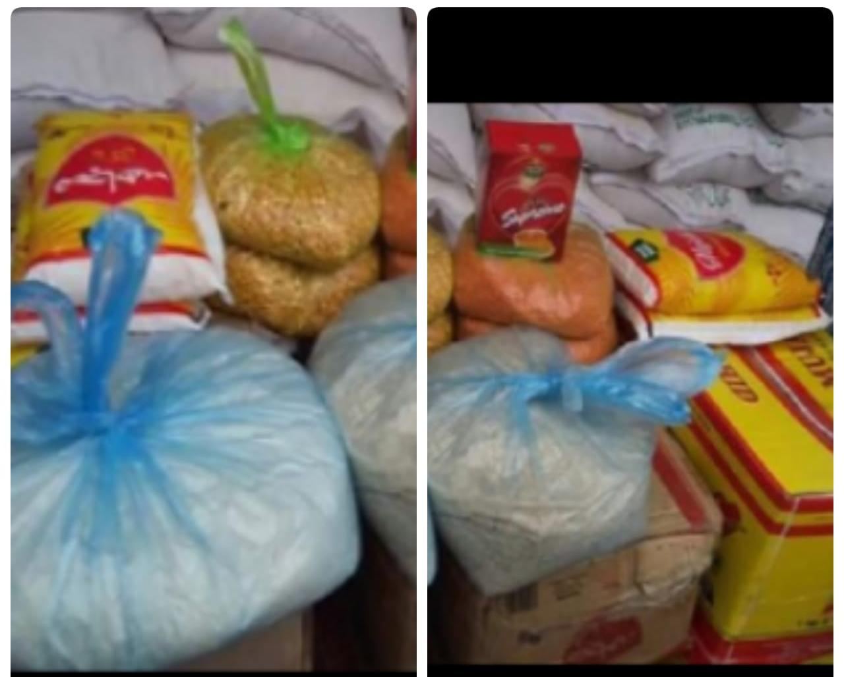

4-Sana Saleem
- I contributed in this work to provide ration (sugar, oils, tea, flour, rice) etc.
- I also purchased masks with my pocket money that was given to me by parents.
- I bought 200 masks and distributed in bazaar, mosque with the help of my brother.
- I also made charts that had precautionary measures about COVID-19 like don’t touch nose, mouth. Don't contact with Corona patients If people were facing breathing problems than they Should visit to their doctor.
- I made sanitizer with allovera gel; alcohol provided by Dr. Tahira. (Sana Saleem BBTF19BM026)
4.1-Sherbano (sister)
- My sister helped me in making charts on which precautionary measures were written about COVID-19.
- She helped me in making sanitizers for which alovera gel, dettols and rubbing alcohol were used.
- She was contributed in giving masks to protect them from Corona Virus.
4.2-Hamza Saleem(brother)
- He helped me in hanging charts on public places like Mosque, bazaar and public places.
- He also helped me to provide masks to people.
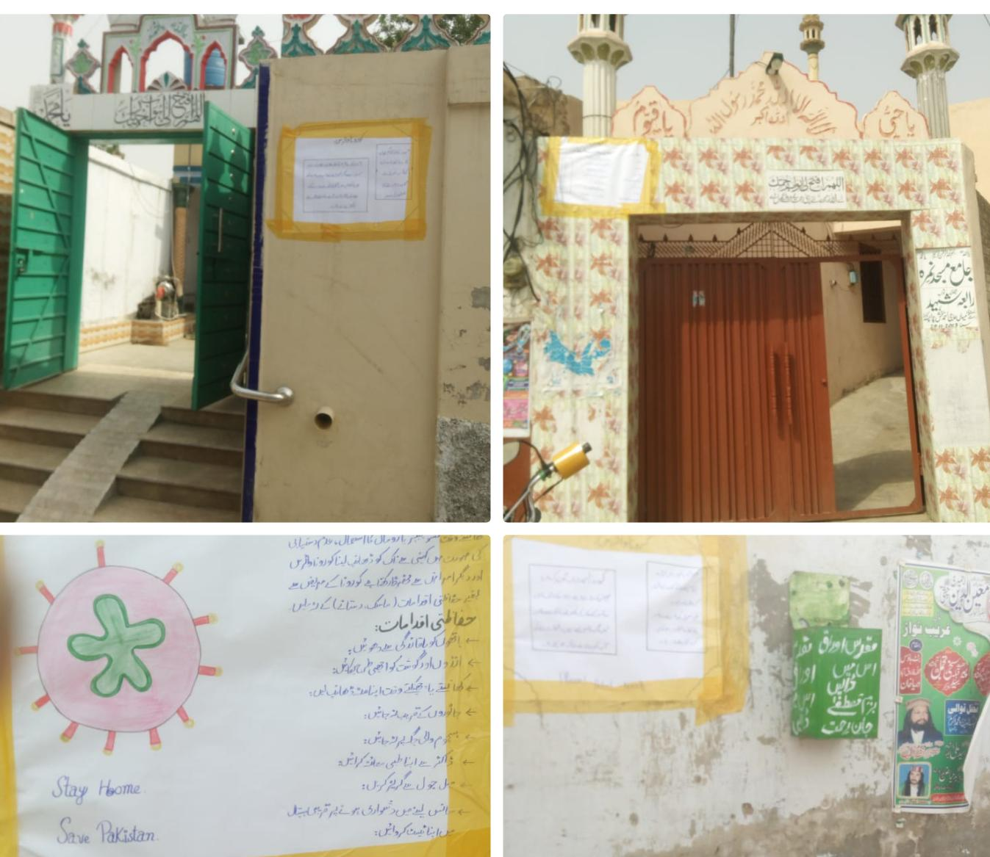

4.3- Saleem Khan(father)
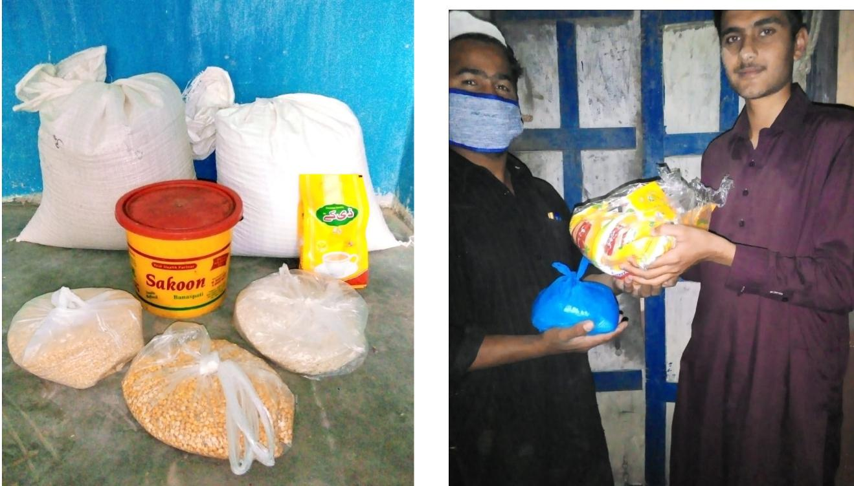
- He helped me financially to provide ration to poor people including flour, rice, oil, tea, sugar etc.
- He also helped me to bought masks and material used for making sanitizer such, allovera gel, Dettol, rubbing alcohol. These all ingredients were approved by Dr. Tahira.

4.4-Dr. Tahira
- She helped me by giving information to made sanitizers.
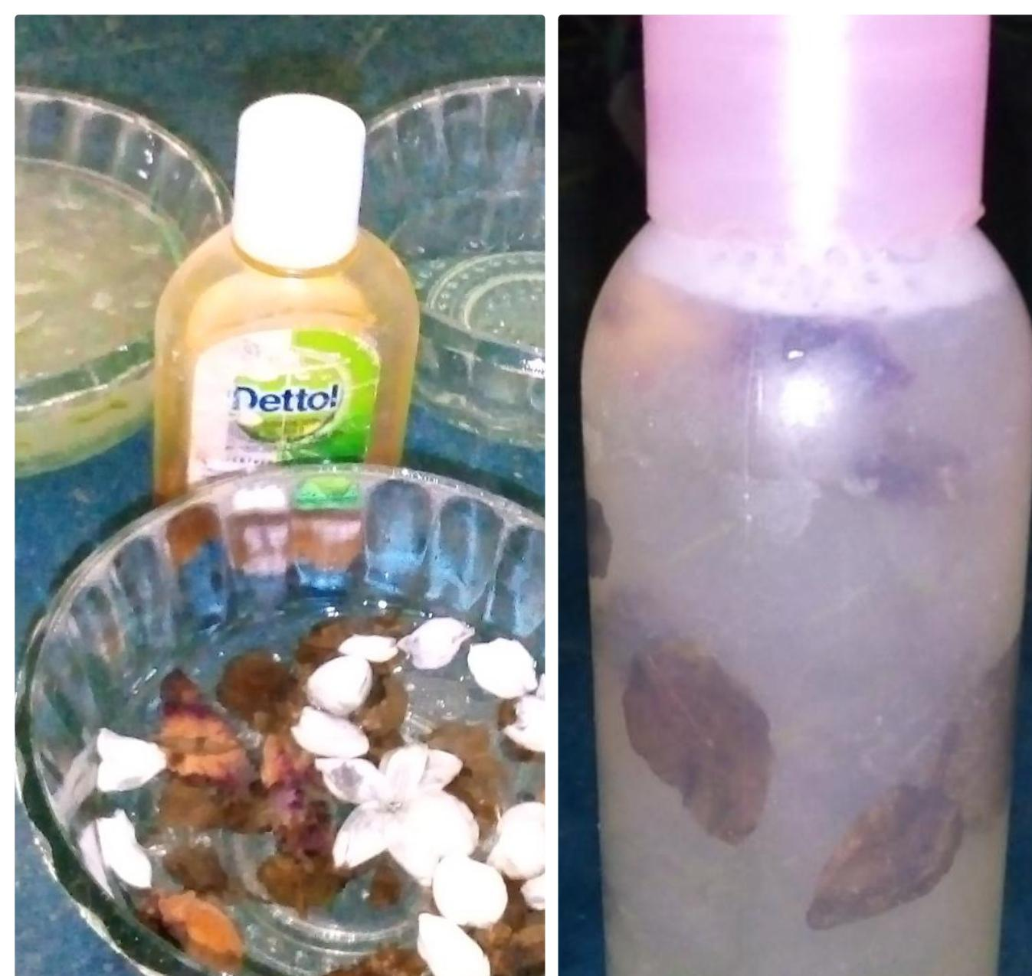
- She provided rubbing alcohols.

4.5 - Naseem Akhtar ( mother)
- She helped me financially to provide ration like oil, sugar , tea ,rice etc.
- She also helped me in giving masks.
5- Fatima Asad
- I performed three different tasks to help the people from COVID-19.
- I purchased masks with the help of my parents.
- I provided these masks to the people for their safety from COVID-19.
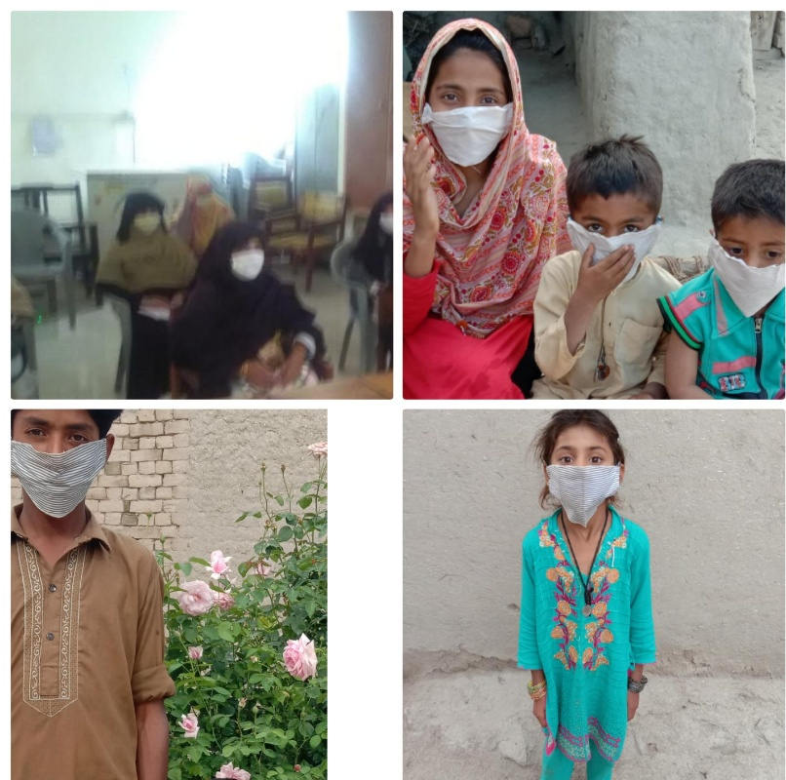
- I prepared charts on which precautionary measures were written and gave awareness through charts and I gave awareness in houses about Corona virus with the help of my mother. (Fatima Asad BBTF19BM053)
5.1-Balkees Fatima (mother)
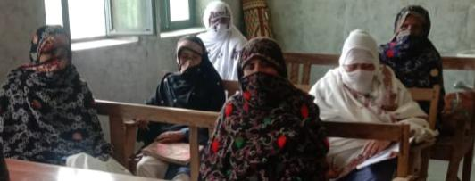
- Lady Heath Worker is the department of my mother. My mother helped me to give masks and helped me to make charts and gave awareness to the people about COVID-19.
5.2- Muhammad Ali(brother)
- My brother provided me masks, Charts, markers, nails and some stationary.

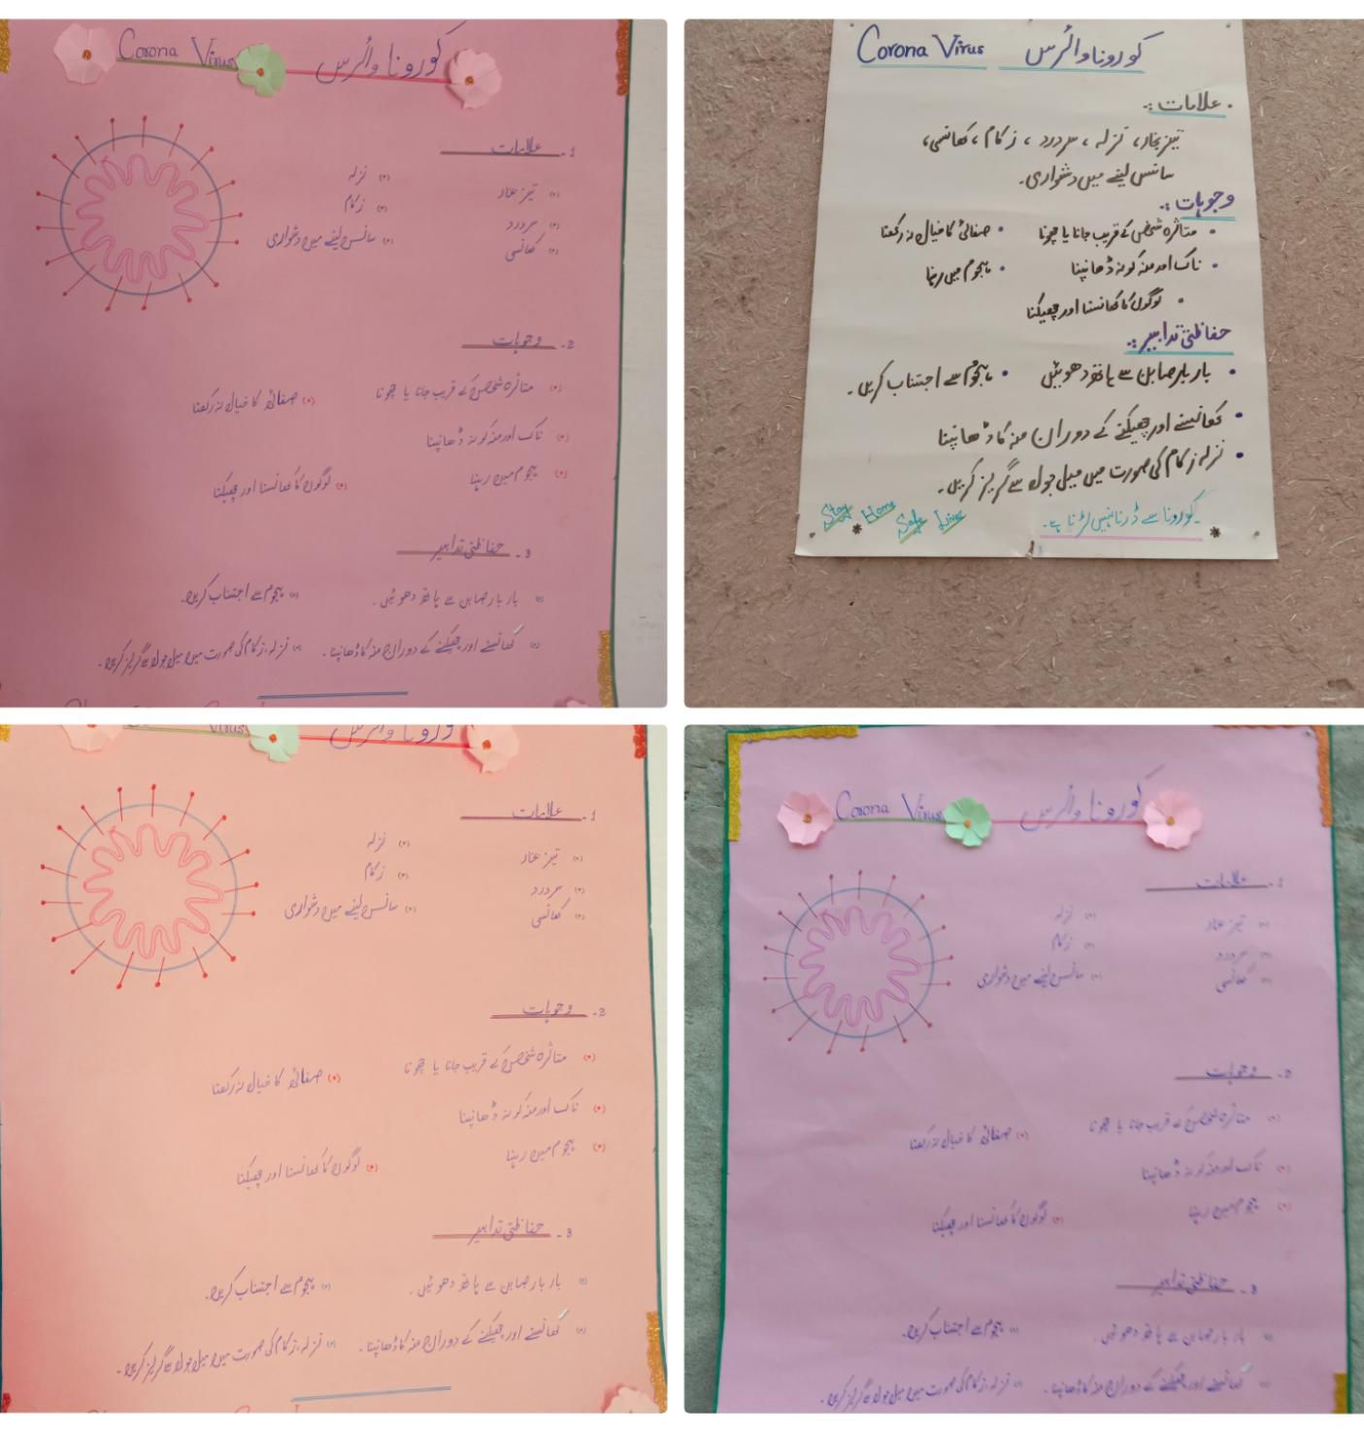
- He hanged charts on different public places like Mosque , Heath House, shops etc.
5.3- Najma Batool ( Sister)
- My sister helped me in this project. She helped me in making charts on which precautionary measures were written about COVID-19 and gave awareness about Corona Virus to protect the people of the respective areas.
6-Riffat Rani
- We all group members actively participated in this project. All members tried their best in this project.
- I made charts and gave awareness about COVID-19 through these charts.
- I with my brother drew circles on public places.
- We also told the people symptoms, causes and told them the precautionary measures given by ministry of health. (Riffat rani BBTF19BM004)
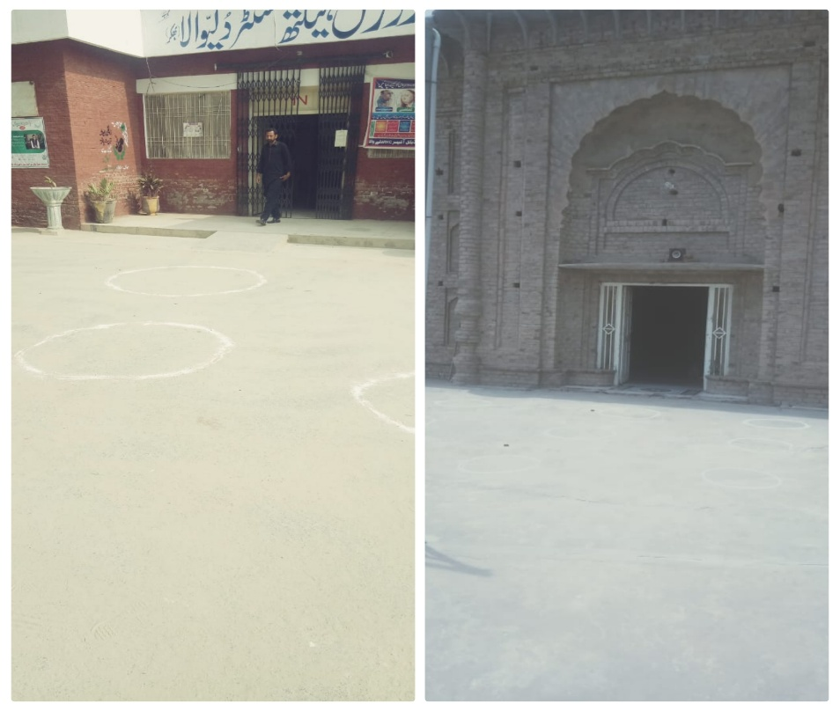

6.1- Zeeshan Ali (brother)
- My brother brought me the material (charts, markers, gum, lime) required for doing this project.
- He brought me all the things necessary for completion of this project.
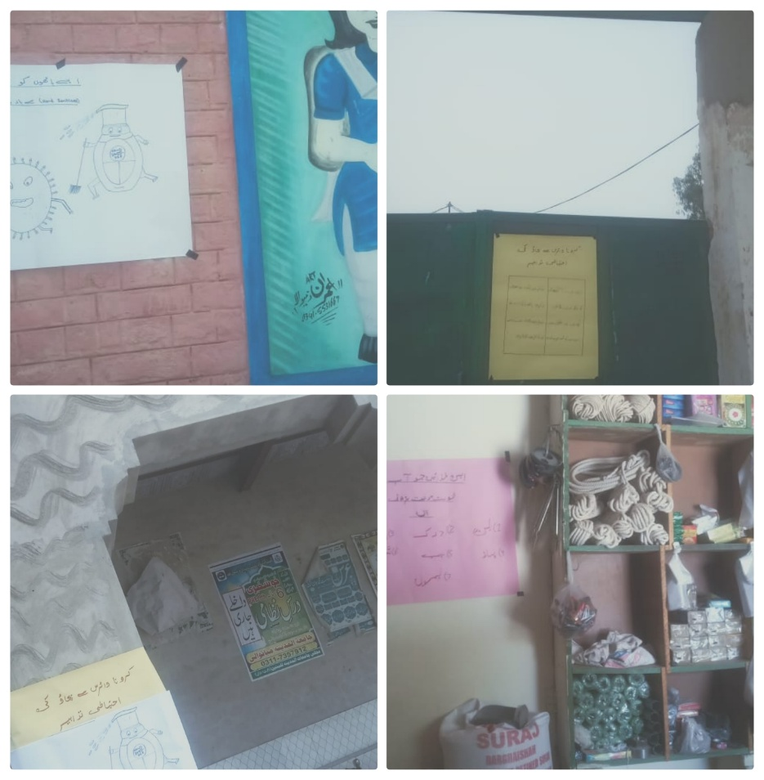
- He helped me in hanging charts, drawing circles and giving awareness to un-educated people.

5.5 Proposed duration of the project:
- We completed this project in 24 days.

6 How will you evaluate your project for possible outcomes?
- Firstly, we decided that what main objectives to do this project is. Main purpose of this project was to help poor and needy people.
- Secondly, we examined that what is importance of our project in present situation of Corona Virus and we analyzed that this project has great important. In this situation, every citizen of country is facing many problems. We planned to do this project.
- We hanged charts in front of the mosque, bank and shops. We asked about charts, from Imam masjid, shopkeepers and gunman and they told us that people come and take awareness through these charts.
- We also gave sanitizers, dettols, soaps, and masks in the mosque. The Imam of Mosque told that when people come here. They use these sanitizers, soaps and masks.
- We also drawn circles at public places like mosque with limestone and we observed that people follow all the precautionary measures. The Imam told that people were following these rules during Ramadan.
- We distributed ration rice, cooking oils, tea, sugar, flour. We had no idea that we are serving people or not but when we met those families whom we gave ration. They said that we helped a lot of their family by giving ration. Every group member supported six to seven families in this dangerous situation due to COVID-19.
- We examined the results which are expected from people and observing ones from us. (Fatima Asad BBTF19BM053, Hira BBTF19BM006 , Sana Saleem BBTF19BM026)

References:

www.cov.gov.pk

(Javed Abbas (BBTF19BM020), BS Botany II semester, Department of Biological Sciences UOS sub-campus Bhakkar.

Rawish Munir (BBTF19BM022), BS Botany II semester, Department of Biological Sciences UOS sub-campus Bhakkar.

Hira (BBTF19BM006), BS Botany II semester, Department of Biological Sciences UOS sub-campus Bhakkar.

Sana Saleem (BBTF19BM026), BS Botany II semester, Department of Biological Sciences UOS sub-campus Bhakkar.

Fatima Asad (BBTF19BM053), BS Botany II semester, Department of Biological Sciences UOS sub-campus Bhakkar.

Riffat Rani (BBTF19BM004), BS Botany II semester, Department of Biological Sciences UOS sub-campus Bhakkar.
“Strong people stand up for themselves, but stronger people stand up for others”.
“When you wish good for others, good things come back to you. This is the law of nature”.

“The End”

