How to Write Effective Meeting Minutes

What are meeting minutes?
Meeting minutes, or mom (for minutes of meeting) can be defined as the written record of everything that's happened during a meeting. They're used to inform people who didn't attend the meeting about what happened, or to keep track of what was decided during the meeting so that you can revisit it and use it to inform future decisions.

What should you include when writing meeting minutes?
The five steps that you must include are:
Or if you're just looking for a list of meeting minutes templates, check out this post.

New to writing meeting minutes?
Whether you’ve been tasked with taking notes for a committee or you’ve been appointed Secretary to the Board of your organization, preparing meeting minutes doesn’t have to be an arduous task. Here are some tips and ideas that will help you get started with writing and preparing effective meeting minutes, as well as a meeting minutes sample and a meeting minutes template that you can follow.
This guide on how to write meeting minutes was prepared by Wild Apricot to help the volunteers and/or staff of small non-profits and membership organizations who may be new to the task of taking and preparing minutes of meeting for committees or Boards of Directors.
Please note that since the format, style and content requirements for meeting minutes varies depending on the organization and the type of committee or Board, this article offers only general guidelines to help get you started.

What is the purpose of meeting minutes?
You shouldn’t be intimidated by the term “minutes” since it’s actually a little misleading. After all, your committee or Board doesn’t want or need a record of its meeting proceedings minute by minute! But it is important to capture the essence of the meeting, including details such as:
- decisions made (motions made, votes, etc.)
- next steps planned
- identification and tracking of action items
Minutes are a tangible record of the meeting for its participants and a source of information for members who were unable to attend. In some cases, meeting minutes can act as a reference point, for example:
- when a meeting’s outcomes impact other collaborative activities or projects within the organization
- minutes can serve to notify (or remind) individuals of tasks assigned to them and/or timelines

Why are they called minutes of a meeting?
According to Today I Found Out, the "minutes" of "meeting minutes" don't refer to the minute measurement of time, but to the "minute" (my-newt) notes taken during meetings.

What’s involved with meeting minutes?
As mentioned above, there are essentially five steps involved with meeting minutes:
- Pre-Planning
- Record taking - at the meeting
- Minutes writing or transcribing
- Distributing or sharing of meeting minutes
- Filing or storage of minutes for future reference

1. Pre-planning meeting minutes:
A well-planned meeting helps ensure effective meeting minutes. If the Chair and the Secretary or minutes-taker work together to ensure the agenda and meeting are well thought out, it makes minute taking much easier. For example, depending on the meeting structure and the tools you use, the minutes-taker could work with the Chair to create a document format that works as an agenda and minutes outline as well.

What is the agenda of a meeting?
Meeting agenda = outline:
At the very least, it’s important to get a copy of the meeting agenda and use it as a guide or outline for taking notes, setting up your mom format, and preparing the minutes – with the order and numbering of items on the minutes of meeting matching those of the agenda.
In addition, the agenda and/or meeting notice also provides information that will need to be included in the minutes, such as:
- the names of all the meeting attendees, including guests or speakers
- documents that are sent out with the agenda or handed out in the meeting – copies (digital or hard copy) of handouts should be stored with the meeting minutes for future reference and for sharing with those who were unable to attend the meeting (and others as determined by the meeting’s Chair).

Clarifying Expectations:
When you take on a new role as minutes-taker or Secretary, be sure to ask the Chair of the committee or Board what their expectations are of your role during the meeting, as well as the type of detail he/she expects in the minutes. For example, if your Board or committee will be dealing with motions, or voting on items/issues, be clear on whether you need to offer names of those making motions, seconding, etc. If you will be dealing with this type of procedures, you (and your Chair) may want to refer to Robert’s Rules of Order.

2. What should be included in meeting minutes?
Before you start taking notes, it’s important to understand the type of information you need to record at the meeting. As noted earlier, your organization may have required content and a specific mom format that you’ll need to follow, but generally, meeting minutes usually include the following:
- Date and time of the meeting
- Names of the meeting participants and those unable to attend (e.g., “regrets”)
- Acceptance or corrections/amendments to previous meeting minutes
- Decisions made about each agenda item, for example:
  - Actions taken or agreed to be taken
  - Next steps
  - Voting outcomes – e.g., (if necessary, details regarding who made motions; who seconded and approved or via show of hands, etc.)
  - Motions taken or rejected
  - Items to be held over
  - New business
  - Next meeting date and time
You can find more templates and details on formatting meeting minutes here.
Tips that might help your note taking:
- Create an outline – as discussed earlier, having an outline (or template) based on the agenda makes it easy for you to simply jot down notes, decisions, etc. under each item as you go along. If you are taking notes by hand, consider including space below each item on your outline for your hand-written notes, then print these out and use this to capture minutes.
- Check-off attendees as they enter the room - if you know the meeting attendees, you can check them off as they arrive, if not have folks introduce themselves at the start of the meeting or circulate an attendance list they can check-off themselves.
- Record decisions or notes on action items in your outline as soon as they occur to be sure they are recorded accurately
- Ask for clarification if necessary – for example, if the group moves on without making a decision or an obvious conclusion, ask for clarification of the decision and/or next steps involved.
- Don’t try to capture it all – you can’t keep up if you try to write down the conversation verbatim, so be sure to simply (and clearly) write (or type) just the decisions, assignments, action steps, etc.
- Record it – literally, if you are concerned about being able to keep up with note taking, consider recording the meeting (e.g., on your smart phone, iPad, recording device, etc.) but be sure to let participants know they are being recording. While you don’t want to use the recording to create a word-for-word transcript of the meeting, the recording can come in handy if you need clarification.
Download our Meeting Minute Checklist for Associations and Nonprofits with sample minutes taken at a meeting and learn how to take better minutes.

Meeting Minutes Template:
Here's a simple template you can refer to next time you need to take meeting minutes.

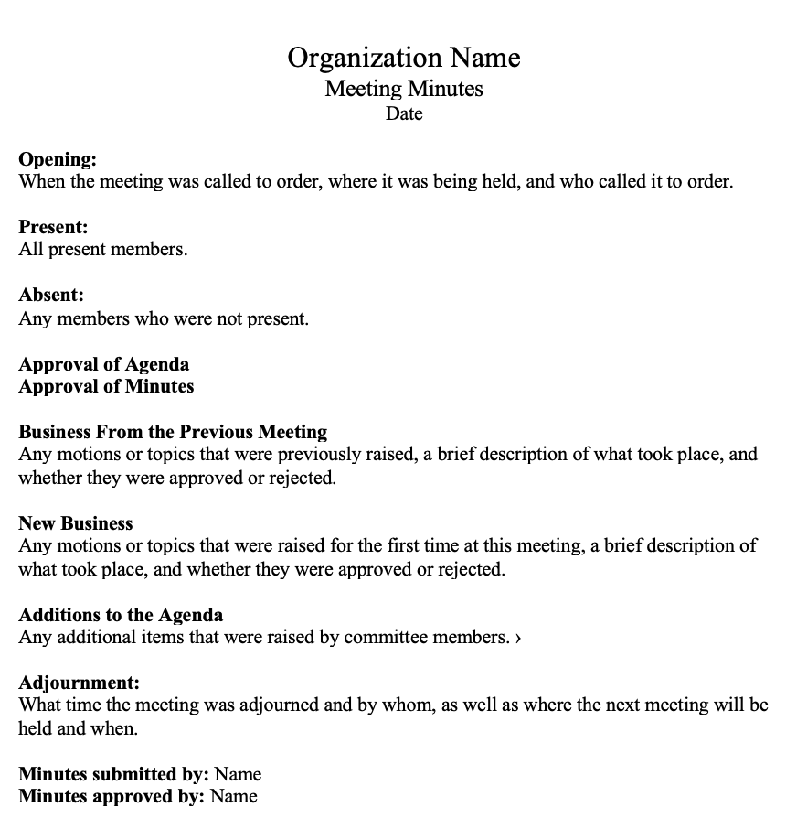
You can also find more meeting minutes templates made for Microsoft Word here.

Meeting Minutes Sample:
Still wondering if you're taking notes correctly? Here's a sample of what meeting minutes at a board meeting might look like.
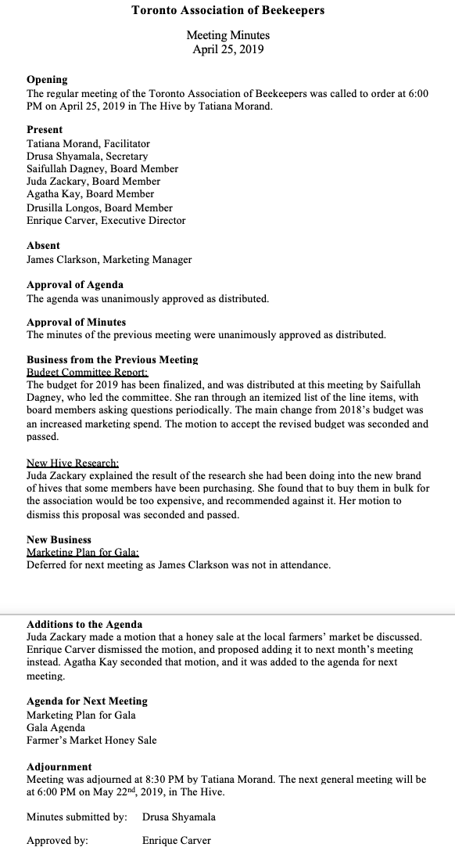

3. The Minutes Writing Process
Once the meeting is over, it’s time to pull together your notes and write the minutes. Here are some tips that might help:
- Try to write the minutes as soon after the meeting as possible while everything is fresh in your mind.
- Review your outline and if necessary, add additional notes or clarify points raised. Also check to ensure all decisions, actions and motions are clearly noted.
- Ensure you're including sufficient detail
  - For Board of Director’s minutes in particular, we recommend including a short description of each action taken, as well as the rationale behind the decision
  - If there was a lot of discussion before passing a motion, write down the major arguments for and against
- Edit to ensure brevity and clarity, so the minutes are easy to read
- In terms of mom format, here are a few things to keep in mind:
  - Be objective
  - Write in the same tense throughout
  - Avoid using names other than to record motions and seconds.
  - Avoid personal observations — the minutes should be solely fact-based
  - If you need to refer to other documents, don't try to summarize them. Rather, simply indicate where they can be found or attach them as an appendix

4. Do meeting minutes have to be approved?
Before you share your meeting minutes, make sure that the Chair has reviewed and either revised and/or approved the minutes for circulation. They are not an official record of a meeting unless this has taken place. Depending on your Board, minutes may also be formally approved at the beginning of the next meeting.

5. Distributing or Sharing Meeting Minutes
As the official “minutes-taker” or Secretary, your role may include dissemination of the minutes.

Online sharing
The method of sharing or distribution will depend on the tools that you and your organization use. Since minutes and other documentation can create a pile of paper, it’s great if you can use a paperless sharing process. For example, if you are using a word processing tool (e.g., Microsoft Word) that doesn’t offer online sharing, you might want to create a PDF of the document and send this and the other attachments or meeting documentation via email. Alternately, if you are all using Google docs – for meeting invitations, agenda and additional document sharing – you can simply “share” the document with that group once it has been finalized. Committee or Board members can simply read the documents online and save a few trees!

Sharing in the Cloud?
If your organization is using a cloud-based membership management system (like Wild Apricot), you can publish the minutes as a web page and give access only to the committee or Board members, depending on your organization’s needs. Through members-only webpages, you can create a secure online Intranet for your Board and committees.

Tools Specifically For Meeting Minutes:
If you are wondering about the types of tools you might use specifically for meeting minutes, here are some tools that organizations we've worked with have found helpful:
- Google Docs: Also supports collaborative note taking. [Here are some meeting minute sample templates in Google docs. If you send out a meeting request using Google Calendar, you can attach a Google doc agenda outline. Once minutes are crafted (using the outline), you can simply share the document with the group using their email addresses.]
- OneNote: (if you are a Microsoft user) - Very fast and allows for organization of notes. Also support audio recording with corresponding note time-stamping.
- Lucid Meetings: Fantastic meeting-tool to automate your meeting processes like notes, attendance, and organization.
- Evernote: Great note taking tool.
- Agreedo: supports creation of meeting minutes and tracking the results.
- minutes.io: allows you to quickly take meeting minutes with hotkey shortcuts and the ability to work online or offline.

6. Filing/Storage of Meeting Minutes
Most committees and Boards review and either approve or amend the minutes at the beginning of the subsequent meeting. Once you’ve made any required revisions, the minutes will then need to be stored for future reference. Some organizations may store these online (e.g., in Google docs or SkyDrive) and also back these up on an external hard drive. You may also need to print and store hard copies as well or provide these to a staff member or Chair for filing.

And... If You're a Nonprofit with Regular Board and Member Meetings
If you're a nonprofit with regular board and member meetings and you want to save time and money managing your organization, get a free trial of Wild Apricot, an all-in-one membership management software which allows you to:
- Easily schedule online events with instant online payment processing and automated invoices.
- Create a stunning website with online member applications.
- Access an easy-to-search and filter contact database.
- Send out professionally-designed newsletters and emails.
- and much more.

