Minerals
Minerals are the inorganic materials that will be present in the ash after ignition of food or any living organism. Minerals are involved in building and regulation of the body. Inorganic materials are required in the diet in our bodies in relatively minute quantities. They are classified into two categories:
- Macro minerals: they are present in appreciable amounts in the body. These are calcium, phosphorus, sodium, chlorine, potassium, magnesium and sulphur.
- Micro minerals: they are present in minute amounts in the body. They include iron, iodine, manganese, copper, zinc, cobalt and fluorine.
Major minerals:
Mineral | Source | Functions | Deficiency disease
Calcium | Milk, milk products, leafy vegetables and some legumes. | Formation of bones and teeth helps blood to clot and heart to function properly. | Children: Rickets  Adults: Osteomalacia
Phosphorus | Milk, meat, eggs, fish, cabbage and whole cereals. | Together with calcium it forms bones and teeth, involved in the storage and release of energy in the body. | -
Sodium | Sea water, rocks | Essential to regulate the water content of the body and maintains the osmotic pressure of the fluids, aids in the transport of CO2 in the blood. | Deficiency is rare. Those working in hot climates suffer from heat cramps caused by loss of NaCl from body during excessive sweating.
Chlorine | Present in form of sodium chloride or common salt. | Helps in the formation of hydrochloric acid essential part of gastric juice required in the digestion of food. | Rare
Potassium | Fruits and vegetables. | Participate in enzyme systems of the body; regulate pH and osmotic pressures of the cell. | Weakness and muscular paralysis.
Magnesium | Present in all foods except butter, cream, honey and sugar, | Found in some enzymes as activator | Rare but results in depression, muscular weakness and convulsions.
Sulphur | Beef, wheat germ and pulses. | In body it is present as part of some amino acids like cysteine, cystine and methionine and helps in protein synthesis. | Rare
.

Micro minerals:
Mineral | Sources | Functions | Deficiency diseases
Iron | Liver, kidney, lean meat, egg yolk, dry beans, pulses, dark green leafy vegetables, dried fruits and whole grains. | It is an integral part of hemoglobin that carries oxygen from lungs to muscles, brain and other parts of the body | Anaemia
Iodine | Sea fish, fish oils and iodized salt. | It is part of hormone thyroxine which increases the rate of oxidation in the body cells. | Goiter characterized by enlargement of the thyroid gland.
Zinc | Kidney, liver and oysters | Part of more than 200 enzymes in the body, essential for normal growth, reproduction and insulin production. | -

Losses during processing:
These inorganic materials are lost during:
- Heat processing
- Physical removal by cutting, trimming.
- Leaching of soluble substances in water
- Complex formation with other compounds and become unavailable e.g. oxalates and phytates.
- Milling of cereals

Experiment # 3
DETERMINATION OF ASH CONTENT OF A FOOD SAMPLE
Purpose:
To determine the inorganic residues (minerals) remaining after incineration of organic matter in the food sample.
Procedure:
- Remove seeds, stones and other inedible parts from the sample (fruit, vegetable, meat, fish, cereals, nuts etc.)
- Prepare a homogenous and representative sample as explained in experiment 1.
- Place the sample in a weighed crucible and weigh.
- Place the crucible on heat at 100ºC until water is expelled from the sample.
- Char the sample gently over a low direct flame.
- Place the crucible in muffle furnace set at 525ºC and leaves until white ash is obtained.
- Moist ash with distilled water, dry on hot plate.
- Re-ash in muffle furnace at 525ºC to constant weight.
Calculations:
Ash (%) = Weight of sample after ashing × 100
Weight of sample

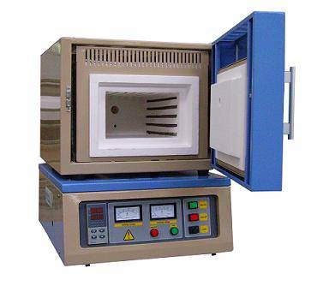
Muffle Furnace

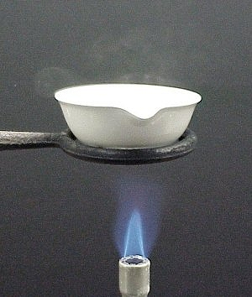

Crucible

