Spring Semester, 2020
Assignment for Sessional Marks

Subject: Drawing Class: Bs Textile
Semester 4
Instructor: Mr Buland Iqbal
Topic : water color
in this class i try to understand the watercolor technique that how watercolor behave on paper and how we can apply on surface
Material required
Water color sheet
Pencil
Eraser
Water colors ( any brand)
Sharpner
Drawing board

Some of the famous artists of watercolor

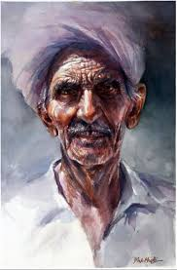
Muhammad ali Bhatti
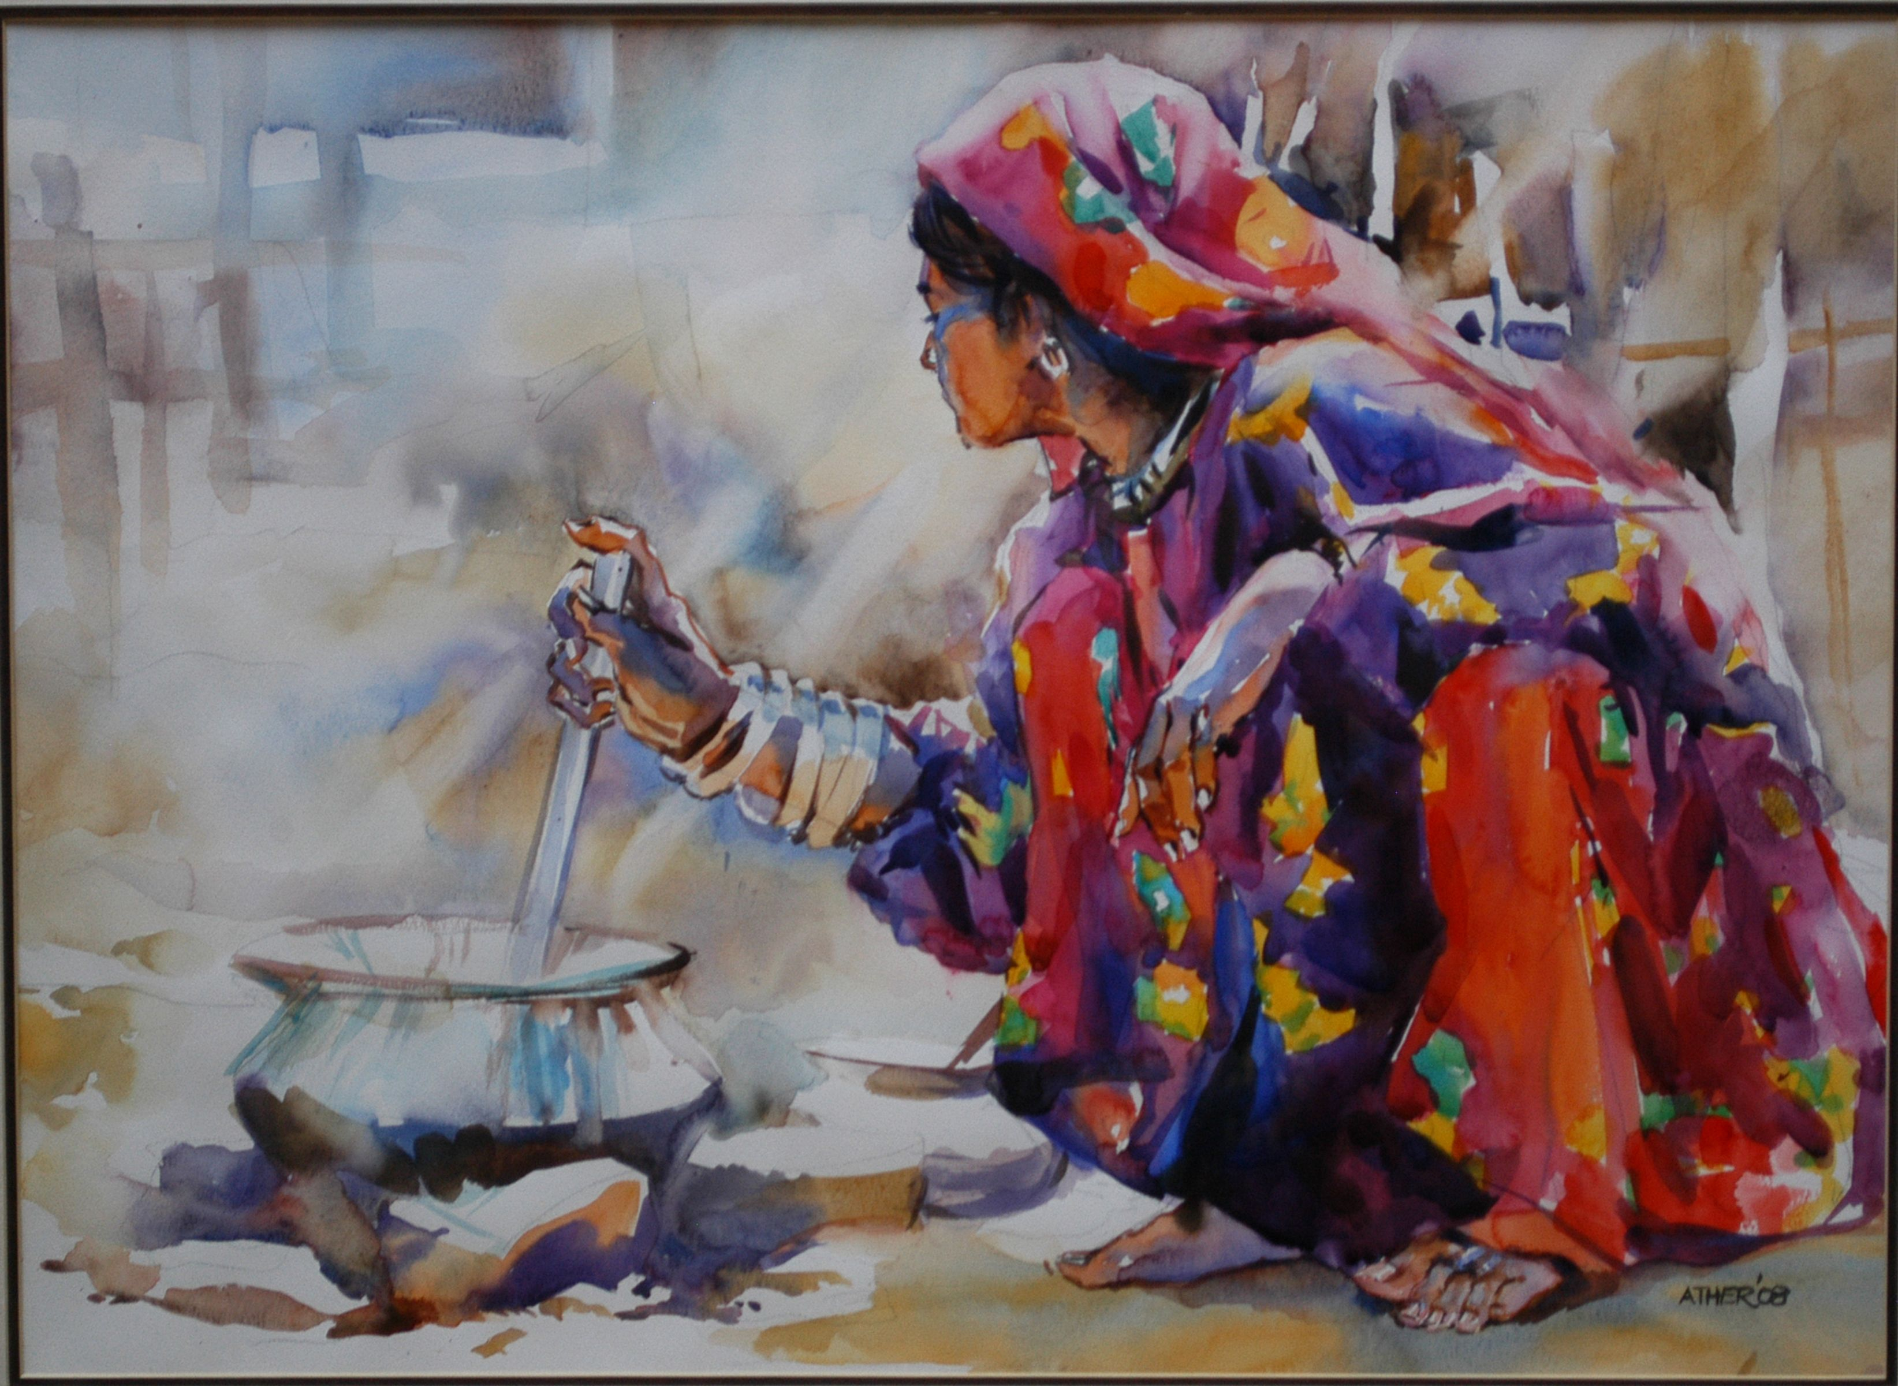
Abbas ali

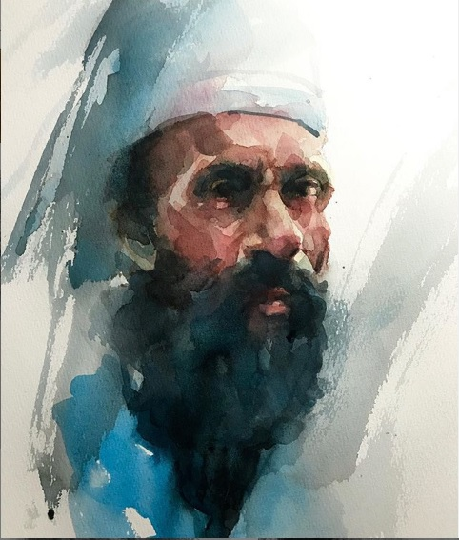
Prakash Thombre

