EDITING
WHAT IS EDITING?
• Editing is a process of lining up language, images, video and sound for Presentation on the newspaper and electronic media.
• A person who edits copy (script) is called proof reader, copy editor or sub editor.
• A person who edits sound is called sound editor and a person who edits video is called video or sound editor.
• Editor comes from a Latin Phrase “e ditus” which means “to put Forward”

FOUR BASIC TYPES OF EDITING
• Print media editing (script , photo)
• Radio editing (Sound editing)
• TV (Video) editing
• Web editing

STAGES /PHASES OF EDITING
• Proofreading/ copy editing/ line editing/ substantive editing
• Proofreading
• Subediting
• Head lines
• Lay out/ make up
• Proofreading or copy editing is traditionally means reading of a proof (first script)
• Proof reading helps to correct the typographical/ grammatical and spelling errors.
• Proofreading or Copy editing is an editorial work.
• Editor does it to improve the manuscript.
• Proofreading is simplest form of editing and the cheapest.
• Copy is a version of a manuscript. When a proofreader checks the copy, he marks the error by marking standard correction marks. Copy editing is a basic requirement for the English or Urdu news scripts.

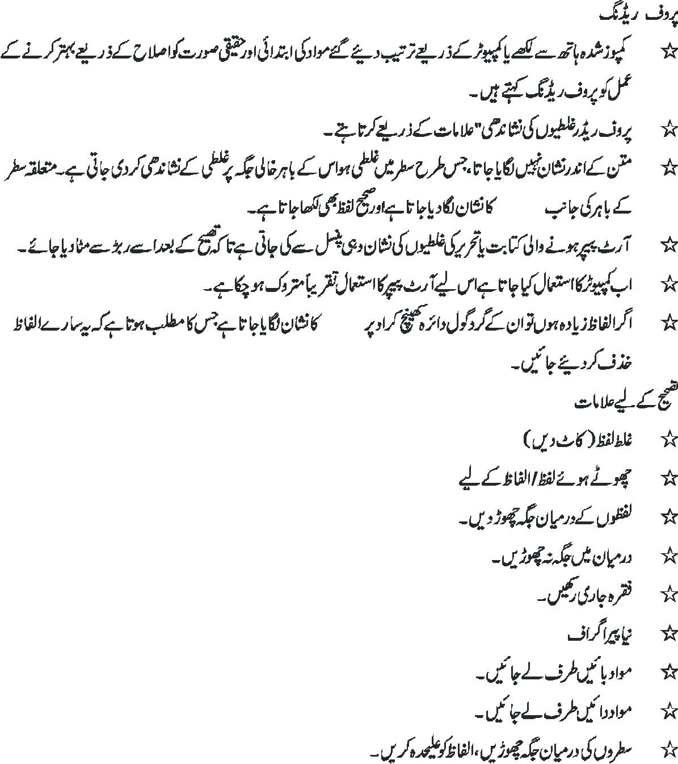

SUB EDITING
• Copy desk is a nerve centre of the news room. It is an important location in the news room. Chief Editor or the incharge of the desk sits at the center.
• The central desk is also called “The Rim”
• Desk is a place where who so ever works he learns, how to write a story, how to improve it, how to edit or how to make the headlines from the new story. In brief desk experience sharpens a future report’s skills.

RESPONSIBILITIES
• Sub editors working on desk is responsible for correcting spelling, grammar, terminology, punctuation and word usage while preserving the meaning of the original text.
• Cross checking references, art, figures, tables and other features.
• Writing, rewriting and even researching
• To check the copyrighted material
• Ensuring Checking for or imposing a consistent format.
• A sub editor has to standardized header, footers, headlines, catch line etc.
• Sub editor has to read entire text before its printing.
• Sub editors are responsible to ensure that text flows, make it sensible, fair accurate and may not provoke any legal problem.
• Sub editor’s has to summarize the copy to make it Clear, Correct, Concise, Comprehensible and Consistent
• Sub editors suppose to have vast general knowledge. This quality helps them to check the facts and the flow of language.
• Diplomacy to deal with writers/ Reporters, making suggestions about the content will annoy them.
• Editors are supposed to have a skill is writing style.
• Writing with style also involves “Organization”.
• Organizing sentences also means constructing them in a simple way.
• Organizing the right words in right place in each sentence
• Style is not a free trait. He has to Follow certain rules and conventions
• Sub Editing is an art, it is not every one’s cup of tea one has to have an extra eye.
• His is the decisive authority.
• News story written by a hurried reporter is a raw diamond and an editor polishes it.
• In fact Editing is tailoring a news story to the required size and shape.
• Placed below is a list of some difficult words and their easy alternates.

