SUB EDITING

IMPORTANCE OF EDITING

• World’s famous writer T.S Eliot while writing his best poem “The wasteland” found himself struck. He asked for help of a sub editor. His friend and fellow poet Ezra Pound assisted him and a perfect piece of English literature came out.
• The original writer loves his writing but other people can examine the work critically. Every writer and reporter ends up agreeing that the copy he received back after editing is improved, more concise, more focused and more effective them that it was earlier.
• Sub editor’s role requires a significant degree of ruthlessness. Without this quality sub editor would not be able to correct or improve the copy. In fact sub editors are unknown solders almost all the award winning books. Articles, exclusive news stories are subject to sub editing.
• Sub editing is a creative activity.
• A sub editor should have the following qualities.

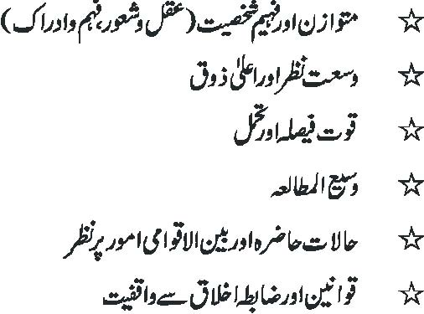

• Editing of the script may be done in a way that the intent of the copy must remain intact.
• Each paragraph address only a single subject/point.
• Present facts in orderly way and with economy of words
• He must know the art of news editing
• Should have good vocabulary
• He knows how to make good sentence structure.
• Tenses should be accurate.
• Make appropriate Paragraphs
• Sub editor must have the capability to know and check the motives behind the news items
• Sub editor must replace difficult words and place alternate word in the script. Following are some difficult words and their easy alternates.

DIFFICULT WORDS EASY WORDS
• Adjacent to near
• Prior to before
• In consequence of because
• Currently now
• He is man who He
• Fill up fill
• Check out check
• Try out try
• At the back of true facts
• A good sub editor must have the quality of Calmness: (be calm and composed come what may, you should not get excite when a big story breaks).
• Decisive: Take quick and current decisions.
• Non-partisan: Never take sides
• Skeptical : Do not accept anything at face value
• Check for taste
• Writes headlines and also sub headings if necessary
• Ethics for Editor
• Facts must not be tampered with. News must be reported with complete objectivity and without distortion.
• A sub editor should not mix news and views and must be careful enough to clearly distinguish between the two.
• Publication of baseless, graceless and manipulated material should be avoided.
• Able to meet needs of the changing times.
• Safeguard yourself and your organization from the legal clutches.
• Sub editing is a challenging Job. In brief sub editor takes care of following seven “Cs” he would have a great success.

SEVEN “Cs”
• Correcting (Grammar, spelling and house style)
• Condensing
• clarifying
• Cutting (or expanding)
• Checking
• Creating
• Consisting

EDITING

MAKE UP

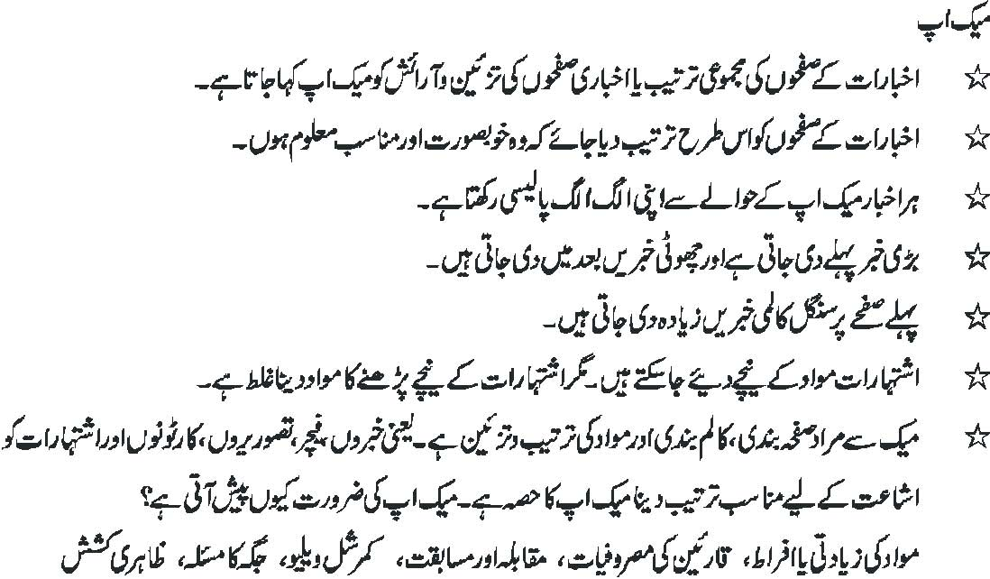

• Purpose of Designing is to grab the reader’s attention and hold to read.
• Designing in Publication is a craft and art and design of a publication is a delicate process.

Designing makes the space and the following elements are accommodated with attraction.
• Headlines,
• Pictures,
• Graphics,
• Advertisement
• Technical limitations of production process
• Body text

CAPTIONS

• Captions are like writing intros. They are the catch liner for readers.
• Every photograph needs a caption.
• Never publish a picture without some identification.
• Must identify all the people in an image.
• A caption can explains the significance of the picture.
• Even the most dull picture can be made relatively interesting by intelligent and a bright caption.
• A good photograph should reflect the feelings and responses of the people photographed.
• Photograph depicts the decisive movement and the caption should reflect that.

TRANSLATIONS

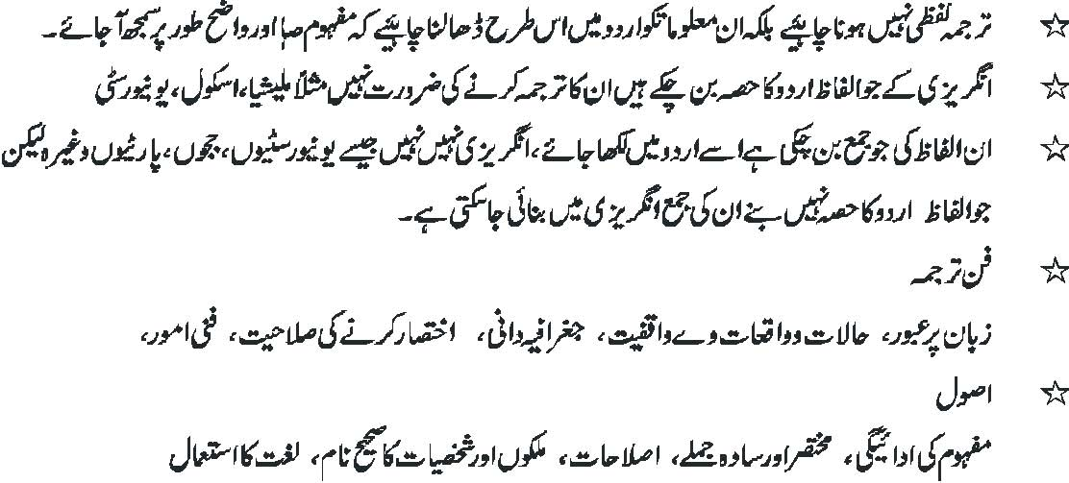
IMAGE EDITING, WHAT IMAGE IS EDITING

• The processes of altering images, whether they are digital photographs, traditional analog photographs, or illustrations.
• Images are stored in a computer in the form of a grid of picture elements.
• These pixels contain the color and brightness information of an image.
• Image editors can change the pixels to enhance the image in many ways.

IMAGE SIZE ALTERATION
• Image editors can resize images in a process often called image scaling, making them large or smaller.
• Noise Reduction
• Dust and scratches.

SPECIAL EFFECTS
• Special effects can create unusual results.
• Contrast and Brightening

EDITING ON COMPUTER

REVOLUTION
• Computers have revolutionized the art of editing. Editing on the screen is faster, more comprehensive and more detailed than on the hard copy.

COMPLICATION
• Computer is a sophisticated machine; its editing operations are complicated.They have to be understood well by sub-editors before they begin to edit.

TECHNICAL KNOW HOW
• Sub-editors do not have to be computer experts to edit. However sub-editors must know how to use the keyboard.

INSTANT / FACILITIES
• Computer editing is instant editing although it is near-perfect editing. Facilities such as spell-check, word-count, short keys cut, paste, copy, make sub-editors job easy.

CURSOR
• Experience suggests that sharp and tight proof-reading cannot be done on the computer because the eye does not stop at each word and tends to move with the cursor. Take out print-outs, and, pencil in hand, read the script again and again.
• A comma at a wrong place can change the entire meaning of a sentence.
• Similarly, a wrongly spelt name or wrongly used word can mar beautifully edited copy.

