HomeWorld HistoryThe Ancient World

Indus civilization
Print Cite Share More
WRITTEN BY
The Editors of Encyclopaedia Britannica
Encyclopaedia Britannica's editors oversee subject areas in which they have extensive knowledge, whether from years of experience gained by working on that content or via study for an advanced degree....
See Article History
Alternative Titles: Harappān civilization, Indus valley civilization
The civilization was first identified in 1921 at Harappa in the Punjab region and then in 1922 at Mohenjo-daro (Mohenjodaro), near the Indus River in the Sindh (Sind) region. Both sites are in present-day Pakistan, in Punjab and Sindh provinces, respectively. The ruins of Mohenjo-daro were designated a UNESCO World Heritage site in 1980.
Subsequently, vestiges of the civilization were found as far apart as Sutkagen Dor in southwestern Balochistan province, Pakistan, near the shore of the Arabian Sea, about 300 miles (480 km) west of Karachi; and at Ropar (or Rupar), in eastern Punjab state, northwestern India, at the foot of the Shimla Hills some 1,000 miles (1,600 km) northeast of Sutkagen Dor. Later exploration established its existence southward down the west coast of India as far as the Gulf of Khambhat (Cambay), 500 miles (800 km) southeast of Karachi, and as far east as the Yamuna (Jumna) River basin, 30 miles (50 km) north of Delhi. It is thus decidedly the most extensive of the world’s three earliest civilizations; the other two are those of Mesopotamia and Egypt, both of which began somewhat before it.
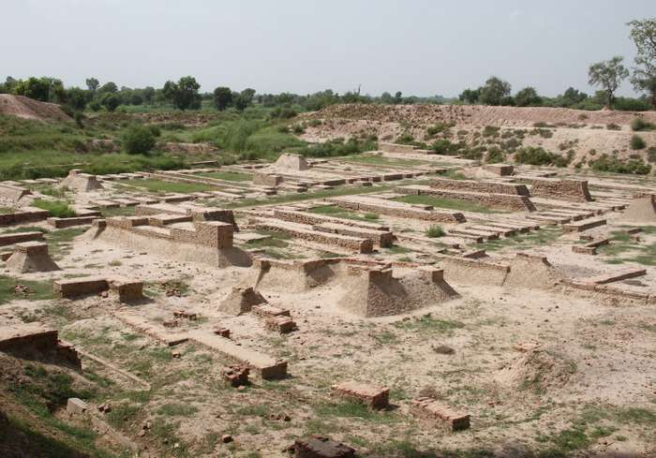
Harappa ruins
Ruins of the ancient city of Harappa in Punjab, Pakistan.
© Smn121
The Indus civilization is known to have consisted of two large cities, Harappa and Mohenjo-daro, and more than 100 towns and villages, often of relatively small size. The two cities were each perhaps originally about 1 mile (1.6 km) square in overall dimensions, and their outstanding magnitude suggests political centralization, either in two large states or in a single great empire with alternative capitals, a practice having analogies in Indian history. It is also possible that Harappa succeeded Mohenjo-daro, which is known to have been devastated more than once by exceptional floods. The southern region of the civilization, on the Kathiawar Peninsula and beyond, appears to be of later origin than the major Indus sites. The civilization was literate, and its script, with some 250 to 500 characters, has been partly and tentatively deciphered; the language has been indefinitely identified as Dravidian.
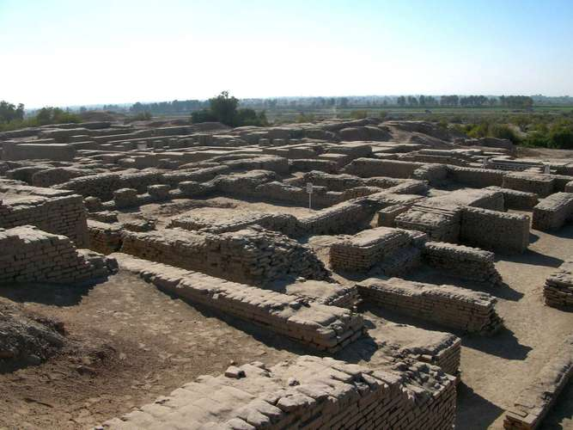
Mohenjo-daro
Portion of the ruins at the Mohenjo-daro archaeological site, southeastern Pakistan.
© Yousaf Fayyaz/Fotolia
Get exclusive access to content from our 1768 First Edition with your subscription.Subscribe today
The Indus civilization apparently evolved from the villages of neighbours or predecessors, using the Mesopotamian model of irrigated agriculture with sufficient skill to reap the advantages of the spacious and fertile Indus River valley while controlling the formidable annual flood that simultaneously fertilizes and destroys. Having obtained a secure foothold on the plain and mastered its more immediate problems, the new civilization, doubtless with a well-nourished and increasing population, would find expansion along the flanks of the great waterways an inevitable sequel. The civilization subsisted primarily by farming, supplemented by an appreciable but often elusive commerce. Wheat and six-row barley were grown; field peas, mustard, sesame, and a few date stones have also been found, as well as some of the earliest known traces of cotton. Domesticated animals included dogs and cats, humped and shorthorn cattle, domestic fowl, and possibly pigs, camels, and buffalo. The Asian elephant probably was also domesticated, and its ivory tusks were freely used. Minerals, unavailable from the alluvial plain, were sometimes brought in from far afield. Gold was imported from southern India or Afghanistan, silver and copper from Afghanistan or northwestern India (present-day Rajasthan state), lapis lazuli from Afghanistan, turquoise from Iran (Persia), and a jadelike fuchsite from southern India.
Perhaps the best-known artifacts of the Indus civilization are a number of small seals, generally made of steatite (a form of talc), which are distinctive in kind and unique in quality, depicting a wide variety of animals, both real—such as elephants, tigers, rhinoceros, and antelopes—and fantastic, often composite creatures. Sometimes human forms are included. A few examples of Indus stone sculpture have also been found, usually small and representing humans or gods. There are great numbers of small terra-cotta figures of animals and humans.
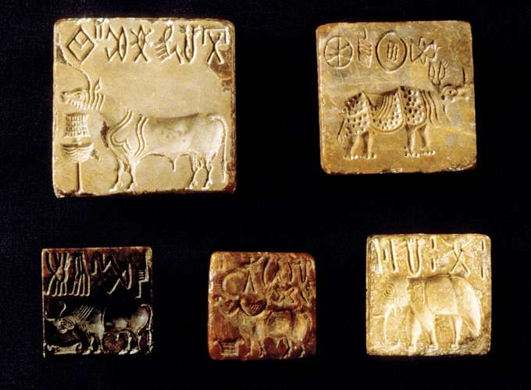
Indus civilization: seals
Assortment of seals with animal motifs in use during the time of the Indus civilization, 2nd–3rd millennium BCE.
Copyright J.M. Kenoyer/Harappa.com; Courtesy Department of Archaeology and Museums, Government of Pakistan
How and when the civilization came to an end remains uncertain. In fact, no uniform ending need be postulated for a culture so widely distributed. But the end of Mohenjo-daro is known and was dramatic and sudden. Mohenjo-daro was attacked toward the middle of the 2nd millennium BCE by raiders who swept over the city and then passed on, leaving the dead lying where they fell. Who the attackers were is matter for conjecture. The episode would appear to be consistent in time and place with the earlier invaders from the north (formerly called Aryans) into the Indus region as reflected in the older books of the Rigveda, in which the newcomers are represented as attacking the “walled cities” or “citadels” of the aboriginal peoples and the invaders’ war-god Indra as rending forts “as age consumes a garment.” However, one thing is clear: the city was already in an advanced stage of economic and social decline before it received the coup de grâce. Deep floods had more than once submerged large tracts of it. Houses had become increasingly shoddy in construction and showed signs of overcrowding. The final blow seems to have been sudden, but the city was already dying. As the evidence stands, the civilization was succeeded in the Indus valley by poverty-stricken cultures, deriving a little from a sub-Indus heritage but also drawing elements from the direction of Iran and the Caucasus—from the general direction, in fact, of the northern invasions. For many centuries urban civilization was dead in the northwest of the Indian subcontinent.
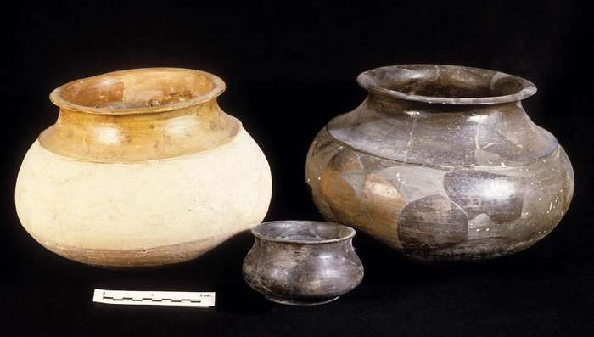
Indus civilization: cooking pots
Harappan cooking pots in use during the Indus civilization, c. 2300–2200 BCE.
Copyright J.M. Kenoyer/Harappa.com; Courtesy Department of Archaeology and Museums, Government of Pakistan
In the south, however, in Kathiawar and beyond, the situation appears to have been very different. There it would seem that there was a real cultural continuity between the late Indus phase and the Copper Age cultures that characterized central and western India between 1700 and the 1st millennium BCE. Those cultures form a material bridge between the end of the Indus civilization proper and the developed Iron Age civilization that arose in India about 1000 BCE.

