SYNTHETIC CULTIVAR

A synthetic cultivar is an advanced generation of a seed mixture of strains, clones, inbreds, or hybrids among them, propagated for a limited number of generations by open-pollination. The word "synthetic" implies a population of plants artificially produced by the breeder. The component strains, clones, or inbreds are maintained, and the synthetic is reconstituted at regular intervals. It is incorrect to apply the term synthetic to populations originating from seed mixtures advanced by open-pollination without periodic reconstitution.

The synthetic procedure is widely used in breeding forage crops. In forage species, the half-sib, full-sib, or S₁ selection procedures are rarely applicable because:

- The quantity of seed produced from a single plant is usually inadequate to grow a progeny test,
- Self-incompatibility inhibits production of selfed seed in many forage species, and
- Controlled cross-pollinations are difficult to make in most forage species.

In addition to forage crops, synthetic cultivars may be developed in corn, sugarbeets, sunflower, and other cross-pollinated species.

The design of the synthetic cultivar utilizes the partial exploitation of heterosis during a limited number of generations of seed increase. This feature has made the synthetic cultivar popular in breeding forage species where conventional crossing procedures to obtain heterosis are not feasible. The procedure for developing a synthetic cultivar has these essential characteristics:

- The synthetic cultivar is constituted from reproducible units of a cross-pollinated crop (clones in forage species, inbreds in corn or sugarbeets).
- The plant materials entering into the synthetic cultivar are selected from performance in combining ability or progeny tests.
- The synthetic cultivar is constituted by random interpollination of the component units.
- The component units are maintained so that the synthetic may be reconstituted at regular intervals.

A model for the development of a synthetic cultivar in a forage species that embodies these characteristics is illustrated in Fig. 10.9. The procedure involves several distinct populations

Source population. Plant selections are assembled from many sources to ensure a broad range of genetic variability. The original plant selections may come from old established pastures or meadows, improved cultivars, introductions, bulked populations after several cycles of recurrent selection for a particular characteristic, or other sources. The clones should be
vigorous and productive so that they can be easily maintained and will produce vigorous and productive progenies.

Clonal line nursery. From the source nursery several hundred superior plants, are chosen and multiplied as clones for establishing a clonal line nursery (Fig. 10.10). Each clonal line in the nursery will be comprised of 20 to 25 plants propagated vegetatively from the original plant. The clonal lines are evaluated for vigor, persistence, and other superior characteristics, depending upon the species and the objectives of the breeding program. Exposure of the clones to adversities, such as severe clipping, disease epidemics, cold, or drought, will aid in identifying clones with superior qualities. Finally, 25 to 50 of the superior clones will be selected for progeny testing in a polycross nursery.

Making the polycross. Seed for growing a progeny performance test is obtained by making a polycross. The polycross is an isolated group of clonal lines replicated in such a manner that each clone will be pollinated by a random sample of pollen from all of the other clones. The seed from each clone is harvested separately with the identity of the clone maintained.

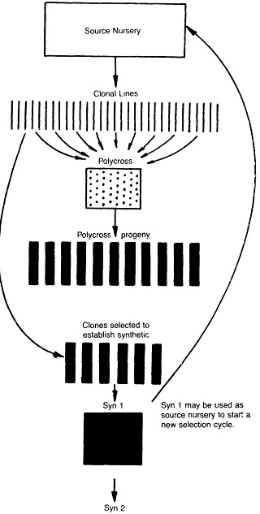

Fig.10.9.Procedure for development of a synthetic cultivar of a forage crop, based on polycross progeny performanc

Polycross progeny test. The open-pollinated seeds harvested from the clone in the polycross are planted in a progeny test for evaluation of yield and other characters. From the polycross progeny test performance, 5 to 10 of the clones are chosen as components for the synthetic.

Syn 0 generation. The 5 to 10 clones chosen to be utilized in the synthetic are vegetatively propagated and randomly transplanted into an isolated seed field, or, in the case of a legume, the clones may be transplanted into an insect-proof cage and pollinated with bees to obtain seed. This constitutes the Syn 0 generation. Random cross-pollination among the Syn 0 clones fosters gene recombination.

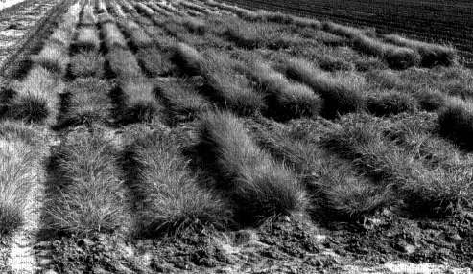

Fig. 10.10.Strains of weeping lovegrass. In the development of a synthetic cultivar in forage crops, the characteristics of the individual breeding lines are evaluated by growing the lines in a field nursery. The combining ability of the lines are evaluated by growing the lines in a polycross yield nursery.

Syn 1 generation. Open-pollinated seed harvested from the Syn 0 generation is planted in isolation for seed increase. This constitutes the Syn 1 generation and may be distributed as a synthetic cultivar if seed can be produced in sufficient quantity. Superior plant selections from the Syn 1 generation may be vegetatively propagated to start a new source nursery.

Syn 2 generation. Open-pollinated seed harvested from the Syn 1 generation is increased in isolation. This constitutes the Syn 2 generation.

The purpose of growing the Syn 2 generation is to increase the quantity of seed that will be available to the farmer. If sufficient seed to meet market demand can be produced in the Syn 1 generation, it will be unnecessary to grow the Syn 2 generation. In most instances it is necesary to go to the Syn 3 or later generations to have adequate seed for sale to farmers. The Syn 1 and

Syn 2 generations are comparable to the F₁ and F₂ generations, respectively, in conventional hybridization. Each generation the synthetic cultivar is advanced beyond the Syn 1 there will be successive reductions in vigor. The original clones are maintained so that the synthetic cultivar can be reconstituted when the seed fields need to be renewed. The Syn 1 generation may be utilized as a source nursery from which to select clones that could be used in breeding future synthetics, thus introducing the recurrent-selection principle. In addition to polycross performance, as illustrated here, to evaluate clones, the clones may be evaluated by S₁ performance trials.

A synthetic cultivar in corn is produced in a similar manner to that illustrated with a forage crop except that the breeder will be working with inbreds instead of clones. The corn inbreds to be used as component lines in the synthetic cultivar are chosen on the basis of combining ability tests, and crossed in all combinations to produce the seed for growing the Syn 1 generation. The inbreds are maintained so that the synthetic can be reconstituted. Similar procedures may be utilized to produce synthetic cultivars in other cross-pollinated crops. In annual species of plants such as corn, the synthetic will need to be reconstituted each season, otherwise, the population behaves as an open-pollinated cultivar.

CHOICE OF SOURCE GERMPLASM AND TEST ENVIRONMENT

With recurrent-selection procedures, the performance level of the source population and the test environment are important. A superior combination of alleles for the character being improved will not be forthcoming if the genes are not in the source population. In choosing component lines for the source population, only those with the highest expression of the desired characters should be included. If the lines have a diverse origin, there may be a greater possibility that they will contain different alleles for the character. When evaluating the populations, they will need to be grown in an environment that fosters expression of the character to be improved, if the superior genotype is to be identified.

