Introducing Realism in International Relations Theory

In the discipline of International Relations (IR), realism is a school of thought that emphasises the competitive and conflictual side of international relations. Realism’s roots are often said to be found in some of humankind’s earliest historical writings, particularly Thucydides’ history of the Peloponnesian War, which raged between 431 and 404 BCE. Thucydides, writing over two thousand years ago, was not a ‘realist’ because IR theory did not exist in named form until the twentieth century. However, when looking back from a contemporary vantage point, theorists detected many similarities in the thought patterns and behaviours of the ancient world and the modern world. They then drew on his writings, and that of others, to lend weight to the idea that there was a timeless theory spanning all recorded human history. That theory was named ‘realism’.
'This is our life': Armenians flee before Azerbaijan arrives
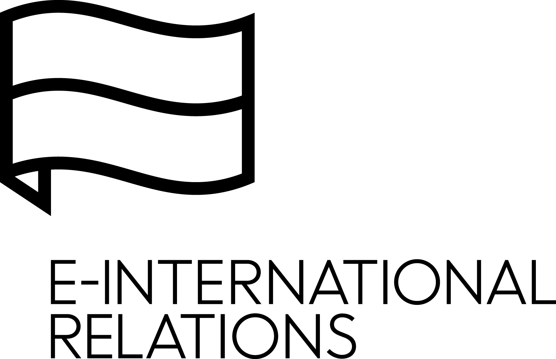
The basics of realism
The first assumption of realism is that the nation-state (usually abbreviated to ‘state’) is the principle actor in international relations. Other bodies exist, such as individuals and organisations, but their power is limited. Second, the state is a unitary actor. National interests, especially in times of war, lead the state to speak and act with one voice. Third, decision-makers are rational actors in the sense that rational decision-making leads to the pursuit of the national interest. Here, taking actions that would make your state weak or vulnerable would not be rational. Realism suggests that all leaders, no matter what their political persuasion, recognise this as they attempt to manage their state’s affairs in order to survive in a competitive environment. Finally, states live in a context of anarchy – that is, in the absence of anyone being in charge internationally. The often-used analogy of there being ‘no one to call’ in an international emergency helps to underline this point. Within our own states we typically have police forces, militaries, courts and so on. In an emergency, there is an expectation that these institutions will ‘do something’ in response. Internationally, there is no clear expectation of anyone or anything ‘doing something’ as there is no established hierarchy. Therefore, states can ultimately only rely on themselves.
As realism frequently draws on examples from the past, there is a great deal of emphasis on the idea that humans are essentially held hostage to repetitive patterns of behaviour determined by their nature. Central to that assumption is the view that human beings are egoistic and desire power. Realists believe that our selfishness, our appetite for power and our inability to trust others leads to predictable outcomes. Perhaps this is why war has been so common throughout recorded history. Since individuals are organised into states, human nature impacts on state behaviour. In that respect, Niccolò Machiavelli focused on how the basic human characteristics influence the security of the state. And in his time, leaders were usually male, which also influences the realist account of politics. In The Prince (1532), Machiavelli stressed that a leader’s primary concern is to promote national security. In order to successfully perform this task, the leader needs to be alert and cope effectively with internal as well as external threats to his rule; he needs to be a lion and a fox. Power (the Lion) and deception (the Fox) are crucial tools for the conduct of foreign policy. In Machiavelli’s view, rulers obey the ‘ethics of responsibility’ rather than the conventional religious morality that guides the average citizen – that is, they should be good when they can, but they must also be willing to use violence when necessary to guarantee the survival of the state.
In the aftermath of the Second World War, Hans Morgenthau (1948) sought to develop a comprehensive international theory as he believed that politics, like society in general, is governed by laws that have roots in human nature. His concern was to clarify the relationship between interests and morality in international politics, and his work drew heavily on the insights of historical figures such as Thucydides and Machiavelli. In contrast to more optimistically minded idealists who expected international tensions to be resolved through open negotiations marked by goodwill, Morgenthau set out an approach that emphasised power over morality. Indeed, morality was portrayed as some- thing that should be avoided in policymaking. In Morgenthau’s account, every political action is directed towards keeping, increasing or demonstrating power. The thinking is that policies based on morality or idealism can lead to weakness – and possibly the destruction or domination of a state by a competitor. In this sense pursuing the national interest is ‘amoral’ – meaning that it is not subject to calculations of morality.
In Theory of International Politics (1979), Kenneth Waltz modernised IR theory by moving realism away from its unprovable (albeit persuasive) assumptions about human nature. His theoretical contribution was termed ‘neorealism’ or ‘structural realism’ because he emphasised the notion of ‘structure’ in his explanation. Rather than a state’s decisions and actions being based on human nature, they are arrived at via a simple formula. First, all states are constrained by existing in an international anarchic system (this is the structure). Second, any course of action they pursue is based on their relative power when measured against other states. So, Waltz offered a version of realism that recommended that theorists examine the characteristics of the international system for answers rather than delve into flaws in human nature. In doing so, he sparked a new era in IR theory that attempted to use social scientific methods rather than political theory (or philosophical) methods. The difference is that Waltz’s variables (international anarchy, how much power a state has, etc.) can be empirically/physically measured. Ideas like human nature are assumptions based on certain philosophical views that cannot be measured in the same way.
Realists believe that their theory most closely describes the image of world politics held by practitioners of statecraft. For this reason, realism, perhaps more than any other IR theory, is often utilised in the world of policymaking – echoing Machiavelli’s desire to write a manual to guide leaders. However, realism’s critics argue that realists can help perpetuate the violent and confrontational world that they describe. By assuming the uncooperative and egoistic nature of humankind and the absence of hierarchy in the state system, realists encourage leaders to act in ways based on suspicion, power and force. Realism can thus be seen as a self-fulfilling prophecy. More directly, realism is often criticised as excessively pessimistic, since it sees the confrontational nature of the international system as inevitable. However, according to realists, leaders are faced with endless constraints and few opportunities for cooperation. Thus, they can do little to escape the reality of power politics. For a realist, facing the reality of one’s predicament is not pessimism – it is prudence. The realist account of international relations stresses that the possibility of peaceful change, or in fact any type of change, is limited. For a leader to rely on such an idealistic outcome would be folly.
Perhaps because it is designed to explain repetition and a timeless pattern of behaviour, realism was not able to predict or explain a major recent transformation of the international system: the end of the Cold War between the United States of America (US) and the Soviet Union in 1991. When the Cold War ended, international politics underwent rapid change that pointed to a new era of limited competition between states and abundant opportunities for cooperation. This transformation prompted the emergence of an optimistic vision of world politics that discarded realism as ‘old thinking’. Realists are also accused of focusing too much on the state as a solid unit, ultimately overlooking other actors and forces within the state and also ignoring international issues not directly connected to the survival of the state. For example, the Cold War ended because ordinary citizens in Soviet-controlled nations in Eastern Europe decided to rebel against existing power structures. This rebellion swept from one country to another within the Soviet Union’s vast empire, resulting in its gradual collapse between 1989 and 1991. Realism’s toolbox did not and does not account for such events: the actions of ordinary citizens (or international organisations, for that matter) have no major part in its calculations. This is due to the state-centred nature of the thinking that realism is built upon. It views states as solid pool balls bouncing around a table – never stopping to look inside each pool ball to see what it comprises and why it moves the way it does. Realists recognise the importance of these criticisms, but tend to see events such as the collapse of the Soviet Union as exceptions to the normal pattern of things.
Many critics of realism focus on one of its central strategies in the management of world affairs – an idea called ‘the balance of power’. This describes a situation in which states are continuously making choices to increase their own capabilities while undermining the capabilities of others. This generates a ‘balance’ of sorts as (theoretically) no state is permitted to get too powerful within the international system. If a state attempts to push its luck and grow too much, like Nazi Germany in the 1930s, it will trigger a war because other states will form an alliance to try to defeat it – that is, restore a balance. This balance of power system is one of the reasons why international relations is anarchic. No single state has been able to become a global power and unite the world under its direct rule. Hence, realism talks frequently about the importance of flexible alliances as a way of ensuring survival. These alliances are determined less by political or cultural similarities among states and more by the need to find fair-weather friends, or ‘enemies of my enemy’. This may help to explain why the US and the Soviet Union were allied during the Second World War (1939–1945): they both saw a similar threat from a rising Germany and sought to balance it. Yet within a couple of years of the war ending, the nations had become bitter enemies and the balance of power started to shift again as new alliances were formed during what became known as the Cold War (1947–1991). While realists describe the balance of power as a prudent strategy to manage an insecure world, critics see it as a way of legitimising war and aggression.
Despite these criticisms, realism remains central within the field of IR theory, with most other theories concerned (at least in part) with critiquing it. For that reason, it would be inappropriate to write a textbook on IR theory without covering realism in the first chapter. In addition, realism continues to offer many important insights about the world of policymaking due to its history of offering tools of statecraft to policymakers.
Realism and the Islamic State Group
The Islamic State group (also known as IS, Daesh, ISIS or ISIL) is a militant group that follows a fundamentalist doctrine of Sunni Islam. In June 2014, the group published a document where it claimed to have traced the lineage of its leader, Abu Bakr al-Baghdadi, back to the prophet Muhammad. The group then appointed al-Baghdadi its ‘caliph’. As caliph, al-Baghdadi demanded the allegiance of devout Muslims worldwide and the group and its supporters set about conducting a range of extreme and barbaric acts. Many of these were targeted at cities in Western nations such as Melbourne, Manchester and Paris – which has led to the issue becoming a global one. Ultimately, the intent is to create an Islamic State (or Caliphate) in geopolitical, cultural and political terms and to deter (via the use of terrorism and extreme actions) Western or regional powers from interfering with this process. Of course, this means that existing states’ territory is under threat. Although the Islamic State group considers itself a state, due to its actions it has been defined as a terrorist organisation by virtually all of the world’s states and international organisations. Islamic religious leaders have also condemned the group’s ideology and actions.
Despite it not being an officially recognised state, by taking and holding territory in Iraq and Syria, the Islamic State group clearly possessed aspects of statehood. The major part of efforts to fight the Islamic State group has comprised airstrikes against its positions, combined with other military strategies such as using allied local forces to retake territory (most notably in Iraq). This suggests that war is considered the most effective method of counterbalancing the increasing power of terrorism in the Middle East and neutralising the threat that the Islamic State group poses not only to Western states but also to states in the region. So, while transnational terrorism, such as that practised by the Islamic State group, is a relatively new threat in international relations, states have relied on old strategies consistent with realism to deal with it.
States ultimately count on self-help for guaranteeing their own security. Within this context, realists have two main strategies for managing insecurity: the balance of power and deterrence. The balance of power relies on strategic, flexible alliances, while deterrence relies on the threat (or the use) of significant force. Both are in evidence in this case. First, the loose coalition of states that attacked the Islamic State group – states such as the US, Russia and France – relied on various fair-weather alliances with regional powers such as Saudi Arabia, Turkey and Iran. At the same time, they downplayed the role of international organisations because agreeing action in places such as the United Nations is difficult due to state rivalry. Second, deterring an enemy with overwhelming, superior force (or the threat of it) was perceived as the quickest method to regain control over the territories under Islamic State’s rule. The obvious disproportionality of Islamic State’s military forces when compared with the military forces of the US, France or Russia seems to confirm the rationality of the decision – which again harks back to realism’s emphasis on the importance of concepts like deterrence, but also on viewing states as rational actors. However, the rational actor approach presupposes that the enemy – even if a terrorist group – is also a rational actor who would choose a course of action in which the benefits outweigh the risks.
Via this point, we can see that while the actions of a terrorist group might appear irrational, they can be interpreted otherwise. From a realist perspective, the Islamic State group, by spreading terror, is using the limited means at its disposal to counterbalance Western influence in Iraq and Syria. The substantial collateral damage of a full military offensive is evidently not a concern for the group’s commanders for two main reasons, both of which may serve to enhance their power. First, it would contribute to fuelling anti-Western sentiment throughout the Middle East as local populations become the target of foreign aggression. Second, the feeling of injustice prompted by these attacks creates an opportunity for the spontaneous recruitment of fighters who would be willing to die to validate the group’s aims – this is equally true for those within the immediate region and those internationally who fall prey to Islamic State propaganda on the internet.
It is for reasons such as those unpacked in this case, in regions that are as complex as the Middle East, that realists recommend extreme caution regarding when and where a state uses its military power. It is easy when viewing realism to see it as a warmongering theory. For example, on reading the first half of the paragraph above you might feel that realism would support an attack on the Islamic State group. But when you read the second half of the paragraph you will find that the same theory recommends extreme caution.
The key point in understanding realism is that it is a theory that argues that unsavoury actions like war are necessary tools of statecraft in an imperfect world and leaders must use them when it is in the national interest. This is wholly rational in a world where the survival of the state is pre-eminent. After all, if one’s state ceases to exist due to attack or internal collapse, then all other political objectives cease to have much practical relevance. That being said, a leader must be extremely cautious when deciding where and when to use military power. It is worth noting that the US invasion of Iraq in 2003, undertaken as part of the Global War on Terror, was opposed by most leading realists as a misuse of power that would not serve US national interests. This was due to the possibility that the disproportionate use of US military force would cause blowback and resentment in the region. Indeed, in this case, realism yielded strong results as a tool of analysis, as the rise of the Islamic State group in the years after the Iraq invasion demonstrated.
Conclusion
Realism is a theory that claims to explain the reality of international politics. It emphasises the constraints on politics that result from humankind’s egoistic nature and the absence of a central authority above the state. For realists, the highest goal is the survival of the state, which explains why states’ actions are judged according to the ethics of responsibility rather than by moral principles. The dominance of realism has generated a significant strand of literature criticising its main tenets. However, despite the value of the criticisms, which will be explored in the rest of this book, realism continues to provide valuable insights and remains an important analytical tool for every student of International Relations.

