Topic: nucleic acid its types and functions

NUCLEIC ACID :
“ Nucleic acid are the main information- carrying molecule of the cell , and by directing the
Process of protein synthesis , they determine the inherited characteristics of every living things”.
Discovery of Nucleic acid:
- Nuleic acid was descover by the German chemist fadrich Miesher.
- He find the nucleic acid in the sperm which is called " Nuclein"
- Nucleic acid is acidic in nature that's way its name is nucleic acid.
- Its name nuclein for that it was desciver in the nucleus of human cell and the sperm of fish
- It was desciverd in the 20th century.
- It was acidic in nature.

EXPLANATION :
Nucleic acid , naturally occuring chemical compound that is capable of being broken

Down to yeild phosphoric acid and sugar , and a mixture of organic basases ( purine , and pyrimidines).
Nucleic acids are the main informations carrying molecule of the cell and by directing the process of
protein syunthesis .They determoine the inheritence characteristics of everything which is living .The two main classes of nucleic acids are.

- Deoxyribonucleic acid (DNA)
- Ribonucleic aci (RNA)

- DNA is the master blueprint for life and constituents the genetic material in all free living organisms and most viruses.RNA is the genetic material of certain virueses

But it also found in all living cells , where it plays an important role in certain process sunch as the making of protein

Significance of nucleic acid :

- Nucleic acid present in the chromosomes of living organisms and viruses.They play very important role in the storage of information and the transmission of informations from one generation to the next generation.

- Nucleic acid also play very important role in the expression of information by the protein synthesis.so we can say that protein play very important role in the expression of genes.

Nucleoprotein:

“ The combined substances are also called nuceoprotein”

Types of Nucleic acid

- There are two types of nucleic acid DNA and RNA. Both play a central role in everything functions of every living organism.Nucleic acid have similar basic structures with important differencess .They are composed of monomers uncleotides.
- Monomer of nucleotides are linkes together in a chain to form the nucleic acid polymers
Nucleoteds of DNA and RNA also consist of nucleoside

Nucleoside:

“Nucleoside is the combination of a pentose sugar and a nitrogen base and also
Consist of a phosphate group “.

- Nitogen base is the main difference between DNA And RNA.
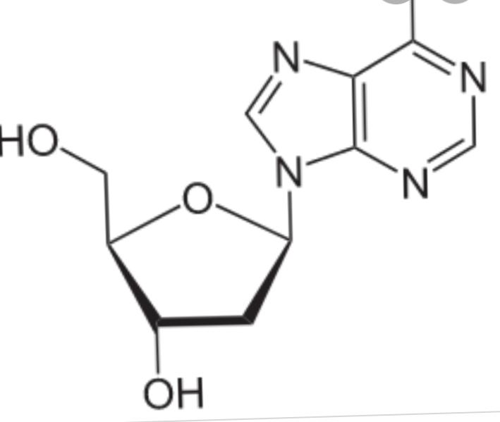
In a nitrogen base there is a difference of oxygen moleucle.

Deoxyribonucleuic acid (DNA):

"The nucleic acid polymer of deoxyribonucleiotides that's why it is called Deoxyribonucleic acid"

- DNA is hereditary material.DNA is present in a nucleus a small amount of DNA is also present in a mitochondria and choloroplast .
- DNA has following four important characteristics .
1.DNA is a important genetic material.DNA is also play important role in the sequence of amino acids.
2.DNA also replicate before cell division and synthesis the protein for its replication.
3.It is present in the nucleus of all eukaryotic cells
4.It can change over time for evolutionary changes.

Chemical composition of DNA

- DNA is a polymer of Deoxyribonucleotides.DNA contain the four nitrogeneous bases
1.Guanine
2. Adinine
3 cytosine
4.Thymaine
- Uracil is present in the case of RNA in the place of Thymaine

- DNA consist of two chain of nucleiotides.The major part of DNA is its genes Each gene control the specific character.
- DNA composed of four basic types of nucleotides .
- d-adenosine monophosphate (d-GMP)
- d-cytosine monophosphate (d-CMP)
- d-ThymiDine monophosphate (d-TMP)
- d-guanine monophosphate (d-GMP)

Phosphodiester bonds :

" phosphodiester bond is a bond which linked and join the nucleotides with each other."

Phosphodiester chain:
"phosphodiester chain which form by the nucleotides"

Erwin chargaff work

- He provided the informations about the bases of DNA moleucle.
- He said that thymine is equal to adenine
- And cytosine is equal to ganine.

Fuctions of DNA :

- In DNA their is present genes in genes their is informations present and information coded in the sequence of nucleotides.
- The sequence of nucleotides is determine by the sequence of amino acid beause nucleotides sequence is very important in the formation of amino acid
- Amino acid sequence is very important in the formation of protein.

Setallite DNA:
" The long portion of DNA is called the satellite DNA"

- Satellite DNA is present between the genes of higer organisms
- Satellite DNA code no protein sometime junk DNA occuresxwithin a gene.
- In this case , the coding portion are " exons" And the noncoding (junk) portion are called " introns"

- Junk DNA makes up the DNA in the human genom
- Little is known of its purpose.

Double helix model of DNA (watson and crick model)

Discovery :

Double helix model was discovered in 1950s that covalent bonds present in a ucleic acids.
- Scientists started work on discovery of that three dimensional structure of DNA.
- Watson and crick propsed the model of DNA molecule.
- The DNA is helical in shape. it is made up of two strands .
- Its nitrogenous bases are. 0.34 nm apart .Ten layers of bases pairs are present on each turn of the helix.
- The phosphate group were present outside the helix .But the nitrogenous bases are presents in the interior of the double helix.
- The double helix are ladder like .It has rigid rungs .Its ladder twists in a spiral fashion.The side ropes are the equivalent sugar - phosphate backbone.The rungs are pairs of nitrogenous bases.
- Franklin 's X-ray data inficate that the helix makes one full turn after every 3.4 nm of its length.
- The pairing of the nitrogenous bases is complements .Adenine pair with thymine (T) and guanine (C) with cytosine.adenine and Gauanine are larger bases .They have two ringed structures.They are called purine base.On the other hand , the cytosine and thymine are "pyrimidine base". They have single ringed .In this way one purine and one pyrimidine combination keep the diameter of the DNA uniform.
- The DNA strands show the complementary .The A and C is one strand corrospond to a T and G in the other.The two polynuleotides in a double helix are therefore complementary i.e the. Sequence of one determining the sequence of the other.

- However there is no restriction on the sequence of bases in any one chain .Adenine (A) could followed by ( T) , G ,C or another A.

- However , if one knows the sequence of bases along a length of one of the chain say A-T-C-C-A-G one can be certain of the sequence of bases along the complementary chain i.e , T-A-G-G-T-C.
- The compLementary Provided a possible machine for the accuracy of DNA replication.

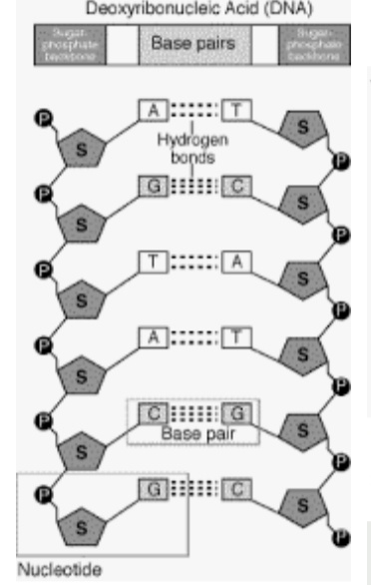
- Both strands of the DNA are anti parallel .Anti parallal means they run in a opposite direction one in right direction the other in left direction.on strand in 3-5 direction then the other strand in 5-3 direction.
- The DNA helix has two grooves .one is major groove and other is minor groove .both types of groove alternate with each other.

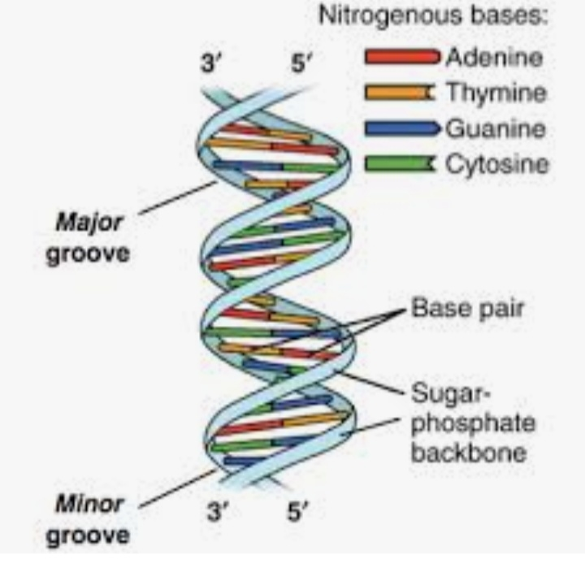
- Between the bases their is a hydrogen bond linkage.Their is a hydrogen bond in the .Betwwen the guanine and ctyosine their is a three hydrogen bond and between the Tymine and purine their is double bond.
- Due to hydrogen bond these bases are very strong .Hydrogen bond is a strong bond.

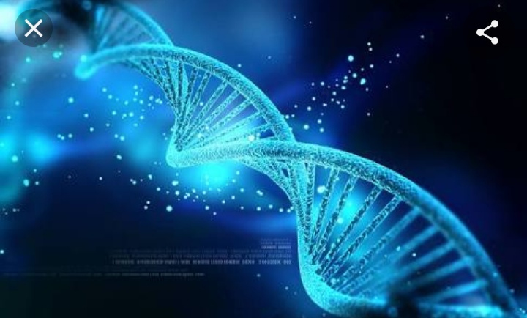

Denaturation of DNA
Defination:
" The denaturation of DNA means that the shape of DNA is change due to some problems may be it is heat aur some other interal problems may be"

Explanation:

- The hydrogen bonds between the bases pairs are week individually but beause these are present in the large number.Its means their quantity is so high.
- Their large quantity is present in the DNA molecule.There for they provide structural stability to the DNA molecule .

- The bonds can be broken and the DNA strands can be separated by heating the DNA molecule .
- The hydrogen bonds denature or melts at a specific temperature .It has been observed that more the hydrogen bonds in a DNA molecule , the higher the temperature needed to denature it.
- Beacause three hydrogen bonds hold the basic pair G-C
Therefore the higher the G-C
Contain in a DNA molecule , the higher the temperature is required to denature that DNA

RNA (Ribonucleic acid)

Defination:
"The polymers of ribonucleotides are called RNA.

Explanation:
The RNA molecule has single strand .sometiomes ,this strand may fold back to give double helical characteristics .The nitrogenous bases form complementary pairings .RNA have nitrogenous base uracil in place of thymine.

- Cytosine (c) forms pair with Guanine (G) and uracil (U) forms pair with Adenine (A) .
- DNA synthesis RNA.

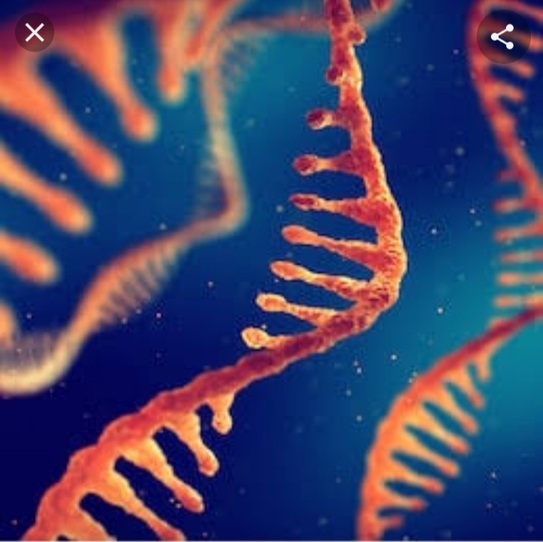

Transcription:

" The process of synthesis of RNA from is called transcription.

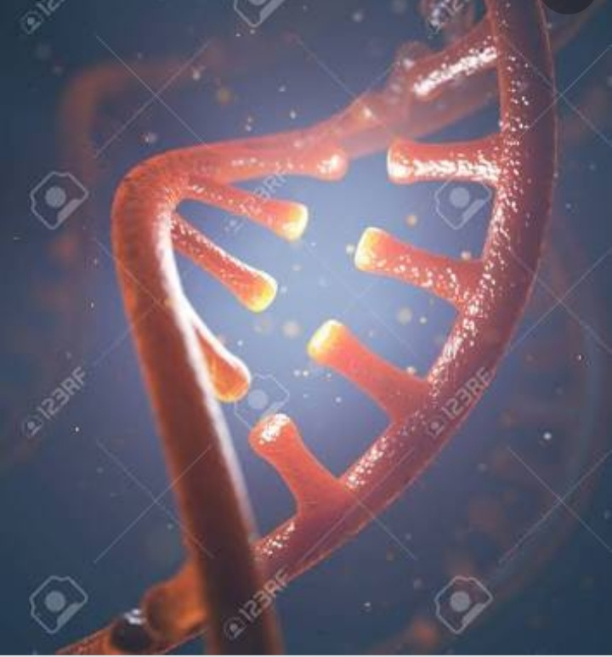

Types of RNA :

There are three main types of RNA .These are messenger (RNA) (mRNA), transfer (tRNA) and ribosomal RNA (rRNA).
- All three types of RNA are synthesized from in nucleus .After their synthesis they are transferred to cytoplasm .
- All three (mRNA , tRNA and rRNA) interact with each other .They synthesize protein from genetic information (gene).

Messenger RNA (mRNA)

Defination:
" The mRNA brings genetic message from nuleus to the ribosome."
Explantion:
The mRNA about 3 to 4 percent of the particular in the cell presence of protein.The ribosomes are present in the cytoplasm for the
synthesis of the paticular protein .DNA transfer its genetic information mRNA .Now , this mRNA has genetic information for the synthesis of specific protein
This mRNA , attaches with the ribosome for synthesis of protein .The mRNA consists single strand of variable length.

Its size depends on size of gene ( on DNA ) for specific protein .For example , the mRNA has 3,000 nucleotides for a protein of amino acids.

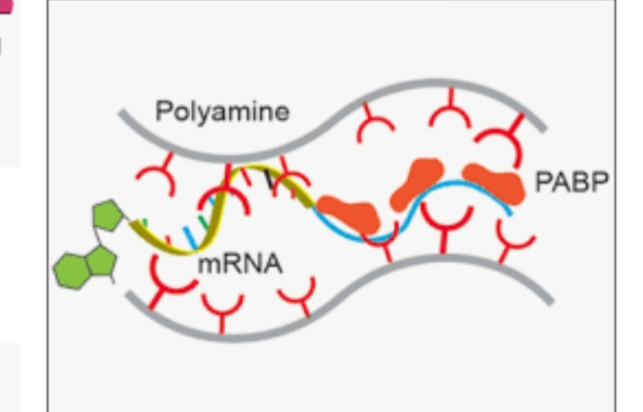
- It is produced in the nucleus from the coded instruction in the DNA and then passes into the cytoplasm where it becomes associated with the ribosomes
- .It carriers chemical information from the DNA of the genes to ribosome fir protein synthesis .Molecules of mRNA are 75- 3000 nucleotides long and are not folded in any soecial way.

Function of mRNA :
- The mRNA brings genetic message from nucleus to the ribosomes
- Its main function is the synthseis of protein
- It has large size .

TransferRNA or tRNA :

Defination:
"The tRNA reads message (code) on mRNA and transfer specific amino acid to the ribosome.

- It has clover leaf like structure .It has anticode .These amino acid are linked to form polypeptides chain of the protein .There is one specific tRNA for each amino acid.
- So the cell contain 20 types of tRNA .Its chain is composed of 75 to 90 Nucleotides.It forms about 10 to 20 percent of the total cellular RNA.The tRNA has small size .
- It carries amino acids to ribosomes during protein synthesis.Each organism synthesis a number of different tRNAs , each in multiple copies.All cells have at least 20 different kinds of tRNA mecules.

- All tRNA has very small shape.The structure of tRNA molecule is nearly similar in bacteria and eukaryotes.

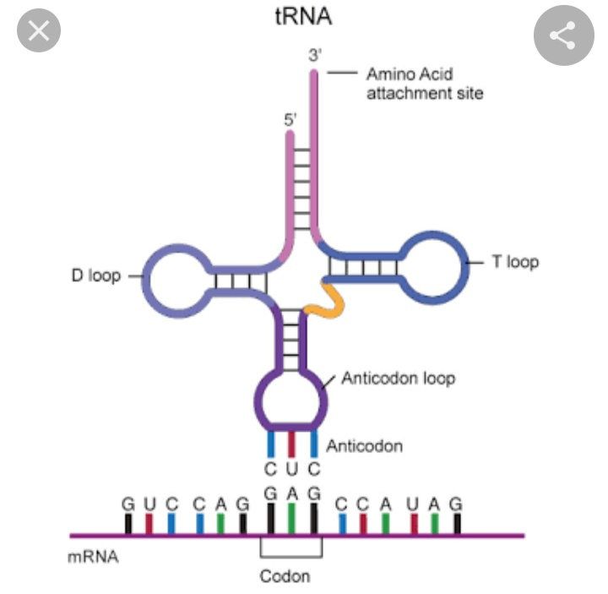

Function of tRNA :
- The tRNA reads message (code) on mRNA and transfer soecific amino acid to the ribosomes.
- Its msin function is the protein synthesis.

Ribosomal RNA :
" The rRNA combine with ribosomal protein and forms ribosome"

Explanation:

- Ribosome is made up of rRNA and protein.The rRNA forms 50 perecent of the ribosome .It forms a large part about 80 percent ot total RNA .
- It acts as machine for the synthesis of protein.

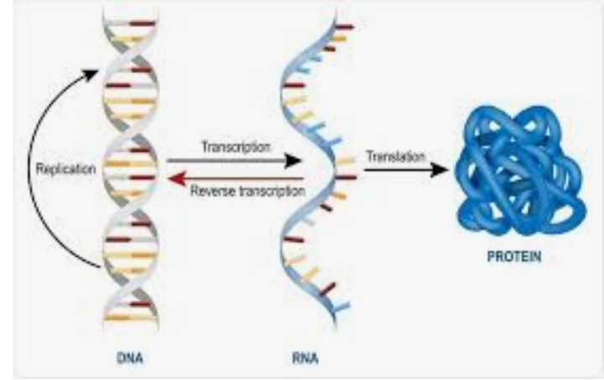
- It is largest of RNA molecule and usually constitute about 80 percent of all RNA in the cells.
- The molecule is composed of thousand of nucleotidez consisting of a single strand with region in which base pairing result in double helix projecting on either side.

- It is produced inside the nucleus within the nucleotides and is a major component of ribosome.
- It also takes part in formation of mRNA and tRNA.

Function of rRNA
- The main function is the synthesis of protein.

Questions
- Why nuclein is called nucleic acid?
- Who diccover the Nucleic acid?
- What are puirne bases?
- What are pyrimindine bases
- How Hydrogen bond play very important role in the attachment of bases
- What do you mean by denature of DNA?
- How high temperature effect on the DNA?
- Function of mRNA?
- Component of rRNA?
- How many types of tRNA?

