Topic: Hugo Devries Mutation Theory :

Introduction :

Hugo de Vries (1848—1935), a Dutch botanist, one of the independent rediscoveries of Mendelism, put forward his views regarding the formation of new species in 1901. He also met some of the objections found in Darwin’s theory. According to him, new species are not formed by continuous variations but by sudden appearance of variations, which he named as mutations. Hugo de Vries stated that mutations are heritable and persist in successive generations.
He is known mainly for the suggestion of concepts :
- Gene
- Rediscovering the law of heredity
- Introduce the word “mutation “
- Develop a mutation theory of evolution.
- He is known as father of mutation.

Mutation :
“The changing of the structure of a gene, resulting in a variant form that may be transmitted to subsequent generations, caused by the alteration of single base units in DNA, or the deletion, insertion, or rearrangement of larger sections of genes or chromosomes.”

According to de Vries theory :

On the basis of above observations, Hugo de Vries (1901) put forward a theory of evolution, called mutation theory. The theory states that evolution is a jerky process where new varieties and species are formed by mutations (discontinuous variations) that function as raw material of evolution.
- According to De Vries mutation are the main source of mutation and speciation.
- Sudden change in gene is the result in phenotype is called mutation.
- According to him speciation occur in sudden change in single step.
- Mutation are random and directionless.
- Mutation are negative and retrogressive.
- Rate of mutation is slow as compare to evolution.

According to de Vries mutation theory there is sudden change in the species not a gradual change “
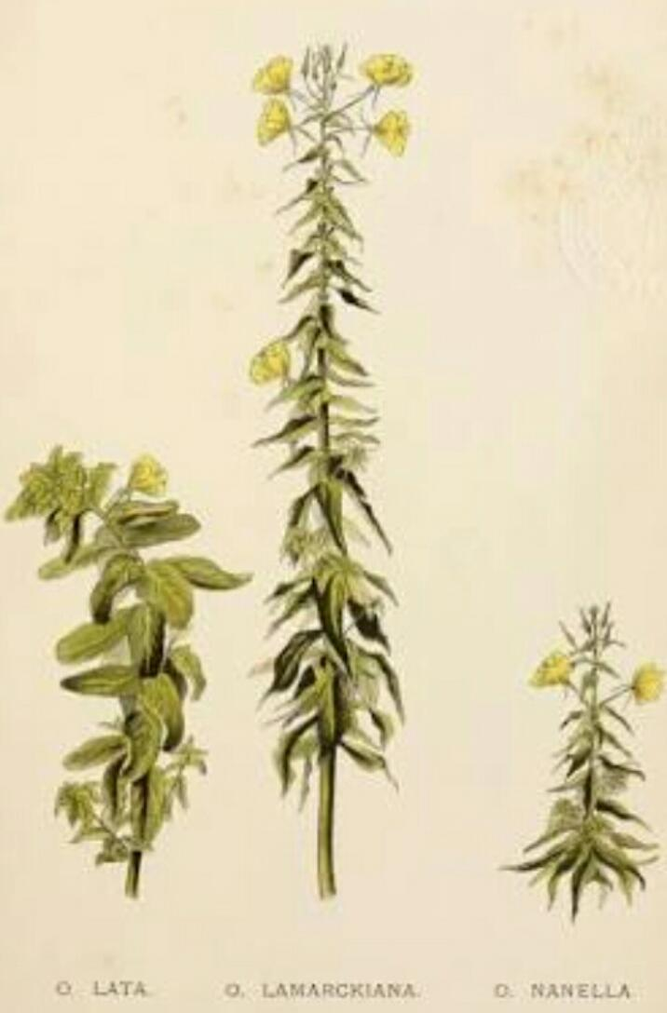
Definition :
“ Sudden, Large, hereditable variations are called mutations. Organisms having mutations are called mutants.”

. Silents feature of mutation theory :

. The salient features of mutation theory are:
1. Mutations or discontinuous variations are the raw material of evolution.
2. Mutations appear all of a sudden. They become operational immediately.
3. Unlike Darwin’s continuous variations or fluctuations, mutations do not revolve around the mean or normal character of the species. All mutation are inheritable.
4. The same type of mutations can appear in a number of individuals of a spec
5. All mutations are inheritable.
6. Mutations appear in all conceivable directions.
7. Useful mutations are selected by nature. Lethal mutations are eliminated. However, useless and less harmful ones can persist in the progeny.
8. Accumulation of variations produce new species. Sometimes a new species is produced from a single mutation.
9. Evolution is a jerky and discontinuous process .
10. Sometimes a. New species is produced from single mutation.
De Vries held that new species arrive suddenly and without prior precedent through the process of mutation, which he considered to be the change of one species into another due to the formation of “a new centre of analogous variations.” Rather than simply argue that species are discontinuous from each other—as in the case of neo-Lamarckism—mutation theory suggested that variations themselves are discontinuous, de Vries argued that new species came into existence fully formed and viable but lacking the defining characteristics of the parent generation. Thus, de Vries’s analysis focused on the creative force of discontinuity as a prime explanation for the origin of new species.
Those ideas not only remained faithful to the saltationist basis for new species formation but also championed de Vries’s devotion to the pure Darwinian belief that allvariation proves beneficial. In doing so, mutationist theories recognized alternative viable organismic formations (often labeled “disabilities” at the human level) as examples of the creative force of new species coming into existence through mutation. That interpretation contradicted assertions by eugenicists and geneticists that some mutations are monstrosities or organismic abominations.

Experiments of de Vries theory :
De Vries can conduct his experiment on Oerathra Lamarckins (Evening Primrose) and found several abberrant types.. When O Lamarckins was self pollinated and its seeds were allowed to grow, majority of F₁plants were similar to the parents, but a few were different plants.
The different plants were also self-pollinated and when their seeds were sown, the majority of the plants were similar to the parents while a few were still more different plants and this continued generation after generation. These plants appeared to be new species, Hugo de Vries suggested from his experiments that new types of inherited characteristics may appear suddenly without any previous indication of their presence in the race.
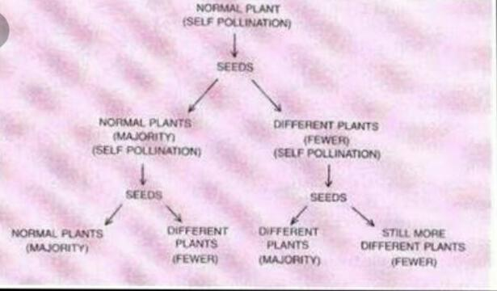
Hugo de Vries believed that mutation causes evolution and not the minor heritable variations which was mentioned by Darwin. Mutations are random and directionless while Darwin’s variations are small and directional. According to Darwin evolution is gradual while Hugo de Vries believed that mutation caused species formation and hence known as saltation (single step large mutation). Sudden, Large, hereditable variations are called mutations. Organisms having mutations are called mutants. Devries observed mutations in Oenothera Lamarckiana. He conducted breeding experiments in that plant. Devries collected the seeds of 0. lamarckiana and sowed the seeds in his field. After sometime, he observed four new varieties of plants in addition to parent variety.
They are oenothera-mutations
i. 0. zygas : It is taller than the parent.
ii. 0. nanella It is shorter than the parent.
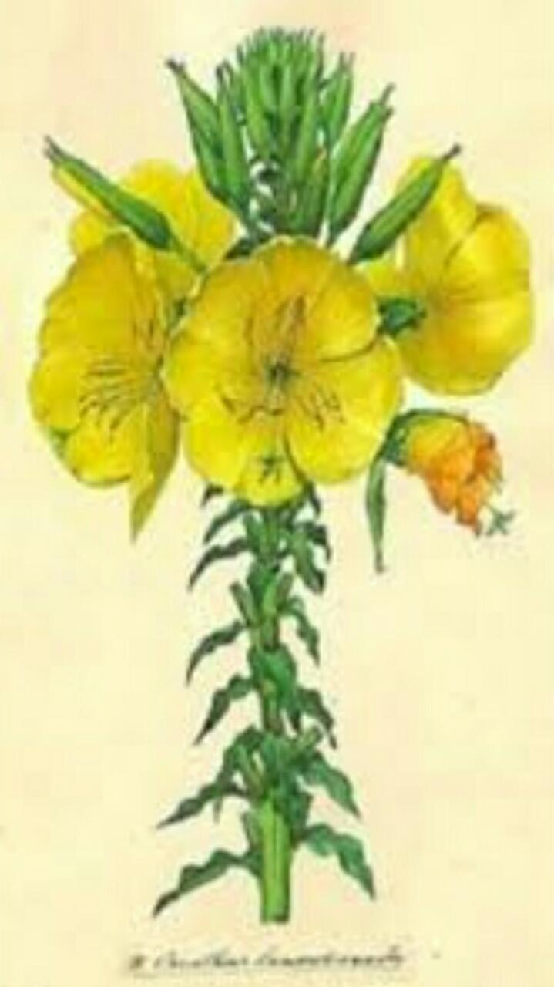
iii. 0. livifolia : It contains more number of leaves than the parent.
iv. 0. brivistylis : It contains shorter style than the parent.
Devries cross pollinated the four new varieties and parent variety.

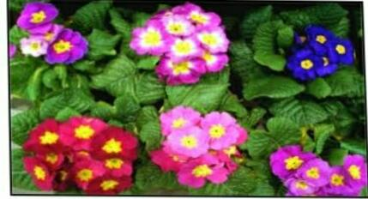
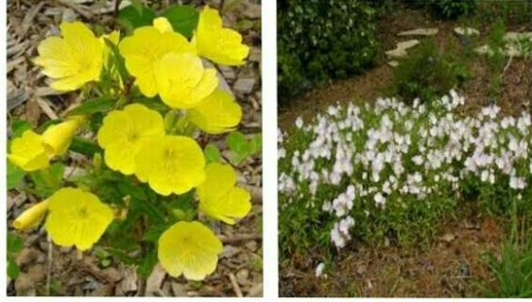
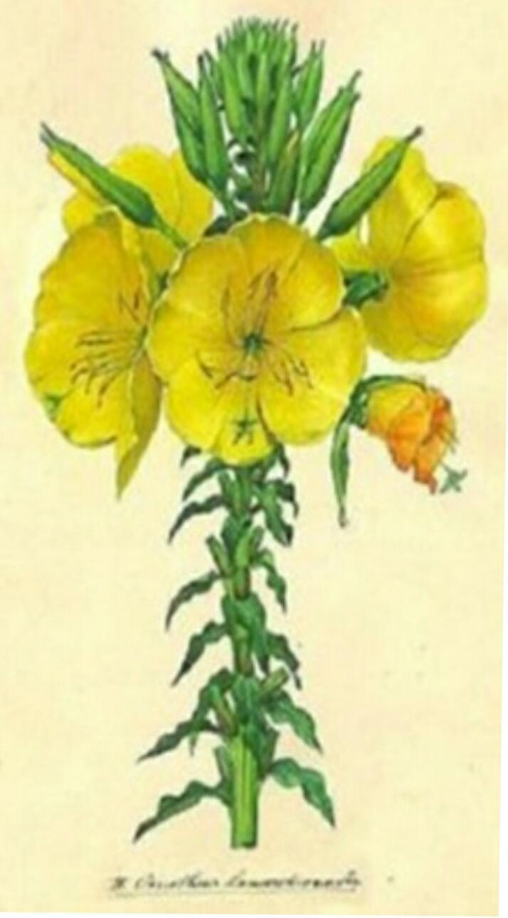
Sudden change :

He got few more new varieties. Devries continued the experiment for about ‘7’ generations. He got 50,000 plants. These 50,000 are 800 varieties. When these varieties were self pollinated, Devries got the same plants. Based on the above experiment, he proposed some observations. They are
A. New species appear suddenly but not slowly.
B. Large, sudden changes appeared in living organisms, these are called mutations.
C. Mutations are hereditable.
D. Mutations occur during gametogenesis or fertilization.
E. Mutations may be harmful or beneficial.
Another example of mutation theory :
Ancon Sheep:
- Mutation are actually the source of all variations and hence fountain head of evolution.
- A single mutation can give rise to a new variety and even species of animals and plants.
- Ancon sheep is an example of mutation theory.
- The mutation theory for the origin of new species was proposed by Hugo de Vries in 1901.
- According to this theory, ‘new species arise from the pre-existing ones in a single generation by the sudden appearance of distinct and discontinuous heritable changes'
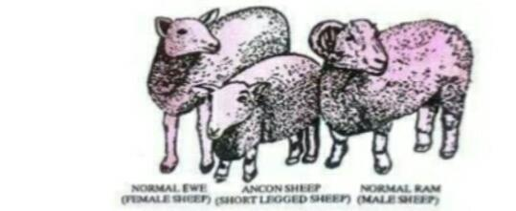
Ancon sheep (also called “Otter” sheep) are a grouping of the domestic sheep with long bodies and very short legs, with the fore – legs being benThe Ancon sheep was produced from an ordinary sheep in single step in 1871. The mutated sheep was short height and it was useful for farmers as they could not be able to jump from low stone fences.
- That type appeared suddenly in the group of sheep, existed for several years and then disappeared.Again after eighty years, they reappeared in Norway and since then they are existing in some European countries.

MUTAGENS
The mutation causing chemicals are called mutagens. These are natural and artificial mutagens. The natural mutagens are ‘X’ rays, u .v rays, temperature etc. The artificial mutagens are formaldehyde, colchicin, ‘X’ rays etc. The mutations caused by natural mutagens are called spontaneous mutations. The mutations caused by artificial mutagens are called induced mutations.
For the success of evolution, mutations must occur in germplasm chromosomes, germplasm genes or germplasm D.N.A. The mutations are physically expressed in the next generation.

4. MUTATIONS — TYPES
Mutations are two types. These are chromosomal and gene mutations.
A. Chromosomal mutations:
These are changes either in number or structure of chromosomes.
Normally individuals are diploid having two sets of chromosomes (paternal and maternal genome). Any change in the number of chromosomes of the gametes results the formation of mutaflons... The chromosomal number changes are polyploidy, haploidy and aneuploidy.
Chromosomal structure changes are of different types. They are duplication, inversion, translocation, deletion etc.

B. Gene mutations:
These are changes in the sequence of nitrogenous bases of D.N.A of gene. Gene mutations are also called Point mutations.
If gene changes, ‘m’ R.N.A is changed and finally sequence of amino acids in a protein is changed. The nutritional mutants or Auxotrophs were first observed in Neurospora by Beadle and Tatum.
Sometimes one gene mutation causes many changes
phenotypically. Such mutations are called pleotrophic or polyphenic mutations.

According to Devries the evolution is very fast like horse running movement, but not slowly like snail’s movement as said by Darwin. Devries also said that there are no middle forms between the ancestor and new species. In other words the new individual was evolved directly from ancestor without middle forms.
A. Evolution of Giraffe:
According to Devries, the Giraffe was directly evolved from short necked Antelope due to the mutation in neck length controlling gene.

B. Evolution in snakes :
According to Devries the snakes were directly evolved from limbed lizards due to the mutation in limbs controlling gene.

C. Evolution of Duck:
According to Devries the duck was directly evolved froth terrestrial birds due to change in the skin of digits of hind limb.

Mutation Theory and Evolution :
Prior to de Vries' work, Charles Darwin had proposed his theory of natural selection as a slow, gradual change of species over time. Many scientists at the time believed in this very slow process, called gradualism. They thought the process involved many small changes occurring and building up over many generations.
However, de Vries disagreed with the slow and steady idea after seeing the 'sudden' mutations in the evening primrose plants. He believed that evolution could occur via discontinuous variation, or large changes happening in a few generations. This means that organisms can have drastic 'jumps' that immediately result in a new species coming into existence.
According to de Vries' mutation theory, living organisms can develop changes to their genes that greatly alter the organism. These changes are passed down to the next generation, and lead to the development of new species. Once a new species has evolved, it becomes fixed and stops changing. The mutations are the mechanism de Vries proposed for his discontinuous variation model of evolution.
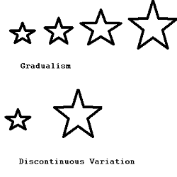
Gradualism, top, has many small changes, while discontinuous variation, bottom, has fewer, more abrupt changes
Points in favours of Mutation theory :
1) Mutations are actually the source of all variations and hence fountain head of evolution.
(2) Mutation theory can explain both progressive and retrogressive evolution.
(3) As the ratio of mutations is not the same in all individuals and their parts, mutation theory can explain the occurrence of both changed and unchanged forms.
(4) A number of mutations have appeared in the past.
Mutations are also induced.
They have given rise to new varieties.
(a) Ancon Sheep is a short legged variety which appeared suddenly in Massachusetts in 1791.
(b) Hornless Cattle developed as mutation from the homed cattle in 1889.
(c) A single mutation can give rise to a new variety and even species of plants, e.g., Delicious Apple, Cicer gigas, Noval Orange, Red Sunflower,
(d) Hairless cats and doubletoed cats have developed through mutations.

Points against of Mutation Theory/ Criticism of the Mutation Theory

- Mutation are generally recessive
- Natural Mutation are not common.
- Oenothera Lamarekiana of Hugo De Vries was not a normal plant but a complex heterozygous form with chromosomal abbreviation.
- Natural selection are not common.
- Oenothera lamarckiana of Hugo de Vries was not a normal plant but a complex heterozygous form with chromosome aberrations.
- Natural mutations are not common.
as Hugo de Vries thought them to occur.
- Most of the mutations are negative or retrogressive.
- Mutations are generally recessive while traits taking part in evolution are usually dominant.
- Mutation theory cannot satisfactorily explain the development of mimicry, mutual dependence of flowers and pollinating insects.
- This theory does not explain the role of nature.

Significance of Hugo De Vries Theory:

This Theory gives direct attention to the mutations. But later on it was thought that evolution cannot occur by mutations alone. Natural selection and isolation of mutants were also essential for evolution.

Multiple choice :
- De Vries is known for his :
  - Evolution theory (b) Mutation Theory
(C) Revolution Theory (d) Selection Theory

Answer. B
- Hugo de Vries the theory of mutation to explain mechanisms. The material on which he performed experiment was :
  - Drosophila Melanogaster (b) Pisum sativum
(C) Oenothera Lamarekiana (d) Escherichia coli

Answer :C
- Oenothera Lamarekiana the plants which are used by De Vries is commonly called :
  - Sweet pea (b) China rose
(C) Evening Primrose (d) none of these

Answer :C

4.According to Hugo de Vries the mechanisms of evolution is :
(a) minor mutation (b) Multiple step mutation
(c) phenotypic variation (d) saltation

Answer :D
5.Mutation are :
(a) heritable change (b) Inheritable change
(c) change that may or may not inheritable (d) none of these

Answer :A
6.The theory of mutation by De Vries consider that :
(a) only small mutation in variation. (b) only large mutation
In variation
(C) Both small and large mutation in variation (d) none

Answer :C
7.According to De Vries theory of evolution is :
(a) jerky (b) discontinous
(c) continuous and smooth (d) Both a and b

Answer :D
8.According to Hugo de Vries mutation are :
(a) Random (b) small and directional
(c) directionless (d) both a and c

Answer : D
9.In Oenothera Lamarekiana de Vries continued the experiment in how many generation :
(a) 6. (b) 7. (c) 8. (d) 9

Answer : B
10. Hugo de Vries believed that mutation caused species formation and know as :
(a) mutation (b) Pleotrophic
(C) Saltation (d) Polyploidy

Answer : C

