The Nervous System
The nervous system is a complex network of nerves and cells that carry messages to and from the brain and spinal cord to various parts of the body.
The nervous system includes both the Central nervous system and Peripheral nervous system. The Central nervous system is made up of the brain and spinal cord and The Peripheral nervous system is made up of the Somatic and the Autonomic nervous systems.
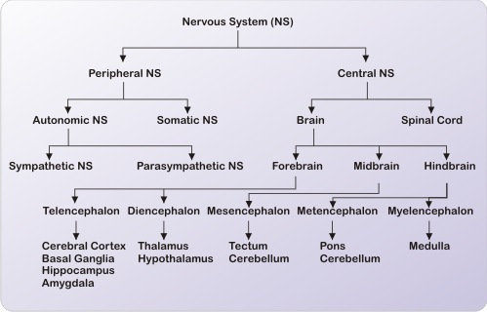

The Central Nervous System (CNS)
The central nervous system is divided into two major parts: the brain and the spinal cord.

The Brain
The brain lies within the skull and is shaped like a mushroom. The brain consists of four principal parts:
- the brain stem
- the cerebrum
- the cerebellum
- the diencephalon
The brain weighs approximately 1.3 to 1.4 kg. It has nerve cells called the neurons and supporting cells called the glia.
There are two types of matter in the brain: grey matter and white matter. Grey matter receives and stores impulses. Cell bodies of neurons and neuroglia are in the grey matter. White matter in the brain carries impulses to and from grey matter. It consists of the nerve fibers (axons).

The Brain Stem
The brain stem is also known as the Medulla oblongata. It is located between the pons and the spinal cord and is only about one inch long.

The Cerebrum
The cerebrum forms the bulk of the brain and is supported on the brain stem. The cerebrum is divided into two hemispheres. Each hemisphere controls the activities of the side of the body opposite that hemisphere.
The hemispheres are further divided into four lobes:
- Frontal lobe
- Temporal lobes
- Parietal lobe
- Occipital lobe

The Cerebellum
This is located behind and below the cerebrum.

The Diencephalon
The diencephalon is also known as the fore brain stem. It includes the thalamus and hypothalamus. The thalamus is where sensory and other impulses go and coalesce.
The hypothalamus is a smaller part of the diencephalon

Other Parts of the Brain
Other parts of the brain include the midbrain and the pons:
- the midbrain provides conduction pathways to and from higher and lower centers
- the pons acts as a pathway to higher structures; it contains conduction pathways between the medulla and higher brain centers
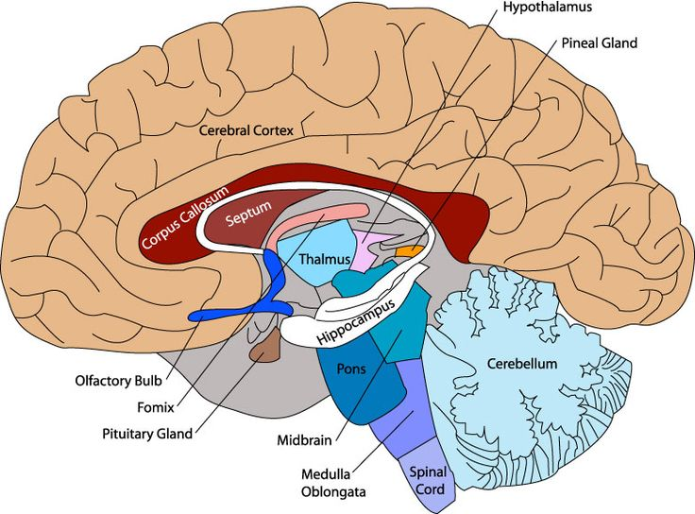

The Spinal Cord
The spinal cord is along tube like structure which extends from the brain. The spinal cord is composed of a series of 31 segments. A pair of spinal nerves comes out of each segment. The region of the spinal cord from which a pair of spinal nerves originates is called the spinal segment. Both motor and sensory nerves are located in the spinal cord.
The spinal cord is about 43 cm long in adult women and 45 cm long in adult men and weighs about 35-40 grams. It lies within the vertebral column, the collection of bones (back bone).

Other Parts of the Central Nervous System
The meninges are three layers or membranes that cover the brain and the spinal cord. The outermost layer is the dura mater. The middle layer is the arachnoid, and the innermost layer is the pia mater. The meninges offer protection to the brain and the spinal cord by acting as a barrier against bacteria and other microorganisms.
The Cerebrospinal Fluid (CSF) circulates around the brain and spinal cord. It protects and nourishes the brain and spinal cord.
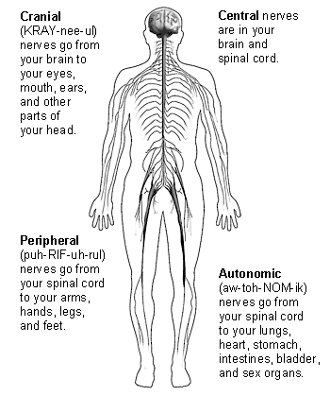

Neurons
The neuron is the basic unit in the nervous system. It is a specialized conductor cell that receives and transmits electrochemical nerve impulses. A typical neuron has a cell body and long arms that conduct impulses from one body part to another body part.
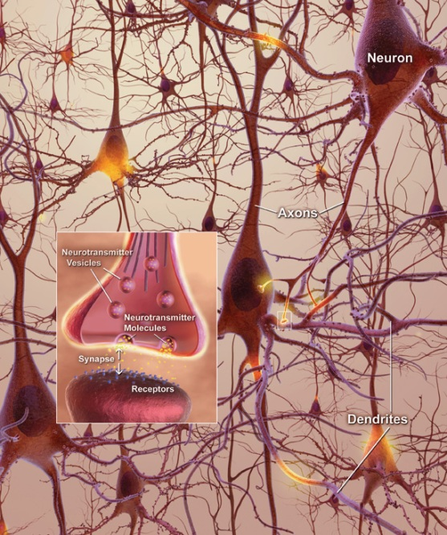
There are three different parts of the neuron:
- the cell body
- dendrites
- axon

Cell Body of a Neuron
The cell body is like any other cell with a nucleus or control center.

Dendrites
The cell body has several highly branched, thick extensions that appear like cables and are called dendrites. The exception is a sensory neuron that has a single, long dendrite instead of many dendrites. Motor neurons have multiple thick dendrites. The dendrite's function is to carry a nerve impulse into the cell body.

Axon
An axon is a long, thin process that carries impulses away from the cell body to another neuron or tissue. There is usually only one axon per neuron.

Myelin Sheath
The neuron is covered with the Myelin Sheath or Schwann Cells. These are white segmented covering around axons and dendrites of many peripheral neurons. The covering is continuous along the axons or dendrites except at the point of termination and at the nodes of Ranvier.
The neurilemma is the layer of Schwann cells with a nucleus. Its function is to allow damaged nerves to regenerate. Nerves in the brain and spinal cord do not have a neurilemma and, therefore cannot recover when damaged.

Types of Neuron
Neurons in the body can be classified according to structure and function. According to structure neurons may be multipolar neurons, bipolar neurons, and unipolar neurons:
- Multipolar neurons have one axon and several dendrites. These are common in the brain and spinal cord
- Bipolar neurons have one axon and one dendrite. These are seen in the retina of the eye, the inner ear, and the olfactory (smell) area.
- Unipolar neurons have one process extending from the cell body. The one process divides with one part acting as an axon and the other part functioning as dendrite. These are seen in the spinal cord.

The Peripheral Nervous System
The Peripheral nervous system is made up of two parts:
- Somatic nervous system
- Autonomic nervous system

Somatic Nervous System
The somatic nervous system consists of peripheral nerve fibers that pick up sensory information or sensations from the peripheral or distant organs (those away from the brain like limbs) and carry them to the central nervous system.
These also consist of motor nerve fibers that come out of the brain and take the messages for movement and necessary action to the skeletal muscles. For example, on touching a hot object the sensory nerves carry information about the heat to the brain, which in turn, via the motor nerves, tells the muscles of the hand to withdraw it immediately.
The whole process takes less than a second to happen. The cell body of the neuron that carries the information often lies within the brain or spinal cord and projects directly to a skeletal muscle.

Autonomic Nervous System
Another part of the nervous system is the Autonomic Nervous System. It has three parts:
- the sympathetic nervous system
- the parasympathetic nervous system
- the enteric nervous system
This nervous system controls the nerves of the inner organs of the body on which humans have no conscious control. This includes the heartbeat, digestion, breathing (except conscious breathing) etc.
The nerves of the autonomic nervous system enervate the smooth involuntary muscles of the (internal organs) and glands and cause them to function and secrete their enzymes etc.
The Enteric nervous system is the third part of the autonomic nervous system. The enteric nervous system is a complex network of nerve fibers that innervate the organs within the abdomen like the gastrointestinal tract, pancreas, gall bladder etc. It contains nearly 100 million nerves.

Neurons in the Peripheral Nervous System
The smallest worker in the nervous system is the neuron. For each of the chain of impulses there is one preganglionic neuron, or one before the cell body or ganglion, that is like a central controlling body for numerous neurons going out peripherally.
The preganglionic neuron is located in either the brain or the spinal cord. In the autonomic nervous system this preganglionic neuron projects to an autonomic ganglion. The postganglionic neuron then projects to the target organ.
In the somatic nervous system there is only one neuron between the central nervous system and the target organ while the autonomic nervous system uses two neurons.

