HYBRIDIZATION
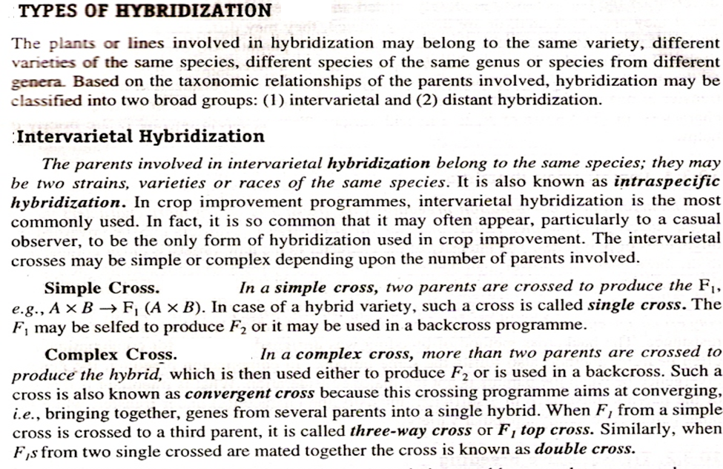
Crossing of individuals of unlike genetic constitution; a method of breeding new cultivars that utilizes crossing to obtain genetic recombination.

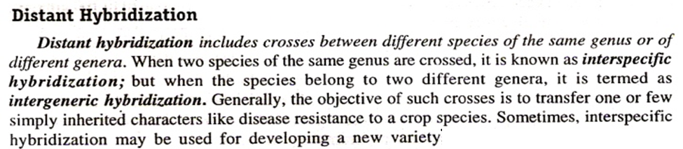
Somatic Hybridization: This hybridization refers to the hybridization at cellular level. As two cells of different genotypes are fused together so that a new variant cell of different genotype is attained.

