Context:
Introduction ……………………………………………………………………….1 Hydrophytes……………………………………………………………………….2
Morphological Adaptations………………………………....................................2.1
Anatomical Adaptations………………………………………………………….2.2 Physiological Adaptations………………………………………………………..2.3
Types of Hydrophytes……………………………………………………………2.4
Ecological and economic importance……………………………………………2.5
Xerophytes…………………………………………………………………………3
Morphological Adaptations………………………………....................................3.1
Anatomical Adaptations………………………………………………………….3.2 Physiological Adaptations………………………………………………………..3.3
Types of Xerophytes……………………………………………………………...3.4
Ecological and economic importance…………………………………………….3.5
Conclusion………………………………………………………………………….4
Reference…………………………………………………………………………...5

1. Introduction:
Plants of one place are different from the plant of different places. This difference is due to adaptive features of plants. For example, seaweed is adapted to live under water but cactus is adapted to live in desert. Adaptation is defined in this way:
Specific characteristics that enable a plant to survive and reproduce in a specific region.
Basically, plants adopt themselves to maintain their osmotic adjustment (To keep solute and solvent in equilibrium).
Adaptation causes changes in the DNA sequence as a result of which there are changes in the genotype and changes in genotype influence the phenotype, which is plant adaptive features that is determined by environment and place where the plant lives. Advantage of the mutation is that beneficial change is passed to the plants progeny as a result of which survival time of plants is increased. According to society,
Mutation has become an adaptation (2019)
According to Fisher (1930):

For plants adaptation does not involve coping with the physical abiotic environment, which are light temperature, water et cetera, but also with the biotic environment, such as predators
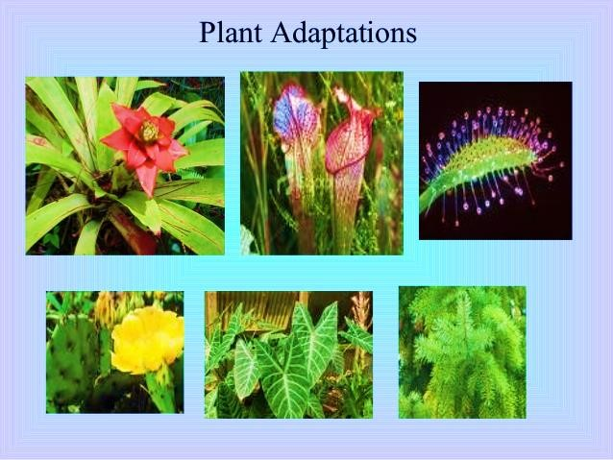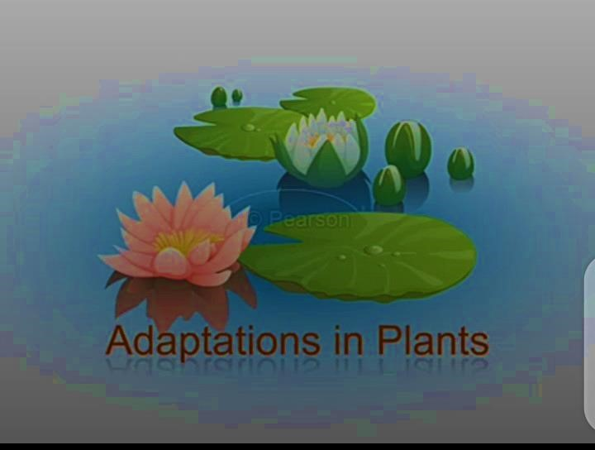

On the basis of adaptation, there are two categories of plants
- Terrestrial plants: Include-mountains, plains, deserts, coasts and swampy areas.
- Aquatic plants: Include free floating plants, fixed plants, under water plants
Here we discuss two types of plants
- Hydrophytes
- Xerophytes
Xerophytes are, “specialize in water conservation, allowing them to thrive in these conditions” (Foundation 2019). While hydrophytes are in contrast with xerophytes.

Hydrophytes are aquatic plants that are especially suited for living in aquatic environment (Ponds, 2019).

2. Hydrophytes

Now, we discuss hydrophytes and xerophytes individually in detail
Hydrophytes are derived from Greek words (Hudor = water, Phyton = plant).
Plants that live and grow in water bodies are called hydrophytes. Species may be fully submerged, partially submerged or floating on water surface. Since they live in excess amount of water that’s why they need some adaptive features to deal with water logging. Moreover, it is difficult for them to obtain carbon dioxide and sun light. Therefore, general adaptations focus on dealing with excess water, obtaining sun light, sufficient carbon dioxide, oxygen and strong current movements.
Examples: Lotus (Nelumbo), Hydrilla which is present in ponds and lakes etc, Eichhornia which is called water hyacinth, Trapa, Vallisneria, Potamogeton, Savinia, Typha, Nymphaea and Ceratophyllum etc. Smallest aquatic plant is duckweed and largest aquatic plant is Amazon water lily.
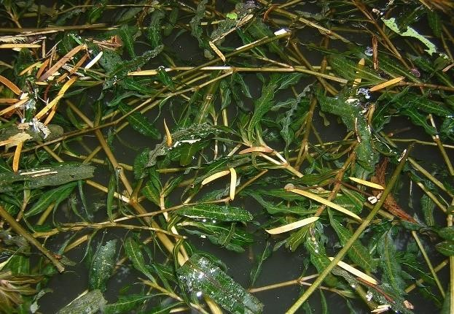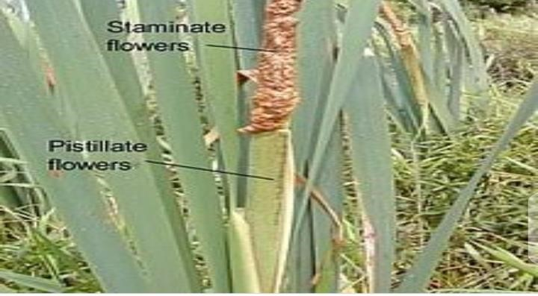

Ceratophyllum Typha
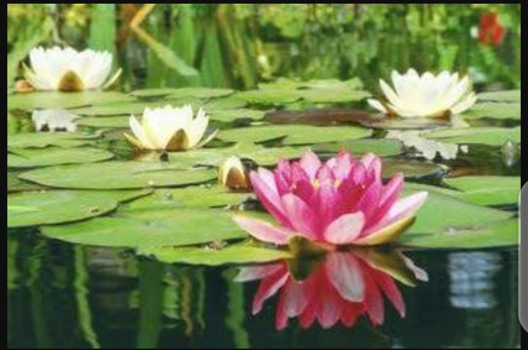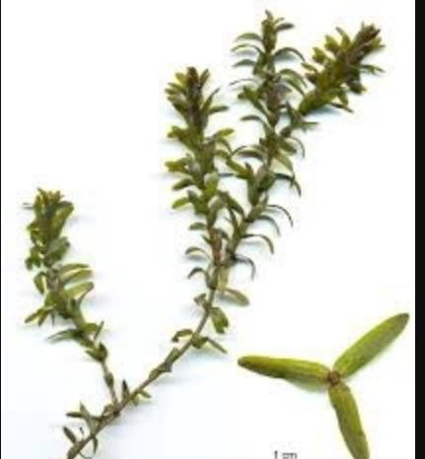

Lotus Hydrilla
Distribution: Basic factor that control distribution of hydrophytes is depth and duration of flooding. Other factors include nutrients, disturbance from waves, grazing and salinity. A few species are also present in brackish, saline and salt water.

2.1. Morphological Adaptations
Morphological adaptation of hydrophytes are given below:
- Roots: Because of abundant water, roots are least significant and have secondary importance. Aquatic plants have small, short and feathery roots, which have tiny air spaces between them so that minerals and oxygen can be absorbed from H₂O. Root caps are absent. These are replaced by root pockets in Pistia. In some aquatic plants, there are no roots such as Wolfia. But in Eichornia, Poorly developed adventitious roots are present for balancing. Main function of roots is for anchorage in water not absorption of H₂O.
- Stem: Stems of hydrophytes are thin and flexible. They are present in bended form but when H2O enter in them, they become straight to support the plant. Stems grow usually parallel to surface. Lignin and woody elements are accumulated in centre of stem to maintain centre of gravity and resist the pulling effects of air current. s
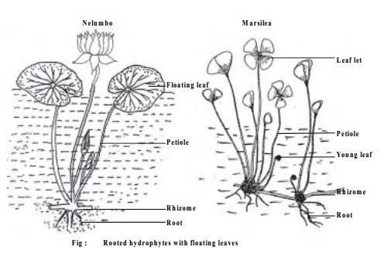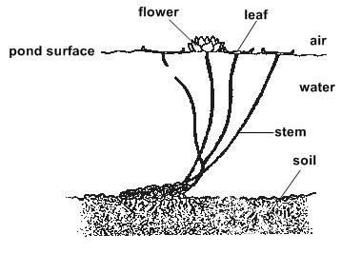
- Leaves: Some aquatic plants float on surface of water. This is because of flat leaves. For example, water lily have leaf diameter 12 inch. Leaves are spread horizontally on surface of water to increase area of contact with sunlight and atmosphere promoting gases exchange and obtaining materials for photosynthesis. But in submerged plants leaves are small and in form of whorls. Leaves allow direct diffusion of minerals, CO2 and O2 into plants. Leaves of partly submerged plants are similar to leaves of terrestrial plants. These are green in colour due to well-developed mesophyll cells.

- Support: Hydrophytes generally do not need vascular system for balance. Since, these are surrounded by water so water gives them support. That’s why, they do not need xylem and phloem for support.

- Stomata: In hydrophytic plants, levels of stomata differ. In fully submerged plants, stomata are absent. Because these are present in water not in air. So, these plants obtain gases from the water not through stomata. But in partly submerged plants, stomata are present on upper epidermis because these plants float on surface of water. These stomata ensure the entry of gases into plant and also compensate rate of transpiration.

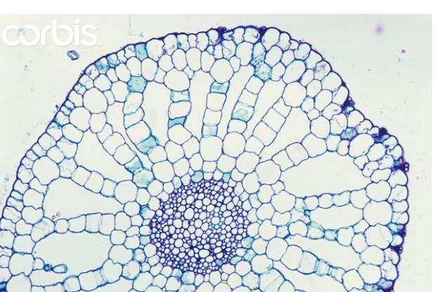
- Air spaces: Some hydrophytic leaf and stem cells have intercellular air spaces called parenchyma. These air spaces increase byonacy of leaves. Gases diffuse throughout whole plant through these air spaces without air spaces. It is difficult for plant to receive
essential gases so these will be no photosynthesis. Air spaces of Bladderwort
- Cuticle: since hydrophytes are present in water so they need not to conserve water so cuticle is absent or thin waxy cuticle is present. Hydrophytes that float on surface of water have thin waxy cuticle which present water clogging cuticle protects stomata and keep it open to clear surrounding water. In fully submerged plants, cuticles are not needed.
- Water repellent epidermal hairs: On the surface of leaves, there is a dense network of fine hair which increase surface area and helps to trap a layer of moisture and air between them.
For example, “Kariba weeds have rows of cylindrical papillae with hairs on their distal ends, joined together in a cage like structure”.

2.2. Anatomical adaptation
Anatomical adaptations of hydrophytes are given below:
- Cuticle is completely absent in submerged parts of the plants.
- Cuticle may be present as a thin film on surface of parts exposed to atmosphere.
- Epidermal cells are with chloroplast useful for absorption and assimilation. Epidermis is not protecting layer.
- Hypodermis is poorly developed.
- Exchange of gases occurs through cell walls by diffusion.
- Stomata are totally absent in submerged hydrophytes.
- Non-functional stomata are seen in Potamageton.
- Epistomatous leaves (stomata found only on upper surface) are present in hydrophytes with floating leaves Eg; Nelumbo.
- Mechanical tissues are absent or poorly develop. In Nymphaea, special type of star shaped lignified cells (asterosclereids) are present for mechanical support. Collenchyma and sclerenchyma are absent.
- Xylem is poorly developed in hydrophytes as the water absorption takes place all over surface of the plant body.
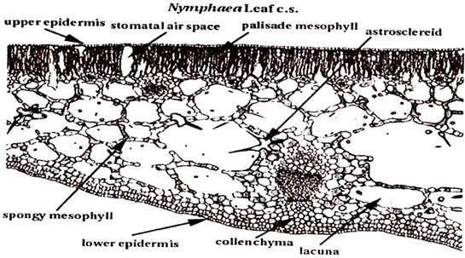

Crossection of leaf
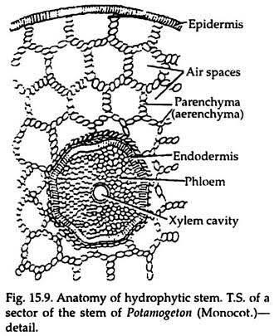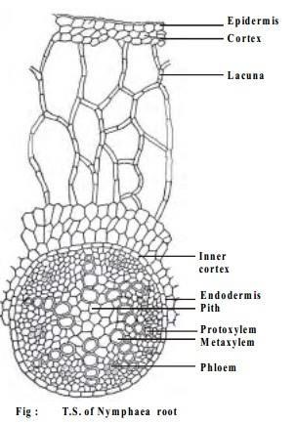

2.3. Physiological Adaptations
- Petioles of floating hydrophytes have ability to grow again and again because of hormone auxin. Long petioles adapt themselves to the depth of water thus keep their lamina on surface of water.
- In hydrophytes, osmotic concentration of cell sap is equal to or slightly higher than surrounding water.
- Initiation of flowers depend upon nutrition. For example, Utricularia, a carnivorous plant flowers when grown in the inorganic nutrient medium supplied with organic nitrogenous compounds e.g.:- mixture of peptone and meat extract.
- Hydrophytes possess mucilage cell that produce mucilage which prevent decay of plants in water.
- Oxygen produced by photosynthesis is retained in the air cavities. This oxygen is utilize when required.

2.4. Types of Hydrophytes
Hydrophytic plants may be arranged in to following groups:
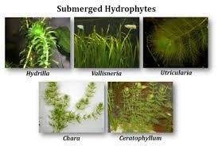
- Submerged Hyrophytes: These are aquatic plants that grow below the water surface. They are not in direct contact with air. For example, Hydrilla, ceratophylum etc. Roots are absent. Stem is soft, spongy and weak. Leaves are filamentous, thin and ribbon like. Reproduction is by fragmentation. Some have spines and pickles for protection.

- Free-floating Hydrophytes: These plants are not attached to bottom. They move freely in water. For example, Walfia, Azzola, Pistia. Their roots are absent. Stem is soft with internodes leaves float on surface of water.
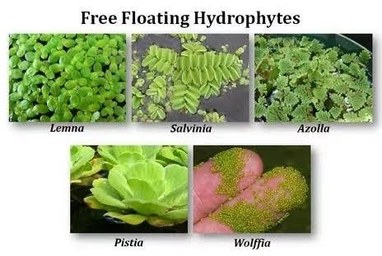
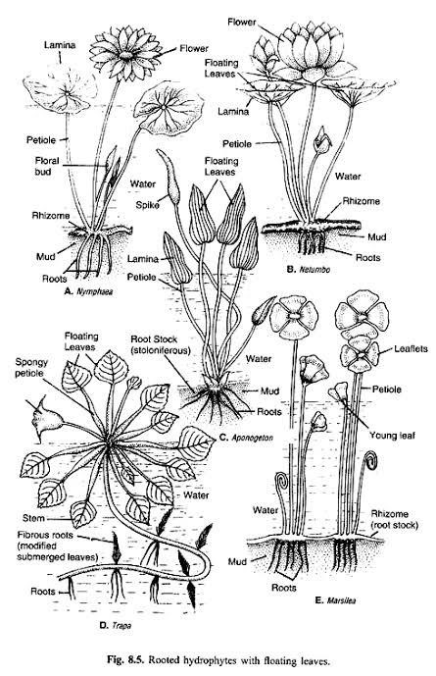
- Fixed floating Hydrophytes: These plants are fixed in mud and their leaves float on water surface. For example, Nymphaea, Victoria, Marsilea etc. They have well developed roots which help in fixation in mud. Stem is in form of rhizome. Leaves are large, thick and float on water surface.

- Amphibious Hydrophyte: These are plants which are fixed in mud by roots but their upper part grow in the air.
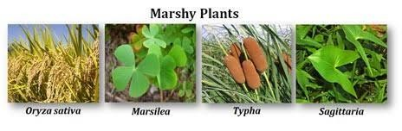
Such plants are present in marshy places. For example, Typha, Scirpus, Juncus etc. Roots are developed for fixation in soil. They have two types of leaves. Lower leaves are
dissected and present in water while upper leaves have simple.

2.5. Ecological and economic importance
Hydrophytes of great ecological and economic importance.
- They are primary producers and act as a source of food for many organisms. For example, water lily act as a source of food for fishes that are present in aquaculture. Some people also use seeds of Nymphaea and Victoria as a source of food.
- They also regulate soil chemistry and light levels because they slow down water flow and capture pollutants from it. They basically absorb pollutants in their tissues.
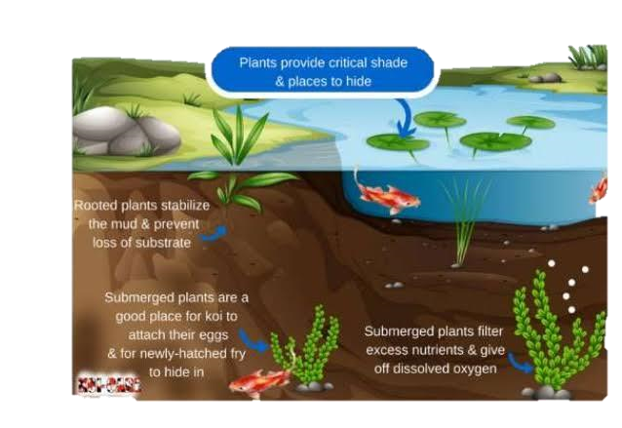
This diagram indicates that hydrophytes play an important role to increase the productivity of ecosystem.
- Many animals use hydrophytes for different purposes. For example, duckweed is used by small animals for protection against predators and as a habit.
- Many hydrophytes are used as medicines such as centella asiatica, Nelumbo nucifera and Nasturtium officinale are anti-cancer and oxidative natural products and leaf extract of lucdwigia adscendens reduces activity of glucosidase.
- Water lily is of great aesthetic importance because of it beautiful flower that float on surface of water.

3. Xerophytes

Xerophytes are derived from Greek word (Xero = dry, phyton = plant).

Xerophytes are the plants that live in the dry desert like habitats due to their adaptive features. Main atmospheric problems that they face are scarcity of water, scarcity of nutrients, high temperature, strong sunlight exposure and strong winds. Thus, main function of adaptation is to prevent loss of water through transpiration.
Examples; include Acacia, Eriogonums, Adenia glauca, Agave, Euphorbia, Joshua tree, Artic willow, Cactus family, Barbary fig, Antarctic hair grass etc.
Distribution: Xerophytes are widely distributed in dry deserts of world such as Arabian
Desert (Western Asia), Lop Desert (China), Cholistan Desert (Pakistan), Maranjab Desert (Iran), Chihuahuan Desert (North America), Black Rock Desert(USA), Negev (Israel), Blue Desert (Egypt), Namib (Southern Africa), Oltenian Sahara (Romania) etc.

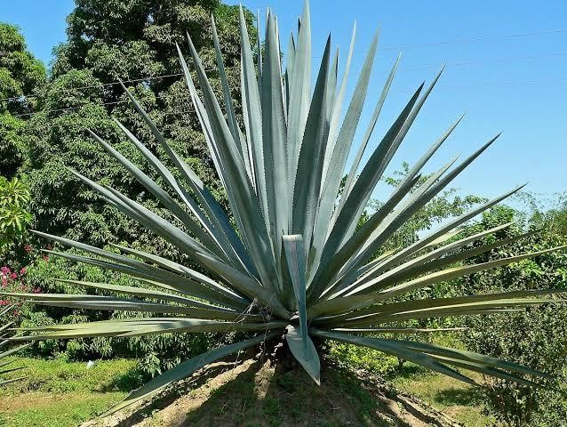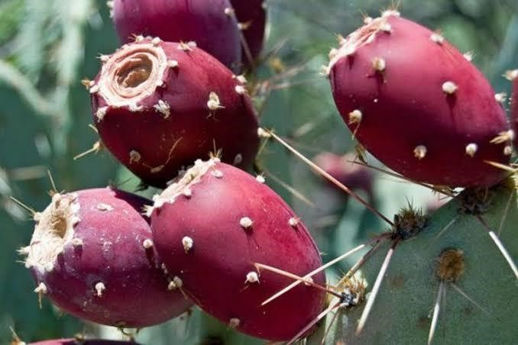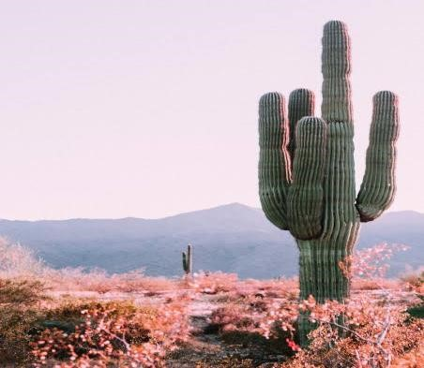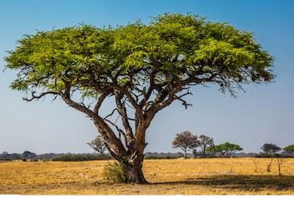3.1. Morphological Adaptations
- Leaves: Xerophytes have leaves that roll tightly under dry conditions. Rolling of leaves is because of special motor cells (hinge) on upper surface of leaves. In xerophytic grasses,
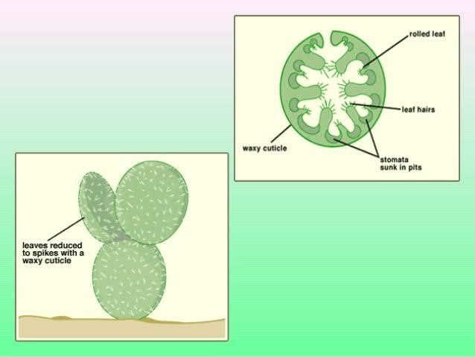
motor cells are well developed. Leaves are scale like or very small in size so that surface area for exposure of light is reduced. Generally, leaves are absent in mature plants. Xerophytes with reduced leaves are called micro-phyllous.
- Stems: are hard, woody, stunted, and dry and covered with bark. Stem in some plants are covered with silica and wax to reduce water loss such as in Equisetum. Stems may be modified into thorns.
- Roots: Xerophytes have extensive root system. Depending on species, roots may be tap or fibrous. Tap roots help to absorb water soon after rainfall whereas fibrous roots help to access nutrients and water in deep underground reservoirs.
“Extensive root system help the xerophytes to compete with fast changes in desert, where water is quickly lost to both evaporation and drainage, so absorption happens before depletion of sources”. (Gupta, 2018)
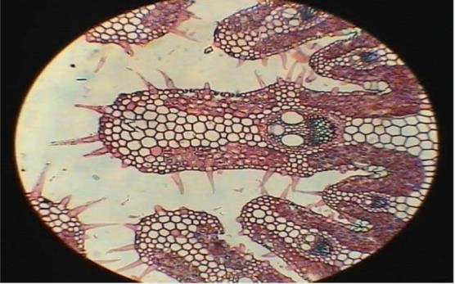
- Thorn or hairs on surface: Xerophytes have no leaves or their leaves are replaced by sharp thorns or a layer of epidermal hair on surface.
” These hairs trap moisture and air between them thus decreasing water potential difference between interior and exterior of plant thus reducing
evaporation of water.(Michael, 2017)”.
Thorns serves as mechanical defence system thus preventing plant from being eaten by consumers.
- Cuticle: Xerophytes have thick waxy cuticle which is composed of cutin, cutan, waxes, lipids and polysaccharides. This cuticle protects the plant from erosion, breaking under strong winds and reduce water loss due to evaporation and transpiration.
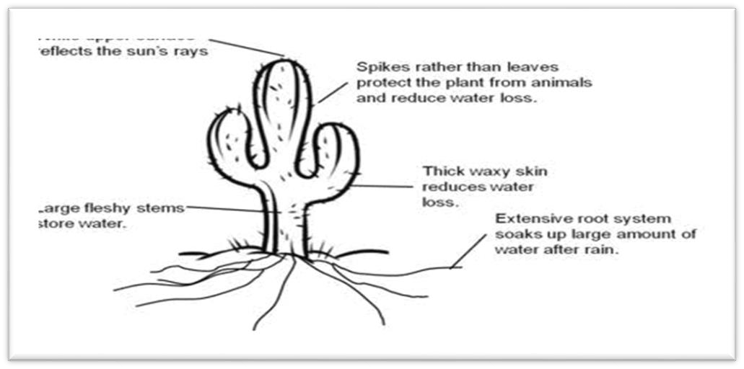
- Stomata: Xerophytes contain less stomata because of reduction of leaf surface. To reduce excessive transpiration, stomata remain sunken in pits. Such stomata are called sunken stomata (e.g.
Agave). Sometimes stomata are confined to depressions of leaf in form of groups (e.g.
Nerium).

3.2. Anatomical Adaptations

- Epidermis is covered thick cuticle to reduce rate of transpiration .Epidermal and sub epidermal cells are lignified. Sometimes, covering of wax is formed on epidermis. These cells are radially elongated. Epidermal cells may have silica crystals.
- Hypodermis is single to multi-layered and is in form of a sheet of fibrous tissue or a layer of sclerieds. In many plants, mucilage, gums and tanning are also found in hypodermis.
- Waxy coating is present on leaves and stem e.g.: Nerium.
- Stomata are generally confined to lower epidermis of leaves called hypostomatous.
- Stomata are present in pits are called sunken stomata.
- Mesophyll is differentiated in to plaside and spongy parenchyma. Sclerenchyma is in leaves either in groups or continuous sheets.
- Mechanical and vascular tissues are well developed.
- Many fleshy xerophytes possess water storage tissues and mucilaginous substance in them. These tissues basically reserve water during droughts.
- These plants also possess latex tubes that reduces transpiration to some extent.
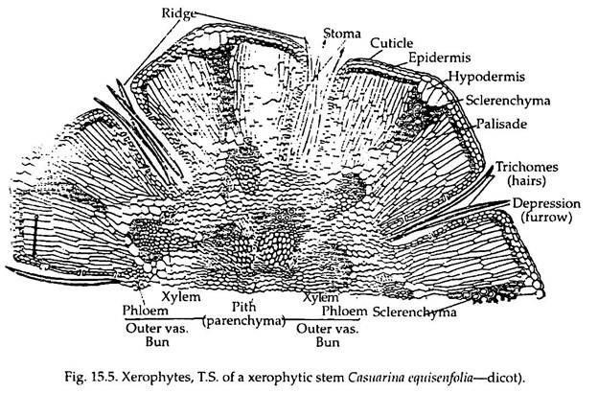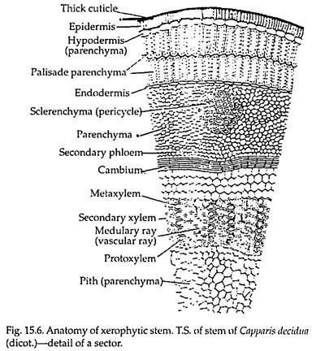

3.3 Physiological Adaptation
- Production of protective molecules: Xerophytes secrete resins and waxes on their surface to reduce transpiration. For example, flammable resins of chaparral plants or chalky wax of Dudleya. When these plants are exposed to continuous sunlight then UV rays can cause damage to plant and lead to DNA mutations. But when main molecule that are involved in photosynthesis such as photosystem two is damaged by UV rays that it induces changes in plant leading to synthesis of protectant molecules such as flavonoids .
Flavonoids absorb UV radiations and act like sunscreen for plant.
- Stomata closure: Xerophytes have inverted stomatal rhythm. When sun is at its peak during midday, stomata of xerophytes are closed. But at night stomata is main channel for movement of water in xerophytes. At night, stomatal aperture is larger as compared to day.
- Phospholipid saturation: Plasma membrane of xerophytes is composed of phospholipids. These phospholipids becomes fluid when temperature increases. Thus, plants undergo biochemical changes to change their plasma membrane composition to have more saturated lipids to maintain membrane integrity during hot weather. If plant does not do so then plant cells become susceptible to disease causing bacteria.
- CAM mechanism: During day, uptake of carbon dioxide by plant is very low. During photosynthesis carbon dioxide is required as substrate to produce sugar. So, plants have Efficient photosynthesis system which produce maximum sugar with little uptake of carbon dioxide. Many xerophytes use CAM photosynthesis cycle because their stomata are open at night so they collect carbon dioxide during night and use it for photosynthesis during daytime.
- Delayed germination and growth: rate of seed germination is reduced in xerophytes. For e.g.; by slowing down shoot growth these desert plants will consume less water for transpiration and growth. Thus, plant can utilize water for longer periods of time.
- Xanthophyll cycle: Desert plants employ xanthophyll cycle to remove excess energy as heat. Xanthophyll are actually carotenoid molecules (Violaxanth and Zeaxanthin) in chloroplast. Zeaxanthin dissociates light channelling from photosynthesis reaction thus light will not be more transmitted to photosynthetic pathway.

3.4. Types of xerophytes
There are three types of xerophytes;
- Ephemerals:
These desert plants complete their life cycle within very short period of time (about 6-8 weeks). They grow in the rainy season. Roots are present near soil surface to absorb rain water. Shoots are larger than roots. During dry period, these are in form of seeds.
For example; Solanum xanthocarpum and Suaeda fructicose.
- Succulent plants:
These plants store food and water to survive in dry period. These plants are of two types:
Stem succulent:
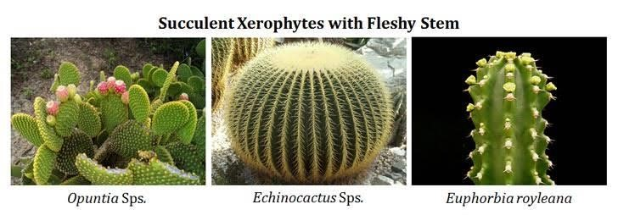
In these plants, leaves are converted into spines so their stem is green in colour. Stem prepares food. It also store food and water. For example; Cactus and Opuntia etc.
Leaf succulents:
In these plants, stem is reduced but leaves are vertical and radial in position. Leaves store food and water.
For example; Agave, Yucca etc.

3. True Xerophytes:
These plants face extreme dry conditions and high temperature both internally and externally.
Roots grow deep in soil to get water. Leaves are small in size to reduce rate of transpiration. Fruits process hard pericarp for protection against dry conditions. For example; Calotropis, Alfalfa, Acacia etc.
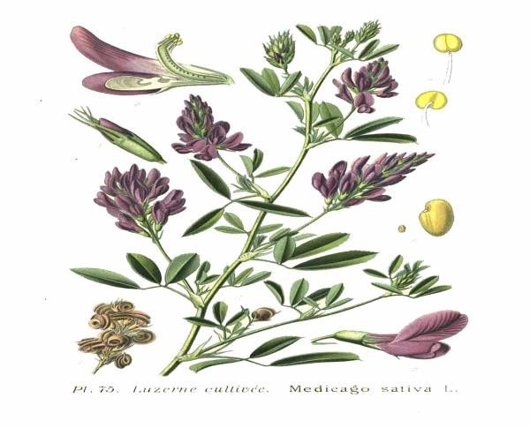

3.5. Ecological and economic importance
Xerophytes are of great ecological and economic importance such as Cactus possess several alkaloids that are a source of hallucinogen and folk medicine.
Ameridians in Southwestern United States and Mexico use cactus for religious experience and revelations.
Some people use Opuntia as a fence to keep cattle out of gardens. In earliest types of phonographs, spines of cacti are used as needles.
Many desert plants are used as ornaments such as Solanum xanthocarpum.
Many types of cactus are kept by people in homes because do not need much water and they are easy to maintain.

4. Conclusion
Since xerophytes and hydrophytes live in different environments so they have different adaptive characteristics to survive in the environment. Among all adaptive features, xerophytes possess thick waxy cuticle, small number of stomata present deep in pits, reduced or no leaves, well developed root system, formation of spines, thorns and hairs and evenly distributed chloroplasts on lower epidermis. On the other hand, hydrophytes possess thin cuticle, large stomata on upper epidermis, large leaves, air sacs for flotation, poorly developed roots and flexible stem.
Xerophytes have adaptive features according to their environment where temperature is high and there is scarcity of water. They conserve water by reducing rate of transpiration. On the other hand, hydrophytes adaptive features according to their environment where water is in abundance. So, their major problem is not water but to obtain carbon dioxide, sunlight and oxygen and to deal strong current movements.
In conclusion, main reasons of appearance of adaptive features of hydrophytes and xerophytes depend on abiotic environmental factors and availability of resources. Xerophytes deal with scarcity of water whereas hydrophytes have to cope with much abundant water.

