A still life is a drawing or painting that focuses on still objects. The subject matter is inanimate and never moves, typically with a focus on household objects, flowers, or fruits.
Still life work contrasts figure drawing which focuses on a live human model. With a still life you know the objects won’t ever move and you can practice objects with different properties like shiny metal, clear porcelain, or bulbous apples.
Fruit bowls are a popular choice because they’re made up of simple shapes and everyone has fruit lying around.
Creating a still life is a starting point for someone to practice fundamental skills. When drawing inanimate objects you can be sure they will stay in the same position until you move them, making it an easier task for beginners.
Still life artwork comes in many different styles and mediums. The brush strokes can be loose and wild or precise and bold. As long as the subject matter remains inanimate, even pen and pencil can create a still life piece.

What Goes Into A Still Life
Starting off as a way for students to practice shape and form, the still life has evolved into a fully-fledged genre of art.
Artists predominantly use paints like oil to complete their work but watercolor, acrylic, and carbon pencil are also popular.
You can arrange any collection of inanimate objects to be the subject of a still life.
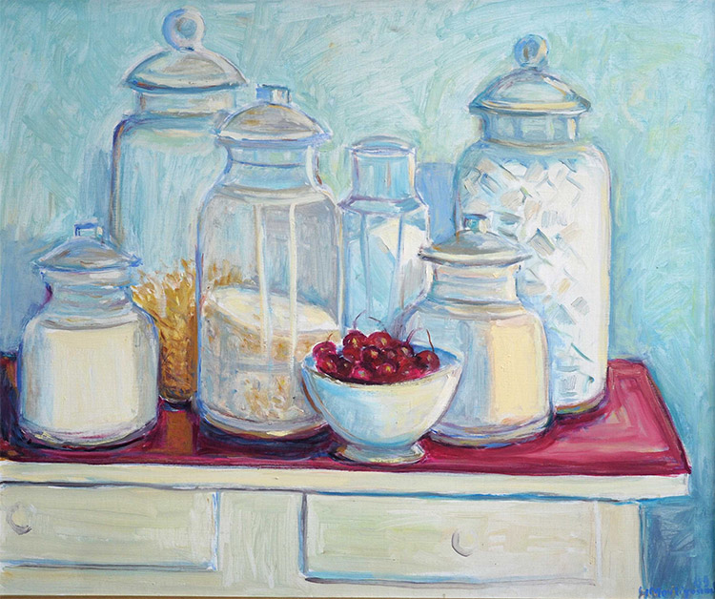Image source
In an art class the instructor will most likely arrange the composition for you.
But when working on your own projects you have full control. The beauty is that you can limit the amount that you reference from a photograph and instead create directly from life.
When the still life genre was recognized many freshly killed animals and old skulls made their way onto the canvas. Even today this is a popular trend.
These objects served as grim reminders of the briefness of life and a subtle warning that worldly possessions do not follow you into the afterlife.
But here are some of the most common themes and object choices when doing a still life:
Flower arrangements – Bouquets or vases of flowers are one of the most popular subjects of still life artworks.
Table spreads and foods –These artworks contain everything from dead birds to sliced fruit to untouched banquet tables.
Common objects – Normal objects that you would find lying around your house suddenly transform into the subject of your art. They can be in a specific arrangement or placed to tell a story through visuals.
Symbolic arrangements – By utilizing visuals, composition, color, and subject matter, an artist can paint objects that represent symbols or patterns for their still life work.

Different Styles
Let’s take a look at some examples and varying styles of still lifes.
These should grab your attention in different ways and help to illustrate the purpose of this practice.

