Pronoun: Definition & Types
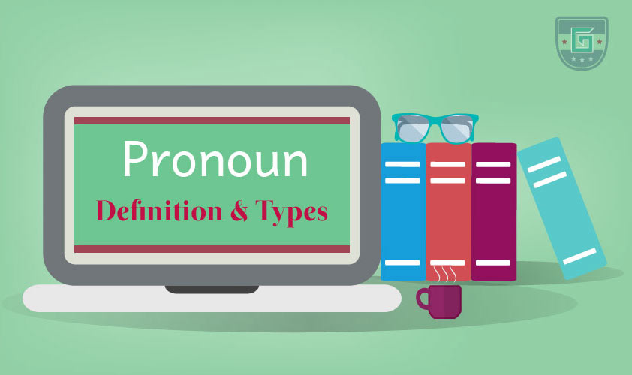
A pronoun is used in place of a specific noun mentioned earlier in a sentence so that you don’t have to keep saying/writing that particular noun.
Example:
- Michael is a good boy. He gets up early in the morning. (Here, you don’t have to mention ‘Michael’ again)
- The coach selected several key points. He wanted the team to memorize them. (‘He’ replaces ‘the coach’; ‘them’ replaces ‘several key points’)
The word or phrase that a pronoun replaces is called the antecedent of the pronoun. In the previous example, original noun ‘the coach’ is the antecedent and the pronoun ‘he’ is the referent because it refers back to the original noun. The antecedent and the pronoun/s must agree in terms of number and gender.
More Examples of Pronoun

Types of Pronoun:
- Subject Pronouns
- Object Pronouns
- Possessive Pronouns
- Reflexive Pronouns
- Intensive Pronouns
- Relative Pronouns
- Demonstrative Pronouns
- Interrogative Pronouns

Subject Pronouns
Subject pronouns work as the subject of the verb in a sentence. A subject pronoun normally replaces the subject/object (a noun) of the previous sentence.
Example:
- Mike can’t attend the party. He has gone to his grandparents.
- Marta is a good storyteller. She told a ghost story that scared everyone.
- Julie made some cakes. They look tasty. (Here, the subject pronoun replaced the object of the previous sentence)
More Examples of Subject Pronoun

Object Pronouns:
Object pronouns work as the object or indirect object in a sentence replacing the antecedent object. This form of the pronoun is also used after prepositions.
Example:
- I’ll give you a present on your birthday. I have a great idea for you. (after preposition)
- Tell her that you’ll take the job.
- I have a gift for your boss. Give it to your boss. (Here, ‘it’works as an object)
More Examples of Object Pronoun

Possessive Pronouns:
Possessive pronouns replace the nouns of the possessive adjectives: my, our, your, her, his, their. The possessive pronouns are mine, ours, yours, hers, his, its, theirs. The pronoun ‘who’ also has a possessive form, whose.
Example:
- I thought my bag was lost, but the one Kesrick found was mine. (Here, ‘mine’ refers to ‘my bag’)
- Their vacation will start next week. Ours is tomorrow. (Here, ‘ours’ refers to ‘our vacation’)
- Those four suitcases are ours.
- Is this yours?
You have to take either her car or theirs. Hers is better than theirs. (Here, ‘her’ is possessive adjective and ‘hers’ and ‘theirs’ are possessive pronouns which replaced ‘her car’ and ‘their car’)
More Examples of Possessive Pronoun

Reflexive Pronouns:
Reflexive pronoun redirects a sentence or a clause back to the subject, which is also the direct object of that sentence. A reflexive pronoun comes when the subject performs its action upon itself. Here, ‘itself’ is a reflexive pronoun.
Example:
- Since she is her own boss, she gave herself a raise. (Here, ‘herself’ is the direct object of the clause and the same person is the subject)
- She allowed herself more time to get ready.
- The computer restarts itself every night.
- We told ourselves that we were so lucky to be alive.
More Examples of Reflexive Pronoun

Intensive Pronouns:
Intensive pronouns add emphasis/importance but do not act as the object in the sentence. They can appear right after the subject.
Example:
- I will do it myself. (Here, ‘myself’ is not an object)
- I myself saw the missing boat into the harbor.
- We intend to do all the work ourselves.
- You yourselves are responsible for this mess.

Relative Pronouns:
Relative pronouns introduce the relative clause. They are used to make clear what is being talked about in a sentence. They describe something more about the subject or the object.
The relative pronouns are:
Subject | Object | Possession | Uncertainty
Which | Which | Whose | Whichever ---- (for things)
That | That |  | ---- (for both things and people)
Who | Whom | Whose | Whoever/whomever/whosever ---- (for person)
Example:
- The car that was stolen was the one they loved most.
- A person who loves nature is a good person.
- Our school, which was founded in 1995, is being renovated.
- I will accept whichever party dress you buy me on Valentine's Day.
- Whoever you are behind this great initiative, I want to thank you.
More Examples of Relative Pronoun

Demonstrative Pronouns:
Demonstrative pronouns normally indicate the closeness of or distance from the speaker, either literally or symbolically. This, these, that, and those are the demonstrative pronouns. They also work as demonstrative adjectives when they modify a noun. However, demonstrative pronouns do not modify anything rather replace the nouns/noun phrases.
Sometimes neither, none and such are also used as demonstrative pronouns.
Example:
- That is a long way to go. (demonstrative pronoun)
- This is my car. (demonstrative pronoun)
- Hand me that cricket bat. (demonstrative adjective)
- Neither is permitted to enter the building.
- Such are ways of life.

Interrogative Pronouns:
Interrogative pronouns produce questions. They are what, which, who, whom, and whose.
Who, whom, and whose refer to questions related to a person or animal; what refers to an idea, object, or event; and which can indicate either a person/s or a thing/s.
Example:
- What was the name of your dog?
- Which is your favorite movie?
- Who works for you?
- Whom do you prefer in this competition?
- There’s a new bike on the lawn. Whose is it?

