- Topic
“ compound lipids “

Lipids:

“ lipids are the heterogeneous group of compound related to fatty acid.
- Lipids are hydrophobic compound.
- Lipids are insoluble in water.
- Because water is polar while lipids are nonpolar.
- So like dissolve like. Lipid are soluble in non polar inorganic solvent like ether, benzene, etc.
- Lipids have high proportion of C-H
bond and low proportion of oxygen so it store double amount of energy as compared to carbohydrates.
- Lipids include fats, oil, waxes, cholesterol and related compound.
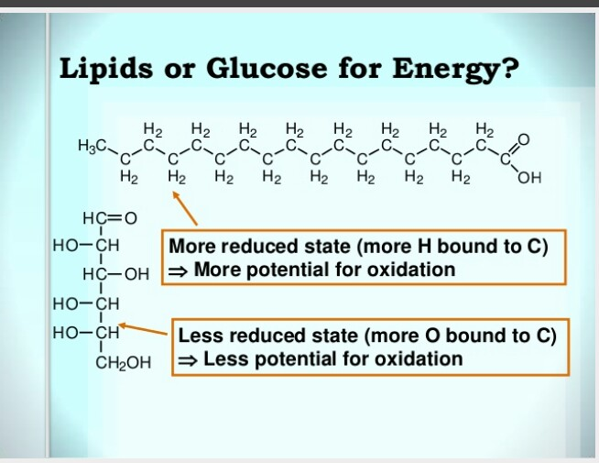

- Easter bond formed between fatty acid and related alcohol.
- During easter bond formation H from fatty acid and OH from alcohol like glycerol, combined fr water and elimination of water take place.
- C-o-C bond form called easter bond.

Fatty Acid:
“fatty acids are aliphatic carboxyllic acid.
- Having the general formula_R_(CH2)n_COOH.
- They occur mainly in easterfied form in natural oils and fats.
Also accrue in non easterfied forms as free fatty acid, a transport form found in plasma membrane.
- Fatty acid in natural fats usually occur in straight chain derivative contains even number of carbon.
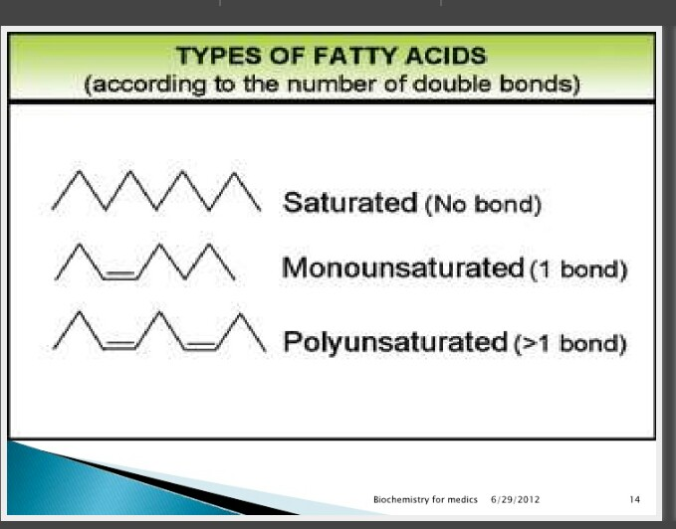

- Fatty acid may be saturated and unsaturated.
Saturated fatty acid:
- There is no double bond in saturated fatty acid.
- Saturated fatty acid are solid at room temperature.
- Mostly animals fats is saturated.
Unsaturated fatty acid:
- There is double bond in unsaturated fatty acid.
- Unsaturated fatty acid are liquid at room temperature.
- Plant oils are unsaturated

- Classification of lipid:
- Simple lipid
- Compound lipid
- Derived lipid/ precursor

- Simple lipid:
“ of simple fatty acid with various alcohol.”
Fats. Easter of fatty acid with glycerol.
Waxes.easter of fatty acid with higher molecular weight of monohydric alcohol.
- Compound lipid:
“Compound lipid contains other group in addition to fatty acid and glycerol. “
- Contains in addition to fatty acid and glycerol or other alcohol, phosphoric acid residue, nitrogenous base and other substitutes.
- Derived lipid:
“ hydrolysis product of simple and compound lipid. “
- Derived lipid also act as precursor.
- Derived lipid contains fatty acid, glycerol, steroid, alcohol,fatty aldehyde, keto bodies, hydrocarbons, lipids soluble vitamins and hormones.
Steroid
Cholesterol
Bile acid
Vitamin D
Sex hormones
Adrenocortical hormone.

*******COMPOUND LIPIDS*****

Compound lipids contain other group in addition to fatty acid and glycerol or various alcohol.
- In other group consists of phosphorus acid,nitrogenous base and other substitute.
- According to the group attached with fatty acid and alcohol like if phosphorus present than compound lipid Called phospholipid.
- Examples:
Phospholipid
Glycolipid
Sulfolipid
Aminolipid ( lipoprotein)

*Phospholipid:*
- Structural formula.
Glycerol+ 2 fatty acid+ phosphorus+ choline
- In addition to fatty acid phospholipid contains
An alcohol
An phosphoric acid
May have nitrogenous bases, choline, serine,ethanolamine.
- It is the constitute of cell membrane.
- It is consider the derivative of phosphotidic acid.
- Important examples of phospholipid are.
1.glycerophospholipid.( alcohol is glycerol)
2. Sphignosinephospholipid(alcohol is sphignosine.
1.Glycerophospholipid.
- Structural formula.
Glycerol+ phosphate+ 2 fatty acid+ nitrogenous bases.
- It also called phosphoglyceride.
- It is membranes lipid.
- If we see its structure .than it shows that
Glycerol is 3C alcohol .
From 1st and 2nd C two fatty acids are attached with the help of easter bond formation.
While with 3rd C of glycerol ,a highly charged or polar body phosphate ( PO4)- .
Phosphate group attache with the 3rd C of glycerol by formation of dieaster linkage.

- Important types of glycerophospholipid are.
Lecithin
Cephaline
Cardiolipid
Phosphotidic acid.
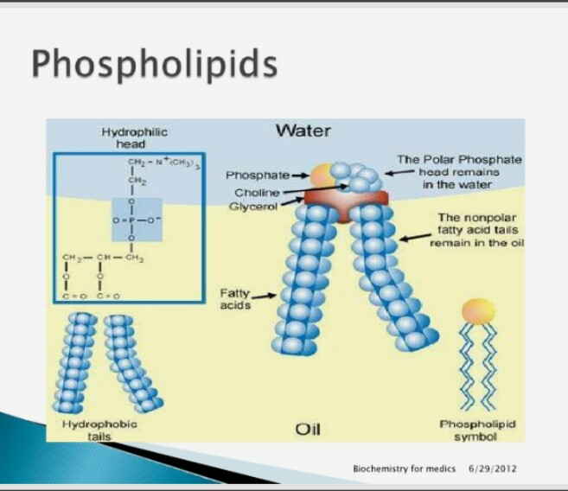
- Lecithin
- Lecithin also called phosphatidyl Cholines.
- Choline is nitrogenous base which is the part of neuro- transmitter.
- Lecithin abundant in nervous tissue and do the transmission of nerve impulse across synaptic system.
- Choline is the part of lecithin.
- Dipalmitoyl lecithin is very effective active surface agent.
- Dipalmitoyl lecithin is the major constitute of surfactant.
“surfactant,lipid and protein make the lining of lungs ,called surfactant. “
- Surfactant keep the lungs fully inflate .
- So due to this lugs not collapse. Air pass easily and breathing easily take place.
- If the deficiency of surfactant take place than many respiratory disorders occur.
- Because due to deficiency of surfactant .lining of protein+ lipid in lungs not .
- Lungs not fully inflate.
- Lung constrict due to the constriction of lungs alveoli within the lungs collapse With each other and damaged.
- Alveoli damage and accumulated in the air passage way.so due to this difficulty occurs in breathing.
- And it causes ofany respiratory disorders.
- Disorder occurs by surfactant deficiency called respiratory distress syndrome.

- Cephaline.
- Also called phosphotidyl ethanolammine.
- Cphaline structurally similar to the lecithin.
- Exception is that base ethanolammine replaced the base choline.
- Brain and nervous tissues are rich in cephaline.
Function of phospholipid.
- Components of cell membrane
- It perform the both structurally and regulatory function.
- Structurally .lipid bilayer
- Regulations. Head is hydriphillic which remains out side while tail is hydrophobic which remains in side in core.
- Phospholipid in mitochondria like lecithin,cephaline .

- These phospholipid maintain the electron transport chain ETC.
- Help in transport of lipid.
- Cephaline help in the blood clotting.
Sphignosine lipid:
- Found in large quantity in brain and nervous tissues.
- Fatty acid, phosphoric acid, choline and complex amino alcohol,sphignosine.
- No glycerol is present.
- Combination of fatty acid and sphingosine called the Ceramide.
- Ceramide found in sphignosinephospho lipid.

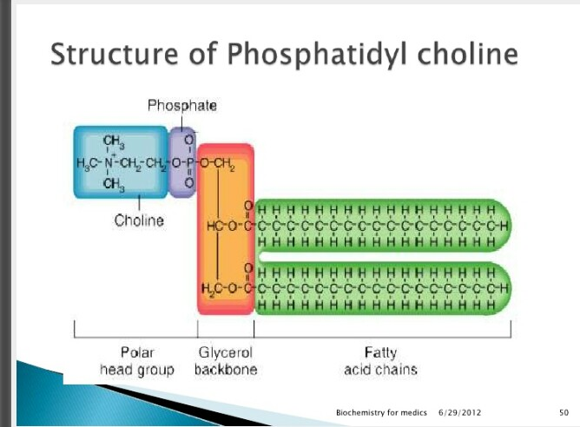

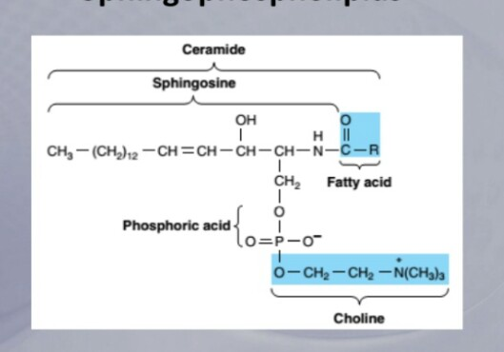
*Glycolipid:*
- Widely distributed in every tissue of the body.
- Particularly in brain tissues present abundantly.
- Outer leaf let of plasma membrane.where they contributed to cell surface carbohydrate.
- Example:
- Glycosphingolipids.
- It contains ceramides and one or more sugar.
- Glucosylceramides
- Ganglioside
1.ganglioside:
- These are acidic .
- These are negatively charged at physiological pH.
- The negative charged imparted by the N _ acetyl neuraminic acid (silic acid).
- Brain ganglioside contains up to four silic acid

2.Glactosylceramid:
- It contains ceramides due to presence of it , its name is galactosylceramide .
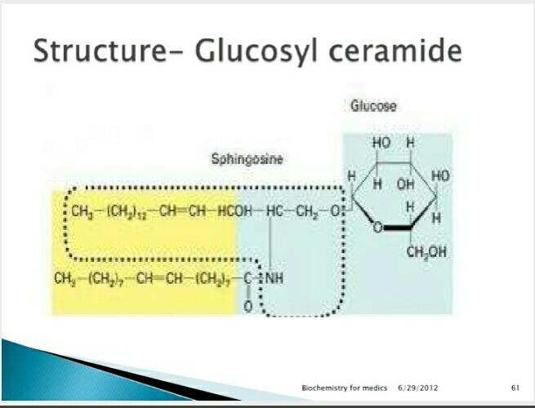

* Aminolipid( lipoprotein)
Define:
“ complexes of protein with lipids called aminolipid.
- Aminolipid also called lipoprotein because amino acid are the Structural and functional units of protein.
- Lipoprotein are transport protein .
- It is used as a transport vehicles for lipids.
- Five types of lipoprotein are following.
- Chylomicron
- Very low density lipoprotein
( VLDL)
- Low density lipoprotein(LDL)
- High density lipoprotein
- Free fatty acid complexes
- Chylomicron.
- The density of chylomicron less than the 0.95 g/ ml .
- The ranges of diameter in 100 to 1000 nm.
- These lipoprotein responsible for the transportation of triglycerides in the gastrointestinal tract to the other part of body such as transport to liver, Skelton tissues and adipose tissues.
- Low density lipoprotein.
- Low density lipoprotein responsible for the transportation of fat molecules such as phospholipid, cholesterol and
Triglycerides around the body.
- It is sometimes called “ bad cholesterol “ because elevated concentration of low density lipoprotein are the indicators of underlying diseases such as atherosclerosis.
3.High density lipoprotein.
- High Density lipoproteins responsible for the collection of fat molecules such as phospholipid, cholesterol and triglycerides from the cell of body and transport to the liver to be broken down.
- High density lipoprotein also called good cholesterol because high concentration of this lipoprotein corresponding to healthier blood vessels and lowered the risk of arthrosclrosis.

******************

:FUNCTIONS OF LIPIDS:
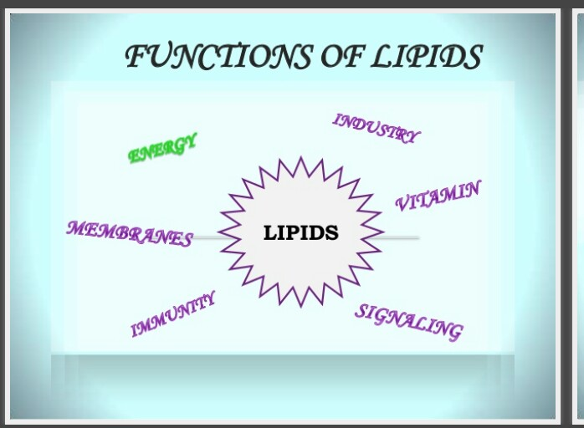
- Energy storage:
- As we know about this , lipids have high proportion of C- H bond
- Due to this lipids stores double amount of energy as compared to the carbohydrates.
- Lipids carry 9 kcal energy as compared to the carbohydrates.
- Carbohydrate carry 4 kcal energy. So ,its clear that lipid store double amount of energy as compared to the carbohydrates.
- Fat store in adipose tissues in the vertebrates.
- Fats also stored in seeds. In the form of glyoxysomes.
- Thermal insulation.
- Adipose tissues act as thermal insulation.
- Adipose tissues conducted the heat very slowly.
- So triglycerides which store fats in vertebrae important for maintain the optimum temperature.
- Mechanical protection:
- Adipose tissues act as the physical cushion
- It present in the palm of hand, sole of feet, around eyes and around the body organs such as kidneys.
- Waxy cuticle on the leaf epidermal act as water proof.
- Waxy cuticle also protect from external agent.
- Inside body chemical reactions n. (Metabolism)
- In liver cholesterol is the precursor of bile acid.
- Bile acid contains salts and enzymes which help in digestion process.
- Cholesterol is the precursor of the vitamin D3.
- Vitamin D3 produced when body skin come in exposure of sunlight.
- This is necessary for healthy bones.
- Deficiency of this vitamin cause bone diseases such as rickets.
- Plasma membrane rich in cholesterol and sphingolipid.
- This is important for neuron cell adhesion ,guide the axon and synaptic transport.
- Immunity.
- Lipids activated the aggregation of platelets at injury .
- Prostaglandlin maintained this process.
- Lecithin act as surfactant.
- Absence of surfactant caused the respiratory disorders.
- Phosphotidyl serine play role in apoptosis.
- Apoptosis is the program death of cell.
- Lipid and derivatives of lipid involved in sleep induction.

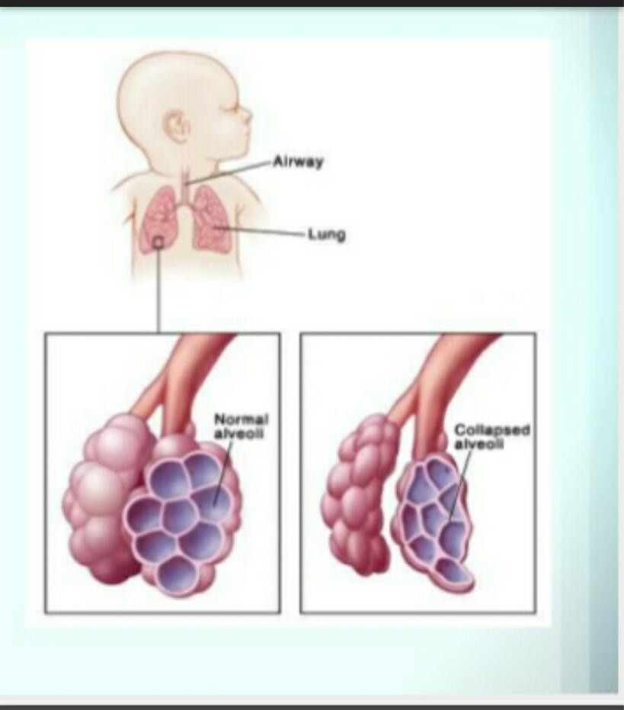

- Medical:
- Transport the drugs to target area.
- Liposome combined With tissue specific antibodies. Function as carry the drugs in the circulation to target area.
- Isopernoids compound include rubber and camphor.
- Camphor use for cough .
- In pesticides:
- They use as pesticides.
- Citronella oil uses in Candle, lotion sprays to repel insects.
- Lubricant:
- Waxy cuticle act as lubricant .
- It protect from abrasive damage.
- Cosmetics industry:
- Soaps , hand lotions, cream and other cosmetic.
- Lipid play important rule in cosmetic industry.
- Dirty particles react with non polar fatty acids .while polar head make bonding with water and in this way wash out the dirt’s and soap clean our skin.
- Buoyancy.
- Fats and oils have less density .
- So fats and lipids are less dense than water and this help the fishes in buoyancy.
- Hibernation:
- This is dormant and inactive period of time .
- Breathing rate ,blood circulation rate became less .
- Not feed even.
- So store triglycerides give energy in this dormant period and organism can survived without feed.
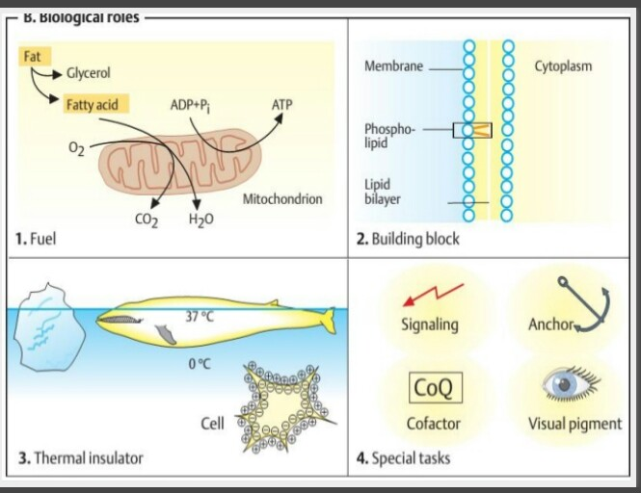

MCQS.
1.why lipid store double amount of energy as compared to carbohydrate
(a) high oxygen proportion
(b)high hydrogen proportion
(c) C-H high proportion
(d)C-O high proportion
2.lipid carry------ kcal energy and carbohydrates carry------ kcal energy respectively.
( a) 5,9
(b)8, 7
(c)9, 4
(d)9, 6
3.structural formula of phospholipid is.
(a)glycerol+ fatty acid+ choline
(b)glycerol+ fatty acid
(c) glycerol+ 2 fatty acid+ phosphate+choline
(d)fatty acid + phosphate
4.fatty acid with the combination of glycerol called
(a) sphignosine
(b) ceramide
(c) coral
(d)phospholipid
5.which act as the surfactant.
(a) choline
(b)cephalin
(c) glycolipid
(d)lecithin
6.in phospholipid which attach to the glycerol 3C.
(a)phosphate group
(b) choline
(c)alcohol
(d)serine
7.which protein is transport protein.
(a) phospholipid
(b) lipoprotein
(c)glycoprotein
(d)sulfolipid
8.which tissue act as the thermal insulation.
(a)kidney tissue
(b) adipose tissue
(c)complex tissue
(d)xylem tissue
9.precursor of steroids, vitamin D,hormones is ------.
(a)acetone
(b)glycerol
(c) cholesterol
(d)triglyceride
10.when skin exposed to sunlight ,vitamin D secrete.
(a)calcium
(b) phosphorus
(c)both
(d) none

*******”*****”****************
- This is all of my side .l try best for this assignment.
- Thanks for giving the chance, to write assignment.

