Title of the Assignment: Ribosomes, Centrosomes and Vacuoles

CONTENT

- RIBOSOMES
      - Introduction
- Structure of Ribosomes
- Functions of Ribosomes
- CENTROSOMES
- Introduction
- Structure and functions of Centrosomes
- Centrosomes in Plant Cell
- Centrosomes in Animal Cell
- VACUOLES
- Introduction
- Structure and functions of Vacuoles
- Other Storage Functions

- RIBOSOMES
Ribosomes: Ribosomes are very small sub-spherical granular organelles, not bounded by any membrane. They are comprised of ribonucleoproteins and they are the place of protein synthesis. They take place in big number.
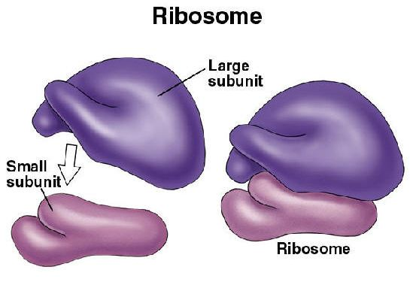
Figure:Ribosome

All ribosome are150-250A in diameter and comprises of two unequal sub units, a big dome shaped and a smaller ovoid one. The smaller sub unit fits over the bigger one similar to a cap. These two sub units take place separately in the cytoplasm and attach to form ribosomes only at the time of protein synthesis. At the time of protein synthesis numerous ribosomes line up and attach an mRNA chain to synthesize numerous copies of a particular polypeptide. Such a string of ribosomes is termed as polysome.
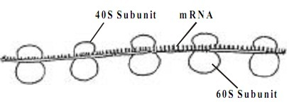
Figure: Polyribosome
Ribosomes take place in cytoplasmic matrix and in certain cell organelles. Accordingly, they are termed as cytoplasmic ribosomes or organelle ribosomes. The organelle ribosomes are found in mitochondria and plastids. The cytoplasmic ribosomes might remain free in the cytoplasmic matrix or joined to the surface of the endoplasmic reticulum. The attached ribosomes usually transfer their proteins to cisternae of endoplasmic reticulum for transport to other portions both inside and outside the cell. Depending on size or sedimentation coefficient(s), ribosomes are of two kinds: 70s and 80s. 70s type of ribosomes are mainly found in all prokaryotic cells and 80s type are found in eukaryotic cells. S is Svedberg unit that is a measure of particle size with which the particle sediments in a centrifuge. In eukaryotic cells, synthesis of ribosomes takes place within the nucleolus. The ribosomal RNA is synthesized in the nucleolus. The ribosomal proteins are synthesized in the cytoplasm and move to the nucleolus for the creation of ribosomal sub units by complexing with rRNA. The sub units pass out into the cytoplasm via the nuclear pores. In prokaryotic cells, both proteins and ribosomal RNAs are synthesized in the cytoplasm. Therefore the ribosomes operate as the protein factories of the cell.
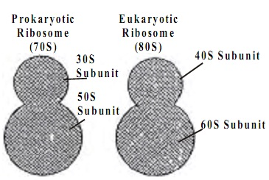

- Structural Biochemistry/Cell Organelles/Ribosome:
The purpose of the ribosome is to translate messenger RNA mRNA to proteins with the aid of tRNA. In eukaryotes, ribosomes can commonly be found in the cytosol of a cell, the endoplasmic reticulum or mRNA, as well as the matrix of the mitochondria. Protein Synthesized in each of these locations serve a different role in the cell. In prokaryotes ribosomes can be found in the cytosol as well. This protein-synthesizing organelle is the only organelle found in both prokaryotes and eukaryotes, asserting that the ribosome was a trait that evolved early on, most likely present in the common ancestor of eukaryotes and prokaryotes. Ribosomes are not membrane bound.
Ribosomes are also play a key role in the catalysis of two important and crucial biological processes. They are responsible for peptidyl transfer, in which they form peptide bonds during protein synthesis as well as peptidyl hydrolysis; in this process, the ribosome releases the completely formed protein from the peptidyl transfer RNA after completion of translation. Translation is the process of converting mRNA (from transcription) to functional proteins; The three steps involved are initiation, elongation, and termination. Proteins are translated one amino acid (three base pairs) at a time. During this process, tRNA assists the ribosome by bringing the complementary bases to the ribosome as translation proceeds.
Because ribosome synthesis is a major metabolic activity that involves hundreds of individual reactions in eukaryotes, errors will occur eventually during these processes. To deal with the error in ribosome synthesis if it occurs, eukaryotes will degrade the erroreous ribosomes. In addition, not only the erroneous ribosomes will be degraded but also the excess ribosomes. Recent researches show that eukaryote cells enhanced many strategies to recognize specific dysfunctional or functionally deficit ribosomes for degradation.
- Translation: Eukaryotic and Bacterial

Along with having more complicated assembly regulations than bacterial ribosomes, eukaryotic ribosomes are triggered differently than bacterial ribosomes in translation initiation. Eukaryotic ribosomes use a scanning mechanism and require at least nine initiation factors. In bacteria, ribosomes can identify the right reading frame and know where to attach to a mRNA stran, by finding the Shine Dalgarno sequence on the mRNA. This ribosome binding site is upstream from the AUG start codon on the mRNA. In the bacterium E. Coli, the Shine Dalgarno site is a purine-rich nucleotide sequence—5’ AGGAGGU 3’, on the mRNA that is located four to eight bases ahead of the start codon. This Shine-Dalgarno sequence is complementary to the sequence 5’ ACCUCCU 3’ on the 16S rRNA, which is found in the 30S subunit of the ribosome.

Structure:
Ribosomes usually comprise 2 protein subunits and some component of rRNA. The protein componenet of the ribosomes is first synthesized in the cytosol much like any other protein. The newly synthesized protein subunits are then transported from the nucleus into the nucleolus, the center of ribosomal RNA transcription. RNA polymerase are then used to polymerize the rRNA needed for the synthesis of the ribosome. Cells that have a high rate of protein synthesis have many ribosomes.
In the past, scientists studied ribosome to get a better understanding about its components, which is consists of 30S, 50S, 70S, and 100S. All are made of by the same particles but different concentration of Mg ions. 30S and 50S are small and large subunits of 70S while 100S is a collection of 70S. Ribosomal structure varies between eukaryotes and prokaryotes. Eukaryotes have 40S (small) and 60S (large) subunits, together the subunits form the 80S ribosome. Prokaryotes have 30S (small) and 50S (large) subunits. These subunits work together during translation to synthesize proteins.
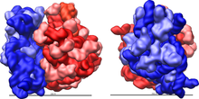
EColi 70S Ribosome. The red is the 50S large subunit and the blue is the 30S small subunit
In prokaryotes, the small subunit (30S) and the large subunit (50S) together make the 70S ribosome. The 30S subunit is composed of 21 ribosomal proteins and 16S rRNA. Its function is to decode and decipher mRNA to determine the corresponding amino acid to the three bases in codons. The small subunit consists of the body (5’), the platform region (central domain), and the head (3’). Each component can be formed separately of each other. The small subunit also contains a 3’-minor domain consisting of the last two helices (44 and 45) and the end of the 3’ end of the rRNA. The structural components of the small subunit have been shown to be structurally independent from each other suggesting that during protein synthesis they move and conform relative to one another. The long 44 helix stretches across the small subunit from the body to the head functioning as a potential relay for information across the entire subunit. Unlike the small subunit, the large subunit is mostly rigid with mobility restricted its peripheral regions. The 50S subunit consists of 33 proteins and the 23S and 5S rRNA.
The mRNA binding site is located along the neck of the small subunit while the large subunit contains the peptidyl transferase center (PTC) where aminoacyl and peptidyl-tRNA attach. The three binding sites are A, P, and E. Binding site A attracts aminoacyl-tRNA, binding site P attracts peptidyl-tRNA, and binding site E, the exit site, attracts deacylated tRNA. The anticodon stem loop is attached to its complementary codon on the mRNA binding site of the small subunit while the amino acid end of the tRNA attaches to A and P sites both located in the PTC. The GTPase-associated center and the sarcin/ricin loop are located on the large subunit and help to stimulate GTP hydrolysis needed for elongation of the protein.
Ribosome assembly consists of transcription, translation, the folding of rRNA and ribosomal proteins, the binding of ribosomal proteins, and the binding and release of the assembly components to make the ribosome. There are two intermediates in ribosome assembly, in vitro and in vivo. One method of in vitro assembly of the 30S is to only use free rRNA and ribosomal proteins. Another is to combine 16S rRNA with purified and recombinant proteins and precursor 16S rRNA. With the different ways to assemble proteins, the assembly of ribosomes also varies with different temperatures. At low temperature of 0°C -15°C, the reconstitution intermediate (RI) particle, composed of 16S rRNA and 15 ribosomal proteins, is formed and settled to 21S-22S. Then the RI particle is rearranged after getting heated to 40°C and settled to 25S-26S. After completing these two processes, the RI particle together with the remaining proteins can form the 30S subunit.
In contrast, the in vitro assembly of the 50S subunit requires more steps and harsher conditions compared to the assembly mechanism of the 30S. There are three reconstitution intermediates each dependent on different temperatures and ionic conditions. RI50 (1), the first intermediate, yields the 33S particle. As RI50 (1) is heated, RI50 (2) forms and sediments at the 41S-43S. The remaining proteins form the RI50 (3) which create the inactive 48S particle. In order for the 48S particle to become the active 50S subunit, the temperature and concentration of magnesium needs to be increased along with the involvement of the 5S rRNA.
Like the in vitro assembly mechanism, the in vivo assembly of the 30S subunit has two intermediates (p130S and p230S) and the 50S subunit has three intermediates (p150S, p250S, and p350S). However, the reconstitution intermediates are not the same as in vitro. The intermediates of the 30S subunit yield 21S and 30S particles while the intermediates of the 50S subunit yield 32S, 43S, and 50S particles. The intermediates in the in vivo assembly are precursor rRNA which is different from in vitro which uses matured rRNA. To complete the mechanism of ribosome assembly, these precursor rRNA gets transformed in the polysomes.
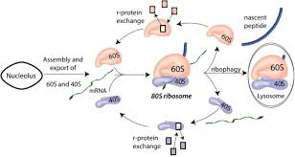

Eukaryotic Ribosomes:
A eukaryotic ribosome is composed of a 40S and 60S subunits, they both have a solvent exposed side and a subunit interface. The solvent exposed side contains a higher concentration of protein and RNA elements that are only in eukaryotes compared to the subunit interface.
The eukaryotic specific proteins are responsible for 40S structure being stabilized by tertiary contacts. The majority of the eukaryotic specific proteins and extensions are to interconnect other proteins in the 40S and 60S subunit. The 40S subunit has 14 of these interconnected proteins located in the head. eukaryotic specific proteins and extensions 40S subunit has 14 of these interconnected proteins located in the head. eukaryotic specific proteins and extensions play a bigger role in 60S subunits because their protein mediated connections are more extensive and reach across the subunit.
The 60S specific extensions consist of beta sheets and long alpha helices which are crucial in long distance tertierary interaction, meaning they have the ability to interact across the subunit. This trait is unique for eukaryotes because protein-protein contact is very rare in the prokaryote ribosome. The 40S and 60S subunits are joined by eukaryote specific inter-subunit bridges that connects them thus forming 80s. This is done by eukaryotic specific bridges forming at the 40S and the RPL19 interacts with ES6E and RPL24 intracts with rpS6. The other two eukaryotic specific bridges connect by 60S segment ES31 that connects to rpSA and another 60S segment, ES41 that connects with rp58 from the 40S subunit.
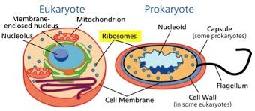

Functions of Ribosomes:
- They assemble amino acids to form specific proteins, proteins are essential to carry out cellular activities.
- The process of production of proteins, the deoxyribonucleic acid produces mRNA by the process of DNA transcription.
- The genetic message from the mRNA is translated into proteins during DNA translation.
- The sequences of protein assembly during protein synthesis are specified in the mRNA.
- The mRNA is synthesized in the nucleus and is transported to the cytoplasm for further process of protein synthesis.
- In the cytoplasm, the two subunits of ribosomes are bound around the polymers of mRNA; proteins are then synthesized with the help of transfer RNA.
- The proteins that are synthesized by the ribosomes present in the cytoplasm are used in the cytoplasm itself. The proteins produced by the bound ribosomes are transported outside the cell.

- CENTROSOMES
Definition:
“Centrosome is a microtubule-organizing centre in animal cells.”

- Structure of Centrosome:
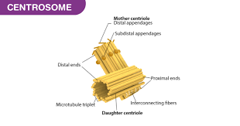

The centrosome is made up of two perpendicular centrioles, a daughter centriole, and a mother centriole, linked together by interconnecting fibres. It consists of a complex of proteins that helps in the formation of additional microtubules. An amorphous pericentriolar matrix surrounds the centrioles. It is involved in the nucleation and anchoring of cytoplasmic microtubules.
Centrosome in the animal cells is very much like DNA. During cell division, one centrosome from the parent cell is transferred to each daughter cell. In proliferating cells, the centrosome starts dividing before the S-phase begins. The newly formed centrosomes participate in organizing the mitotic spindles. During Interphase, the centrosome organizes an astral ray of microtubules that help in intracellular trafficking, cell adhesion, cell polarity, etc. In post-mitotic cells, the centrosome consists of a mature centriole and an immature centriole, known as the mother centriole and daughter centriole respectively.
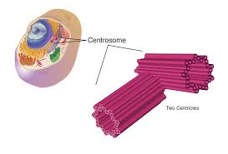
The centrosome cycle consists of four phases:
- G1 phase where the duplication of centrosome takes place.
- G2 phase where the centrosome maturation takes place.
- The mitotic phase where the centrosome separation takes place.
- A late mitotic phase where the chromosome disorientation takes place.

- Centrosome Functions:
The major functions of centrosome are listed below:
- The centrosomes help in cell division.
- They maintain the chromosome number during cell division.
- They also stimulate the changes in the shape of the cell membrane by phagocytosis.
- In mitosis, it helps in organizing the microtubules ensuring that the centrosomes are distributed to each daughter cell.
- They regulate the movement of microtubules and cytoskeletal structures, thereby, facilitating changes in the shapes of the membranes of the animal cell.

Centrosome in Animal Cells
In most animal cells, centrosomes are not required in the cell division process even though they add to the effectiveness of the mitotic spindle arrangement. In humans, disfunctioning of centrosomes can stimulate cancer as a result of an increase in the levels of instability in chromosomes or due to the metastatic capability of cancer cells. However, the study on this lacks evidence.

Centrosome in Plant Cells
Plants and fungi do not possess centrosomes hence make use of MTOC structures to coordinate their microtubules. Plant cells do not possess spindle pole bodies or centrioles except in flagellate male gametes which are completely present in a few flowering plants(conifers). The primary function of the MTOC for spindle organization and microtubule nucleation appears to be taken up by the nuclear envelope whiles the mitosis of the plant cell.
A rare pathway has been developed by higher plants to regulate the dynamics and assembly of the cytoskeleton. The microtubules are nucleated at the organizing and nucleation centres in many other eukaryotes which are committed to establishing polarity. Though animal and plant cells share the main cytoskeleton elements that imply controlled working, plants do not exhibit centrosome resembling organelles but yet are capable of building spindles thus have developed cytoskeletal arrays such as the preprophase band, the cortical arrays and the phragmoplast that participate in fundamental growth processes.
Certain elements such as the gamma-tubulin etc have a major role to play in the microtubule nucleation taking place at the surface of the nucleus which is referred to as the major operative plant microtubule-organizing centre.

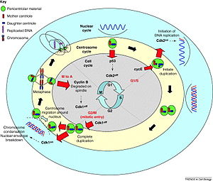

- VACUOLES

Definition:
“A vacuole is an organelle in cells which functions to hold various solutions or materials”. This includes solutions that have been created and are being stored or excreted, and those that have been phagocytized, or engulfed, by the cell. A vacuole is simply a chamber surrounded by a membrane, which keeps the cytosol from being exposed to the contents inside. Because vacuoles are surrounded by semi-permeable membranes, they only let certain molecules through.

Vacuole Structure:
A vacuole has a broad definition, and includes a variety of membrane-bound sacs. The membranes are composed of phospholipids, but each organism may use slightly different phospholipids. Embedded in the membranes are proteins, which can function to transport molecules across the membrane or give it structure. Various combinations of these proteins allow different vacuoles to handle and hold different materials. In each organism, different genetics cause different proteins to be embedded in the membrane of the vacuole, which allow different molecules through, and gives the vacuoles different properties. Most plant cells have evolved to use vacuoles as water storage organelles, which provide a variety of functions to the cell. Animals don’t rely on this water storage for the rigidity of their form, and use their vacuoles for the storage of various products and for exocytosis and endocytosis.

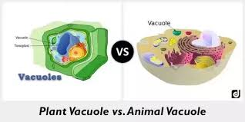

Functions of a Vacuole

Water Storage
In plants, a large vacuole occupies the majority of the cell. This vacuole is surrounded by the tonoplast, a type of cytoplasmic membrane that can stretch and fills itself with a solution known as cell sap. The vacuoles also fill itself with protons from the cytosol, creating an acid environment inside of the cell. The vacuole can then use the chemical gradient created to transport materials in and out of the vacuole, a type of movement called proton motive force. This includes the movement of water and other molecules. The following is a picture of a plant cell, and the vacuole inside.
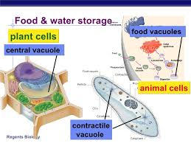
- Turgor Pressure
Plants use their vacuoles for a second function, which is of utmost importance to all plants. The vacuole, when completely filled with water, can become pressurized and exert a force on the cell walls. Although the force in each cell is small, this turgor pressure allows the cells to create a form, and stand up to wind, rain and even hail. Although woody plants create additional proteins and fibers that help them stand tall, many non-woody plants can reach a height of several feet on turgor pressure alone.
While this is an efficient way for plants to structure themselves, the plant will droop when the pH balance is off, or they don’t have enough water. If you see your houseplants drooping, make sure they have water. Oftentimes a quick drink will have them from wilted to turgid in a matter of hours. If that doesn’t work, check the pH of the soil. Without the right conditions, the roots can’t take up water or nutrients to store in the vacuoles of the cells, and the plant wilts. Change the pH, and the plant will stiffen right up.

Endocytosis and Exocytosis
A vacuole is used whenever a large amount of substance is taken in through endocytosis, or excreted through exocytosis. Many cells, plant and animal, take in substances and must store them separate from the cytosol. This could be because the substances are reactive, in which case they will cause unwanted reactions. It could also be because the substances would interfere with cellular processes because they are two large. Lysosomes are vesicles used to intake substances to be digested. Sometimes these lysosomes can fuse to form a large, digestive vesicle that can digest nutrients in an acid environment, then transfer them to the cytosol or other organelles to be used. This process is endocytosis, and varies among different types of cells.
Going the opposite direction, many cells function as secretory cells, and must produce and excrete large amounts of different substances. The substances are produces in the endoplasmic reticulum, travel to the Golgi apparatus to be modified and labeled for distribution. The substances can then be put into vesicles. The vesicles travel into the cytoplasm and can merge into a larger vacuole before being excreted. This is known as exocytosis. The vacuoles that carry different substances to and fro vary in structure in different cells, and even within cells when they have different functions. An animal cell may contain many vacuoles that preform many functions. An example of an animal cell and its vacuoles can be seen below, the smaller unlabeled sphere would be vesicles. Once they fuse together, they would also be considered vacuoles.
- Other Storage Functions
Vacuoles are able to store many different types of molecules. Fat cells, for instance, store huge amounts of lipids in specialized vacuoles. This allows single cells to store a large amount of fat, which organisms can use when resources are low. The expandability of the vacuole means an organism can gain or lose weight without too many cells being created or lost. Other times, vacuoles of organisms are used to create entire ecosystems, in which symbiotic organisms can live. Coral polyps often eat algae through endocytosis, but the algae are allowed to live in vacuoles within the coral. This allows the coral to gain the oxygen and nutrients given off by the algae.

REFERENCE
- Sebastian Klinge, Felix Voigts-Hoffmann, Marc Leibundgut and Nenad Ban. "Atomic structures of the eukaryotic ribosome." Zahra Shajani, Michael T. Sykes, and James R. Williamson. "Assembly of Bacterial Ribosomes." http://www.ncbi.nlm.nih.gov/pubmed/21529161
- Gilbert WV. "Functional Specialization of Ribosomes?" Trends Biochem Sci. 2011 Mar;36(3):127-32. Epub 2011 Jan 16. PMID: 21242088 [PubMed - indexed for MEDLINE] http://www.ncbi.nlm.nih.gov/pmc/articles/PMC3056915
- Bornens, M.; Azimzadeh, J. (2008). "Origin and Evolution of the Centrosome". Eukaryotic Membranes and Cytoskeleton. Advances in Experimental Medicine and Biology. 607.
- Mahoney, N. M.; Goshima, G.; Douglass, A. D.; Vale, R. D. (2006). "Making Microtubules and Mitotic Spindles in Cells without Functional Centrosomes". Current Biology. 16
- Biologydictionary.net Editors. “Vacuole.” Biology Dictionary, Biologydictionary.net, 17 Dec. 2016, https://biologydictionary.net/vacuole/.

MULTIPLE CHOICE QUESTIONS
- Ribosomes are present in
- Eukaryotes only
- Eukaryotes and Prokaryotes (correct)
- Prokaryotes only
- Eukaryotes, prokaryotes and viruses

- In 70S Ribosomes ‘S’ stands for
    - SI unit
    - Solubility factor
    - Svedberg Unit (correct)
    - All of these

- Which of the following statements are true
- Ribosomes are self-replicating organelles
- Ribosomes are double membrane bound organelles
- Ribosomal components are coded by DNA (correct)
- Ribosomes are deoxyribonucleoproteins

- Ribosomes are madeup of
- RNA only
- Proteins and RNA (correct)
- RNA, DNA and Proteins
- Nucleic acids, proteins and lipids

- Genetic information stored in mRNA is translated to polypeptide by
- Nucleus
- Ribosome (correct)
- Endoplasmic Reticulum
- Golgi apparatus

- Which of the following statement defines Polysome?
- Lyssosomal aggregation
- Multiple units of ribosomes
- Attachment of many ribosomes to common mRNA (correct)
- Attachment of many mRNA to ribosomes

- The Centrosome present in eukaryotic cells are alsp known as
- Vacuoles organizer
- DNA organizer
- Nucleus organizer
- Cytoskeleton organizer (correct)

- The main function of the centrosome is
- Secretion
- Osmoregulation
- Protein synthesis
- Formation of spindle fibre (correct)

- In centrosome maturation takes place in
    - S phase
    - G2 phase (correct)
    - Mitotic phase
    - G1 phase

- Cell sap is found inside
- Protoplasm
- Cytoplasm
- Nucleoplasm
- Vacuoles (correct)

- Tonoplast is a differentially permeable membrane surrounding the
    - Vacuole (correct)
    - Cytoplasm
    - Mitochondria
    - Nucleus

- What are some of the differences in between plant cells and animal cells
- The vacuole is larger in an animal cell and it doesn’t store water
- The vacuole is larger in a plant cell and there can be multiple vacuoles in an animal cell (correct)
- There are no differences
- In a plant cell there can be multiple vacuoles which is why it takes up more space

- Why do plants fall over?
- The plants is hungry
- The cells are tired
- The vacuole is empty (correct)
- The vacuole is broken

THANK YOU

