Diffusion of Innovation Theory
Diffusion research examines how ideas are spread among groups of people. Diffusion goes beyond the two-step flow theory, centering on the conditions that increase or decrease the likelihood that an innovation, a new idea, product or practice, will be adopted by members of a given culture. In multi-step diffusion, the opinion leader still exerts a large influence on the behavior of individuals, called adopters, but there are also other intermediaries between the media and the audience's decision-making. One intermediary is the change agent, someone who encourages an opinion leader to adopt or reject an innovation (Infante, Rancer, & Womack, 1997).
Innovations are not adopted by all individuals in a social system at the same time. Instead, they tend to adopt in a time sequence, and can be classified into adopter categories based upon how long it takes for them to begin using the new idea. Adoption of a new idea is caused by human interaction through interpersonal networks.
AdopterCategorization :
The criterion for adopter categorization is innovativeness. This is defined as the degree to which an individual is relatively early in adopting a new idea then other members of a social system. Innovativeness is considered "relative" in that an individual has either more or less of it than others in a social system (Rogers, 1971).
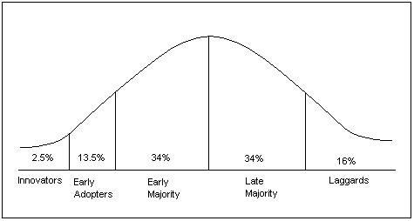
Fig. 1 - Adopter categorization on the basis of innovativeness
Adopter distributions closely approach normality. The above figure shows the normal frequency distributions divided into five categories: innovators, early adopters, early majority, late majority and laggards. Innovators are the first 2.5 percent of a group to adopt a new idea. The next 13.5 percent to adopt an innovation are labeled early adopters. The next 34 percent of the adopters are called the early majority. The 34 percent of the group to the right of the mean are the late majority, and the last 16 percent are considered laggards (Rogers, 1971).
AdopterCategories
Innovators are eager to try new ideas, to the point where their venturesomeness almost becomes an obsession. Innovators’ interest in new ideas leads them out of a local circle of peers and into social relationships more cosmopolite than normal. Usually, innovators have substantial financial resources, and the ability to understand and apply complex technical knowledge. While others may consider the innovator to be rash or daring, it is the hazardous risk-taking that is of salient value to this type of individual. The innovator is also willing to accept the occasional setback when new ideas prove unsuccessful.
Early adopters tend to be integrated into the local social system more than innovators. The early adopters are considered to be localites. People in the early adopter category seem to have the greatest degree of opinion leadership in most social systems. They provide advice and information sought by other adopters about an innovation. The early adopter is usually respected by his or her peers and has a reputation for successful and discrete use of new ideas.
Members of the Early majority category will adopt new ideas just before the average member of a social system. They interact frequently with peers, but are not often found holding leadership positions. As the link between very early adopters and people late to adopt, early majority adopters play an important part in the diffusion process. Their innovation-decision time is relatively longer than innovators and early adopters, since they deliberate some time before completely adopting a new idea. Seldom leading, early majority adopters willingly follow in adopting innovations.
The Late majority are a skeptical group, adopting new ideas just after the average member of a social system. Their adoption may be in response to increasing social pressure. They are cautious about innovations, and are reluctant to adopt until most others in their social system do so first. An innovation must definitely have the weight of system norms behind it to convince the late majority. While they may be persuaded about the utility of an innovation, there must be strong pressure from peers to adopt.
Laggards are traditionalists and the last to adopt an innovation. Possessing almost no opinion leadership, laggards are localite to the point of being isolates compared to the other adopter categories. They are fixated on the past, and all decisions must be made in terms of previous generations. Individual laggards mainly interact with other traditionalists. An innovation finally adopted by a laggard may already be rendered obsolete by more recent ideas already in use by innovators. Laggards are likely to be suspicious not only of innovations, but of innovators and change agents as well.

