HISTORICAL ART IN PAKISTAN

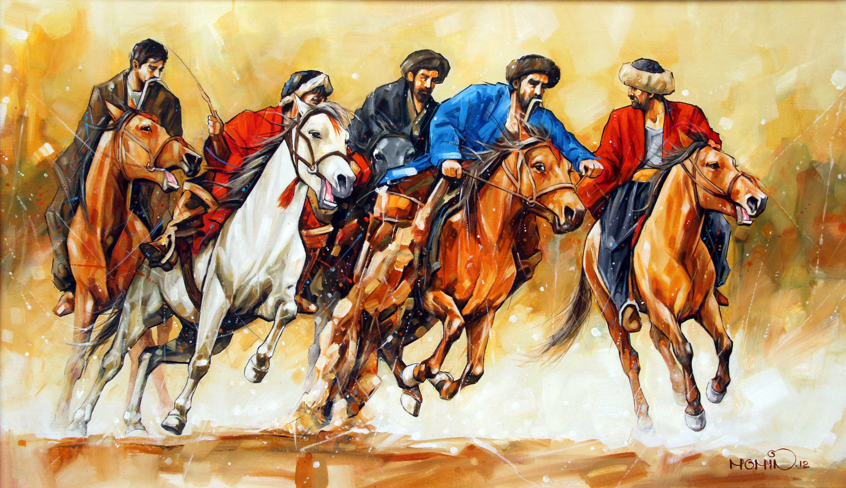

Art as a Cultural Phenomenon
Art is a collective term used to signify a vast array of cultural as well as historic traditions that signify a certain civilization, or era. Art can be considered the single richest phenomenon that distinguishes different aspects of a culture from each other, as well as differentiating it from other cultures prevalent elsewhere in the world. Art is a broad term, and it usually comprises sub-classes including painting, sculpture, music, dance, poetry, calligraphy, performing arts, and other forms of visual art. Thus anything which translates the human emotions or norms of a particular genre or era through the use of expressive mediums like colors, sound, words, and movement; can be classified as art.

History of Art in Pakistan
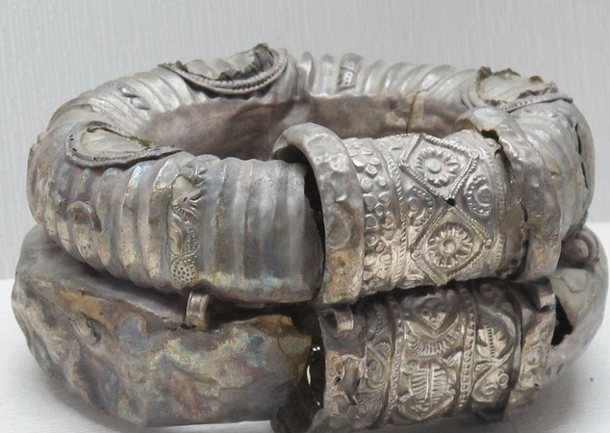Pakistan is a country having roots in historic culture that dates back more than 5000 years and contains reminiscences of the Indus civilization. The artistic influences found in major Pakistani culture are that of Islamic ideology, and also borrows heavily from the Indian subcontinent.
The ancient artifacts found in the city of Moen-Jo-Daro and similar excavations all over the country have yielded that the region was very advanced in day to activities and had a rich culture.
More recent cultural influences are those of Mughal era, which has left its mark on much of our literature, painting, architecture, as well as societal norms as we practice today. The current array of arts in Pakistan is hugely divergent and spans a broad range of trends that are different in individual provinces, cultures and regions of the country.

Famous Artists
There have been many notable artists; sculptor and painters that have given our country much in the way of cultural traditions and in essence; capturing the very soul of the times. Pakistani art galleries are filled with historic as well as modern paintings of breathtaking beauty; comprising landscapes, calligraphy, abstract as well as unconventional art of historic times.
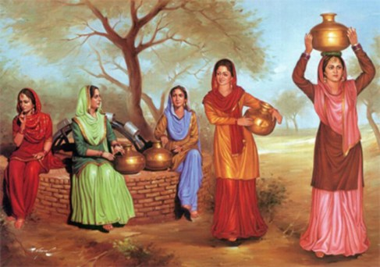
Via maryamdotcom.files.wordpress.com
Among the famous artists of the land include Sufi Waqar, Hal Beyan Petman, Naseeruddin Sheikh, Muhammad Aslam Minhas, Ustad Bashir-ud-din, Ayesha Siddiqui, Sir Hugh Casson, Askari Mian Irani, Moyene Najmi, Raheel Akbar Javed, Naseem Hafeez Qazi, Habib Burkie, Zulqarnain Haider, Anna Molka Ahmad, Zubaida Javed, Bushra Hameed, Ghazanfar Ali, Nusrat Ali, Muhammad Asif, Shakil Ahmad, Collin David, Hasan Shahnawaz Zaidi, Iqbal Ahmed, Durre Wasim, Nazir Ahmed, Iqbal Hussain, Ghulam Mustafa, Gulji, Â Zubaida Agha, Sadequain, and others.
The art scene is Pakistan is one of varied subjects and diverse artists that create striking paintings; calligraphers are much patronized and create traditional design Arabic writings of great elegance as well as modern Urdu phrases. Landscape artists create eye catching designs of physical and abstract nature elements that can relate to human emotion and culture.

Famous Poets
Poetry is also a major factor that contributes to the culture of a society, and Pakistani culture contains rich poetry in all major regional languages including Sindhi, Punjabi, Hindko, Balochi, and Pashto, as well as the national language Urdu. Famous poets of the land include Allama Iqbal, Shah Abdul Latif Bhittai, Sachal Sarmast, Baba Bulhe Shah. Recent poets include Perveen Shakir, Ahmed Faraz, Amjad Islam Amjad, among others.

Musical Heritage of Pakistan
Music has also been one of Pakistanâ€™s cultural heritages, classical music was the predominating niche up until the 1960s, Pakistani music has always drawn its influences from Hindustani music, Ghazal and Qawwalis are the primary historic music of Pakistan and are still enjoyed among literary circles, as well as being featured on local media. The maestros of classical music in Pakistan include Ghulam Ali and Mehdi Hassan. Sufism is also a recurring musical style prevalent in the Pakistani culture; it owes much of its recent popularity to Alam Lohaar and Nusrat Fateh Ali Khan. Traditional musical instruments used in Pakistani classical music include Sitar, Dhol, and Rabab.
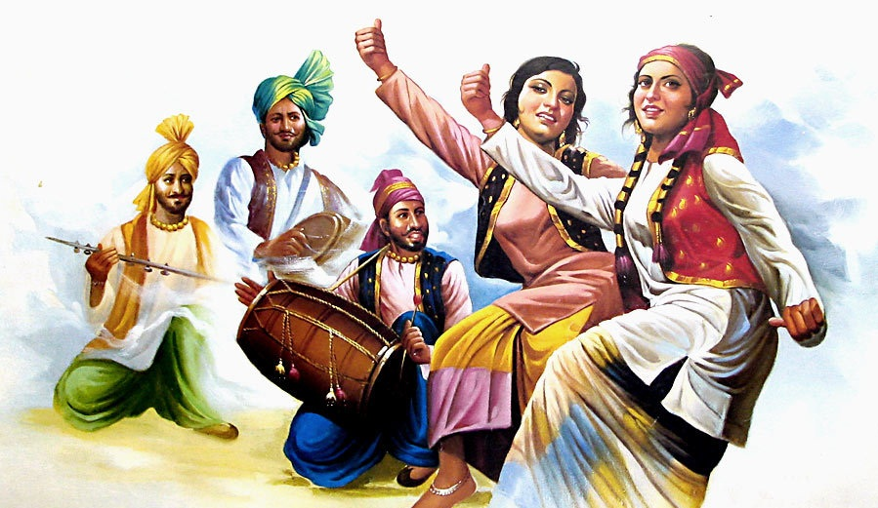
Via www.lexicolatry.com
Much of Pakistanâ€™s modern music developed during the early 1980s when Pop music was first introduced by Nazia Hassan, and soon followed by a burst of musical bands like the Vital Signs, Strings, and Junoon.

Traditional Folk Dances
Folk dances like Kathak are still enjoyed all over Pakistan and are a part of the local culture. There is also other dance traditions signature of various regions.

