- Unit-2: Measurement of Trees

2.1 Diameter Measurement
- A diameter is a straight line passing through the center of a circle or sphere and meeting at each end of circumference or surface.
- The most common diameter measurements taken in forestry are of the main stem of standing trees, cut portions of trees and branches.
- Diameter measurement is important because it is one of the directly measurable dimensions from which tree cross sectional area and volume etc. can be computed.
- The point at which diameters are measured will vary with circumstances.

2.1.1 DBH measurement and its significance
- The most frequent tree measurement made by forester is diameter at breast height (dbh).
- DBH is defined as the average stem diameter outside bark, at a point 1.3 m above ground as measured
- The rational of DBH measurement of individual trees is to estimate the quantity of timber, fuel wood or any other forest products which can be obtained from them.
- These measurement are also necessary for making inventory of growing stock as well as to correlate height, volume, age, increment with most easily determinable dimension i.e. dbh
DBH has been accepted as the standard height for diameter measurement because …
- It is a convenient height for taking measurement.
- It is economic (the base of the tree is generally covered with the grasses and shrubs and even thorns sometimes).
- Majority of the trees develop root swell near the base (abnormalities at the base).
- It gives a uniform point of measurement and standardization is maintained.

2.1.2 Rules of DBH measurement and instruments used

Rules of DBH measurement
- Moss, creepers, lichens and loose bark found on the tree must be removed before measuring the diameter over bark.
- Breast height (BH) should be by means of a measuring stick on standing trees at 1.3m above the ground level.
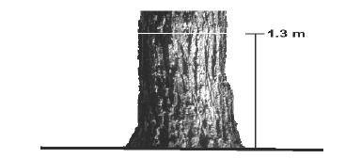

Figure3: Level ground

- BH point should be marked by intersecting vertical and horizontal lines 12 cm long, painted with white paint.

- On sloping land, the diameter at BH should be measured on the uphill side.
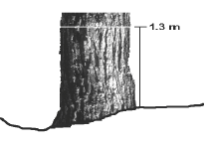
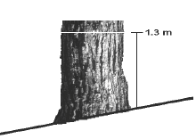

Figure 5: Uneven ground
Figure 4: Sloped ground

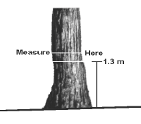
- In case of the tree is leaning, dbh is measured along the tree stem and not vertically, on the side of the lean for trees growing on flat ground and on the uphill side, for trees growing on sloping ground.
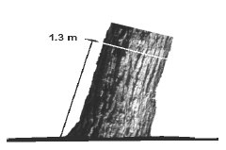
Figure 6: Leaning tree

Figure 7: Crooked tree

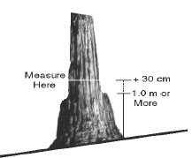
- The dbh should not be measured at 1.3m if the stem is abnormal at the level. BH mark should be shifted up or down as little as possible to a more normal position of the stem and then dia. Measured.
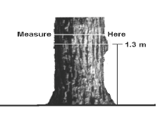

Figure 8: Defect at 1.3m
Figure 9: Buttressed tree

- BH should be taken at the lowest point above which the buttress formation is not likely to extend
- When the tree is forked above the BH, it is counted as one tree, but when it is forked below BH, each fork should be treated as though it were a separate tree.

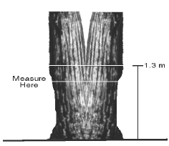
Figure 10: Fork at 1.3 m (1 tree)
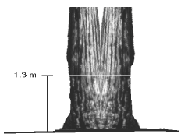
Figure 11: Fork above 1.2 m (1 tree)

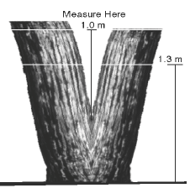
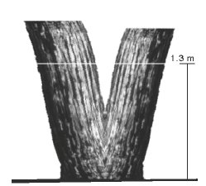

Figure13: Fork below 1.3m (2 trees: alternative method)
Figure 12: Fork below 1.3 m (2 trees)

Diameter measuring instruments
- The most commonly used instruments for measuring diameters at BH are: Diameter tape, calipers, Biltmore stick and other optical instruments.
- Collectively, instruments employed in determining tree diameters are referred to as dendrometers.
Biltmore stick
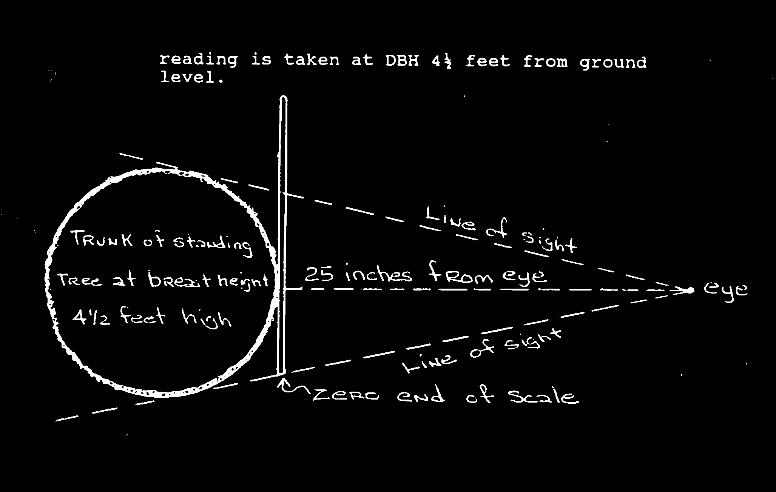
- It is a specially graduated stick used for diameter measurement.
Figure 14: Measuring with a Biltmore stick
- The stick measures a tangent to a circle, from a point, exactly 25 inches from the tree. (The stick is graduated to show the diameter as if it were projected from the user’s eye into the tree.)

- This specially graduated stick is placed against the tree trunk with the diameter scale facing the user. Keep your head 25 inches from the stick, and without moving your head, slide the stick so that the left edge of the stick appears to line up exactly with the left edge of the tree trunk.
- Keep your head stationary, and move your eyes to read the number on the scale those lines up exactly with the right edge of the tree trunk. That number is a reasonable estimate of the diameter of the tree at breast height (DBH).
- If the measurement of the right edge of the tree falls between two numbers on the scale, the lower number is used as the diameter.
- The Biltmore stick tends to be inaccurate on large timber. Trees over 20 inches should be checked with a diameter tape.

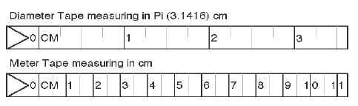
Diameter tape
Figure 15: Tape

- The diameter of a tree cross section may be obtained with a flexible tape by measuring the circumference of the tree and dividing by π(D=C/ π).
- The diameter tapes used by foresters, however are graduated at intervals of π units (in or cm), thus permitting a direct reading of diameter.
- A diameter tape is a measuring tape that has scales on both sides: one side is specially marked to show the diameter of a tree, and the other is a normal scale.
Precautions in using tape
- The tape should not be old.
- It must lie flat against the tree and not in twisted manner.
- It must lie in a perpendicular to the axis of the tree.
- The tape should be taken care of.

Advantage of tape
- Tape is convenient to carry.
- It does not require constant adjustment.
- Only one measurement is needed even with irregular trees.
- Diameter measurement by tape is the easiest in the case of logs lying on ground.
- The errors in case of tape are always positive and systematic.
- Tape negotiates the whole circumference of the tree.
- Tape readings are more consistent.
Disadvantages of tape
- The tape exaggerates the diameter if the tree has rough bark.
- It is somewhat slower to particularly in areas with dense shrub growth.
Difference in tension of the tape due to elasticity affects true diameter.
Calipers
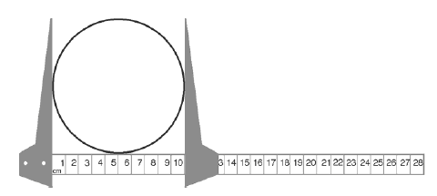
- Calipers are often used to measure tree dbh or when diameters are less than about 60 cm.
Figure 16: Caliper
- A calipers may be constructed of metal, plastic or wood, consists of a graduated beam/rule with two perpendicular arms.
- One arm is fixed at the origin of the scale and the other arm slides. When the beam is pressed against the tree and the arms closed, the beam of the caliper can be read on the scale.
- For an accurate reading, the beam of the caliper must be pressed against the tree with the beam perpendicular to the axis of the tree stem and the arms parallel and perpendicular to the beam.

Diameter measurement using calipers
- Place the calipers over the stem at the required height.
- Record the diameter then take another measurement at a right angle to the first and record this measurement and
- Calculate the average of the two measurements and record to the nearest to 0.1cm.

Precautions in use
- The calipers must be placed on the tree with movable arm well opened and must not be forced on the tree.
- The reading must be taken before the caliper is removed from tree.
- If the cross section of the stem is more or less elliptical, it is necessary to measure two diameters.
- Calipers must be placed at right angles to the axis of the tree.
- The two arms of the caliper must be in contact with the tree and the movable arm should be at right angles to the scale arm.
- Not only should the two arms of the caliper be in contact with the tree but the scale arm must also touch it.

Advantages
- Diameters can be read directly in centimeters and millimeters, thus making the instrument applicable for precise scientific work.
- By pressing the arms against the tree bole, the loose swollen bark is crushed out and irregularity from this source is avoided.
- It is adaptable for use by unskilled labour.
- The errors are both positive and negative and therefore the chances are that they may neutralize to give more accurate results than the tape.

Disadvantages
- They are not accurate when not in adjustment.
- Calipers sufficient in size to measure large trees are very awkward to carry and handle.
- Two measurements have to be taken on every tree to get the correct diameter.
Movable arms often stick when the scale is wet or dirty, thus wasting a lot of time.

