REPRODUCTIVE SYSTEMS IN MAJOR CROP PLANTS

Reproduction in crop plants may be by seeds, sexual, or by vegetative parts, asexual. In sexual reproduction specialized reproductive cells called gametes are formed, a process known as gametogenesis. Fusion of the male and female gametes leads to the development of an embryo and eventually the seed. Crop plants such as corn, wheat, rice, soybean, tomato, or common bean normally reproduce sexually and are multiplied from seeds
In asexual reproduction new plants arise from specialized vegetative organs such as tubers, rhizomes, runners, bulbs, corms, or by various artificial means of propagation such as rooting of plant cuttings, grafting, layering, or tissue culturing. Crops such as sugarcane, potato, bermudagrass, or cassava may reproduce sexually but are normally propagated asexually for commercial use.
Flowers may be Complete containing all four floral organs (sepals, petals, stamens, pistil), or Incomplete, lacking one or more of these floral organs. Complete flowers are borne on cotton, tobacco, rape, potato, cowpea, soybean, common bean, tomato, clovers, alfalfa, cabbage, and many other field and vegetable crop plants (Fig. 2.2A, B, C, and D). Flowers of buckwheat and sugarbeet are incomplete lacking petals and sepals (Fig. 2.3A). Crops belonging to the grass family, including corn, sorghum, millet, wheat, triticale, barley, oat, sugarcane, rice, forage grasses, and turf grasses, have incomplete flowers in which petals and sepals are lacking (Fig. 2.3B). In lespedeza, Cleistogamous flowers, inconspicuous flowers that do not open, are frequently produced on the same plant with normal, showy flowers.

Perfect flowers are bisexual, bearing stamens and a pistil in the same flower structure, but one of these essential organs is absent in Imperfect or unisexual flowers. Most crop plants have perfect flowers, for example, wheat, oat, barley, rye, rice, sorghum, cotton, flax, potato, tobacco, sugar beet, sugarcane, soybean, common bean, tomato, common forage and turf grasses, and forage legumes. Imperfect flowers may be staminate, bearing stamens but no pistil, or pistillate, bearing a pistil but without stamens. The corn plant has staminate flowers in the tassel and pistillate flowers on the shoot. In castor and wild rice, pistillate flowers are commonly borne in the upper portion of the floral structure and staminate flowers in the lower portion. Crop plants in which staminate and pistillate flowers are borne on the same plant, as in corn, cassava, squash, or castor, are monoecious (Fig. 2.4); plants in which the staminate and pistillate flowers are borne on different plants are dioecious (Fig. 2.5A and B). Hemp, hops, buffalograss, papaya, and asparagus are species with dioecious flowers, although occasional hemp or papaya plants may produce monoecious flowers. Imperfect flowers are always incomplete. Some incomplete flowers, such as occur in the grasses or in buckwheat, are perfect because both the stamens and a pistil are present in the same flower although petals or sepals may be missing.

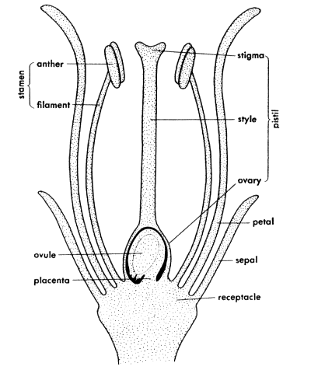

Fig. 2.1.Parts of the flower.

POLLINATION& FERTILIZATION

Seeds are formed within a plant by a succession of steps in the reproductive cycle as illustrated in Fig. 2.6. Within the immature anther are four cavities containing many microspore or pollen mother cells. Each mother cell undergoes two successive nuclear divisions and forms a tetrad of four microspores, each with potential for developing into a mature pollen grain. The microspore is transformed into a mature pollen grain by a thickening of the spore wall and a division of the microspore nucleus to form a tube cell nucleus and a generative nucleus. As the anther matures, the pollen sacs open and the pollen grains are dispersed. The pollen grains are produced in great numbers; from 20 to 50 million may be produced on the tassel of a single plant of corn.

