Statistical Inference: The process of drawing inferences about a population on the basis of information contained in a sample taken from the population is called statistical inference. Statistical inference is divided into two areas: Estimation of parameters and testing of hypothesis.
Testing of hypothesis is a procedure which enables us to decide on the basis of information obtained by sampling whether to accept or reject any specified statement or hypothesis regarding the value of the parameter in a statistical problem.
Steps involved in hypothesis testing
- Formulation of hypotheses (Null and alternative hypothesis)
- Level of significance
- Test statistic
- Calculation
- Critical Region(Acceptance and Rejection region)
- Conclusion

What is a one-tailed test?
Next, let’s discuss the meaning of a one-tailed test. If you are using a significance level of .05, a one-tailed test allots all of your alpha to testing the statistical significance in the one direction of interest. This means that .05 is in one tail of the distribution of your test statistic. When using a one-tailed test, you are testing for the possibility of the relationship in one direction and completely disregarding the possibility of a relationship in the other direction.
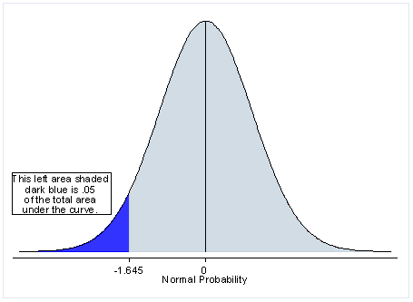

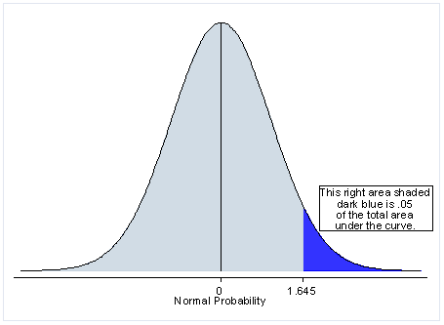

What is a two-tailed test?
First let’s start with the meaning of a two-tailed test. If you are using a significance level of 0.05, a two-tailed test allots half of your alpha to testing the statistical significance in one direction and half of your alpha to testing statistical significance in the other direction. This means that .025 is in each tail of the distribution of your test statistic. When using a two-tailed test, regardless of the direction of the relationship you hypothesize, you are testing for the possibility of the relationship in both directions.
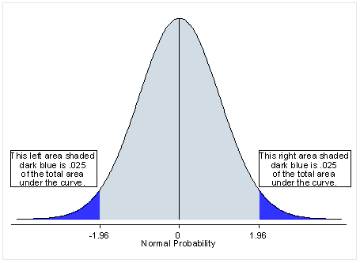
$${A) Null Hypothesis; H}_{0}: μ=μ_{0}$$
$${Alternative Hypothesis;H}_{1}: μ≠μ_{0}$$
One Sided Test Hypothesis
$${B) Null Hypothesis; H}_{0}: μ≥μ_{0}$$
$${Alternative Hypothesis;H}_{1}: μ<μ_{0}$$
$${C) Null Hypothesis; H}_{0}: μ≤μ_{0}$$
$${Alternative Hypothesis;H}_{1}: μ>μ_{0}$$
Type I and type II error
Decision | H₀ is TRUE | H₀ is FALSE
Accept H₀ | OK (Confidence) 1-α | Type II Error  β = probability of Type II Error
Reject H₀ | Type I Error  α = probability of Type I Error | OK (Power) 1-β

Testing of mean when population variance is known
Z- Test for one and Two Samples
Testing of mean when population variance is unknown
T- test for one and two sample
Testing of variances one sample Chi square-test
Testing of two variances F-test
Procedure of Hypothesis Testing
Step 1: Formulation of hypotheses
$${Null Hypothesis; H}_{0}: {σ^{2}}_{1}={σ^{2}}_{2}$$
$${Alternative Hypothesis;H}_{1}: {σ^{2}}_{1}≠{σ^{2}}_{2}$$
Step 2: Level of Significance
$$α=5\%=0.05$$

Step 3: Test Statistic
$$F=\frac{{s^{2}}_{1}}{{s^{2}}_{2}}$$
Step 6: Conclusion OR Decision
$$if F_{cal}>F_{tab} Reject H_{0}$$

Z test for one sample
Step 1: Formulation of hypotheses
$${Null Hypothesis; H}_{0}: μ=μ_{0}$$
$${Alternative Hypothesis;H}_{1}: μ≠μ_{0}$$
Step 2: Level of Significance
$$α=5\%=0.05$$

Step 3: Test Statistic
$$Z=\frac{\overline{X}-μ}{σ/\sqrt{n}}$$
Step 6: Conclusion OR Decision
$$if Z_{cal}>Z_{tab} Reject H_{0}$$
______________________________________________________________
T test for one sample
Step 1: Formulation of hypotheses
$${Null Hypothesis; H}_{0}: μ=μ_{0}$$
$${Alternative Hypothesis;H}_{1}: μ≠μ_{0}$$
Step 2: Level of Significance
$$α=5\%=0.05$$

Step 3: Test Statistic
$$t=\frac{\overline{X}-μ}{s/\sqrt{n}}$$
Step 6: Conclusion OR Decision
$$if t_{cal}>t_{tab} Reject H_{0}$$

Step 1: Formulation of hypotheses
${Null Hypothesis; H}_{0}: μ_{1}=μ_{2}$
$${Alternative Hypothesis;H}_{1}: μ_{1}≠μ_{2}$$

$$t=\frac{\left(\overline{X}-{\overline{X}}_{2}\right)-\left(μ_{1}-μ_{2}\right)}{s_{p}\sqrt{\frac{1}{n_{1}}+\frac{1}{n_{2}}}}$$
$${s^{2}}_{p}=\frac{\left(n_{1}-1\right){s^{2}}_{1}+\left(n_{2}-1\right){s^{2}}_{2}}{n_{1}+n_{2}-2}$$
$$Z=\frac{\left(\overline{X}-{\overline{X}}_{2}\right)-\left(μ_{1}-μ_{2}\right)}{\sqrt{\frac{σ_{1}^{2}}{n_{1}}+\frac{σ_{2}^{2}}{n_{2}}}}$$

Step 4: Calculations
Step 5: Critical Region Acceptance or Rejection Region
Tabulated values (for Z test)
Significance level $α$ | Two-tailed test | One-tailed test
0.10 (10%) | $$±1.645=z_{α/2}$$ | $$±1.28=z_{α}$$
0.05 (5%) | $$±1.96$$ | $$±1.645$$
0.01 (1%) | $$±2.58$$ | $$±2.33$$

Step 6: Conclusion OR Decision
$$if t_{cal}>t_{tab} Reject H_{0}$$

d.f (one sample)= n-1

d.f (two sample)= $n_{1}+n_{2}-2$= 6+7-2=11

