Topic: Lipids, their Properties, Classification & Simple Lipids

Chapter 1

Cell Biology

Lipids:
“Lipids are a family of organic compounds that are mostly insoluble in water. Composed of fats and oils, lipids are molecules that yield high energy and have a chemical composition mainly of carbon, hydrogen, and oxygen.”
Introduction:
- The word lipid is derived from a Greek word “lipos” which means fat.
- They naturally occur in most plants, animals, microorganisms and are used as cell membrane components, energy storage molecules, insulation, and hormones.
- Lipids are made of the elements Carbon, Hydrogen and Oxygen, but have a much lower proportion of water than other molecules such as carbohydrates.
- Unlike polysaccharides and proteins, lipids are not polymers—they lack a repea­ting monomeric unit.
- Specific gravity of lipid is 0.8.
- Lipids are soluble in non-polar solvents. Non-polar solvents are typically hydrocarbons used to dissolve other naturally occurring hydrocarbon lipid molecules that do not (or do not easily) dissolve in water, including fatty acids, waxes, sterols, fat-soluble vitamins (such as vitamins A, D, E, and K), monoglycerides, diglycerides, triglycerides, and phospholipids.
- Lipids are mainly composed of hydrocarbons in their most reduced form, making them an excellent form of energy storage, as when metabolized the hydrocarbons oxidize to release large amounts of energy. The type of lipid found in fat cells for this purpose is a triglyceride, an ester created from glycerol and three fatty acid.

Properties:
Following are the main properties of lipids:
- Solubility:
Lipids are chemically diverse group of organic compounds which are insoluble in water. They are soluble in non-polar solvents such as ether, chloroform and benzene etc.
- Insulation:
Lipids also provide insulation from the environment for plants and animals. For example, they help keep aquatic birds and mammals dry because of their water-repelling nature. Fats are important for heat insulation as well. Many marine mammals have layer of fat called blubber to keep them warm.
- Source of Energy:
Lipids contain high energy C-H bonds. They are chief source of energy, they provide 6-fold as much energy as an equivalent mass of glycogen. Similarly, they provide double energy as compared to the same amount of carbohydrates. Fat and oils are the principle stored forms of energy in many organisms.
- Fatty Acids:
Lipids are basically composed of fatty acids. The fatty acids may contain up to thirty-six carbon atoms, a carboxyl group (-COOH) at one end. Fatty acids with single bond are saturated fatty acids. And fatty acids with one or more double bonds are unsaturated fatty acids.
- Triglycerides:
When fatty acids and glycerol combined together by Condensation process, triglyceride is formed by releasing water.
3 fatty acids + Glycerol Triglyceride + H2O

- Hydrolysis of triglycerides:
Triglycerides like any other esters react with water to form their carboxylic acid and alcohol– a process known as hydrolysis.
- Saponification:
Triglycerides may be hydrolyzed by several procedures, the most common of which utilizes alkali or enzymes called lipa­ses. Alkaline hydrolysis is termed saponification because one of the products of the hydrolysis is a soap, generally sodium or potassium salts of fatty acids.
- Hydrogenation:
The carbon-carbon double bonds in unsaturated fatty acids can be hydrogenated by reacting with hydrogen to produce saturated fatty acids.
- Halogenation
Unsaturated fatty acids, whether they are free or combined as esters in fats and oils, react with halogens by addition at the double bond(s). The reaction results in the decolorization of the halogen solu­tion.
- Rancidity:
The term rancid is applied to any fat or oil that develops a disagreeable odor. Hydrolysis and oxidation reactions are responsible for causing rancidity. Oxidative rancidity occurs in triacylglycerols containing unsaturated fatty acids.
Classification:
Lipids are classified into following groups:
- Simple Lipids
- Compound Lipids
- Terpenoids

Simple Lipids:
“These consist of long chain fatty acids which may be either free or combined with an alcohol by an ester linkage.”
- These lipids belong to a heterogeneous class of predominantly nonpolar compounds, mostly insoluble in water, but soluble in nonpolar organic solvents such as chloroform and benzene.
- Hydrolysis of these lipids yields glycerol and fatty acids, sterols and fatty acids, and fatty alcohols plus fatty acids, respectively.
- Simple lipids are of two types:
- Triglycerides (Fats and Oils)
- Waxes

- Triglycerides (Fats and Oils):
The major form of fat stored by the body. A triglyceride consists of three molecules of fatty acid combined with a molecule of the alcohol glycerol.
- A fat molecule consists of two kinds of parts: a glycerol backbone and three fatty acid tails. Glycerol is a small organic molecule with three hydroxyl (OH) groups, while a fatty acid consists of a long hydrocarbon chain attached to a carboxyl group.
- A typical fatty acid contains 12–18 carbons, though some may have as few as 4 or as many as 36.
- To make a fat molecule, the hydroxyl groups on the glycerol backbone react with the carboxyl groups of fatty acids in a dehydration synthesis reaction. This yields a fat molecule with three fatty acid tails bound to the glycerol backbone via ester linkages (linkages containing an oxygen atom next to a carbonyl, or C=O, group).
- Triglycerides may contain three identical fatty acid tails, or three different fatty acid tails (with different lengths or patterns of double bonds).

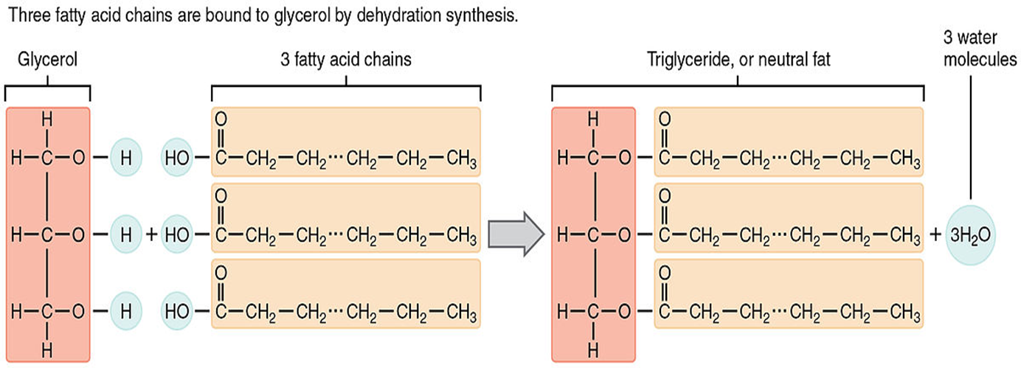

- Fat molecules are also called triacylglycerols, or, in bloodwork done by your doctor, triglycerides. In the human body, triglycerides are primarily stored in specialized fat cells, called adipocytes, which make up a tissue known as adipose tissue. Adipocytes are abundantly found under the skin, in the abdominal cavity and in the mammary glands.
- Triglycerides can be stored in quantities, sufficient to supply the energy needs of the body for many months, as in the case of obese persons.
- While many fatty acids are found in fat molecules, some are also free in the body, and they are considered a type of lipid in their own right.
- They constitute about 98% of total dietary lipids ; the remaining 2% consists of phospholipids and cholesterol and its esters.
- Like all the other large biological molecules, fats in the right amounts are necessary to keep your body (and the bodies of other organisms) functioning correctly.
- Elevated triglyceride levels are considered to be a risk factor for atherosclerosis (hardening of the arteries) because many of the triglyceride-containing lipoproteins that transport fat in the bloodstream also transport cholesterol, a known contributor to atherosclerosis.
- The charges are evenly distributed around the molecule so hydrogen bonds to not form with water molecules making them insoluble in water.

Saturated and unsaturated fatty acids:
The three fatty acid tails of a triglyceride need not be identical to each other. Fatty acid chains may differ in length, as well as in their degree of unsaturation.
- If there are only single bonds between neighboring carbons in the hydrocarbon chain, a fatty acid is said to be saturated. (The thing that fatty acids are saturated with is hydrogen; in a saturated fat, as many hydrogen atoms as possible are attached to the carbon skeleton.)
- When the hydrocarbon chain has a double bond, the fatty acid is said to be unsaturated, as it now has fewer hydrogens. If there is just one double bond in a fatty acid, it’s monounsaturated, while if there are multiple double bonds, it’s polyunsaturated.
- Most animal fats such as those from meat, milk and eggs are relatively rich in saturated fatty acids but contain a rather low content of polyunsaturated fatty acids; two exceptions are chicken fat and fish fat.
- The plant fats contain a large proportion of unsaturated fatty acids (esp., polyunsaturated). The unsaturated fatty acids have low melting point and confer liquid state to the plant fats
- The double bonds in unsaturated fatty acids, like other types of double bonds, can exist in either a cis or a trans configuration.
- In the cis configuration, the two hydrogens associated with the bond are on the same side.
- While in a trans configuration, they are on opposite sides (see below). A cis double bond generates a kink or bend in the fatty acid, a feature that has important consequences for the behavior of fats.

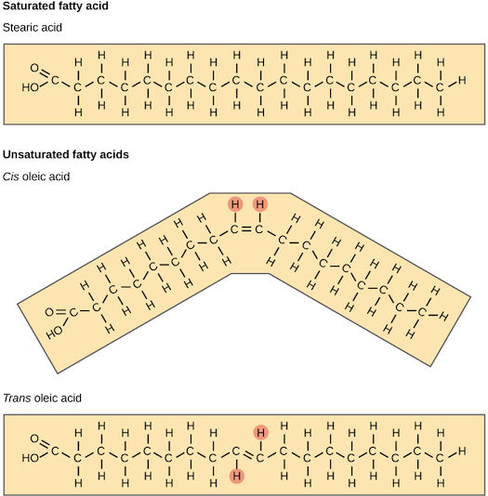

- Saturated fatty acids tails are straight, so fat molecules with fully saturated tails can pack tightly against one another. This tight packing results in fats that are solid at room temperature (have a relatively high melting point). For instance, most of the fat in butter is saturated fat.
- In contrast, cis-unsaturated fatty acid tails are bent due to the cis double bond. This makes it hard for fat molecules with one or more cis-unsaturated fatty acid tails to pack tightly. So, fats with unsaturated tails tend to be liquid at room temperature (have a relatively low melting point) – they are what we commonly call oils. For instance, olive oil is mostly made up of unsaturated fats.

Waxes:
Biological waxes are esters of long-chain (C14 to C36) saturated and unsaturated fatty acids with long-chain (C16 to C30) alcohols.
- Their melting points (60 to 100 C) are generally higher than those of triacylglycerols.
- Waxes are unusually inert due to their saturated nature of the hydrocarbon chain.
- They can be split slowly with hot alcoholic KOH.
- Natural waxes may contain unsaturated bonds and include various functional groups such as fatty acids, primary and secondary alcohols, ketones, aldehydes and fatty acid esters.
- Synthetic waxes often consist of homologous series of long-chain aliphatic hydrocarbons (alkanes or paraffins) that lack functional groups.
Plant and animal waxes
Waxes are synthesized by many plants and animals.
- Those of animal origin typically consist of wax esters derived from a variety of fatty acids and carboxylic alcohols.
- In waxes of plant origin, characteristic mixtures of unesterified hydrocarbons may predominate over esters. The composition depends not only on species, but also on geographic location of the organism.
- Wax covers the feathers of some aquatic birds and the leaf surfaces of some plants, where its hydrophobic (water-repelling) properties prevent water from sticking to, or soaking into, the surface. This is why water beads up on the leaves of many plants, and why birds don’t get soaked through when it rains.
Animal Waxes:
The best-known animal wax is beeswax used in constructing the honeycombs of honeybees, but other insects also secrete waxes. A major component of the beeswax is myricyl palmitate which is an ester of triacontanol and palmitic acid. Its melting point is 62-65 °C.
- Spermaceti occurs in large amounts in the head oil of the sperm whale. One of its main constituents is cetyl palmitate, another ester of a fatty acid and a fatty alcohol. Lanolin is a wax obtained from wool, consisting of esters of sterols.
- Lanolin (from lamb’s wool), beeswax, carnauba wax (from a Brazilian palm tree), and wax extracted from spermaceti oil (from whales) are widely used in the manufacture of lotions, ointments, and polishes.
- Triacontanoylpalmitate, the major component of beeswax, is an ester of palmitic acid with the alcohol triacontanol as shown below:
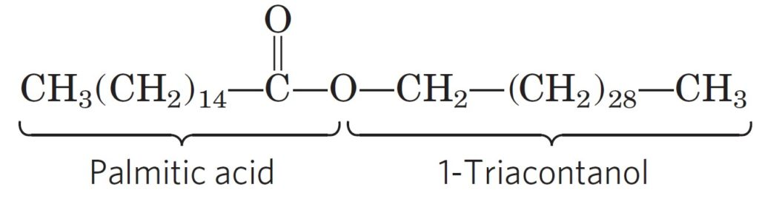

Plant waxes:
Plants secrete waxes into and on the surface of their cuticles as a way to control evaporation, wettability and hydration. The epicuticular waxes of plants are mixtures of substituted long-chain aliphatic hydrocarbons, containing alkanes, alkyl esters, fatty acids, primary and secondary alcohols, diols, ketones and aldehydes.
- From the commercial perspective, the most important plant wax is carnauba wax, a hard wax obtained from the Brazilian palm Copernicia prunifera. Containing the ester myricyl cerotate, it has many applications, such as confectionery and other food coatings, car and furniture polish, floss coating, and surfboard wax.
- Other more specialized vegetable waxes include jojoba oil, candelilla wax and ouricury wax.
- The shiny leaves of holly, rhododendrons, poison ivy, and many tropical plants are coated with a thick layer of waxes, which prevents excessive evaporation of water and protects against parasites.
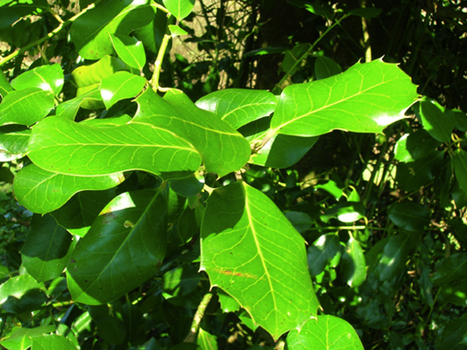

The End

MCQs:
- Lipids are highly energetic due to:
- Carboxyl group
- C-H bond
- C-O bond
- Double bonds
- Which of these is not a lipid?
- Candelilla
- Tau
- Ouricury
- Spermaceti
- Carnauba wax is:
- Soft wax
- Liquid wax
- Hard wax
- Animal wax
- The specific gravity of lipid is:
- 1.5
- 1.0
- 0.8
- 0.2
- Fat storing cells are called:
- Melanocytes
- Adipocytes
- Thrombocytes
- Hepatocytes
- Esters of fatty acids with higher alcohols other than glycerol are said to be:
- Waxes
- Fats
- Both of the above
- None of the above
- Hydrolysis of fat by alkali is called:
- Rancidity
- Saponification
- Both of the above
- None of the above.
- Triacylglycerols are:
- Soluble in water
- Insoluble in water
- Soluble in water at elevated temperature
- Partially soluble in water
- Atherosclerosis can cause blood
- Thinning
- Clotting
- Thickening
- None of these
- Unsaturated lipids are derived from:
- Humans
- Plants
- Aquatic animals
- None of these

