Experiment No-3
To implement and verify voltage divider in series circuit and current divider in parallel circuit.

OBJECTIVE:
Verify the divider rules for voltage (VDR) and current (CDR).
APPARATUS:
1. Power Supply 2. Resistances 3. Digital Multi-Meter (DMM)
4. Connecting Wires 5. Bread Board

THEORY:
Voltage Divider Rule (VDR)
The Voltage Divider Rule (VDR) states that the voltage across an element or across a series combination of elements in a series circuit is equal to the resistance of the element or series combination of elements divided by the total resistance of the series circuit and multiplied by the total impressed voltage or we can say the voltage is divided between two resistors which are connected in series in direct proportion to their resistance. Equation below is used for the calculation of voltage across a particular resistor.
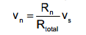
The voltage divider rule is a simple and most important electronic circuit, which is used to change a large voltage into a small voltage. Using just an input voltage and two series resistors we can get an output voltage. Here, output voltage is a fraction of input voltage. The best example for voltage divider is two resistors are connected in series. When input voltage is applied across the pair of the resistor and the output voltage will appear from the connection between them. Generally, these dividers are used to reduce the magnitude of the voltage or to create reference voltage and also used at low frequencies as a signal attenuator. For DC and relatively low frequencies, a voltage divider may be appropriately perfect if made only of resistors; where frequency response is required over a wide range.
Fig. 3.1 Voltage Divider Circuit

Current Divider Rule (CDR)
The Current Divider Rule (CDR) states that the current through one of two parallel branches is equal to the resistance of the other branch divided by the sum of the resistances of the two parallel branches and multiplied by the total current entering the two parallel branches. That is,
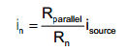
It is equally useful to consider how current divides across parallel resistors. We can calculate Req for a set of parallel resistors. For the circuit shown below:

Fig. 3.2 Current Divider Circuit
Thus, current entering a set of parallel resistors splits such that more current passes through the less resistive path. Note that if one of these resistors is a short (R = 0), all of the current will pass through that resistor.

PROCEDURE:
Part 1: Voltage Divider Rule (VDR)
Construct the circuit
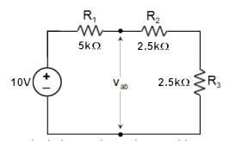
Without making any calculations, what value would you expect for the voltage across each resistor? Explain your reasoning.

Calculate V1 using the VDR with the measured resistor values. Measure V1 and determine the percent difference between the theoretical and experimental results. How do they compare?

If R2 = R3, then the VDR states the V2 = V3 and V1 = V2 + V3. Measure voltages V2 and V3, and comment on the validity of these statements.

Part 2: Current Divider Rule (CDR)
Construct the circuit
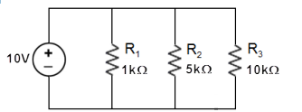

Without making any calculations, what value would you expect for the current through each of the resistors? Explain your reasoning.

Calculate the currents I1, I2, and I3 using the CDR from the measured value of Is. Measure the currents I1, I2, and I3.

Conclusion:

Comments:

