Electron Transport and Oxidative Phosphorylation

• | Final stages of aerobic oxidation of biomolecules in eukaryotes occur in the mitochondrion | Mitochondrial Electron Transport  - How did we get here?  - Summary of glycolysis
- Reduced coenzymes NADH glucose + 2 NAD⁺ + 2P_{i} + 2ADP → 2 pyruvate + 2ATP + 2NADH + 2H⁺
and FADH₂ from: | • | Summary of the citric acid cycle (including pyruvate dehydrogenase)
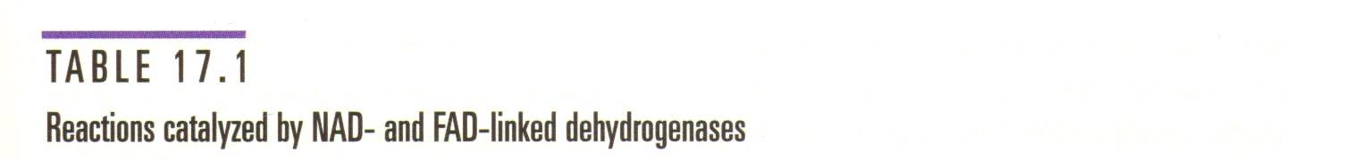
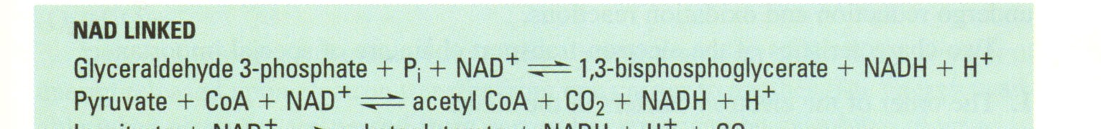
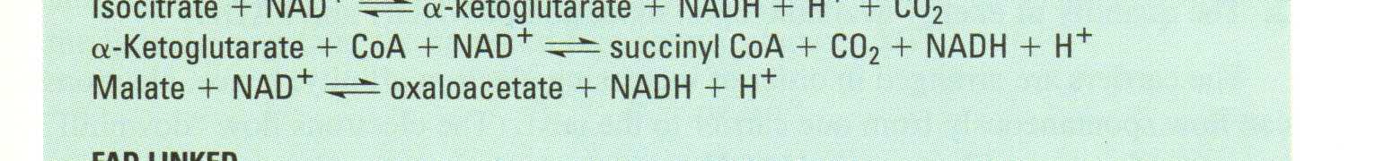
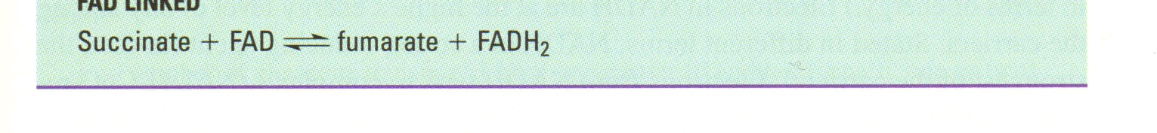
  - Aerobic oxidation of pyruvate + 4 NAD⁺ + FAD + GDP + 2 H₂0 → 3 CO₂ + 4NADH + 4H⁺ + P_{i} + GTP + FADH₂ pyruvate by the citric acid cycle
  - Oxidation of fatty acids and amino acids
FADH₂ are oxidized and a proton | Electron Transport and Oxidative Phosphorylation
Electron Transport Chain is the process by which NADH and gradient is formed.
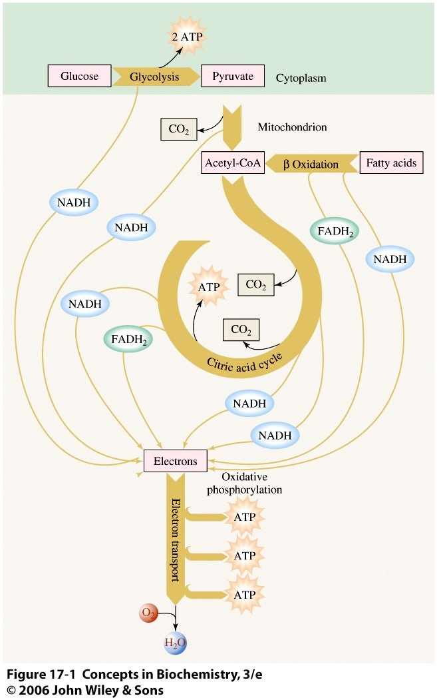
Oxidative phosphorylation is the process of making ATP by using the proton gradient generated by the ETC.
Respiration by mitochondria
- Oxidation of substrates is coupled to the .phosphorylation of ADP
- Respiration (consumption of oxygen) proceeds only when ADP is present
- The amount of O₂ consumed depends upon the amount of ADP added

Location of mitochondrial complexes
- Inner mitochondrial membrane:
  - Electron transport chain: oxidizes reduced coenzymes
  - ATP synthase: machinery to synthesize ATP

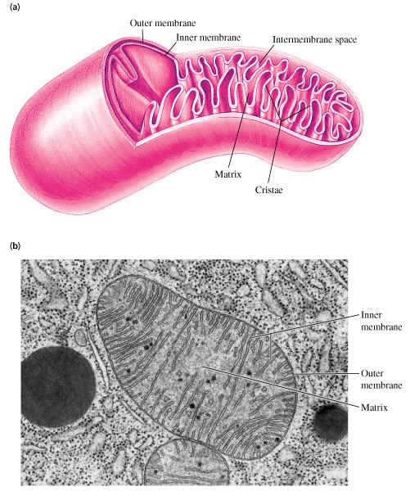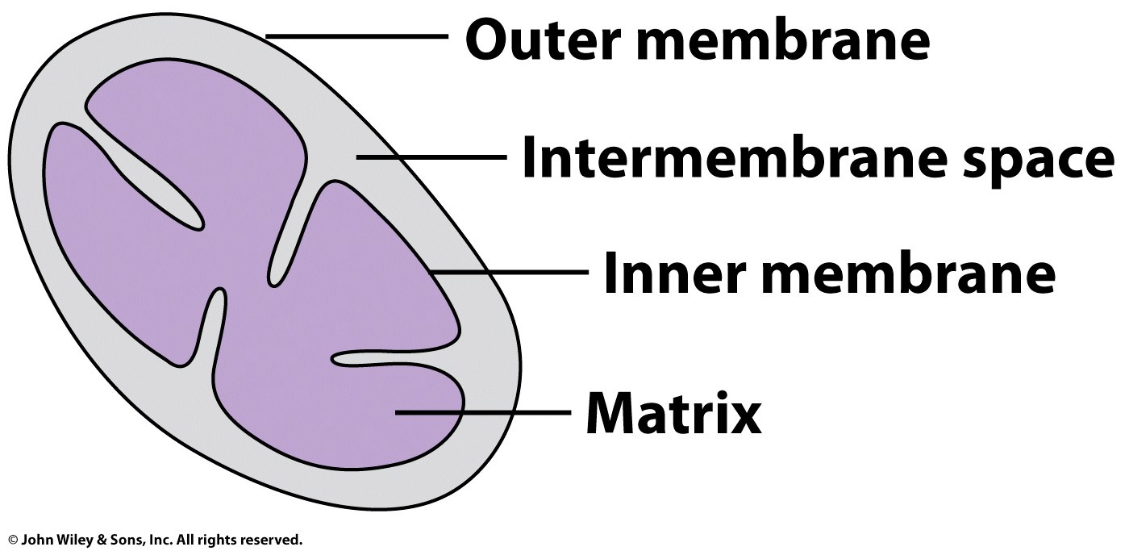
Electron transport

and
oxidative phosphorylation

capture the energy in the redox potential of NADH and
FADH
2

–

2
separate

processes that are
COUPLED

to
result in ATP production

Extensive folding of IMM provides a large surface area on
the matrix side to form lots of assemblies of proteins to
maximize ATP production

- Respiratory electron-transport chain (ETC) Series of enzyme complexes embedded in the inner mitochondrial membrane, which oxidize NADH and FADH₂. Oxidation energy is used to transport protons creating a proton gradient – protons pumped from matrix to intermembrane space across IMM

- ATP synthase uses the proton gradient energy to produce ATP; It is the release of the energy in the gradient back through the membrane through the protein ATP Synthase that drives ATP synthesis
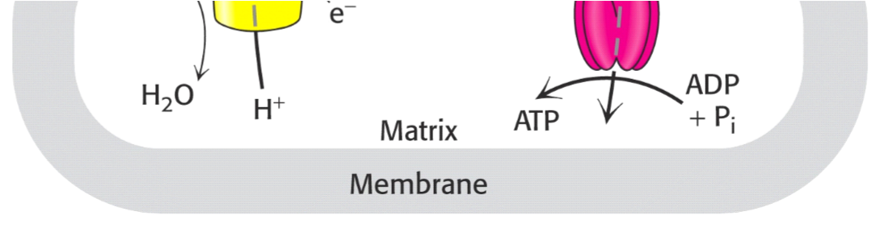
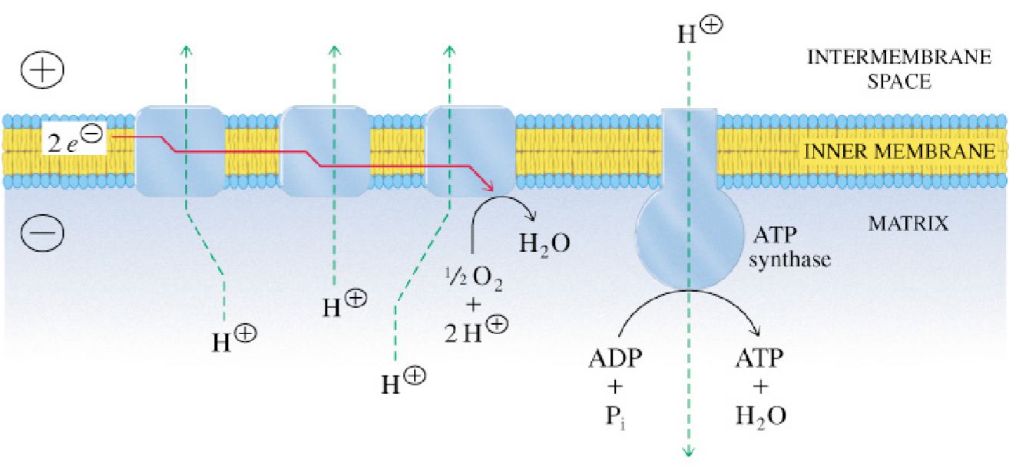
Overview of electron transport chain and oxidative phosphorylation

Electron transport chain (ETC)

  - Series of sequential oxidation/reduction (redox) reactions
  - Finally see role of oxygen
  - Passes electrons from NADH or FADH₂ to O₂ producing H₂O through a series of protein complexes (source of metabolic water!)
  - Since NAD⁺ and FAD are in limited supply, they must be recycled.

- FOUR protein complexes in the IMM make up the ETC
- Complexes I, II, III, IV
- Work together in succession to catalyze redox reactions
- Electrons are transferred to molecular oxygen that is Recycling is accomplished by oxidation and then reduced to water transfer of electrons to oxygen.
Complex I  • Electrons from FADH₂ enter at  Complex II | 2 2 2  NAD⁺ and FAD are then available for additional oxidative metabolism. The energy released during electron transport is coupled to ATP synthesis.
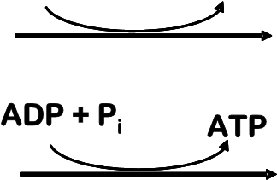
- Electrons move through the _{ADP + P}i ATP complexes in order ⁺ + 1/2 O₂NAD⁺ + H₂O
NADH + H
  - Electrons from NADH enter at
FADH + 1/2 OFAD + H O
  - Flow of electrons is spontaneous and thermodynamically favorable because the next carrier has greater affinity for electrons than the previous
  - In each reaction, an electron donor is oxidized and an electron acceptor is reduced
– Areduced + Boxidized ↔ Aoxidized + Breduced
- Compounds differ from one another in how readily they will be oxidized or reduced
  - can be compared using Eo’ (volts)
  - starting with 1 M “A” and 1 M “B”, the component with most positive (low) redox potential will be reduced and the component with the most negative (high) reduction potential will be oxidized
  - Electrons flow downhill – spontaneously moving from molecules that are strong electron DONORS to strong electron ACCEPTORS = move from high energy state to low energy state – 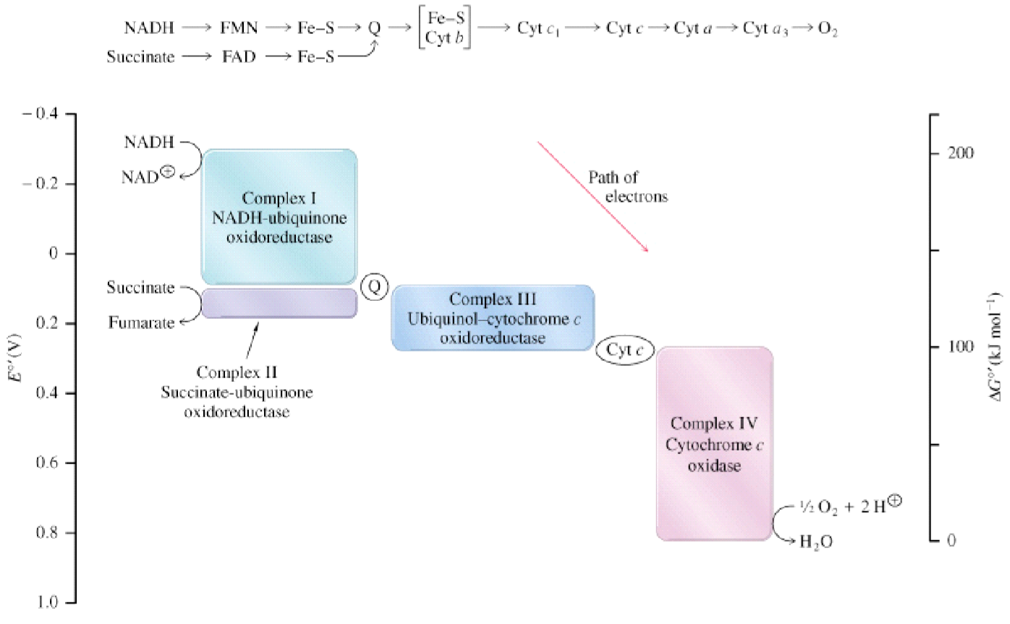

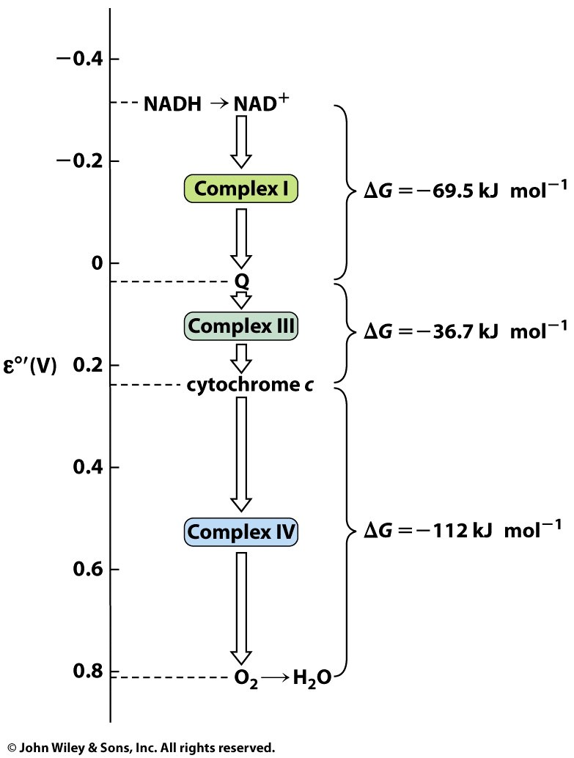
- NADH = strongest donor
- O₂ = strongest acceptor
- The redox potential energy of NADH is released stepwise via the electron transport chain
- The flow of electrons results in energy that is released in increments through the ETC
- Energy is used to pump protons (H⁺) across the inner mitochondrial membrane (IMM) and set up the pH gradient
- It is the release of the energy in the gradient back through the membrane through the intergral membrane protein ATP Synthase that drives ATP synthesis

Co-factors in Electron Transport
- Complexes contain enzymes with electron carrying groups or oxidation – reduction components
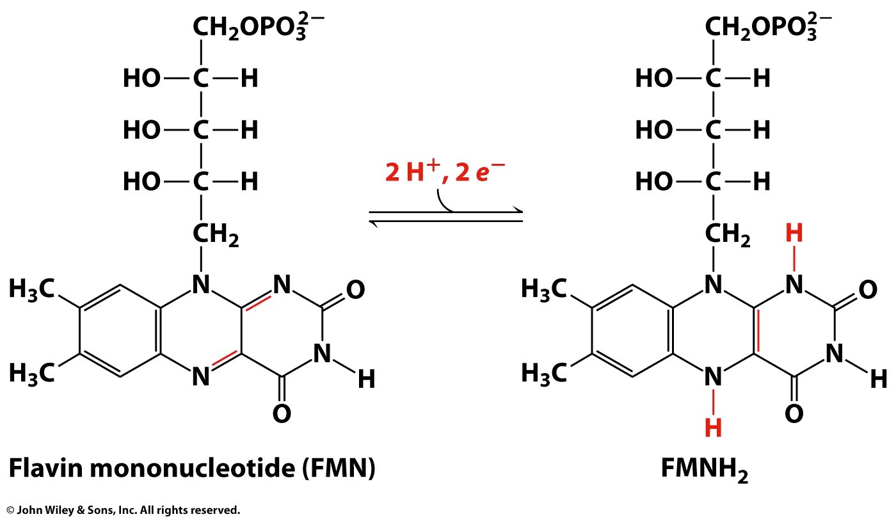
- Protein components use metalcontaining prosthetic groups or flavins to carry electrons
- Metal-containing groups such as iron-sulfur clusters, copper ions, hemes
- Flavins:
- (Complex I) FMN - FMNH₂ • (Complex II) FAD - FADH₂

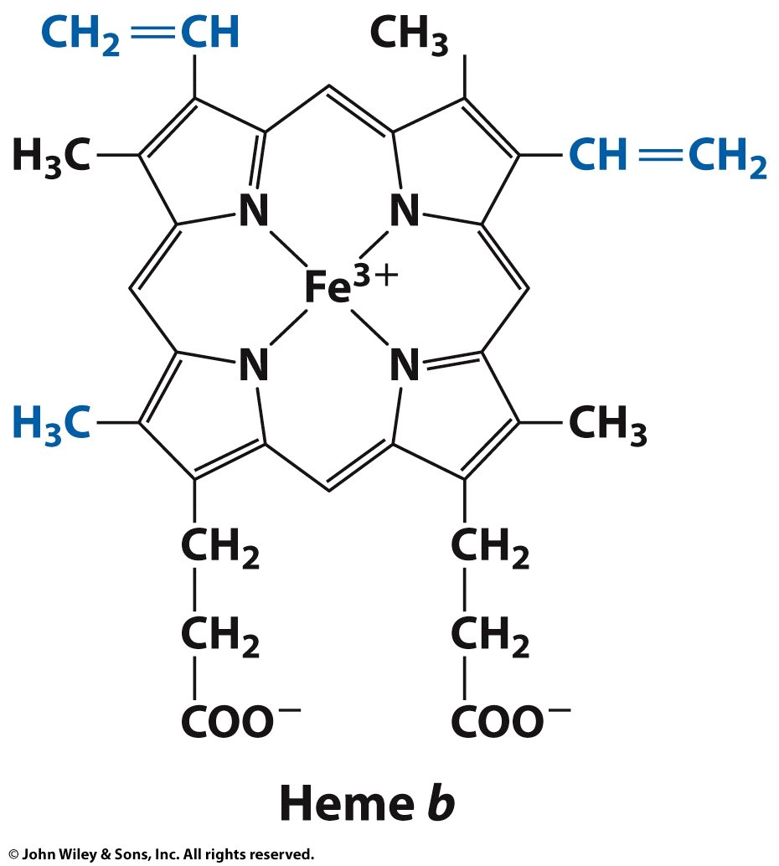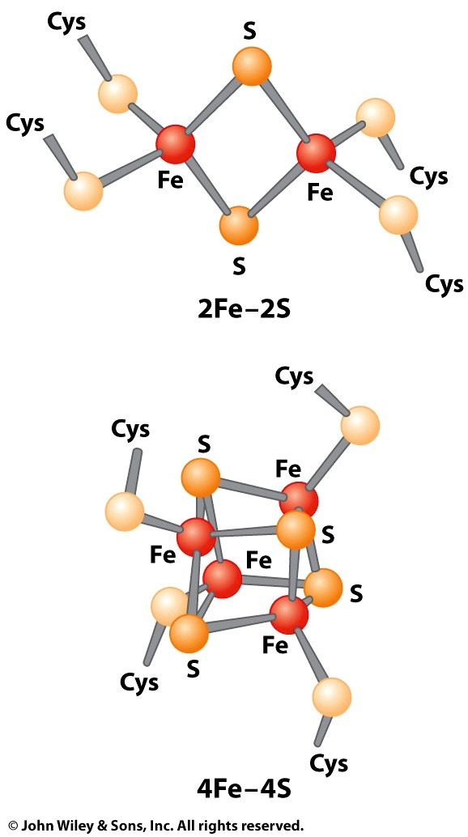

Mobile electron carriers – serve as links between ETC complexes
- Ubiquinone (Q)
  - Also called coenzyme Q
  - A membrane-soluble low molecular weight compound
  - Long hydrophobic tail keeps Q anchored in the mitochondrial inner membrane
  - Q is a lipid soluble molecule that diffuses within the lipid bilayer, and shuttles electrons from Complexes I and II and pass them to III
  - Not a part of any complex

- Cytochrome c
  - A peripheral membrane protein associated with the outer face of the membrane, transports electrons from III to IV
  - Cytochromes are heme-containing proteins – contains Fe
  - Not a part of any complex
  - Shuttles electrons and protons from Complex III
to Complex IV Structure of cytochrome c heme group.
Overview of Electron Transport
  - The electron transport chain is associated with the mitochondrial inner membrane
  - Complexes I-IV contain multiple cofactors, and are involved in electron transport
  - OVERALL TRANSFER OF 2 ELECTRONS FROM NADH THROUGH ETC TO MOLECULAR OXYGEN:
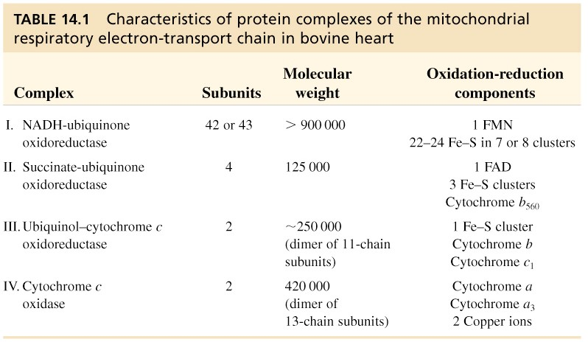
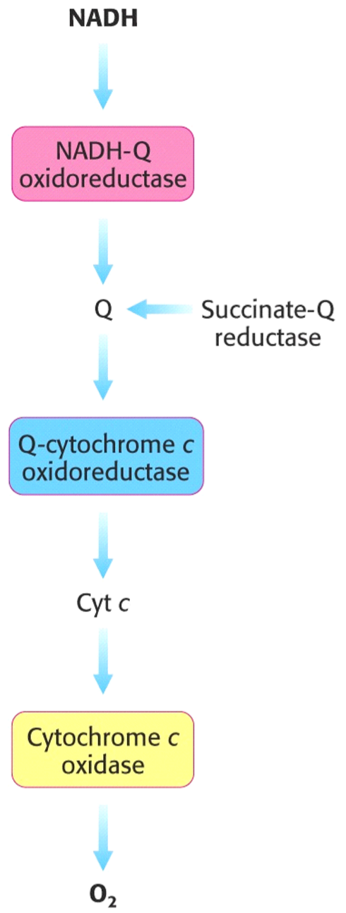
+ +
NADH + H

+
½
O
2

→→

NAD

+
H
2
O

Complexes I

–

where NADH electrons enter the chain

Complex II
–

Where FADH
2

electrons enter the chain

Electrons passed from
Complex I or II to Coenzyme Q

Coenzyme Q

shuttles electrons to
complex III

Complex III

shuttles electrons to
cytochrome C

Cytochrome C

shuttles electrons to
Complex IV

•
•
•
•
•
•
  - Complex IV transfers electrons to O₂ which is then reduced to water
  - Flow through Complexes I, III and IV release energy which is used to pump protons across the IMM and form a “proton gradient”
  - Proton gradient has lots of potential energy
  - When the energy is released (protons flow back into matrix through ATP synthase), the energy drives ATP synthesis

Electron transfer and proton flow in Complex I
- Also called NADH-ubiquinone oxidoreductase
- Complex I includes a flavoprotein (contains FMN – related to FAD) and proteins with Fe-S centers (iron-sulfur clusters)
- These proteins provide two centers for oxidation reduction reactions
- Transfers electrons from NADH to Coenzyme Q via FMN and iron-sulfur proteins
- NADH transfers a two electrons as a hydride ion (H:-) to FMN
- Reduction of Q to QH₂ requires 2 e-
- About 4 H+ translocated per 2 e- transferred
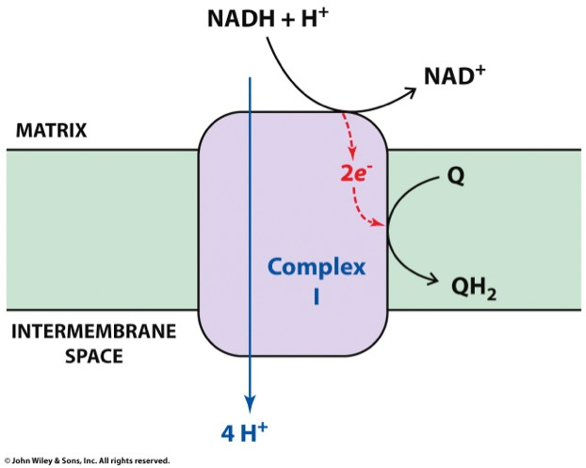

Electron transfer in Complex II
- Succinate-ubiquinone oxidoreductase
- Same as succinate dehydrogenase, a component of the TCA cycle
- Succinate dehydrogenase
- Directs transfer of electrons from succinate to CoQ via FADH₂.
- Catalyzes the reduction of Q to QH₂
- Acyl-CoA dehydrogenase
- From β-oxidation of fatty acids. It also transfers electrons to CoQ via FADH₂.

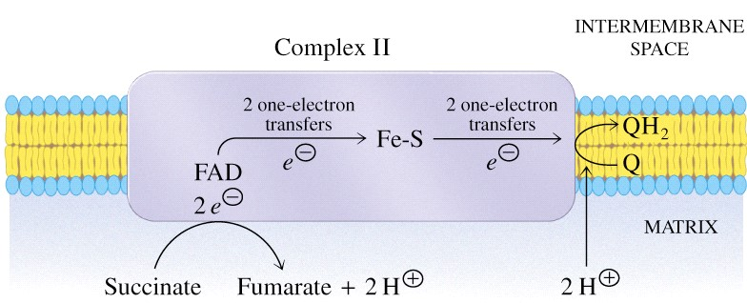

- Complex II proteins provide two centers for oxidation reduction reactions
- FAD → FADH₂
- Fe³⁺ → Fe²⁺ (iron-sulfur cluster)
- FAD of Complex II is reduced in a 2-electron transfer of a hydride ion from succinate
- Complex II does NOT contribute to proton gradient, but supplies electrons from succinate
**Note that all electrons from FADH₂ and NADH must pass through CoQ.**

Electron transfer and proton flow in Complex III
- Ubiquinol-cytochrome c oxidoreductase
- Transfers electrons to cytochrome c

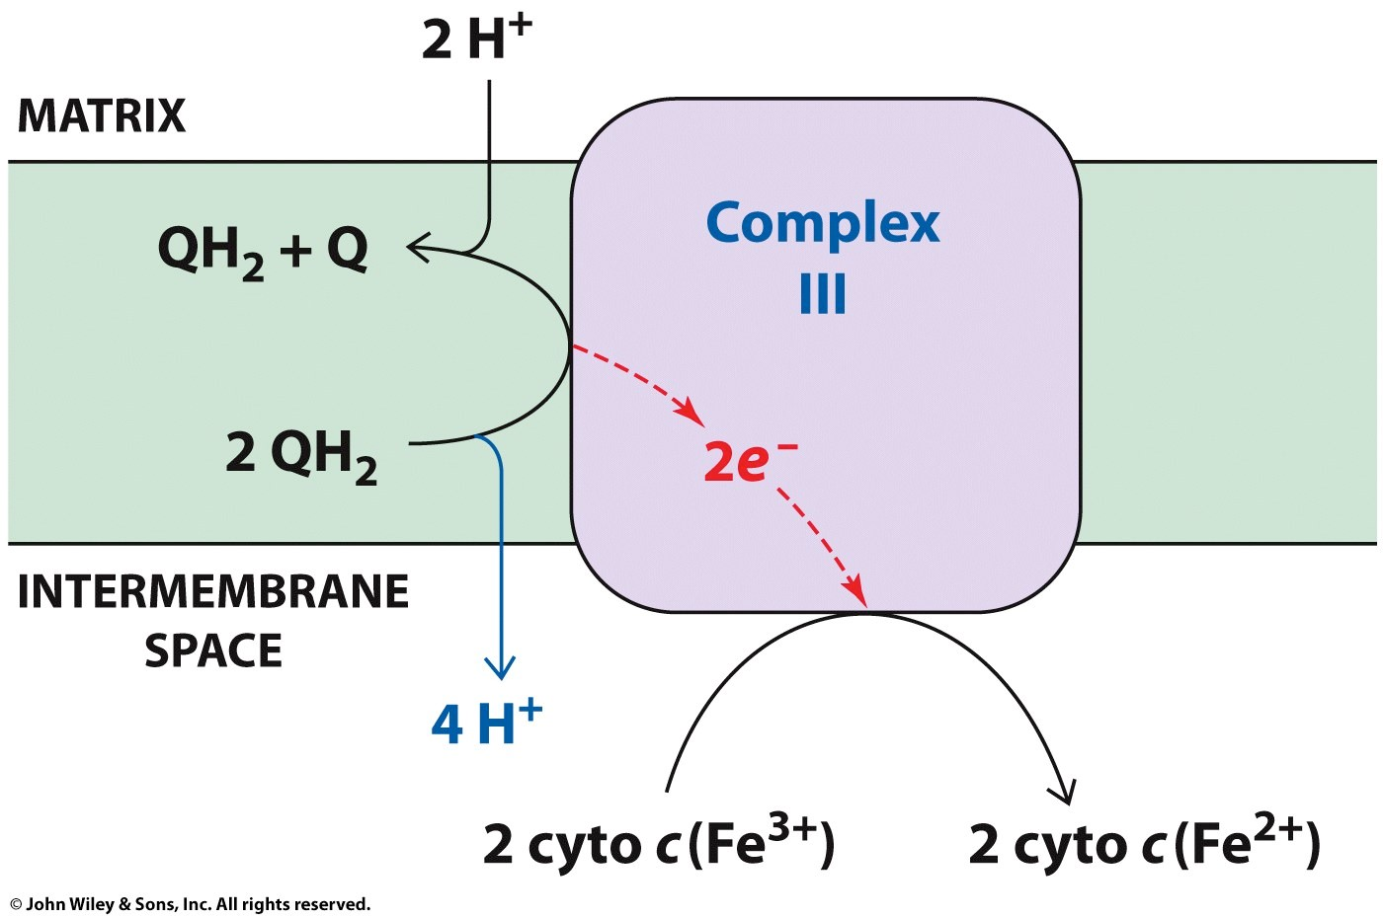

- Complex III contains several cytochromes (heme prosthetic group) and Fe-S center proteins which provide several centers for oxidation reduction reactions
- Oxidation of one QH₂ is accompanied by the translocation of 4 H+ across the inner mitochondrial membrane
- Two H⁺ are from the matrix, two from QH₂
- Regenerates Q for next round

lectron transfer and proton flow in Complex IV • Cytochrome c oxidase - Combination of cytochromes
- A complex of 10 protein subunits that contains 2 cytochromes (a and a₃) and proteins with copper centers that provide multiple centers for oxidation-reduction
- Consists of, 2 types of prosthetic groups - 2 heme and 2 Cu.
- Fe³⁺ → Fe²⁺
- Cu²⁺ → Cu¹⁺
- Source of electrons is cytochrome c (links Complexes III and IV)
- Catalyzes a four-electron reduction of molecular oxygen (O₂) to water (H₂O)
- Cytochromes a and a₃ are the only species capable of direct transfer of electrons to oxygen.
- Translocates H⁺ into the intermembrane space and contributes to the proton gradient

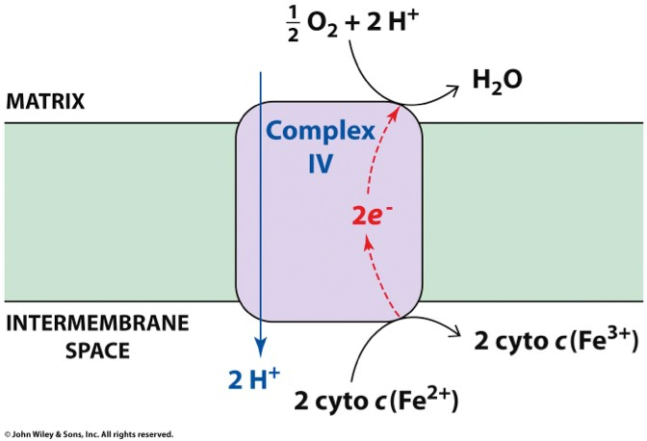

Complex IV contributes to the proton gradient

Net effect is transfer of four H⁺ for each pair of e⁻

O₂ + 4 e⁻ + 4H⁺ 2 H₂O
1. Proton translocation of 2 H⁺ for each pair of electrons transferred (each O atom reduced)
HOWEVER, FOR EACH PAIR OF ELECTRONS (e.g. NADH), ONLY GET 2H⁺ TRANSFERRED TO INTERMEMBRANE SPACE IN COMPLEX IV

SUMMARY OF ELECTRON TRANSPORT CHAIN

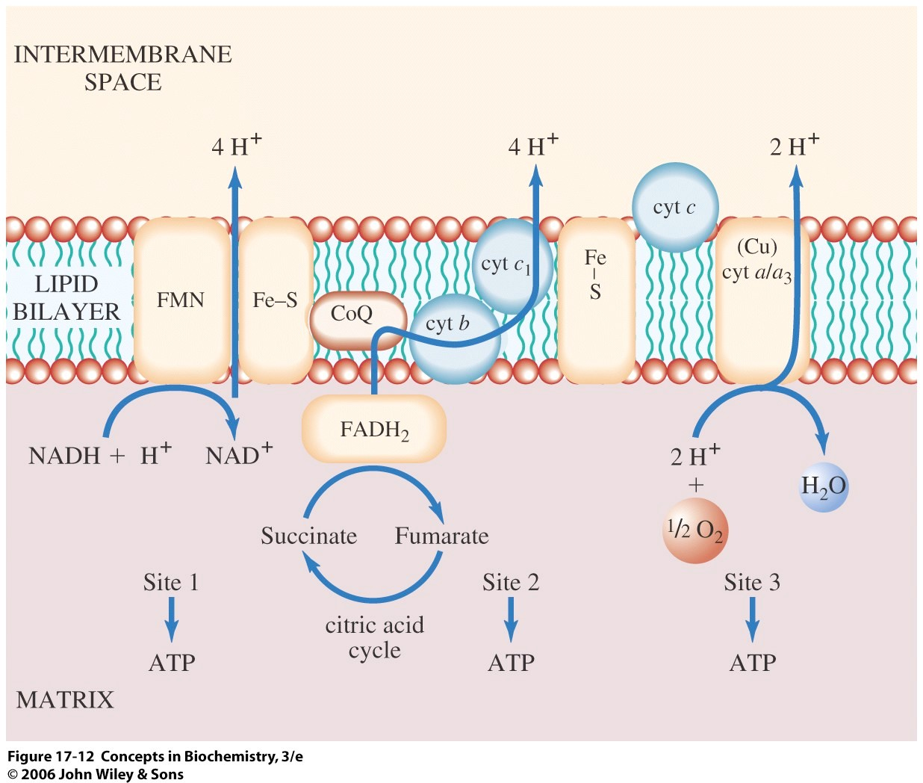

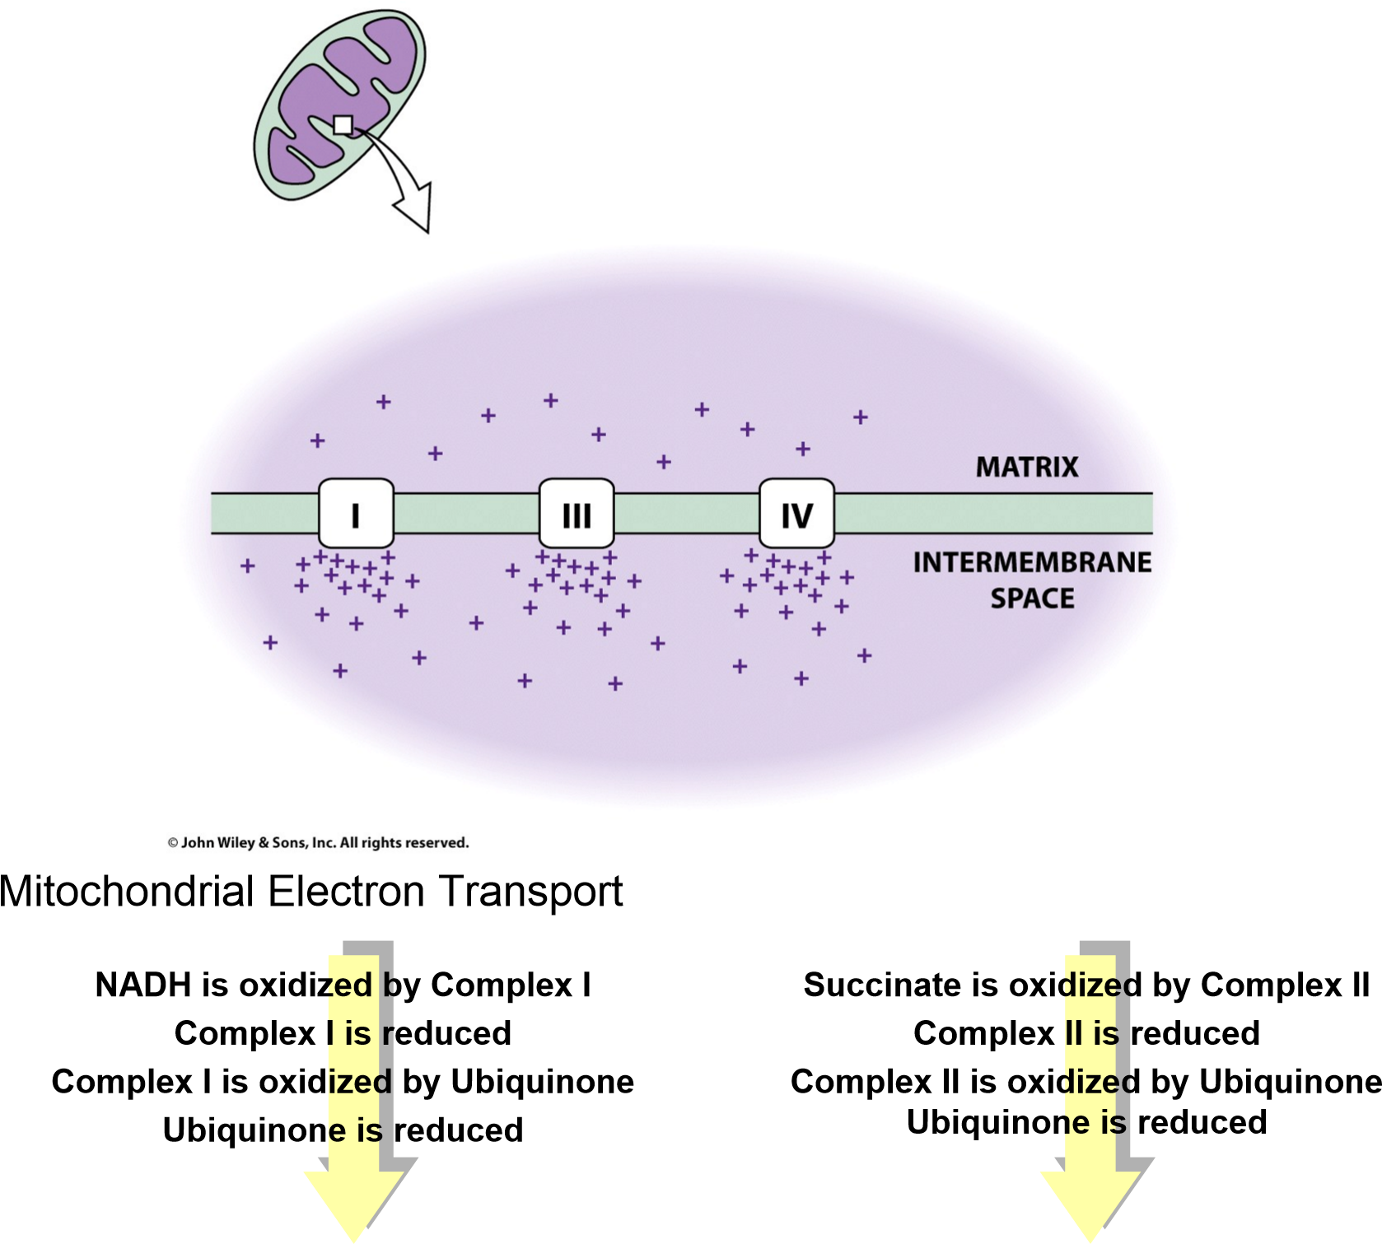
Ubiquinone is free to diffuse through the mitochondrial inner membrane
Ubiquinone is oxidized by Complex III
Complex III is reduced
Complex III is oxidized by Cytochrome C
Cytochrome C is reduced
Cytochrome C is free to diffuse through the mitochondrial inter-membrane space
Cytochrome C is oxidized by Complex IV
Complex IV is reduced
Complex IV is oxidized by oxygen
Oxygen is reduced

Electron Transport and Oxidative Phosphorylation

ENERGETICS:
- Complex I, Complex III and Complex IV pump protons across the inner mitochondrial membrane
  - pumping uses the energy liberated from the oxidation of NADH and FADH₂
  - pumping generates a membrane potential because it generates an electrochemical gradient
- negative inside, positive outside
- alkaline inside, acidic outside

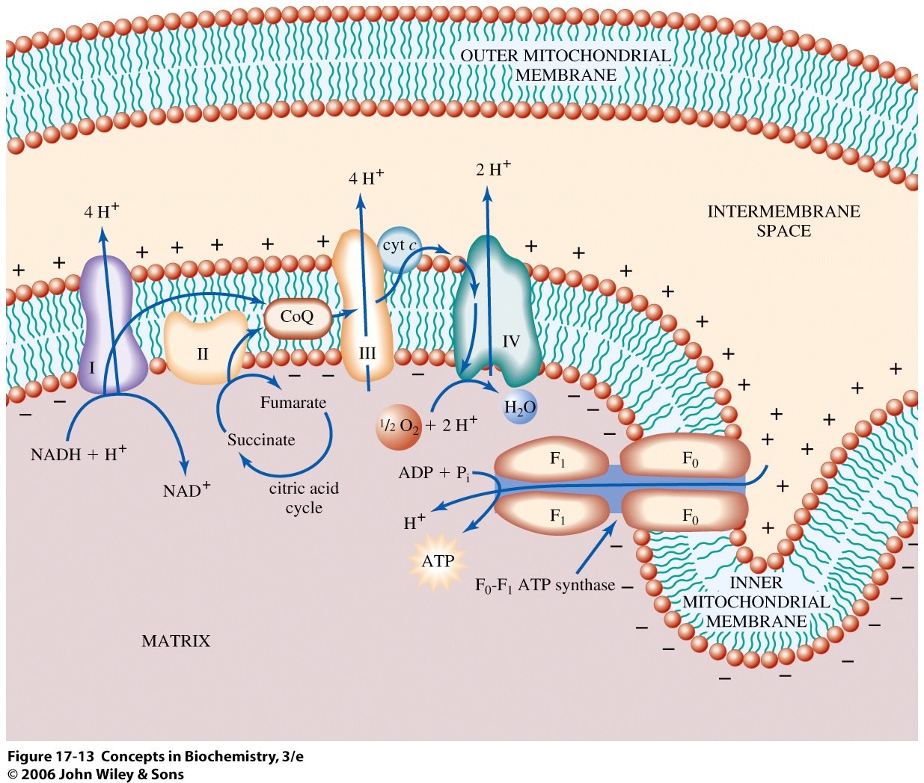

The Chemiosmotic Hypothesis
- Proposed by Peter Mitchell in the 1960’s (Nobel Prize in 1978)
- A proton concentration gradient serves as the energy reservoir for driving ATP formation
- Electron transport through the ETC generates a proton gradient (pumps H+ from the matrix to the intermembrane space)
- Protonmotive force (Δp) is the energy of the proton concentration gradient
- Protons that are translocated into the intermembrane space by electron transport, flow back into the matrix via ATP synthase
– H⁺ flow forms a circuit (similar to an electrical circuit)
- The transmembrane protein, ATP synthase, catalyzes the phosphorylation of ADP in a reaction driven by movement of H⁺ across the inner membrane into the matrix
- As protons move back into the matrix through ATP Synthase, the energy stored in the electrochemical proton gradient is used to make ATP

Coupling of electron-transport
with ATP synthase

Outer mitochondrial membrane
H+ H+ ₊ H+ H+ H+ H⁺
H
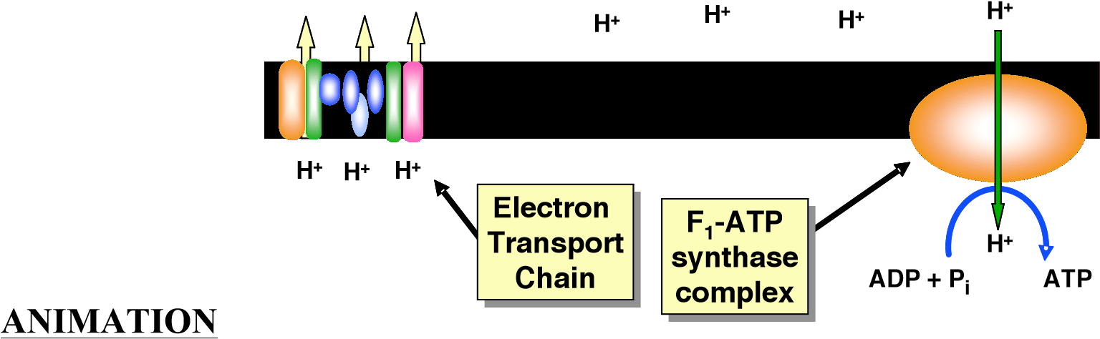
http://www.science.smith.edu/departments/Biology/Bio111/etc.html http://www.wiley.com/college/fob/anim/
Chapter 17
- Fig. 17-8 -- The Mitochondrial Electron Transport Chain

ATP Synthase
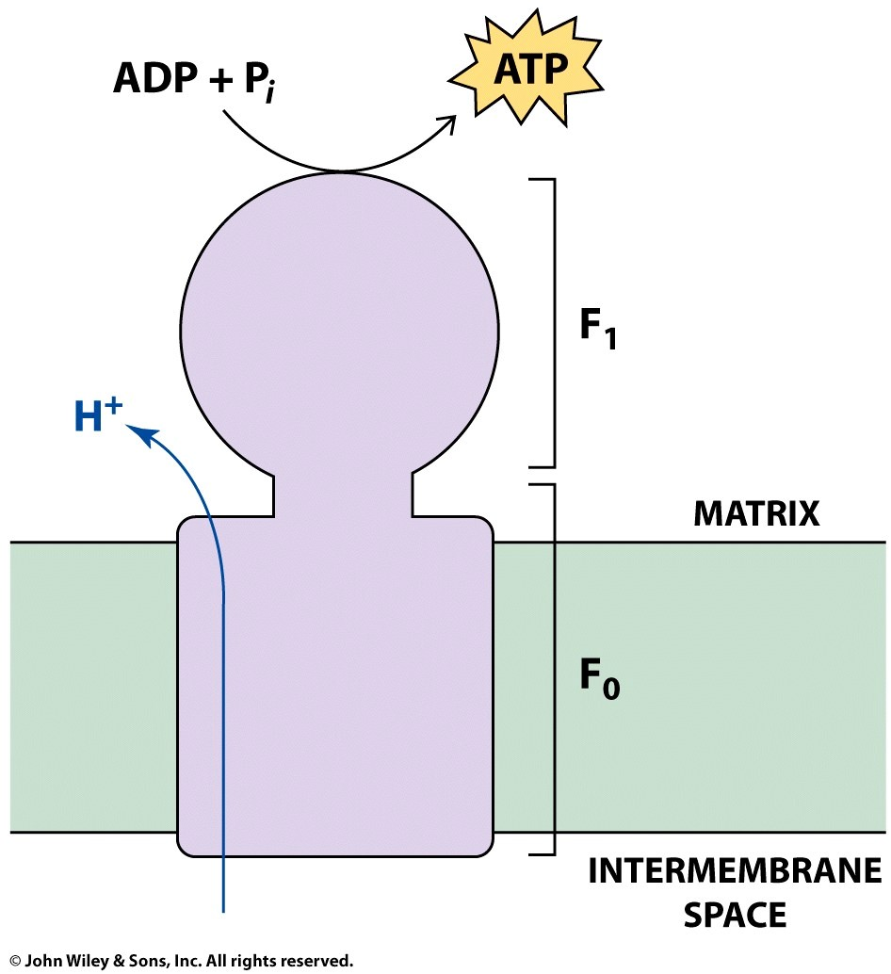
- F₀F₁ ATP Synthase uses the proton gradient energy for the synthesis of
ATP
- Large transmembrane protein complex
- Faces into the mitochondrial matrix – spans the IMM
- Composed of a “knob-and-stalk” structure
- F₀ (stalk) has a proton channel which spans the membrane. • Forms a proton pore
- Membrane-spanning portion – integral membrane protein • Made up of 4 different subunits
- F_{o} subunit composition: a₁b₂c₉₋₁₂ (c subunits form cylindrical, membrane-bound base)

• F₁ (knob) contains the catalytic subunits (ATP-synthesizing subunits)
- Where ATP synthesis takes place
- F₁ knobs: inner face of the inner mitochondrial membrane
- (subunit composition: α3β3γδε)
- α3β3 oligomer of F₁ is connected to c subunits by a multisubunit stalk of γ and ε chains
- Passage of protons through the F_{o} (stalk) into the matrix is coupled to ATP formation
- Estimated passage of 3 H+ / ATP synthesized
- F_{o} is sensitive to oligomycin, an antibiotic that binds in the channel and blocks H⁺ passage, thereby inhibiting ATP synthesis

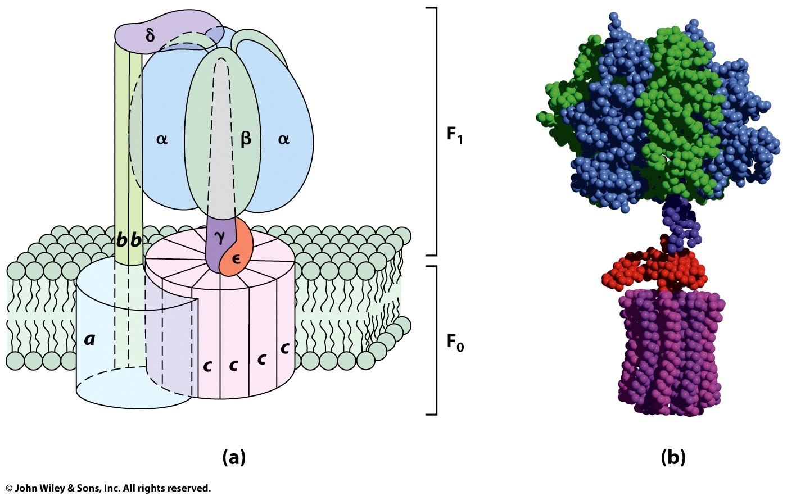
Mechanism of ATP Synthase
- F₁-F₀ complex serves as the molecular apparatus for coupling H+ movement to ATP synthase.
- There are 3 active sites, one in each β subunit
- Passage of protons through the Fo channel causes the rotor to spin in one direction and the stator to spin in the opposite direction

Proton flow →→ C unit rotates →→ γ rotates →→ conformation change →→ ATP synthesized
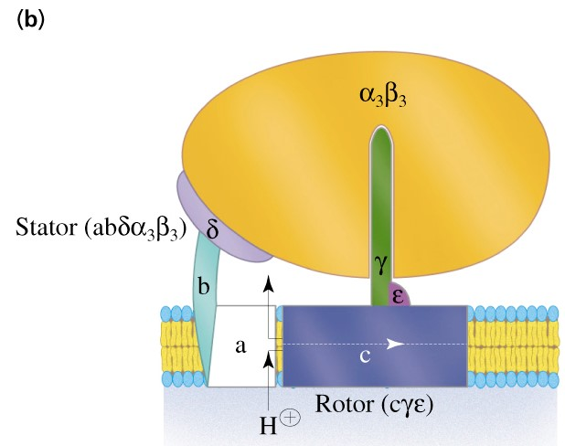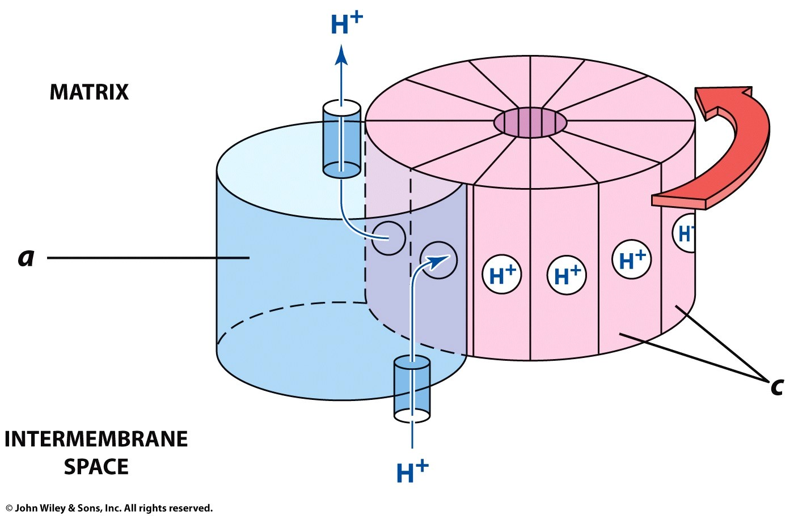

Animation:
http://www.stolaf.edu/people/giannini/biological%20anamations.html mitochondrial electron transport
ATP synthase
ATP synthase mechanism

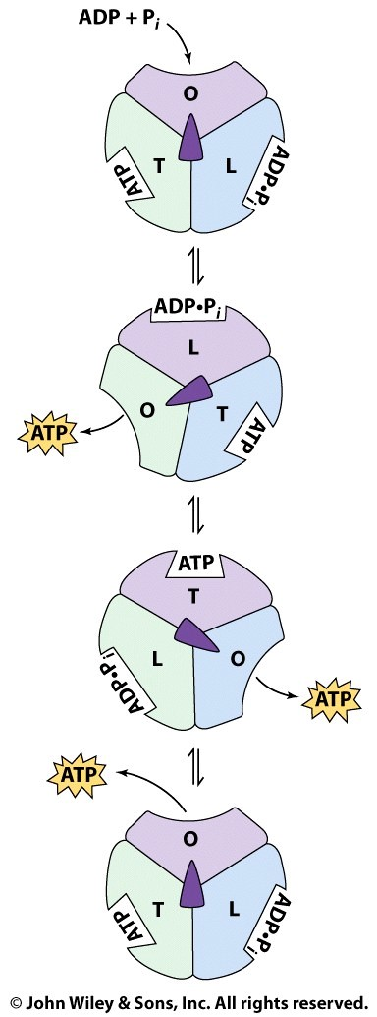
Binding-change mechanism of ATP synthase (This page is NOT for the Exam)
- ADP, Pi bind to an open site
- Inward passage of protons, cause a conformational change, and
ATP is synthesized from ADP and Pi
- ATP released from open site, ADP and Pi form ATP in the tight site
α/β subunits are asymmetric:
T is catalytically active, binds to ADP tight;
O has low affinity for substrate
L is also inactive, but can bind ADP

ADP+Pi first binds to L state; rotation of α/β subunits converts L to T, T to O
and O to L states, one ATP is made.

The binding change mechanism. F₁ has three chemically identical but conformationally distinct interacting αβ protomers: O, the open conformation, has very low affinity for ligands and is catalytically inactive; L binds ligands loosely and is catalytically inactive; T binds ligands tightly and is catalytically active. ATP synthesis occurs in three steps: (1) ADP and P_{i} bind to site L. (2) An energy-dependent conformational change converts binding site L to T, T to O, and O to L. (3) ATP is synthesized at site T and ATP is released from site O. The enzyme returns to its initial state after two more passes of this reaction sequence. The energy that drives the conformational change is apparently transmitted to the catalytic α3β3 assembly via the rotation of the γδε assembly, here represented by the centrally located asymmetric object (green). [After Cross, R.L. Annu. Rev. Biochem. 50, 687 (1980).]

Animation:
http://www.wiley.com/college/fob/anim/
Chapter 17: Fig. 17-21 -- The Binding Change Mechanism for ATP Synthesis
Regulation:
- Electrons do not flow unless ADP is present for phosphorylation
- Increased ADP levels cause an increase in catabolic reactions of various enzymes including:
  - glycogen phosphorylase
  - phosphofructokinase
  - citrate synthase

Active Transport of ATP, ADP and Pi Across the Inner Mitochondrial Membrane
- ATP is synthesized in the mitochondrial matrix
- ATP must be transported to the cytosol, and ADP and Pi must enter the matrix
- ADP/ATP carrier exchanges mitochondrial ATP⁴⁻ for cytosolic ADP³⁻
- The exchange causes a net loss of -1 in the matrix (draws some energy from the H+ gradient)
- Adenine nucleotide translocase: unidirectional exchange of ATP for ADP (antiport) • Symport of Pi and H⁺ is electroneutral
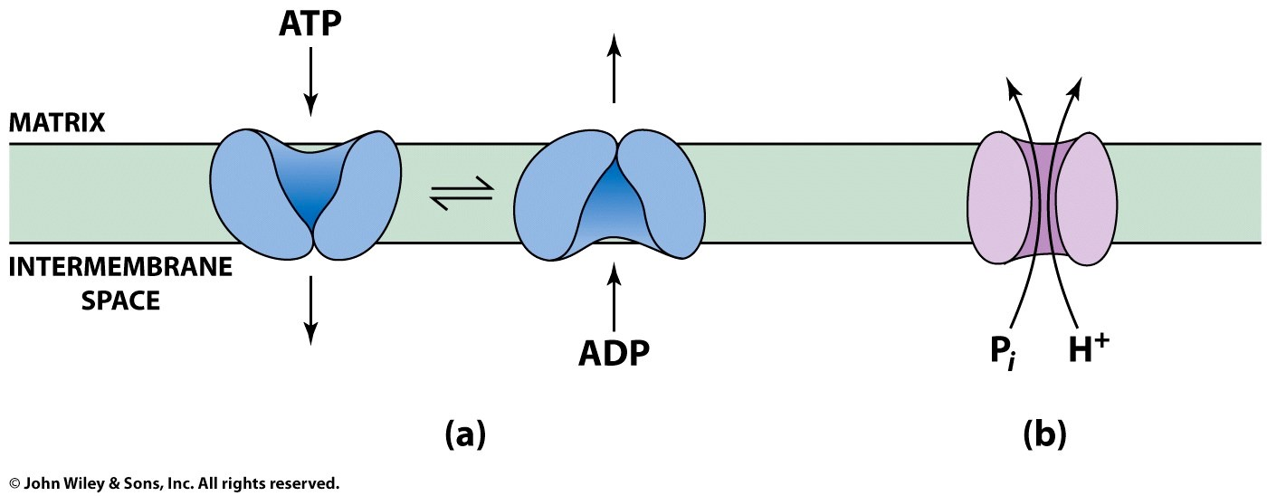

The P:O Ratio

molecules of ADP phosphorylated
P:O ratio = ---------------------------------------- atoms of oxygen reduced
- Translocation of 3H⁺ required by ATP synthase for
each ATP produced

- 1 H⁺ needed for transport of P_{i}, ADP and ATP
- Net: 4 H⁺ transported for each ATP synthesized

Calculation of the P:O ratio

Complex I III IV
#H⁺ translocated/2e⁻ 4 4 2
Since 4 H⁺ are required for each ATP synthesized:

For NADH: 10 H⁺ translocated / O (2e⁻)
P/O = (10 H⁺/ 4 H⁺) = 2.5 ATP/O

For succinate substrate = 6 H⁺/ O (2e⁻)
P/O = (6 H⁺/ 4 H⁺) = 1.5 ATP/O

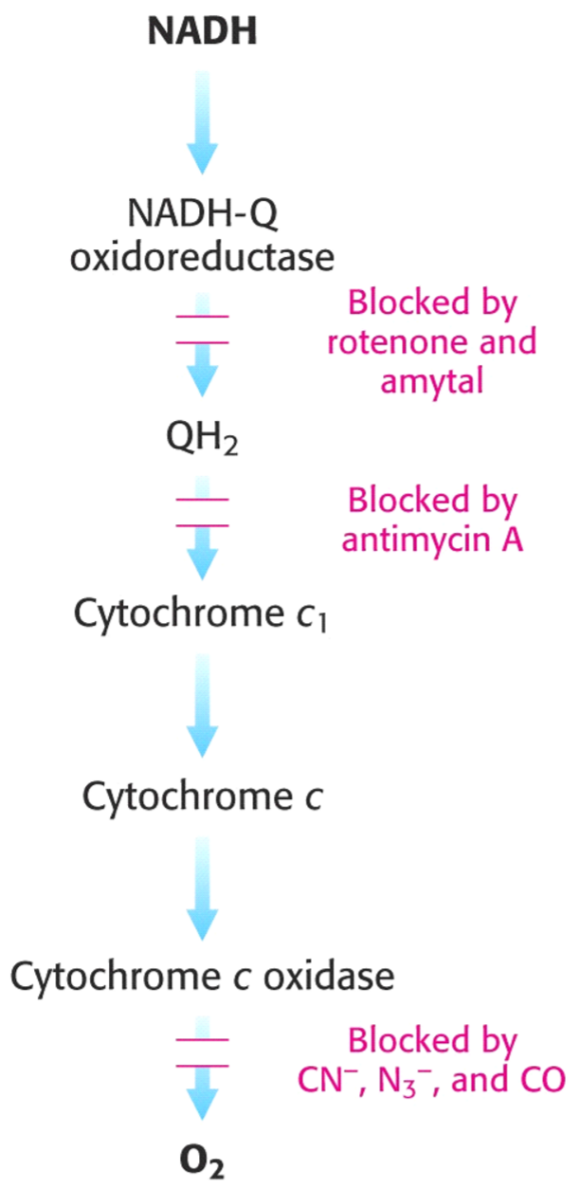
RESPIRATORY INHIBITORS & UNCOUPLERS:
Inhibitors are chemicals that can block electron transfer through specific complexes in the ETC
- Complex I: blocked by rotenone, barbiturates
- Complex III: blocked by antimycin A
- Complex IV: blocked by cyanide, azide, carbon monoxide

Uncouplers
- In some special cases, the coupling of the two processes can be disrupted.
- Uncouplers stimulate the oxidation of substrates in the absence of ADP
- Large amounts of O₂ are consumed but no ATP is produced.
- Uncouplers are lipid-soluble weak acids
- Both acidic and basic forms can cross the inner mitochondrial membrane
- Uncouplers deplete any proton gradient by transporting protons across the membrane
- Do NOT affect electron transport
- Allow protons back into the matrix without making ATP
- Stimulate oxygen consumption

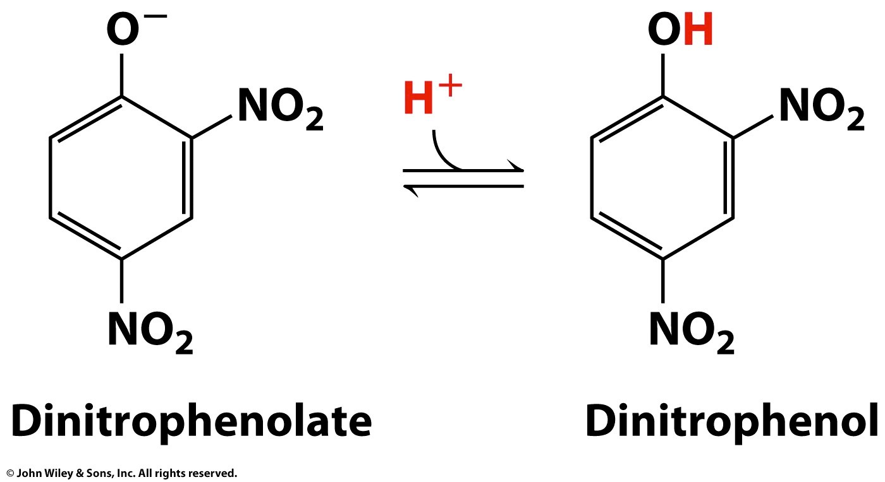
2,4-Dinitrophenol: an uncoupler
- Used as a diet/weight loss drug
- Hydrophobic low molecular weight substance that can diffuse through the mitochondrial inner membrane
- Shuttles protons across the membrane and dissipates proton gradient
- ATP synthesis goes down
  - ADP concentration in cells goes up and acts as a stimulator
  - Signals to turn on pathways to make ATP
  - Therefore, electron transport and O₂ consumption turned on fully and is NOT regulated
- Energy produced by electron transport released as HEAT rather than harnessed into ATP synthesis
- Fuels (carbs and fats) are consumed at great rates and get quick weight loss BUT
  - Get heavy breathing – using lots of oxygen
  - Excessive fever (heat generation)
  - BIG problem – no control over uncoupling
  - Brain, heart and muscles are affected as well
- 2,4-dinitrophenol is extremely toxic and pulled from the market

NATURAL UNCOUPLERS
- In newborn and hibernating animals, brown fat oxidizes large amounts of substrate (mostly fatty acids) to generate heat
- ‘Brown fat’- brown because of the large number of mitochondria and their associated cytochromes
- In brown fat mitochondria oxidation of NADH and FADH₂ is uncoupled from ATP synthesis – Mitochondria contain thermogenin (uncoupling protein).
– Thermogenin allows the release of energy as heat instead of ATP.

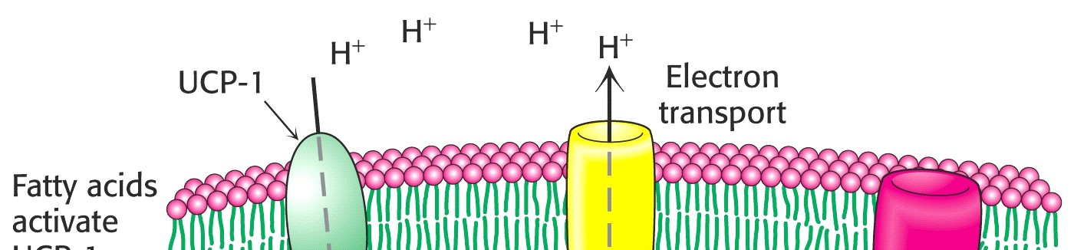
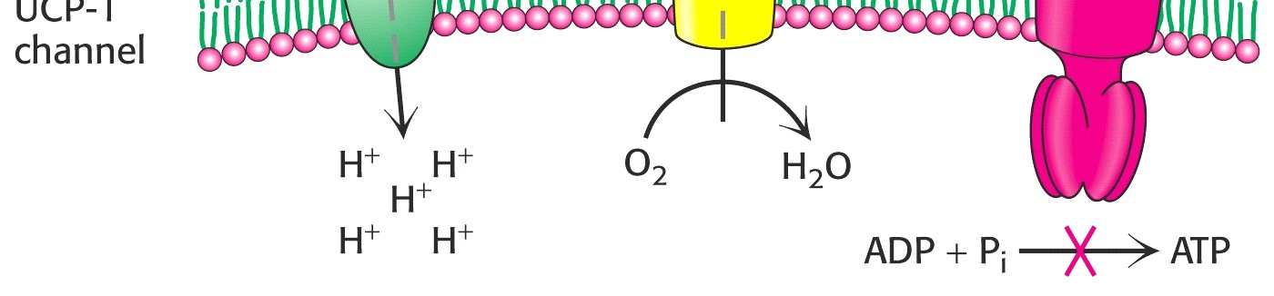
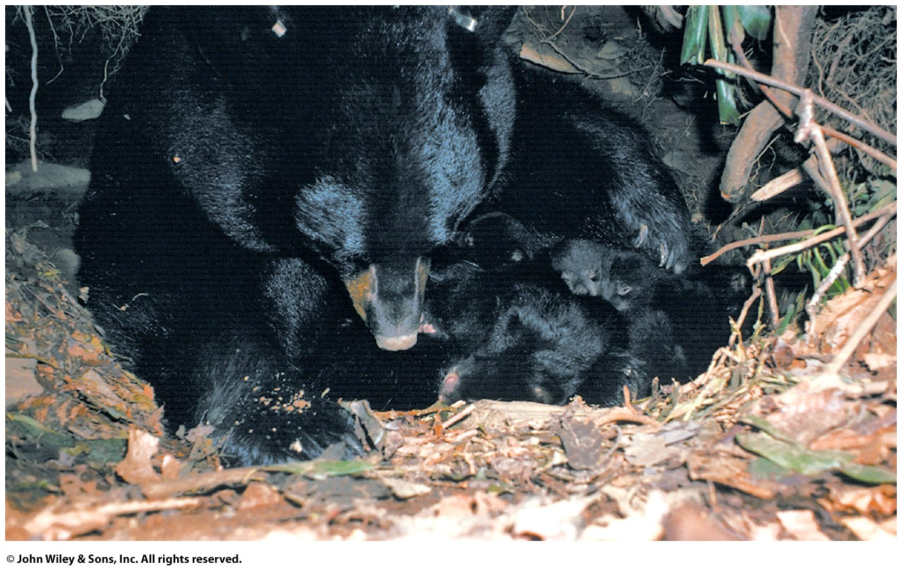
•
–

T
hermogenin

dissipates p
roton
electrochemical gradient

•

By providing another channel for return of
protons
-

bypasses

ATP synthase

•

Also called
uncoupling protein (UCP)

In brown fat mitochondria, the energy
that would have been used to make ATP is
liberated as heat

Electron Transport Chain and Oxidative Phosphorylation Animation Websites:
- http://www.cat.cc.md.us/biotutorials/cellresp/etsar.html

- http://wunmr.wustl.edu/EduDev/LabTutorials/Cytochromes/etc_movie.html

- http://faculty.nl.edu/jste/electron_transport_system.htm

- http://cwx.prenhall.com/horton/chapter14/deluxe.html Live Figures:
Figure 14.10 Mitochondrial electron transport.
Figure 14.19 Demonstration of the rotation of a single molecule of
ATP synthase

- http://www.wiley.com/college/fob/anim/

Chapter 17
- Fig. 17-8 -- The Mitochondrial Electron Transport Chain
- Fig. 17-18 -- The Coupling of Electron Transport and ATP Synthesis
- Fig. 17-21 -- The Binding Change Mechanism for ATP Synthesis

- Great site with lots of information: http://www.brookscole.com/chemistry_d/templates/student_resources/shared_resources/animations/oxi dative/oxidativephosphorylation.html

- http://www.science.smith.edu/departments/Biology/Bio111/etc.html **

- http://www.stolaf.edu/people/giannini/biological%20anamations.html **

mitochondrial electron transport
ATP synthase
ATP synthase mechanism

