GENERAL MICROBIOLOGY
“Microbiology is the study of living organisms of microscopic size which includes bacteria, viruses, fungi, algae and protozoa which range in size from nanometer to few mm in size. Algae and protists are larger enough to be seen with naked eye. It is concerned with their anatomy, physiology, reproduction, metabolism, classification and their effects on human beings, animals and plants.”
Disciplines in Microbiology
- Bacteriology: Study of bacteria
- Virology: Study of viruses
- Protozoology: Study of protozoa
- Phycology : Study of algae
- Mycology: Study of fungi
- Parasitology Study of Parasites
Nomenclature:
Each species of microorganism has only one officially accepted name. A system of scientific name referred as scientific nomenclature. The system of nomenclature (naming) for organisms in use today was established in 1735 by Carolus Linnaeus because this system gives a name consisting of two parts to each organism this system is called binomial nomenclature. Scientific names are latinized because Latin was the language traditionally used by scholars. These parts are
- Genus name
- Specie name
Genus name is always capital the specie name is never capitalized both the names are given in italic or underline. e.g.
- Penicillium notatum or Penicillium notatum
- Staphylococcus aureus or Staphylococcus aureus
Classification of microorganisms:
“It means the orderly arrangements of unit under study in the group or larger units.”
The fundamental rank of the classification as set down by Linnaeus is the species. For microorganisms, a species is defined as a group of organisms that are 70 percent similar from a biochemical standpoint. In the classification scheme, various species are grouped together to form a genus. Various genera are then grouped as a family because of similarities, and various families are placed together in an order. Continuing the classification scheme, a number of orders are grouped as a class, and several classes are categorized in a single phylum or division. The various phyla or divisions are placed in the broadest classification entry, the kingdom
Until 18th century, all living organisms are placed in two kingdoms.
- Animal kingdom
- Plant kingdom
In 1886 a zoologist Hackle suggested a third kingdom Monera which includes those organisms that are typically neither plants nor animals.
Herbert Copeland proposed a system that divide Monera into
- Eukayotic (Protozoa and algae)
- Prokaryotic (bacteria)
A more recent and comprehensive system of classification the five kingdom system was proposed by Robert Whittaker in 1969 in which Fungi was included as a separate Kingdom.
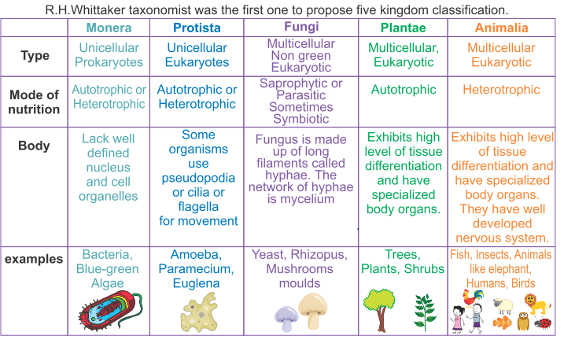

In 1977 Carlwose discovered Archaea a group having bacterial resemblance (simple structure, lack of nucleus, grow in wide range of environment) resemble with eukaryotes in gene expression. However they differ in genetic sequence from bacteria and from eukaryotes.
Woes Discovery Replaced Five Kingdom Concept with six kingdom concept.
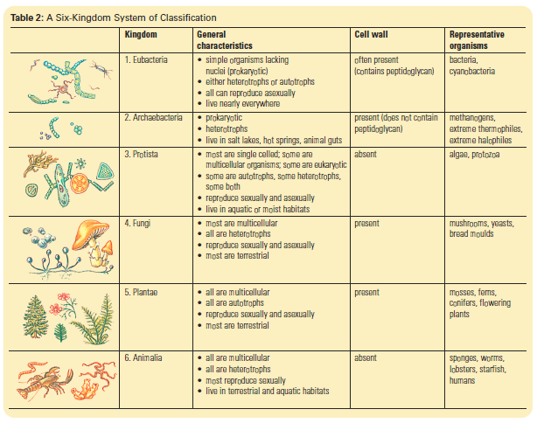

Scope of microbiology with special reference to pharmaceutical sciences:
- Control of infectious diseases
- Antibiotic production
- Vaccine development
- Recombinant DNA technology
- Gene therapy
- Factory or hospital hygiene
- Production of biopolymers
- Microbial enzymes
Control of infectious diseases:
Public health care officers have focused on prevention of bacterial, viral, fungal or protozoal diseases through education. Microbiology techniques will continue to be applied to help scientist to learn about the structure of causative organisms about the transmission of diseases about their growth in cells and how drugs can be directed against them and whether an effective vaccine can be developed.
Antibiotic production:
Antibiotics are basically chemicals provided by micro-organisms and are used to kill or inhibit the growth of others microorganisms’ .There are basically three ways of antibiotic production
Natural: Micro-organisms are one of the sources of antibiotics. Penicillin production leads to search of other antibiotic producing micro-organisms especially from soil.
Semi-synthetic: Some modification in the natural antibiotics gives us semi-synthetic production. This modification is done chemically i.e. at the end of chain a specific group is replaced by some other functional group.
Synthetic production. Antibiotics that are not made by micro-organisms are made synthetically.
Vaccine development:
Vaccine is the administration of the antigenic material to stimulate an individual immune system. Vaccine is produced from killed virulent microbes, live attenuated germs, isolated components of virulent micro-organisms. Examples of some vaccines are:
- Influenza vaccine
- Chicken pox vaccine
- MMR (Measles, mumps and Rubella )
Recombinant DNA technology:
Micro-organisms can generally engineer to manufacture large amount of human proteins, vaccine and enzymes. Examples are hepatitis B vaccine, human insulin, human growth hormones and clotting factors.
Gene therapy:
Gene therapy is an experimental technique that uses gene to treat or prevent diseases. In gene therapy viruses (retro virus, adeno virus etc) are used to insert missing gene or to replace defective genes. Example, disease that are treated by gene therapy
- cystic fibrosis
- Absence of clotting factors
- Certain hemophilia
Factory and hospital hygiene:
Area designed for manufacturing of sterilized products such as injectables, eye preparation etc. in pharmaceutical manufacturing units have special high facilities to assure asepsis which includes environmental control i.e. used of filters HEPA (high efficiency particulate air filters) to supply aseptic air (99.99% removable of dust)
- Training of personals
- Sterilization facilities
- Routine microbial monitoring
Production of biopolymers:
A huge variety of biopolymers, such as polysaccharides, polyesters, and polyamides, are naturally produced by microorganisms. This range from viscous solutions to plastics and their physical properties are dependent on the composition and molecular weight of the polymer. The genetic manipulation of microorganisms opens up an enormous potential for the biotechnological production of biopolymers with tailored properties suitable for high-value medical application such as tissue engineering and drug delivery.
Microbial Enzymes
Microorganisms are favored sources for industrial enzymes due to easy availability, and fast growth rate. Enzymes have many significant and vital roles in the pharmaceutical and diagnostic industries. These are extensively used as therapeutic drugs in health issues associated with enzymatic deficiency and digestive disorders, and in diagnostic procedures such as ELISA and diabetes testing kits. At present, most prominent medical uses of microbial enzymes are removal of dead skin, and burns by proteolytic enzymes, and clot busting by fibrinolytic enzymes. Few examples are amylases , Protease , ligase etc.
Patients with inherited congenital sucrase-isomaltase deficiency are unable to digest sucrose, and therefore, sacrosidase enzyme is given orally to facilitate digestion of sucrose

