Experiment # 4
DETERMINATION OF CRUDE FIBER IN A FOOD SAMPLE
Crude Fiber:
After fat extraction from a food sample, we get a fat-free sample. Now when we treat that fat-free sample with any acidic or alkaline media, some part of the fat-free sample is not soluble in them. That part is called Crude fiber. Crude fiber mainly contains the indigestible lignin, cellulose, pentosans, etc. present in the food sample. So, crude fiber is also called the Insoluble carbohydrate or the non-soluble carbohydrates. If we eat these crude fibers, they are not digested by our digestive juices, so they do not get degraded by the hydrochloric acids that are secreted by our gastrointestinal mechanism.
EXAMPLE: If we add weak acid and weak base to foods like grains, legumes, seeds or okra (having roughage content in it), we will observe that their sugars and proteins are dissolved in the solution, but few components like cellulose, aligning and hemicellulose are not dissolved. These undissolved components are collectively called Crude Fiber.
Importance of Dietary Fiber estimation in foods:
- Humans do not have Cellulase enzyme, so they cannot digest the crude fibers, for example, cellulose.
- Sometimes intentional adulteration in foods is done. So, to confirm the composition and quality, estimating crude fiber can be very useful.
- We can also guess the freshness of fruits and vegetables if we estimate the crude fiber. More mature and aged fruit or vegetable means more percentage of fiber in it.
SAMPLE PREPARATION:
The food should be fat-free, i.e. the food should be firstly passed via the soxhlet apparatus for fat estimation and removal. Then that fat-free sample is ground well and passed through a 1mm sieve. Now we use that filtrate as the sample source.

PROCEDURE:
- Weigh 3g of the fat-free sample. (Sample amount may differ according to food products and institution manuals)
- Now place the sample in a beaker. Beakers have no spot which provide easy flow to the liquids.
- Add 100ml of 1.25% H2SO4 into the spotless beaker.
- Then boil the content for half an hour
- Filter out the content
- Now scrap the unfiltered content from the filter paper and put it into the same beaker.
- Then add 100ml of 1.25% NaOH and boil for half an hour
- Filter the content and scrap the unfiltered part again. Place the content in crucibles which are already oven-dried and weighed.
- Place those crucibles at 130C for 3 hours and weigh again.
- Now place these crucibles in a muffle furnace for 3 hours at 550C and weigh again.
HYPOTHETICAL CALCULATION:
Crude fiber % = W2- W1 × 100
Sample weight (5g)
W1= Weight of crucible before ashing= 14.5336
W2= Weight of crucible after ashing= 14.5908
So, we obtained the crude fiber content as 1.8866%. We can also note that crude fibers are also greater than the dietary fibers written on the food packs.

Experiment # 5
DETERMINATION OF pH OF A FOOD SAMPLE
Apparatus and Reagents:
pH-meter, beakers, tap water, tissues and buffer tablets of pH 4 and pH 9
Procedure for pH-meter:
- Standardise the pH-meter with buffer solutions of pH 4 and 9.
- Pour 10ml of sample (juice) in beaker and insert the electrode to determine the pH.
- After taking first reading, wipe the electrode with clean tissue paper soaked with distilled water.
- Record the reading and repeat the procedure for replicate readings.
- Rinse the electrode with wet tissue paper and continue with the next determination
Procedure for pH paper:
- Wet about 0.5mm length of pH paper strip with the sample solution.
- Note the change in color of strip.
- Record the reading from the pH chart provided with the pH paper.

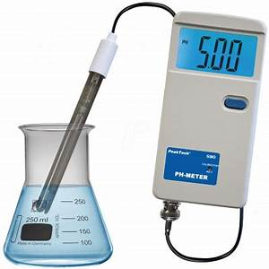
pH-meter
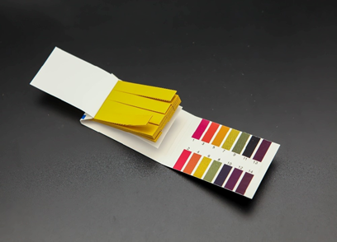
pH paper strips with pH chart

