Submittedto
:
SirAnsari
Submittedby
:
SabaRashid
Rollno
:
BBOF18M15
Semester
:
Fourth
APPLICATIONSOFECOLOGY

OnlineAssignment
UniversityofSargodha
ECOLOGY: | 1
WhoareEcologists? | 2
ApplicationsofEcology: | 2
1)UseofEnvironmentalResources: | 2
a)CarbonCycle: | 2
Contents
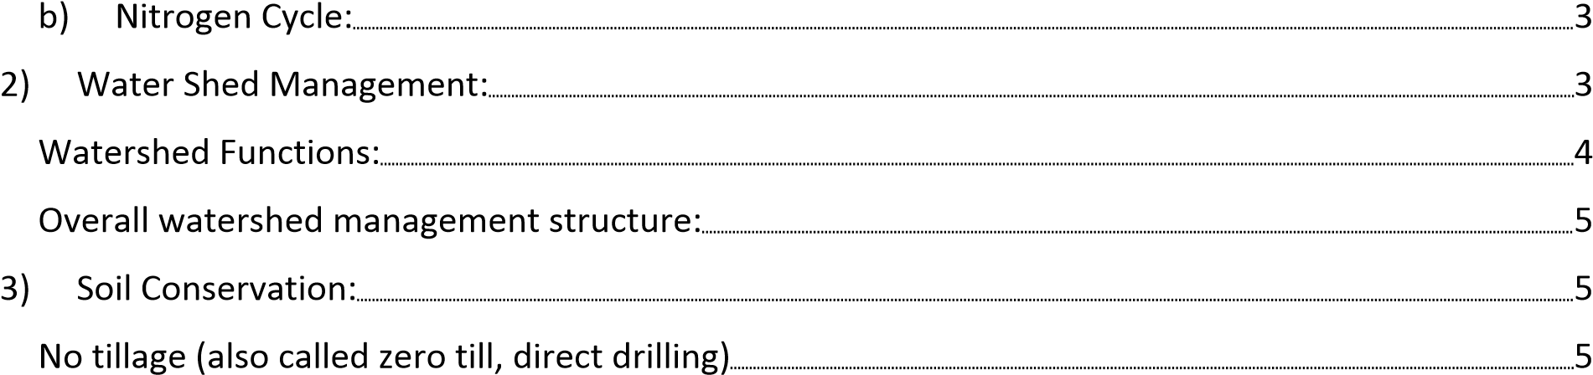
ConservationAgriculture(CA) | 6
Sustainablelandmanagement(SLM) | 6
4)AquaticEcology: | 6
7
5)Forestry: 8
6)Wildlifemanagement: | 9
FormsofWildlifeManagement | 9
7)Rangelandmanagement: 10
8)Controlofpollution:11
Bioremediation: 11
ECOLOGY:
Allorganisms,nomattertheirsize,theirspecies,orwheretheylive,needtointeractwith otherorganismsintheir'neighborhood'andwiththeirenvironmentinordertosurvive. Ecologyisthescientificstudyoftheinteractionsbetweenorganismsandtheir environment.ThetermcomesfromtheGreek'studyofhouse',orthestudyoftheplace welivein.
Thescopeofecologyishuge,anditencompassesallorganismslivingonEarthand theirphysicalandchemicalsurroundings.Forthisreason,thefieldisusuallydivided intodifferentlevelsofstudyincluding:organismalecology,populationecology, communityecologyandecosystemecology.Itseekstounderstandthevital connectionsbetweenplantsandanimalsandtheworldaroundthem.Ecologyalso providesinformationaboutthebenefitsofecosystemsandhowwecanuseEarth’s resourcesinwaysthatleavetheenvironmenthealthyforfuturegenerations[1].
WhoareEcologists?
Ecologistsstudytheserelationshipsamongorganismsandhabitatsofmanydifferent sizes,rangingfromthestudyofmicroscopicbacteriagrowinginafishtank,tothe complexinteractionsbetweenthethousandsofplant,animal,andothercommunities foundinadesert.
Ecologistsalsostudymanykindsofenvironments.Forexample,ecologistsmaystudy microbeslivinginthesoilunderyourfeetoranimalsandplantsinarainforestorthe ocean[1]. ApplicationsofEcology:
Themanyspecialtieswithinecology,suchasmarine,vegetation,andstatisticalecology, provideuswithinformationtobetterunderstandtheworldaroundus.Thisinformation alsocanhelpusimproveourenvironment,manageournaturalresources,andprotect humanhealth.Thefollowingexamplesillustratejustafewofthewaysthatecological knowledgehaspositivelyinfluencedourlives[1].
1)UseofEnvironmentalResources:
Ecosystemplaysaveryimportantroleinrecyclingofnutrients.Likeenergy,nutrients involvedinnutrientcyclesareneverlostorwastedfromthecycle.Excessnutrients are stored indifferentformssuchasfossilfuels,livingorganismsorCO ₂.Avery importantroleplayedbymicroorganismsisthattheyfeedondeadmaterial by saprotrophicnutrition,convertingcomplexorganicmoleculestosimpleones.This conversionisacriticalpartofrecycling,enablingongoingmovementanddispersingof nutrientsacrosstheecosystem.Inthisway,theydividetheenvironmentalresources. Twomaincycleswhichareareinvolvedinrecyclingofnutrientsandtheirdivisionare carbonandnitrogencycle[2].
a)CarbonCycle:
Alllifeisbasedoncarbon.Itiscontainedinproteins,carbohydratesindeedallorganic moleculescontaincarbon.Soitisthemostimportantnutrientinanecosystem.The carboncycleinvolvesseveralstagesofcarbonbeingfixed(incorporatedaspartof)by plantsfromtheatmosphere.Thiscarbonistransferredtoconsumersbyeating,orit becomesfossilfuelinfossilization[2].
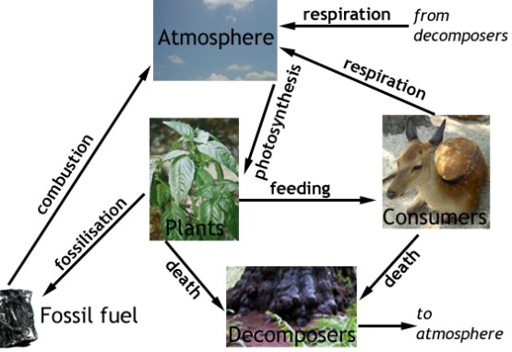
Figure1Carboncycle
b)NitrogenCycle:
Nitrogenisalsoaveryimportantcompoundforanecosystem.Despiteitsabundancein theatmosphere(79%ofairisnitrogen),itisofteninverylimitedsupply.Thisisbecause itisrequiredbyplantsasammonium(NH4+ornitrate(NO3-).Aftercarbon,nitrogenis themostimportantatominorganiccompounds.ItisparticularlyimportantinDNA,and aminoacids,whichmakeupproteins[2].
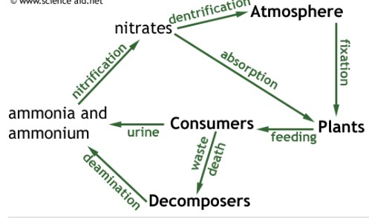
Figure2
Figure3NitrogenCycle
2)WaterShedManagement:
Watershed:Anareaoflandthatdrainswater,sedimentanddissolvedmaterialstoa commonreceivingbodyoroutlet.Thetermisnotrestrictedtosurfacewaterrunoffand includesinteractionswithsubsurfacewater.Watershedsvaryfromthelargestriver basinstojustacresorlessinsize[3].
WatershedEcology:Thestudyofwatershedsasecosystems,primarilytheanalysisof interactingbioticandabioticcomponentswithinawatershed’sboundaries.
Watershedecologyisessentialknowledgeforwatershedmanagersbecauseitteaches usthatwatershedshavestructuralandfunctionalcharacteristicsthatcaninfluence howhumanandnaturalcommunitiescoexistwithinthem.Thegrossstructureofa watershed,itsheadwatersarea,sideslopes,valleyfloor,andwaterbody,aswellasits soils,minerals,nativeplantsandanimalsareinonesensearerawmaterialforallthe humanactivitiesthatmaypotentiallyoccurtherelikeproductionofelectricityfrom dams.Thewatershed’snaturalprocessesrainfallrunoff,groundwaterrecharge, sedimenttransport,plantsuccession,andmanyothersprovidebeneficialserviceswhen functioningproperly,butmaycausedisasterswhenmisunderstoodanddisrupted.Itis crucialforpeopletounderstandwatershedsandhowtheyworkbeforetheymake decisionsortakeactionsthatmayaffectimportantwatershedstructuralorfunctional characteristics[3].
WatershedFunctions:
1)Transportandstorage(ofwater,energy,organisms,sediments,andothermaterials) Awatershedisanareathatdrainstoacommonbodyofwater,oneofitsmain functionsistotemporarilystoreandtransportwaterfromthelandsurfacetothewater bodyandultimately(formostwatersheds)onwardtotheocean.But,inadditionto movingthewater,watershedsandtheirwaterbodiesalsotransportsedimentandother materials(includingpollutants),energy,andmanytypesoforganisms.Itisimportant whenrecognizingthetransportfunctiontoalsorecognizetemporaryretentionor storageatdifferentlocationsinthewatershedandthisfunctionismainlyusedfor developmentofdamstoproduceelectricity[4].
2)CyclingandTransformation
Cyclingandtransformationareanotherbroadclassofnaturalfunctionsinwatersheds. Variouselementsandmaterials(includingwater)areinconstantcyclethrough watersheds,andtheirinteractionsdrivecountlessotherwatershedfunctions.For example(overleaf),illustratesinteractionsofthecarbonandnitrogencycleswith streambiotaandtheresultinginfluenceondissolvedoxygen.Elementslikecarbon, nitrogen,andphosphoruscomprisethewatershed’smostimportantbiogeochemical cycles.Cyclinginvolvesanelementofinterest’stransportandstorage,changeinform, chemicaltransformationandadsorption[4].
Overallwatershedmanagementstructure:
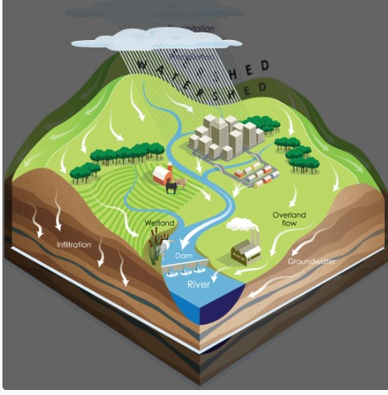
Figure4watershedmanagementstructure[4]
3)SoilConservation:
Soilisacentralcomponentofterrestrialecosystems,andafundamentalconstituentin sustaininglifeonearth.Thedegradationofsoilrepresentsalossinecosystemservices andalossofnaturalcapitalassets.Thehealthofterrestrialecosystems,definedas ecosystemintegrity,dependsontheecosystemcomponentsandthesynergyof processesamongthem.Ahealthyecosystemprovidesasteadyflowofproductionand environmentalgoodsandservices(GEF,2004),inwhichthesoilplaysakeyrole.Human over-exploitationoftheseecosystemsresultsinconsiderabledegradationcausing naturalcapitalloss[5].
Traditionalagriculturalpracticesarebasedonploughingandtillingthelandin preparationoftheseedbed.Thesepractices,however,havebeenshowntobehighly destructiveofthesoil,withtheresultthatabout24%ofglobalagriculturallandis degraded.Landdegradationreducesthesoil'sshortandlongtermproductioncapacity, andtheseareseriousconcernsconsideringthefoodproductionrequirementsof growingglobalpopulationsandaglobalGDPwhichisexpectedtotripleby2050.
Usingecology,thetraditionalapproachtosoiltillageisgraduallybeingreplacedbynew paradigmscenteredonconservingandimprovingthesoil,whileenhancingproductivity, profits,andenvironmentalbenefits.Mostoftheseapproachesarebasedonprocedures ofno-tillage,aswellasthebroaderconceptsofconservationagricultureand sustainablelandmanagement[5].
Notillage(alsocalledzerotill,directdrilling)
Underno-till,soildisturbanceisvirtuallyeliminated.Onlyatinyslotismadeduringthe plantingoperationsothattheseed(andeventuallystarterfertilizers)canbeplacedin intimatecontactwiththesoil,promotinggermination.Onlythegrainsareharvested, whiletherestoftheplant(plantmaterialotherthangrains)areleftonthesurface. Gradually,anorganicmulchisdevelopedonthesoilsurface,whichiseventually convertedtostablesoilorganicmatter.Theincreaseinorganicmatterresultsfromthe combinationofeliminatingsoildisturbance,reducingoxidationofsoilorganicmaterials (stubble),increasedbiomassproductionfromimprovedcropyields,andgreater diversityoforganicmaterialsfromincreasedrotationandcovercrops,andreduced erosion.Commonly,surfacesoiltemperaturesareslightlydepressed,whilesoilwater holdingcapacityisincreased.Theseconditionsareparticularlyimportantinthetropical andsemi-tropicalareas.Notillagecanbepracticedonbothlargeandsmallfarming systems[5].
ConservationAgriculture(CA)
CAisapplicationofecologytoimproveproductionwhileconcurrentlyprotectingand enhancingthelandresourcesonwhichproductiondepend.CAencouragesapplication ofmoderntechnologiesthatenhancethequalityandecologicalintegrityofthesoil.CA aimstoincreaselandproductivityandyieldstability,reduceproductioncostsand drudgeryinlandpreparationandmanagement,andimprovethephysical,hydrological andbiologicalqualitiesoftheland.CAisbasedonoptimizing(ratherthanmaximizing) yieldsandprofits,toachieveabalanceofagricultural,economicandenvironmental benefits.Itadvocatesthatthecombinedsocialandincreasinglyeconomicbenefits gainedfromcombiningproductionandprotectingtheenvironment,includingreduced inputandlaborcosts,aregreaterthanthosefromproductionalone.WithCA,farming communitiesbecomeprovidersofmorehealthylivingenvironmentsforthewider community[5].
Sustainablelandmanagement(SLM)
TheecologicalconceptofSustainableLandManagement(SLM)expandsonCAtoincludedimensionsof economics,markets,profitsandsustainability.SLMpromotesvalueaddedproduction,foodsufficiency, andpovertyreduction,throughimprovedcropandanimalproductionandproductioninrelationto marketopportunities.Itcanbeachievedthroughbettermanagementoffieldcrops,agroforestry, specialtycrops,andpermanentcroppingsystems[5].MaingoalsofSLMare,
•maintainandenhanceproduction(productivity)
•reducethelevelofproductionrisk,andenhancesoilcapacitytobufferagainst degradationprocesses(stability/resilience) •protectthepotentialofnaturalresourcesandpreventdegradationofsoiland waterquality(protection)
•beeconomicallyviable(viability)
•besociallyacceptable,andassureaccesstothebenefitsfromimprovedland management(acceptability/equity).
4)AquaticEcology:
Aquaticecologyisabranchofthescienceofecologywhichisconcernedwiththestudy ofaquaticecosystems.Thisfieldcanbebrokenintotwodivisions:freshwaterecology andmarineecology.GiventhatmostoftheEarthiscoveredinwater,understanding aquaticecosystemsisveryimportant,especiallysincewateriscriticaltothesurvivalof alllifeonEarth.Withoutwater,Earthwouldbeaverydifferentplace,andthereprobably wouldn'tbeanyecologistsaroundtostudyit.
Freshwaterecologyinvolvesrivers,lakes,streams,seasonalbodiesofwater, undergroundwaterdeposits,andthesurroundingareas,whilemarineecologyis concernedwiththeocean.Estuaries,wherefreshwatermeetssaltwater,maybestudied byecologistsfromeitherfield,andsometimesboth,workingcooperativelyonprojects whichrequiretheexpertiseoffreshwaterandmarineecologists.Becausewater systemsareinterconnected,thereisagreatdealofcooperationbetweenprofessionals workinginvariousaspectsofaquaticecology,andbetweenaquaticecologistsand othermembersoftheecologyprofession.
Whetheranecologistworkswithsaltwaterorfreshwater,thereareanumberoftopics ofinterestinaquaticecology.Aquaticecologistsstudynaturalpopulationsof organismsinthewater,learningaboutnaturalvariationsandtheimpactofinfluences liketemperature,salinity,waterdepth,location,andseason.Ecologistsmaybe interestedspecificallyinorganismsofeconomicimportance,orinthebiologyofan ecosystemasawhole.
Aquaticecologistsarealsointerestedinhumaninteractionswiththeenvironment,and theimpactofhumanactivityonaquaticecosystems,rangingfromoilspillsintheocean toagriculturalrunoffinlakesandstreams.Somehumanactivitieshaveunintended consequences,andtheseconsequencescantakeonanepicscaleintheworldof aquaticecology,sinceallwatereventuallydrainstotheocean,andtheworld'soceans areallconnected.AmicrobeintheGangesmayendupinaharborinBritain,and ecologistscanexplorethepaththatmicrobetooktogetthere,andwhetherornot humanactivitiesplayedarole.
Thereareahugenumberoffieldsofstudyavailabletopeopleworkinginaquatic ecology,includingwaterconservation,environmentalpreservation,commercialusesof aquaticresources,pollution,thehistoryofwateruse,waterusepolicies,andthestudy ofuniqueorganismsinvariousaquaticenvironmentsallovertheworld.Oneofthe modernapplicationofaquaticecologyisprecisionfishfarming[6].
Precisionfishfarming:Anewframeworktoimproveproductioninaquaculture PrecisionFishFarming(PFF)conceptwhoseaimistoapplycontrol-engineering principlestofishproduction,therebyimprovingthefarmer'sabilitytomonitor,control anddocumentbiologicalprocessesinfishfarms.Byadaptingseveralcoreprinciples fromPrecisionLivestockFarming(PLF),andaccountingfortheboundaryconditions andpossibilitiesthatareparticulartofarmingoperationsintheaquaticenvironment, PFFwillcontributetomovingcommercialaquaculturefromthetraditionalexperiencebasedtoaknowledge-basedproductionregime.Thiscanonlybeachievedthrough increaseduseofemergingtechnologiesandautomatedsystems.Infuture,precision fishfarmingisaimedatsolvingspecificchallengesrelatedtobiomassmonitoring, controloffeeddelivery,parasitemonitoringandmanagementofcrowdingoperations [7].
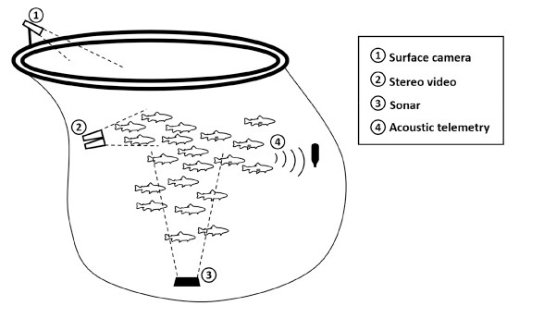
Figure5Precisionfishfarming
5)Forestry:
Thestudyofforestiscalledforestry.ThedevelopingcountrieslikePakistanarefacing problemofpopulationexplosion.Thisrapidincreaseinpopulationgrowthincrease requirementsforfoodandshelter.Thereforemaniscuttingtreesforagricultureandfor woodusedinhouses.Iftheforestsarecontinuouslycutdownatthatrate,therewillbe noleafcanopyleft.Thisleafcanopyprotectsthesoilfromdrivingrain..Consequently, someofthesoilwillrunawaywithwaterandreachintothestreamandriver.Thissoil willhewasted.Thusthefertilityofthesoilwillbereduced.Therearethreeaspectsof forestry:
a)Reforestations:Clearanceofvastareasofforestforlumber,planting subsistencecropsorgrazingcattleiscalledasdeforestation.
b)Reforestation:Thereplantationoftreesinaforestiscalledreforestation.Itis necessarythatdeforestationshouldbereplacedwithreforestation.
Reforestationisespeciallyimportantformanyoftheconifersspecies.
c)Afforestation:Theestablishmentofnewforestswherenoforestsexisted previouslyiscalledafforestation.
Ecologyhelpsinreforestationandafforestation.Ecologistsaredevisingwaystostop deforestation.desertificationandovergrazing[8].
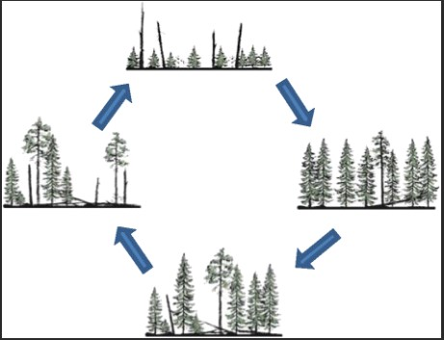
Figure6Cycleincludedinforestry
6)Wildlifemanagement:
Allnon-cultivatedplantsandnon-domesticatedanimalsareincludedinwildlife.Wild lifeplaysveryimportantroleinfoodchain.Thefoodchainisdisturbedwithoutwildlife. So.itbecomesverydifficulttomaintainthebalanceinecosystemwidiomwildlife.Man istryingtochangetheenvironment.Theeffectsofthesechangesinenvironmentare becomingmoreandmoreapparentwiththepassageoftime.Theimbalanceinwildlife canjeopardizetheexistenceofman.
Alllivingorganismsareinterdependent,Abalanceispresentbetweenlivingorganisms andenvironment.Manisdisturbingthisbalancesinceverylong.Aspeciesthatisnear toextinctioniscalledendangeredspecies.Todaytherearethousandsofendangered plantsandanimals.Wildlifeisanon-renewableresource.Ecologistsaretryingtosave theendangeredspeciesmainlydividedintotwotypes:
➢Manipulativemanagementinvolvesregulatingnumbersofanimalsdirectlyby harvestingorbyinfluencingnumbersbyalteringfoodsupply,habitat,densityof predatorsetc.
➢Custodialmanagementispreventiveorprotectiveandminimizesexternal influencesonthepopulationanditshabitat.Itisdonebysettingupnational parkswhereecologicalconditionsareprotectedandthreatenedspeciesare conservedbylaw[9].
FormsofWildlifeManagement
HabitatRestorationandManagement
Habitatmanagementisaprimarytoolwildlifebiologistsusetomanage,protect,and enhancewildlifepopulations.Increasedwildlifediversityinanareamaybeawildlife managementgoal.Itisdifficulttodevelopstrategiesformanagingeachspecies separately.Severalwildlifespeciescanbenefitwhenacompleteecosystemis improvedorpreservedintacttomeettheneedsofthreatenedorendangeredspeciesor groupsofspecies.
Managersmayenhancegrasslandareasbyclearingbrush(prescribedburning,cutting, herbicides)andremovingtrees,aswellasover-plantingthemwithnativeprairiespecies. Thishelpsreducecoverusedbyedgepredators(skunks,raccoons,red-tailedhawks) andimprovesthequalityofthehabitatforgrasslandanimals[10].
Harvest
Managersmaystrivetoreduceormaintainpopulationssoanimalsconflictlesswith humanactivities.Forexample,white-taileddeerareabundantinurbanareas.This presentschallengesforwildlifemanagersbecausehuntingwithfirearmsisnotallowed. Themosteffectivesolutionhasbeencontrolledhunts.Monkeypopulationinurban Indiacanbecontrolledbycaptureandreleaseinwildareas[10].
EndangeredSpeciesManagement
Endangeredorthreatenedspeciesrequireintensivemanagement.Criticalhabitatand locationsofexistingpopulationsmustbeidentifiedsotheycanbemanaged successfully.Ananimalspeciesisconsideredendangeredwhenitsnumbersbecome solowthatexpertsthinkitmaybecomeextinctunlessactionistakentosaveit.
Threatenedspecies’populationsareshowingsignsofunnaturaldeclineortheyare vulnerabletobecomingendangered.Manyendangeredorthreatenedspeciesare specialiststhathaveveryrestrictivehabitatneedsandeatspecializedfoods.The leadingcauseforaspeciesbecomingendangeredorthreatenedishabitatloss[10].
SpeciesReintroduction
Anotherwildlifemanagementgoalmaybetore-establishspeciesinsuitablehabitat. Thelostspeciescanbereintroducedfromotherareasonceagaininreintroduction programsandmanagementefforts.Studyofbiologyandecologicalrequirementsofthe speciesisnecessarybeforetheintroductions[10].
ConservationandPreservation
Wildlifeconservationhelpsensurefuturegenerationscanenjoyourresources.
Conservationcanincludeharvestingnaturalresources,activitiessuchashunting, fishing,trappingandharvestingtimberaswellasnon-consumptiveactivitiessuchas birdwatching,photography,andhiking.Conservationmustbalanceissuesbetween wildlifeandhumanpopulations.Conservationofwildlifeimpliesinsuringthreatenedand endangeredspeciesreceivespecialmanagementtoprotecttheirpresenceinthefuture.
Conservationmayincludepreservationorprotectionofnaturalresourcesthat emphasizesnon-consumptiveactivities.Ahabitatorecosystemcanbepreservedby manipulationandanareaalsomaybemanagedbydoingnothingatall.Forexample,a forestcanbeconservedbyallowingittomaturewithoutanyhumanmanipulationsuch astimberharvest,grazing,ortreeplanting[10].
7)Rangelandmanagement:
Thegrasslandusedbytheanimalsforgrazingiscalledrangeland.Theapplicationof scienceonrangelandforproducingmaximumnumberofgrazinglivestockregularlyis calledrangelandmanagement.Rangelandhasgreatimportance-forlivestock development.Unfortunately.manhaschangedmostoftherangelandintoagricultural land.Therefore,fewerrangelandsleftinthecountry.Theserangelandsareneededtobe protectedfromovergrazing.Overgrazingcanchangearangelandintodesert.
Theoptimumutilizationofrangelandmaintainstherangeland.Italsoprovides continuoussupplyofmilkandfleshtohumans.Maintenanceofrangelandisoneofthe applicationsofecology.Ecologicalstudiestellushowmuchpopulationofgrazera rangelandcansustain.Italsotellsusabouttheimpactofdestructionofrangelandon ecologicalcycle[8].
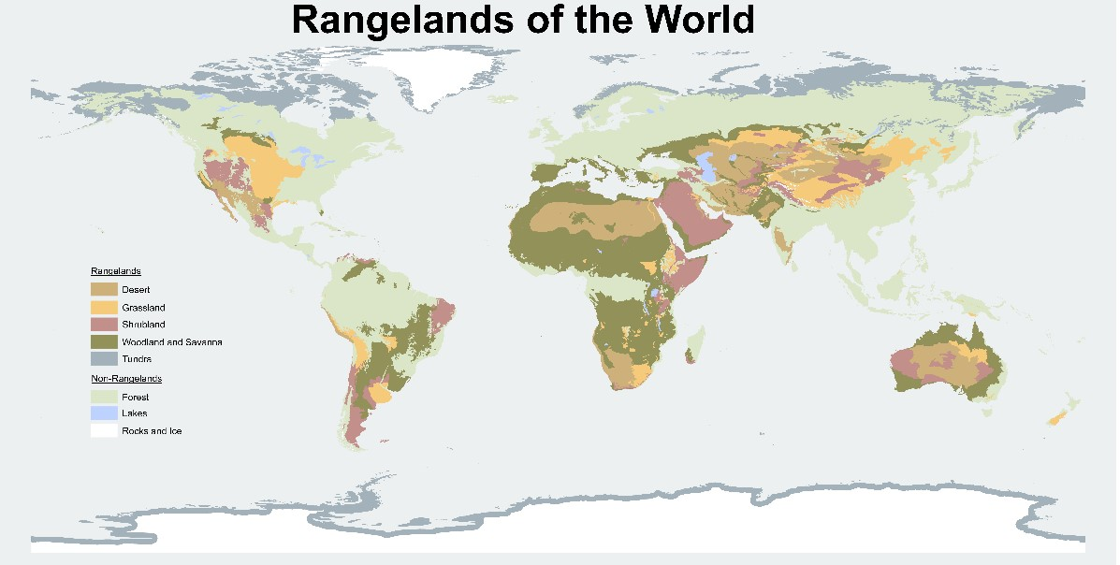
Figure7Rangelandclassification
8)Controlofpollution:
Thecontaminationofenvironmentwithharmfulandunwantedchemicalsiscalled pollution.Industrializationhasdestroyedourenvironment.Theseindustriesare producingahugeamountofindustrialwastes.Thosewastespolluteourenvironment. Theindustrialwastecontainsalargeamountoftoxicandcarcinogenic(cancercausing) materials.Automobilesandtanneriesproduceheavymetalslikechromium.These metalsaffectourhealth.
Ecologyhelpsustocontrolpollution.Theecologistsareusingthetechniqueof bioremediation.theremovalorthedegradationoftheenvironmentalpollutantsortoxic materialsbylivingorganismiscalledbioremediation[8].
Bioremediation:
Micro-organismsarewellknownfortheirabilitytobreakdownahugerangeoforganic compoundsandabsorbinorganicsubstances.Currently,microbesareusedtocleanup pollutiontreatmentinprocessesknownas‘bioremediation’.Bioremediationusesmicroorganismstoreducepollutionthroughthebiologicaldegradationofpollutantsintonontoxicsubstances.Thiscaninvolveeitheraerobicoranaerobicmicro-organismsthat oftenusethisbreakdownasanenergysource.Therearethreecategoriesof bioremediationtechniques:insitulandtreatmentforsoilandgroundwater;biofiltration oftheair;andbioreactors,predominantlyinvolvedinwatertreatment.
Bioremediationcanbetailoredtotheneedsofthepollutedsiteinquestionandthe specificmicrobesneededtobreakdownthepollutantareencouragedbyselectingthe limitingfactorneededtopromotetheirgrowth.Thistailoringmaybefurtherimproved byusingsyntheticbiologytoolstopre-adaptmicrobestothepollutioninthe environmenttowhichtheyaretobeadded[11].
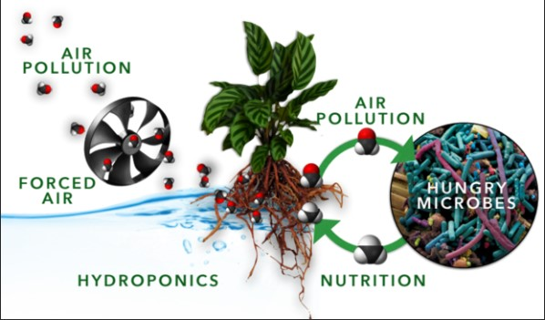
Figure8IOTwithbio-mimicrytoreduceindoorairpollution(Bioremediation)

