Document

Submitted by
M Hamza Tahir
BSSE-F17-32
Maheen Irfan
BSSE-F17-11

Contents
About 2
Apache JMeter 2
Why we use JMeter? 2
How it works? 2
What can I do with it? 2
JMeter Myths 3
Advantages 4
Installation 4
Pre-Requisite for installation 4
Installing 4
Lunching and GUI Components 6
Lunch / Start Modes 6
Starting JMeter in GUI Mode 6
GUI of JMeter 7
Understanding How to use it 8
Create first JMeter Test 8

About

Apache JMeter
The Apache JMeter™ application is open source software, a 100% pure Java application designed to load test functional behavior and measure performance. It was originally designed for testing Web Applications but has since expanded to other test functions
Designed to load test functional behavior and measure performance. You can use JMeter to analyze and measure the performance of web application or a variety of services. Performance Testing means testing a web application against heavy load, multiple and concurrent user traffic

Why we use JMeter?
Let say that one day, your boss asks you to do performance testing of www.google.com for 100 users. What would you do?
It's not feasible to arrange 100 people with PC and internet access simultaneously accessing google.com Think of the infrastructure requirement when you test for 10000 users (a small number for a site like google). Hence you need a software tool like JMeter that will simulate real-user behaviors and performance/load test your site.

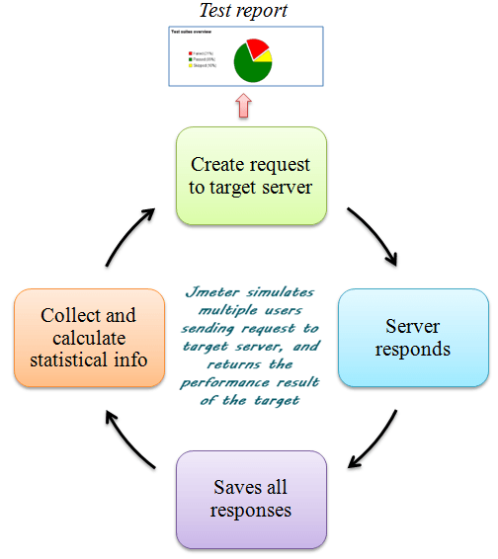

How it works?
JMeter simulates a group of users sending requests to a target server, and return statistics information of target server through graphical diagrams
The completed workflow of JMeter as shown in the figure

What can I do with it?
Apache JMeter may be used to test performance both on static and dynamic resources, Web dynamic applications. It can be used to simulate a heavy load on a server, group of servers, network or object to test its strength or to analyze overall performance under different load types.
Apache JMeter features include:
- Ability to load and performance test many different applications/server/protocol types:
  - Web - HTTP, HTTPS (Java, NodeJS, PHP, ASP.NET, …)
  - SOAP / REST Webservices
  - FTP
  - Database via JDBC
  - LDAP
  - Message-oriented middleware (MOM) via JMS
  - Mail - SMTP(S), POP3(S) and IMAP(S)
  - Native commands or shell scripts
  - TCP
  - Java Objects
- Full featured Test IDE that allows fast Test Plan recording (from Browsers or native applications), building and debugging.
- CLI mode (Command-line mode (previously called Non-GUI) / headless mode) to load test from any Java compatible OS (Linux, Windows, Mac OSX, …)
- A complete and ready to present dynamic HTML report
- Easy correlation through ability to extract data from most popular response formats, HTML, JSON , XML or any textual format
- Complete portability and 100% Java purity.
- Full multi-threading framework allows concurrent sampling by many threads and simultaneous sampling of different functions by separate thread groups.
- Caching and offline analysis/replaying of test results.
- Highly Extensible core:
  - Pluggable Samplers allow unlimited testing capabilities.
  - Scriptable Samplers (JSR223-compatible languages like Groovy and Bean Shell)
  - Several load statistics may be chosen with pluggable timers.
  - Data analysis and visualization plugins allow great extensibility as well as personalization.
  - Functions can be used to provide dynamic input to a test or provide data manipulation.
  - Easy Continuous Integration through 3rd party Open Source libraries for Maven, Gradle and Jenkins

JMeter Myths
JMeter is not a browser, it works at protocol level. As far as web-services and remote services are concerned, JMeter looks like a browser (or rather, multiple browsers); however, JMeter does not perform all the actions supported by browsers. In particular, JMeter does not execute the JavaScript found in HTML pages. Nor does it render the HTML pages as a browser does (it's possible to view the response as HTML etc., but the timings are not included in any samples, and only one sample in one thread is ever displayed at a time).

Advantages

- Visualize Test Result: Test result can be displayed in a different format such as chart, table, tree and log file
- Easy installation: You just copy and run the *.bat file to run JMeter. No installation needed.
- Highly Extensible: You can write your own tests. JMeter also supports visualization plugins allow you to extend your testing
- Multiple testing strategy: JMeter supports many testing strategies such as Load Testing, Distributed Testing, and Functional Testing.
- Simulation: JMeter can simulate multiple users with concurrent threads, create a heavy load against web application under test
- Support multi-protocol: JMeter does not only support web application testing but also evaluate database server performance. All basic protocols such as HTTP, JDBC, LDAP, SOAP, JMS, and FTP are supported by JMeter

Installation

Pre-Requisite for installation
  - Download JKD
Because JMeter is pure Java desktop application, it requires a fully compliant JVM 6 or higher. You can download and install the latest version of Java SE Development Kit. https://www.oracle.com/java/technologies/javase-downloads.html
  - Download JMeter
The latest version of JMeter is Apache JMeter 4.2. You can download it https://downloads.apache.org//jmeter/binaries/apache-jmeter-5.2.1.zip

Installing
After installing JKD, you can use the following procedure to check whether Java JDK is installed successfully in your system

- Go to Terminal by typing CMD on search bar
- Enter command java -version

If the Java runtime environment is installed successfully, you will see the output as the figure below
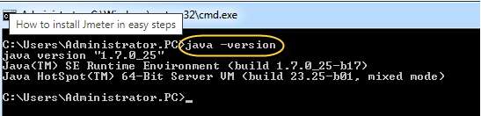
If nothing displays, please re-install Java SE runtime environment. Please see the link for details instructions https://www.guru99.com/install-java.html

Installing
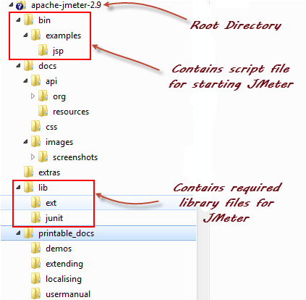
Installation of JMeter is extremely easy and simple. You simply unzip the zip/tar file into the directory where you want JMeter to be installed. There is no tedious installation screen to deal with! Simply unzip and you are done!
Once the unzipping is done installation directory structure should look like as figure

JMeter directories
- /bin: Contains JMeter script file for starting JMeter
- /docs: JMeter documentation files
- /extras: ant related extra files
- /lib/: Contains the required Java library for JMeter
- /lib/ext: contains the core jar files for JMeter and the protocols
- /lib/junit: Junit library used for JMeter

Lunching and GUI Components

Lunch / Start Modes
You can start JMeter by three modes which are following
- GUI Mode
- Server Mode
- Command line Mode

Starting JMeter in GUI Mode
Just run the file /bin/jmeter.bat present in the extracted file to start JMeter in GUI mode as shown below
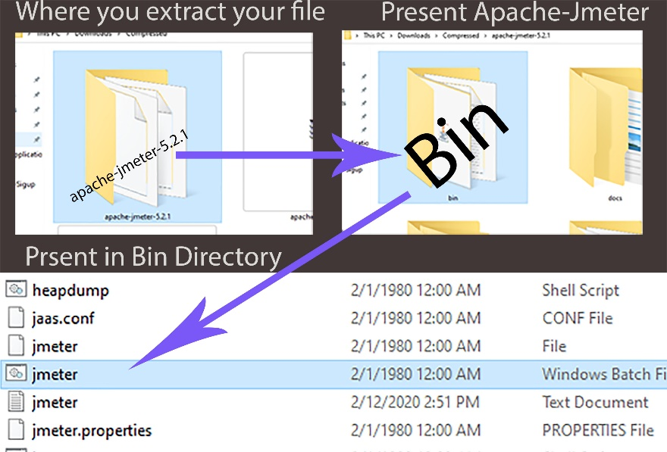
- Open location where you extract/unzip the Apache JMeter file
- Then open it (Apache JMeter Folder)
- Here you see many folders you just open the BIN folder
- Under Bin folder there is a File with name and have extension of Window Batch File
- Run this file and then CMD open and running some commands
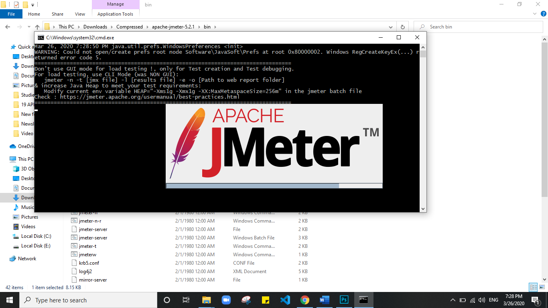
- As shown in figure

GUI of JMeter
Some important Components of GUI
- Menu Bar
- Run Test
- Test Status
- Test Plan Pane
      - Test plan: is container which contain all the element that you need to perform test i.e. Results, Graph and listeners. For permanent saving place your elements in Test plan
      - Workbench: A place where you keep your element for temporary bases.it is not permeant save place (e.g. For complex Test Plan if you want to place some elements separately you place them in workbench).

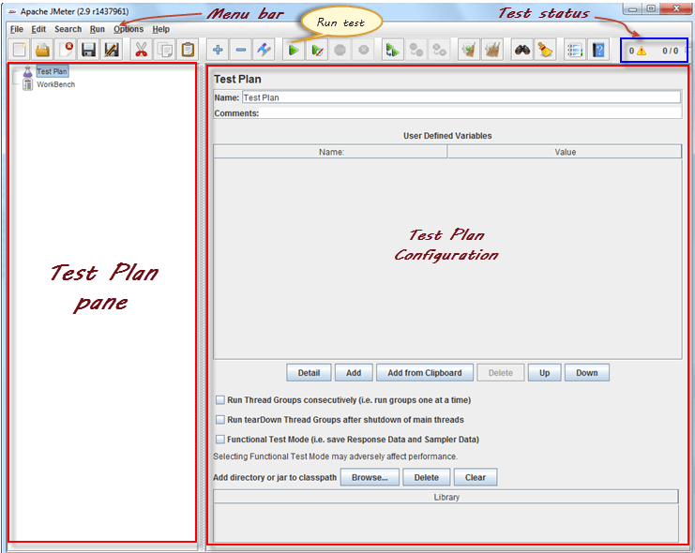
- Test Plan Configuration

Understanding How to use it

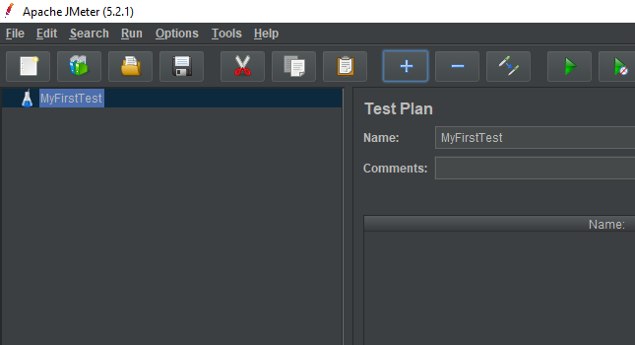
Create first JMeter Test

- On test plan Configuration give the information about your test
- Write the name of your test as I write “MyFirstTest” shown in figure

- Right click on test plan than hover on Add
- Then hover on threads(user) and then click on Threads Group.
- A Gear icon is appeared on under the MyTestPlan.
- As shown below
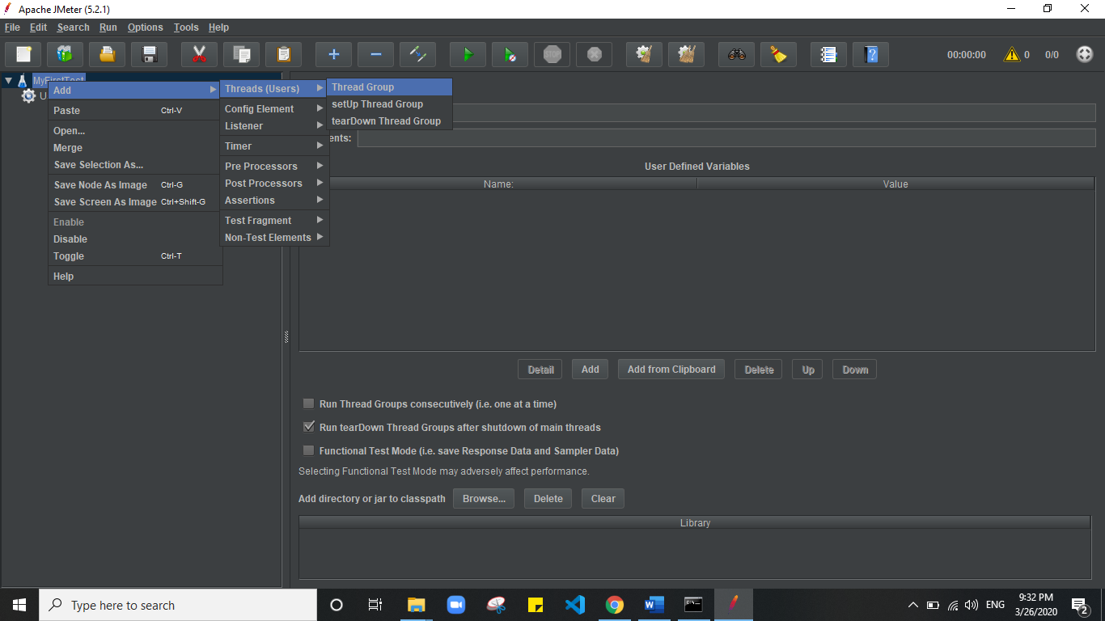
- You also the rename the Thread Group.

- The configuration section of the Thread Group has different options as shown below
- Thread Properties
  - Number of threads show how many requests will
  - Ramp-up period show in how much time these requests will send
  - Loop Count mean how many times these things are repeated

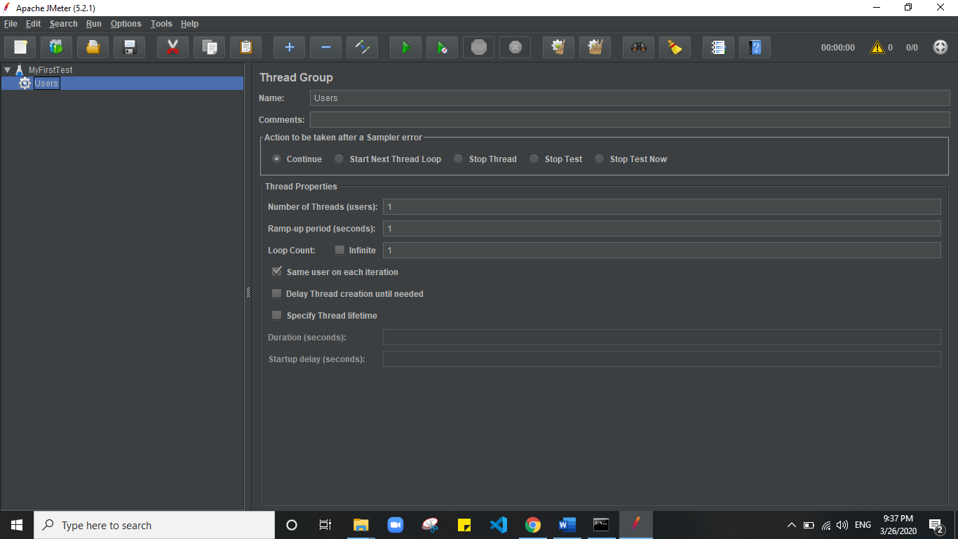
- Right Click on the Gear icon hover on the Add option than Sampler
- You will see a lot of different test in Sampler in which we select HTTP Request test
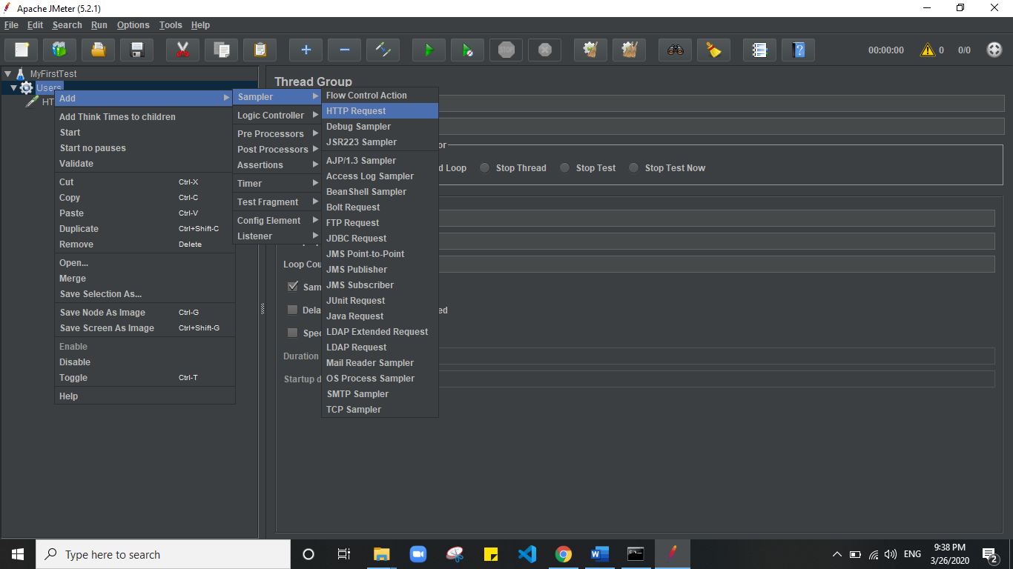
- On click this a new icon will created under the gear icon and the option of Configuration Section v\change

- HTTP Request configuration section First write page which want to test
- Web server option consist of three attributes
  - Protocol (http, https, fttp etc.)
  - Server Name (google.com etc.)
  - Port Number (3000 5000 etc.)
- HTTP Request is another option which have also three attributes
  - Method (GET POST etc.)
  - Path (file location which is present after server name)
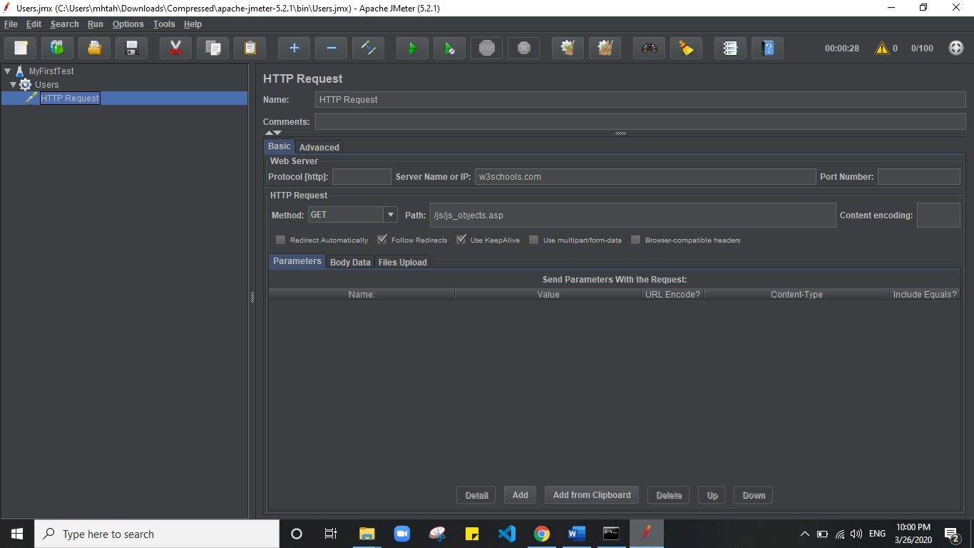
  - Content encoding

- Know we a have to add some analyzer or Result report
- Right click on the Gear icon then hover on Listener
- Then list of different test types is appeared, select some them which you require
- I select view result tree and view result in table
- And then run the test by press Green button on the top of the window

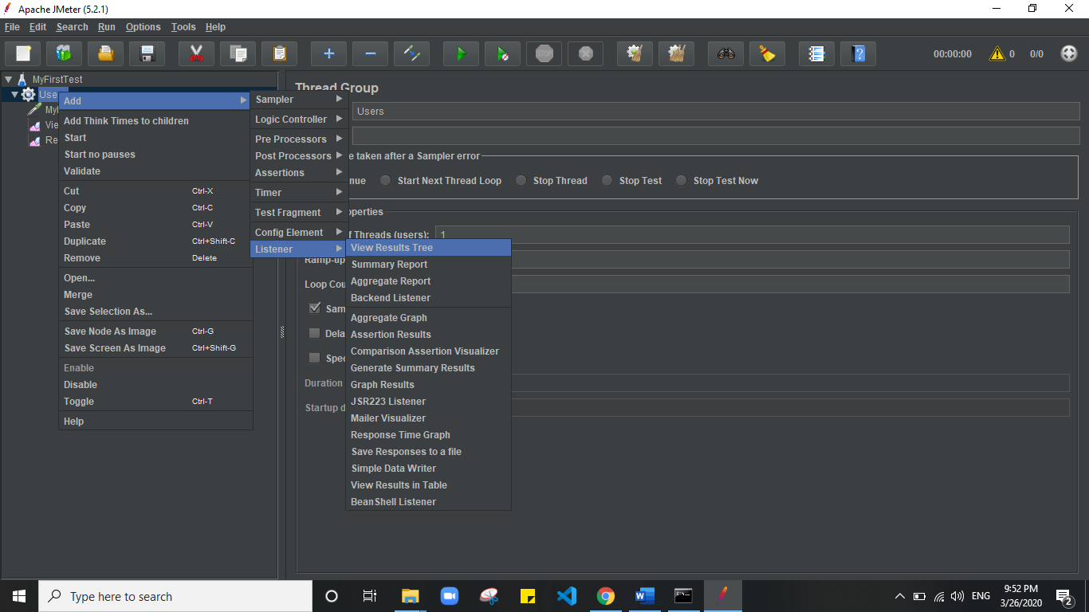

- Now you can see result , that you added from listen option
- By clicking on them
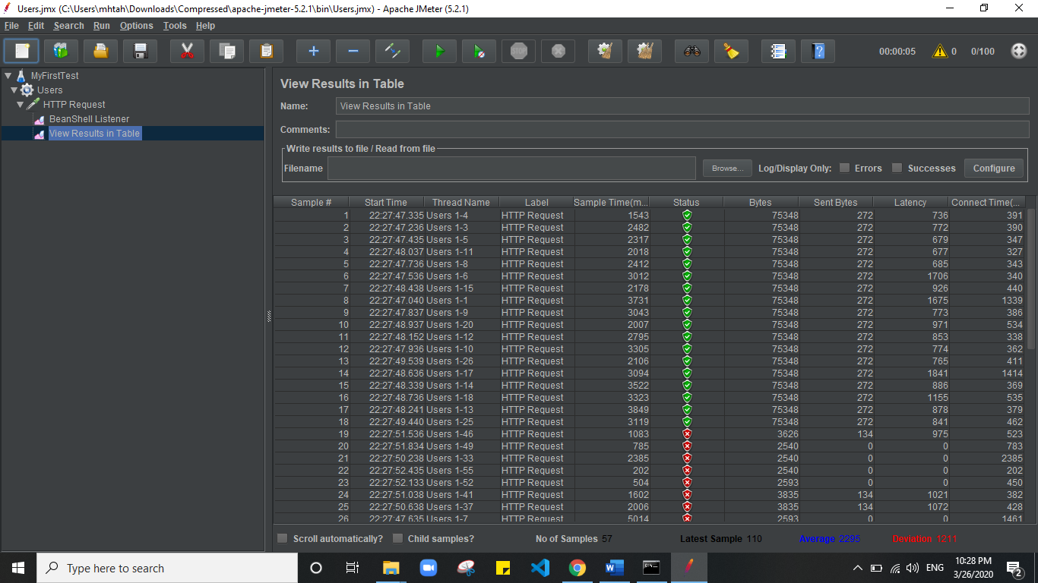
- In following figure you see the result in view result in table

