TOPIC
Cancer Growth Factor
- Introduction
- Cancer initiation
- Processes enabling growth factor to support tumor progression
- Autonomous cell growth
- Accelerated interepithelial proliferation
- Growth factor families involved in tumor progression
- Cancer therapeutics targeting growth factor signaling
- Concluding remarks

Introduction
Under physiological conditions, cells receive fate-determining signals from their tissue surroundings, primarily in the form of polypeptide growth factors. Integration of these extracellular signals underlies tissue homeostasis. Although departure from homeostasis and tumor initiation are instigated by oncogenic mutations rather than by growth factors, the latter are the major regulators of all subsequent steps of tumor progression, namely clonal expansion, invasion across tissue barriers, angiogenesis, and colonization of distant niches. Here, we discuss the relevant growth factor families, their roles in tumor biology, as well as the respective downstream signaling pathways. Importantly, cancer-associated activating mutations that impinge on these pathways often relieve, in part, the reliance of tumors on growth factors. On the other hand, growth factors are frequently involved in evolvement of resistance to therapeutic regimens, which extends the roles for polypeptide factors to very late phases of tumor progression and offers opportunities for cancer therapy.
One of the first lines of evidence associating cancer with soluble growth factors (GFs) emerged from studies performed in the 1950s, in the laboratory of Victor Hamburger, by two fellows, Rita Levi-Montalcini and Stanley Cohen. When studying mechanisms enabling limb innervation in chick embryos, they grafted a lump of a mouse sarcoma onto an embryo and observed more extensive attraction of nerve fibers to the lump. They later found that snake venom and the murine submaxillary gland secrete a similarly active “nerve-stimulating factor,” which instigated the isolation of the first two GFs: nerve growth factor (NGF) and epidermal growth factor (EGF). Two decades later, Cohen and Todaro reported that cells infected by the feline sarcoma virus lost their ability to bind EGF. This observation led to the isolation from a murine sarcoma of two “transforming growth factors,” TGF-α and TGF-β. Subsequent studies revealed that not only virally transformed cells but also chemically transformed cells, as well as cells derived from human tumors, often secrete GFs, which are responsible for self-stimulation (autocrine) of growth. In support of autocrine theories, Waterfield and colleagues reported in 1983 that the transforming gene of the simian sarcoma virus is structurally related to the platelet-derived growth factor (PDGF). In 1984 Waterfield provided yet another link between GFs and cancer: partial sequencing of the EGF-receptor (EGFR/ErbB-1) uncovered homology to another oncogene, the ErbB gene of the avian erythroblastosis virus. Subsequent molecular cloning of EGFR by Ullrich and colleagues boosted the understanding of the intracellular mechanisms of GF action: Like EGFR, most GF receptors are single-pass transmembrane proteins harboring an intracellular tyrosine kinase domain (a serine/threonine kinase in the case of TGF-β receptors). A similarly important development impacted our current understanding at the tissue level: like their roles in embryogenesis, GFs are the short-range mediators of the interplay between tumors and both the extracellular matrix and stromal, non-cancer cells, such as myofibroblasts, macrophages, and endothelial cells. This cross talk underlies processes fundamental to tumor progression, such as sprouting of blood vessels and local inflammatory responses. In this review, we highlight the multiplicity and importance of GFs for the stepwise progression of epithelial tumors, as well as discuss their burgeoning relevance to cancer therapy.
Cancer Initiation: Roles of Genetic Aberrations
The progressive transformation of normal cells into highly malignant derivatives entails accumulation of several genetic changes. Germ-line mutations, such as the loss of tumor suppressor functions and the induction of oncogene functions, facilitate somatic mutations because they often fail DNA repair. The somatic mutations encompass single base mutations, inter- and intrachromosomal rearrangements, as well as copy number changes. Cancer cells may also acquire new DNA sequences from viruses and somatic mutations in the mitochondrial genome have also been reported in tumors . Among somatic mutations, a fine line must be drawn between “passenger mutations” and “driver mutations.” Passenger mutations are often found within cancer genomes but are not directly involved in oncogenesis and do not confer growth advantage. By contrast, a driver mutation confers considerable survival and growth advantage to the cancer cell and can drive clonal expansion. The number of driver mutations per a common adult epithelial cancer is estimated as five or more , but fewer events are required in hematological cancers.
In total, ∼1.6% of the 22,000 functional genes in the human genome show recurrent somatic mutations in cancer. Yet, it is important to realize that there are many more genes than pathways, and driver mutations rarely impinge on more than one gene in a pathway. For example, some gene families, in particular protein kinase cascades placed downstream of GF receptors, are often mutated in tumors such as melanomas (B-RAF), pancreatic (RAS), breast (ErbB-2/HER2), and brain cancer (EGFR), but co-existence of such mutations is very rare. And although some tumors are characterized by enhanced secretion of GFs and chemotactic cytokines (e.g., EGF-like factors and IL-8 secreted by pancreatic tumors), driver mutations directly affecting GF genes are relatively rare. One example entails a PDGF-collagen fusion protein of dermatofibrosarcoma protuberans.
Processes Enabling Growth Factors to Support Tumor Progression
Once initiated by driver mutations, premalignant epithelial cells may accumulate additional oncogenic mutations, but their expansion and progression to metastatic carcinomas depend on a multi-step process orchestrated primarily by GFs. GFs are compact polypeptides, which bind to transmembrane receptors harboring kinase activity, to stimulate specific combinations of intracellular signaling pathways, such as the mitogen-activated protein kinase (MAPK), the phosphatidylinositol 3-kinase (PI3K), phospholipase C-γ, and transcription factors like the signal transducers and activators of transcription (STATs) or SMAD proteins . These modules of cellular activation and the respective GFs are co-opted in several phases of tumor progression.
The process is instigated by a somatic mutation, which confers considerable survival and growth advantages to the initiated cell. GFs like EGF and IGF1 support the consequent expansion of mutation-bearing clones. often leading to intraluminal lesions, such as carcinoma in situ or intraepithelial neoplasia, which are surrounded by the basal membrane. Invasion refers to the migration and penetration by cancer cells into neighboring tissues. This process involves loss of epithelial polarity, acquisition of a motile, mesenchymal-like phenotype, and secretion of proteases. Both oncogenes and tumor suppressors, along with a large group of GFs, control this critical phase of tumor development. Cancer cells enter (extravasation) and exit (intravasation) lymphatic and blood vessels to disseminate and metastasize to distant organs. Extra- and intravasation entail the supporting functions of macrophages, platelets, and endothelial cells. The resulting micro metastases usually display sensitivity to chemotherapy and radiotherapy. However, the acquisition of new mutations and the ability of cancer cells to produce GFs (autocrine loops) propel the outgrowth of resistant clones. Angiogenesis is essential for the establishment of secondary tumors larger than 1 ml. Both sprouting of existing vessels and recruitment of bone marrow-derived endothelial progenitor cells are stimulated by GFs secreted by tumor and stromal cells. In the final phase, relatively large metastases populate a distinct set of target organs. Note that a latency period of several years may precede this final phase. CSF-1, colony stimulating factor 1; EGF, epidermal growth factor; FGF, fibroblasts growth factor; HB-EGF, heparin-binding EGF; NRG, neuregulin; TGF, transforming growth factor; VEGF, vascular endothelial growth factor.
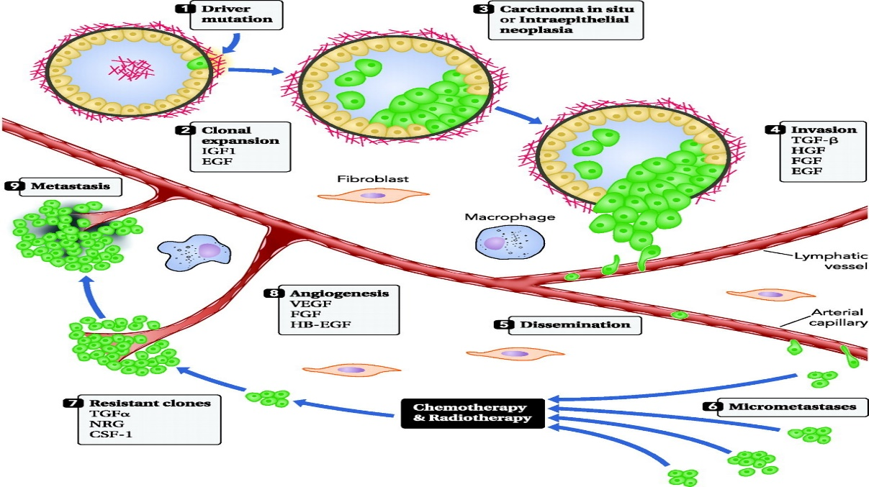
The stepwise progression of cancer and role of growth factor.
The process is instigated by a somatic mutation, which confers considerable survival and growth advantages to the initiated cell .GFs like EGF and IGF1 support the consequent expansion of mutation-bearing clones, often leading to intraluminal lesions ,such as carcinoma in situ or intraepithelial neoplasia, which are surrounded by the basal membrane. Invasion refers to the migration and penetration by cancer cells into neighboring tissues. This process involves loss of epithelial polarity, acquisition of a motile, mesenchymal-like phenotype, and secretion of proteases. Both oncogenes and tumor suppressors, along with a large group of GFs, control this critical phase of tumor development. Cancer cells enter (extravasation) and exit (intravasation) lymphatic and blood vessels to disseminate and metastasize to distant organs. Extra- and intravasation entail the supporting functions of macrophages, platelets, and endothelial cells. The resulting micro metastases usually display sensitivity to chemotherapy and radiotherapy. However, the acquisition of new mutations and the ability of cancer cells to produce GFs (autocrine loops) propel the outgrowth of resistant clones. Angiogenesis is essential for the establishment of secondary tumors larger than 1 ml. Both sprouting of existing vessels and recruitment of bone marrow-derived endothelial progenitor cells are stimulated by GFs secreted by tumor and stromal cells. In the final phase, relatively large metastases populate a distinct set of target organs. A latency period of several years may precede this final phase. CSF-1, colony stimulating factor 1; EGF, epidermal growth factor; FGF, fibroblasts growth factor; HB-EGF, heparin-binding EGF; NRG, neuregulin; TGF, transforming growth factor; VEGF, vascular endothelial growth factor.
The major signaling pathways stimulated by receptor tyrosine kinases (RTKs) and TGF-β receptors are shown schematically. Note that TGF-β can stimulate both the canonical pathway, and non-canonical pathways (not shown), including some components which are listed here under RTK. Activation of the phospholipid PI3K pathway may be achieved by binding of the regulatory p85 subunit to an activated RTK or through the activation of the small GTP-binding protein RAS. On activation, PI3K induces formation of phosphatidylinositol -phosphate (PIP₃), which serves as a docking site for proteins containing phospholipid-binding domains (e.g., PH domains), including protein kinase B and AKT. Recruitment of AKT to the membrane enables its phosphorylation on two stimulatory residues; one of these phosphorylation events (threonine-308) is mediated by PDK, whereas the other (serine-473) is mediated by mTorC2. PTEN and INPP4B are phosphatases that abolish AKT activation and act as tumor suppressors. AKT has many substrates that regulate mainly survival and metabolism. One example is the proapoptotic protein BAD, which is inhibited following phosphorylation by AKT. BAD induces permeabilization of the mitochondrial membrane to enable release of cytochrome C. The latter is involved in the generation of a protein complex known as the apoptozole, which cleaves pro-caspases to generate the active form of caspase 9. The ERK pathway is a multiple layer kinase cascade, in which the most distal MAPK elements are activated on tyrosine/threonine phosphorylation. In the ERK1/2 kinase pathway, binding of a ligand to an RTK enables auto-phosphorylation and recruitment of adaptors like GRB2 and SHC. The adaptors mediate recruitment of a GTP/GDP exchange protein, SOS, which loads GTP onto RAS. Active, GTP-loaded RAS molecules stimulate RAF kinases, which instigate the cascade leading to MEK (MAPK kinase) and then to ERK activation. Active ERK molecules translocate to the nucleus to stimulate multiple transcription programs essential for cell cycle progression and cell migration. The phospholipase Cu-protein kinase C (PKC) pathway is instigated on recruitment of Plc to ligand-bound receptors. The activated enzyme hydrolyzes phosphatidylinositol 4,5-bisphosphate (PIP₂) to form two second messengers, diacylglycerol (DAG) and inositol 1,4,5-triphosphate (IP₃). Binding of IP₃ to receptors on the membrane of the endoplasmic reticulum leads to Ca²⁺ release. Free cytosolic calcium ions, together with DAG, activate members of the protein kinase C (PKC) family, resulting in the phosphorylation of various effector proteins. In addition, cytosolic Ca²⁺ activates the calcium/calmodulin-dependent protein kinases and phosphatases. The SMAD signaling pathway is the canonical signaling pathway of TGF-β family members. TGF-β dimers bind to a type II receptor, which recruits and phosphorylates a receptor-regulated SMAD (R-SMAD). R-SMAD then binds to the common SMAD (SMAD4) to form a heterodimeric complex. This complex then translocate into the nucleus, where it acts as a transcription factor.
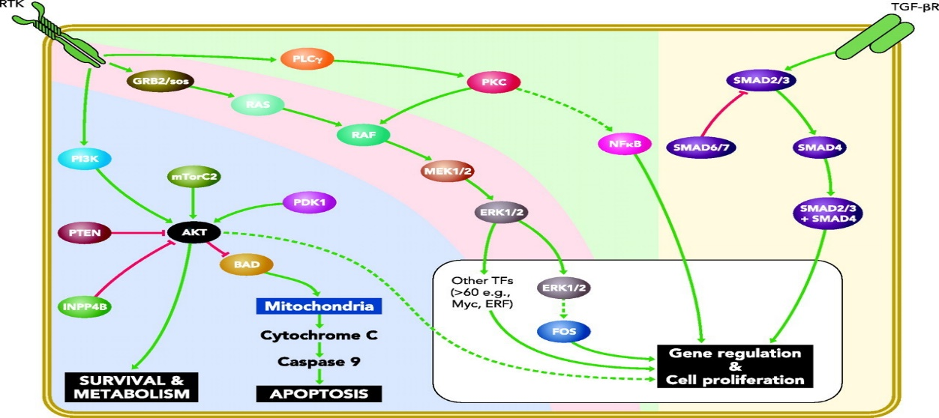
Major signaling pathways stimulated by growth factors and their receptors
Autonomous cell growth and clonal expansion:
GFs are essential for clonal expansion, which permits fixation of oncogenic mutations, as well as increases the pool of initiated cells susceptible to additional mutations. Unlike the paracrine (heterotypic) mode of action of GFs that dominates physiological processes like embryogenesis and wound healing, many cancer cells acquire the ability to synthesize GFs to which they are responsive .Along with such autocrine loops, several distinct mechanisms may lead to constitutive pathway activation in tumors. At the receptor level, overexpression may enable cancer cells to become hyper-responsive to GFs (e.g., EGFR in head and neck cancer, and ErbB-2/HER2 in breast cancer), whereas specific mutations or deletions can elicit ligand-independent signaling (e.g., brain tumor mutants of EGFR) . Mutations affecting downstream mediators may similarly confer growth autonomy. For instance, RAS mutations characterize up to 25% of human cancers, and mutational inactivation of a TGF-β effector, SMAD4/DPC4, is abundant in pancreatic tumors.
Accelerated intraepithelial proliferation:
Morphologically recognizable, putative precursor lesions to cancer have been described, for example in breast [ductal carcinoma in situ (DCIS)] and in prostate cancer [prostate intraepithelial neoplasia (PIN). An important feature of intraepithelial lesions is the integrity of the surrounding basement membrane. Intraluminal cell proliferation, along with disruption of epithelial polarity and aneuploidy, commonly associates with molecular markers consistent with aberrant GF and hormone signaling. Thus ErbB-2/HER2, a close relative of ErbB-1/EGFR, is overexpressed in 40% of DCIS and up to 70% of the high-grade group .Likewise, ∼20% of high-grade PIN lesions harbor a TMPRSS2-ERG fusion gene , which is a common abnormality detectable in up to 50% of prostate cancers. ERG belongs to the ETS family of oncogenic transcription factors, which undergo activation on stimulation of GF receptors and phosphorylation by several MAPKs.
GF-induced basement membrane breakdown and invasive growth
Tumor progression is licensed only when the basement membrane decorating secretory ducts undergoes dissolution. GFs play critical roles in basement membrane disruption, penetration by cancer cells into neighboring tissues, the vascular or lymphatic systems (intravasation), as well as their departure from the bloodstream (extravasation) and subsequent colonization of distant organs. The conversion of tightly packed polarized epithelial cells into motile individual cells, denoted epithelial-mesenchymal transition (EMT), herald’s tumor spread. Autocrine GFs and genetic aberrations that mimic GF binding, in which case GF binding becomes needless, leading to constitutive signaling via the tyrosine kinase domain, may provide the second hits that propel EMT and eruption of intracellular lesions. For example, studies performed with clinical specimens and ErbB-2/HER2-overexpressing spheroids resembling mammary DCIS raised the possibility that TGF-β, or overexpression of the adaptor 14-3-3-zeta , underlay invasive growth. Based primarily on in vitro models, it appears that TGF-β and other growth factors implicated in such transitions (e.g., the hepatocyte and the fibroblast growth factors; HGF and FGFs) enhance the invasive potential of cancer cells by upregulating secreted proteases (e.g., the matrix metalloproteinases MMP-2 and MMP-9) and downregulating protease inhibitors . In parallel, GFs induce several molecular switches of adhesion, such as the loss of the epithelial E-cadherin and gain of the mesenchymal N-cadherin. Another molecular switch replaces tensin-3, linker of the actin cytoskeleton and the extracellular matrix, with tensin-4 (also called ten for c-terminal -like protein), thereby disrupting the bridge and enhancing cell migration. In most epithelial cancers, the dual growth arrest and adhesive functions of E-cadherin are lost through mutational inactivation, transcriptional repression, or proteolysis of the extracellular cadherin domain. A variety of GFs, including TGF-β and EGF, as well as cleaved Notch proteins, induce the expression of potent E-cadherin repressors (e.g., ZEB-2 and Twist). On the other hand, cleavage, ubiquitylation, and endocytosis of E-cadherin are among the inducible means that downregulate E-cadherin.
EMT involves the functional transition of polarized epithelial cells into a polar and motile cell, which resemble fibroblasts and secrete extracellular matrix (ECM) components. Commonly used epithelial and mesenchymal cell markers are listed. Note that intermediate phenotype representing transition states occur in tissues., COOH-terminal tensin-like molecule; FOXC2, box C2; FSP-1, fibroblast-specific protein 1; LEF-1, lymphoid enhance factor 1;, microRNA; MUC1, mucin 1; ZEB-2, E-box zinc-binding protein; ZO-1, .
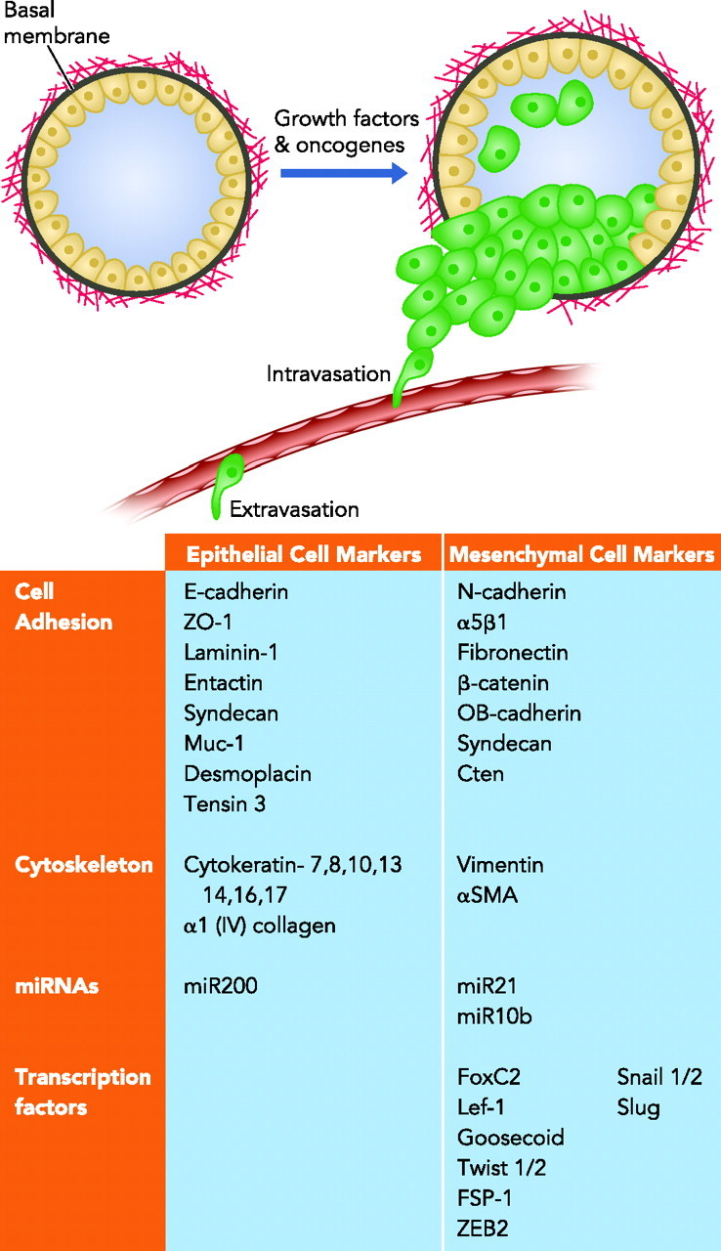
Molecules associated with the epithelial-mesenchymal transition (EMT)
Intravasation, extravasation, and dissemination:
Paracrine interactions among cancer cells, macrophages, and endothelial cells critically facilitate intravasation of post-EMT cells. For example, mammary cancer cells secrete the colony-stimulating factor 1 (CSF-1), which attracts macrophages to tumors and increases local secretion of macrophage-derived GFs. Because macrophages are often found near micro vessels, this self-stimulatory loop enhances intravasation. The hypoxic and inflammatory conditions that occur during tumor progression increase secretion of TGF-β by macrophages. TGF-β-mediated induction of angiopoietin-like 4 (ANGPTL4) in breast cancer cells enables retention of tumor cells in the lungs, because ANGPTL4 enhances the permeability of lung capillaries and facilitates the trans-endothelial passage of tumor cells .Once in the circulation, tumor cells adhere to platelets, especially on stimulation by thrombin, thereby gaining mitogenic stimuli (e.g., PDGF and lysophosphatidic acid) and protection from natural killer cells . Another stromal source of pro-metastasis cytokine is cancer-associated fibroblasts (CAFs). Animal studies demonstrated that CAFs co-injected with pancreatic tumor cells increased their metastasis, and mesenchymal stem cells co-injected with mammary cells similarly promoted metastasis via a paracrine loop involving the chemokine CCL5/RANTES . In line with clinical significance, a gene expression signature based on laser microdissection of the stroma reported prognostic value of angiogenic, immune, and hypoxic responses. In conclusion, paracrine loops involving stromal myeloid, endothelial, and mesenchymal cells complement the autocrine mechanisms of cancer cell stimulation.
GF-induced evasion from cytotoxic therapies:
Some tumor types display 20-year or longer dormancy period (the time between primary tumor diagnosis and detectable metastatic outgrowth), thought to reflect adaptation of disseminated tumor cells to the new microenvironment. In the clinical setting of patients heavily treated with cytotoxic drugs, survival is a formidable challenge for micro metastases. Intrinsic resistance to anti-proliferative and death signals (e.g., TRAIL) is a well-studied hallmark of cancer, which often involves the retinoblastoma protein and E2Fs, transcription factors that control gene expression essential for cell proliferation. Resistance to apoptosis can also be acquired by cancer cells through the loss of a proapoptotic regulator, as is the case when the p53 tumor suppressor gene is mutated. In addition, the PI3K-AKT pathway, which transduces antiapoptotic signals, is often involved in weakening therapy-induced apoptosis in human tumors. This antiapoptotic survival pathway likely underlies the extensive involvement of GFs like IGF-1, as well as several EGF-like ligands, in evasion from apoptosis. As will be discussed below, blocking GF-mediated evasion from cell death bears clinical implications. Early studies indicated that anti-EGFR antibodies can sensitize tumors to chemotherapy, probably by blocking apoptosis evasion. This finding was later translated to combination therapies of colorectal and head and neck cancer patients.
GF-induced angiogenesis:
The generation of new vessels is critical for tumor growth beyond few millimeters of size. New vessels are formed either by mature endothelial cells (angiogenesis) or by bone marrow-derived endothelial progenitor cells (EPCs), which are home to foci of angiogenesis (vasculogenic). Growth factors like the vascular endothelial growth factors (VEGFs), FGFs, and TGF-β play important roles in both vasculogenic and angiogenesis, and VEGF antagonists limit angiogenesis in animals and in patients. EPCs regulate the angiogenic switch through paracrine secretion of proangiogenic GFs as well as by direct luminal incorporation into sprouting nascent vessels. Mobilization of circulating progenitors and other endothelial cells to tumors emerges as a critical step in tumor progression. For example, CAFs promote NE angiogenesis by recruiting EPCs into tumors, an effect mediated in part by their ability to secrete stromal cell-derived factor 1 (SDF-1). Furthermore, Kerbela and associates reported that cancer therapy, including high-dose chemotherapy, could induce mobilization of EPCs to the viable rim of tumors.
Growth Factor Families Involved in Tumor Progression
Neuregulin’s and the EGF family
The family comprises eleven polypeptides sharing a conserved EGF domain. All EGF family members, like many other GFs, such as HGFs, are derived from membrane-bound precursor proteins. For instance, processing of the membrane-anchored Spitz, an EGF homolog in Drosophila, is essential for neurogenesis. Another example, HGF is inactive until activation is caused by a proteolytic cleavage in the single-chain HGF precursor, generating an active two-chain heterodimeric form. The activation of HGF in the extracellular milieu is a critical limiting step in HGF-induced signaling and controls bioavailability that is believed to have important roles in invasive growth of tumor cells and regeneration of injured tissues. All EGF family members bind to a group of four receptor tyrosine kinases, namely ErbB-1/EGFR through -4 (also called HER1–4). Like other tyrosine kinases, each ErbB molecule comprises an extracellular domain to allow ligand binding, a single transmembrane part, and an intracellular protein tyrosine kinase domain. It is important noting that not all ErbB receptors act autonomously: ErbB-2 (also called HER2 and Neu) binds no known EGF-like ligand, and ErbB-3 shows no tyrosine kinase activity . Hence, their activity is restricted to the formation of heterodimers with other ErbB receptors. Nevertheless, because heterodimers evade negative regulation, their signaling is stronger and longer than signals transmitted by the corresponding homodimers. Under normal conditions, the ErbB receptors are folded such that dimerization is prevented. Only on ligand binding does the conformation of the extracellular domain change to expose a dimerization loop in a way that allows dimerization. What follows is the juxtaposition of the tyrosine kinase domain in a head-to-tail configuration that removes and trans phosphorylates an inhibitory carboxyl terminal tail. Phosphorylation of the tail leads to the recruitment of downstream signaling proteins to initiate dimer-specific signaling and transcription cascades. Translocation of receptor fragments, or full molecules , to the nucleus may directly regulate transcriptional programs.
Along with autocrine loops involving an EGF-like ligand, mutation, amplification, or dysregulation of at least one of the ErbB family members has been identified in >20% of solid tumors. For example, ∼50% of glial tumors harbor EGFR gene amplification, and a large fraction of these also present Egeria, a mutant lacking a portion of the extracellular domain . Despite its inability to bind soluble ligands, Egeria exhibits constitutive tyrosine phosphorylation and multiple downstream signaling pathways. Stimulatory EGFR mutations that concentrate at regulatory regions within the kinase domain are found in at least 10% of non-small cell lung cancer patients .ErbB-2/HER2 rarely presents tumorigenic point mutations in tumors , but amplification of the corresponding portion of chromosome 17 is a feature of 20–25% of metastatic breast cancers, and it associates with worse prognosis . Overexpression of ErbB-2 was also observed in ovarian cancer, stomach cancer, and aggressive forms of uterine cancer. ErbB-3 is frequently expressed in human mammary tumors along with ErbB-2, and overexpression of neuregulin’s, the natural ligands for ErbB-3 and ErbB-4, leads to increased tumorigenicity. Recent work demonstrated ErbB-4 mutations in 19% of individuals with melanoma . Seven missense mutations were identified, and they resulted in increased kinase activity and transformation ability.
Insulin-like growth factors:
The insulin-like growth factor (IGF) axis consists of two cell surface receptors (IGF1R and IGF2R), two ligands (IGF1 and IGF2), a family of six high-affinity IGF binding proteins (IGFBP1–6), as well as associated IGFBP degrading enzymes. IGF1 is produced primarily in the liver under the control of the growth hormone. IGF1 plays an important role in childhood growth, and it exerts anabolic effects in adults. Almost all circulating IGF1 molecules are constitutively bound to an IGFBP, which attenuates the bioactivity of these GFs. The action of IGF1 is mediated by binding to two receptor tyrosine kinases, IGF1R and the insulin receptor (at low affinity), as well as their heterodimers. On the other hand, IGF2 can bind IGF1R, and it is the sole ligand for the IGF2R/mannose 6-phosphate receptor.
Early studies by Basra and collaborators used fibroblast cell lines from mouse embryos homozygous for a targeted disruption of the IGF1R gene and demonstrated resistance to malignant transformation by several (not all) oncogenes . Based on this and other studies, it is currently assumed that, although the IGF1 axis may not generate strong oncogenic signals, its intactness is essential for survival of transformed cells. It is notable that the receptors of the IGF axis are expressed on most types of tumors, and by recruiting the PI3K-AKT pathway IGF1R generates extremely potent anti-apoptotic signals. Amplification of the IGF1R locus has been reported in a small number of breast and melanoma cases . In addition, a strong positive association was observed between plasma IGF1 levels and prostate cancer risk . In the same vein, mammographic density studies have shown the importance of the IGF1 axis in the generation of these lesions, which represent a strong risk factor for breast cancer . Like IGF1, animal models support involvement of IGF2 in tumor development , and the corresponding imprinted gene has been linked to several neoplasia’s, including Wilms' tumors and colorectal cancer.
Transforming growth factor-β
TGF-β exists in three isoforms (TGF-β1, TGF-β2, and TGF-β3), but the extended superfamily includes more than 30 additional cytokines, classified into several subfamilies [e.g., bone morphogenetic proteins (BMPs) and activins]. Some cells secrete and respond to TGF-β in an autocrine manner. This cytokine induces a cytostatic effect on many epithelial cell types, and it is also able to control proliferation, differentiation, and programmed cell death in most other cell types because the receptors, heterotetrametric serine/threonine kinases, are widely expressed in derivatives of all three embryonic cell layers. Receptor signaling is regulated both positively, by metalloproteinases that cleave a latent form of the ligand, and negatively, by a cell surface antagonist called Bambi .The receptors play an important role in apoptosis by signaling through the SMAD pathway. In the SMAD pathway, TGF-β dimers bind to a type II receptor, which recruits and activates a type I receptor by phosphorylation. Consequently, the type I receptor recruits a receptor-regulated SMAD (R-SMAD). For instance, SMAD3, an R-SMAD, has been shown to induce apoptosis by binding to SMAD-4 (a common SMAD), translocating into the nucleus and acting as a transcription factor. TGF-β can also trigger apoptosis through death-domain-associated protein 6 (DAXX) .
Under normal physiological conditions, TGF-β prevents the ability of cells to progress through the cell cycle, and it stimulates apoptosis or differentiation. During tumorigenesis, however, genetic and epigenetic events can convert TGF-β into a tumor promoter. Accordingly, a survey of mammary tumors reported that TGF-β1 staining is positively associated with rate of disease progression . Similarly, high TGF-β-SMAD activity confers poor prognosis in patients with glioma .TGF-β activates epithelial-mesenchymal transition (EMT) through activation of both the canonical (i.e., SMAD2/3-dependent) and the noncanonical (i.e., SMAD2/3-independent) pathways . In line with this, SMAD4 deficiency abrogated mammary cell metastasis to the bone in response to TGF-β . On the other hand, several lines of evidence indicate that the noncanonical TGF-β signaling also plays an essential role in mediating TGF-β stimulation of EMT, invasion, and metastasis . This pathway includes RAS/MAPK, PI3K/AKT, RHO/ROCK, Jagged/Notch, WNT/β-catenin, and mTOR .
The oncogenic activities of TGF-β are mediated by dysregulated autocrine and paracrine signaling networks involving epithelial, fibroblast, endothelial, and immune cells that subtly promote tumor angiogenesis and metastasis as well as inhibit host immunosurveillance. The pro-angiogenic functions of TGF-β have been linked to its ability to regulate the expression and/or activities of other angiogenic factors, such as FGF and VEGF . Likewise, stromal fibroblasts may determine whether TGF-β suppresses or promotes tumor formation. For example, conditional inactivation of the TGF-β type II receptor gene in mouse fibroblasts resulted in epithelial lesions of the prostate and the forestomach, presumably by activation of paracrine HGF signaling.
VEGFs
VEGFs regulate both vasculogenic and angiogenesis. The family consists of five glycoproteins, VEGFA (=VEGF), VEGFB, VEGFC, VEGFD, and PlGF (placenta growth factor). In addition, alternative exon splicing generates four VEGF isoforms. Multiplicity also characterizes the respective surface receptors, co-receptors like neuropil ins (NPs) and proteoglycans, as well as the downstream signaling pathways. The VEGF family members bind to at least one of the three known VEGFRs, namely VEGFR-1 (FLT-1), VEGFR-2 (FLK-1 or KDR), and VEGFR-3 (FLT-4). VEGFA binds to VEGFR-1 and VEGFR-2, whereas VEGFB and PlGF bind exclusively to VEGFR-1. VEGFR-2 seems to mediate most known cellular responses to VEGF and has much higher intracellular signaling intermediates than VEGFR-1 . Unlike VEGFR-3, which is largely restricted to lymphatic endothelial cells, both VEGFR-1 and VGFR-2 are expressed in vascular endothelial cells, as well as monocytes, macrophages (VEGFR-1), and hematopoietic stem cells (VEGFR-2). Importantly, expression of VEGFR-1 and VEGFR-2, as well as the co-receptors NP1 and NP2, has been detected on subsets of solid tumor cells, and according to a recent study activation of VEGFR-1 in breast cancer cells supports their growth and survival .
VEGFRs control angiogenesis by simultaneous signaling through several intermediates: cell proliferation and vasopermeability are stimulated by the protein kinase C pathway, cell survival and proliferation by the AKT and MAPK pathway, and cell migration results from signaling through SRC and Paxillin. Other than the proangiogenic effects, VEGF exerts effects independent of vascular processes, such as autocrine effects on tumor cell function (i.e., survival, migration, invasion), immune suppression, and recruitment of bone marrow progenitors. The latter may dictate organ-specific tumor spread by homing to tumor-specific premetastatic sites and forming clusters that provide a permissive niche for incoming tumor cells.
Cancer Therapeutics Targeting Growth Factor Signaling
The understanding gained over the last 25 years on the roles played by GFs in progression of solid tumors has transformed the discipline of clinical oncology in multiple ways, including disease stratification, prognosis, and ultimately cancer therapy. A new class of treatment, called molecular targeted therapy, has joined over the last decade the classical pillars of cancer treatment, namely chemotherapy and radiotherapy. Like its predecessor, hormonal therapy, targeted therapy intercepts signaling pathways by making use of highly specific drugs, such as tyrosine kinase inhibitors (TKIs) and monoclonal antibodies (abs). These drugs are characterized by relatively mild adverse effects and optimum, rather than maximum, tolerable doses .Although their targets differ, responses to targeted drugs are often low/moderate, but they can be enhanced by combining the drugs with chemo- or radiotherapy (6). Another general lesson learned while applying the new drugs in oncology wards relates to patient's resistance, which may be primary or acquired, namely evolving in a few months or years .Mechanisms underlying resistance remain poorly understood, but in a few cases they have been attributed to compensatory circuits, such as enhancement of IGF1R signaling in breast cancer patients treated with an anti-ErbB-2/HER2 antibody , or to preemptive downstream mutations, such as K-RAS mutations conferring primary resistance to anti-EGFR antibodies . What follows is a concise description of targeted therapies aimed at intercepting some major GF pathways involved in epithelial tumor progression.
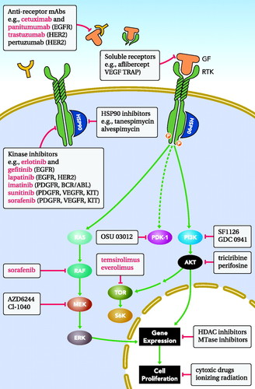
A scheme showing the major therapeutic strategies aimed at blocking growth factor signaling in cancer. The strategies include monoclonal antibodies (abs) against the GFs and their receptors, soluble receptors (TRAPs): small molecule tyrosine kinase inhibitors (TKIs), blockers of heat shock proteins (HSPs), antagonists of specific signaling pathway proteins, as well as inhibitors of histone deacetylases (HDACs) and methyl-transferase (Mutase).
Clinical interceptors of the EGFR/HER2 network:
The mAb cetuximab is a human-mouse anti-ErbB-1 chimeric IgG1 antibody, which has shown efficacy in colorectal cancer and in head and neck cancer. Cetuximab binds to the ligand-binding domain of ErbB-1 and prevents dimerization and subsequent activation by autophosphorylation. Panitumumab is a fully human IgG2 antibody specific to ErbB-1, which is effective and well tolerated in colorectal cancer. Nimotuzumab is yet another humanized mAb that inhibits EGF binding and shows effectiveness in nasopharyngeal cancer and in glioma. One striking feature of Nimotuzumab is the absence of severe adverse effects, such as skin rash, which commonly associate with similar mAbs to EGFR. Low toxicity of nimotuzumab might be due to intermediate affinity and incomplete abrogation of the active conformation . Trastuzumab is an ErbB-2/HER2-specific mAb, which was approved in 1998 for the treatment of metastasizing breast cancer, only if tumors overexpress ErbB-2/HER2 and secrete no soluble version of this protein . By suppressing ErbB-2/HER2 signaling, trastuzumab interferes with cell cycle control, angiogenesis, and the PI3K pathway. Another mechanism of action of trastuzumab involves the induction of antibody-dependent cell-mediated cytotoxicity (ADCC) .Yet another potential mechanism entails antibody-induced degradation of ErbB-2/HER2, a process enhanced on combining two antibodies directed at distinct sites of the oncoprotein . Compared with mAbs, TKIs are low molecular weight mimics of ATP, whose mechanism of action is clear but target specificity quite broader. Along with mono-specific inhibitors like the EGFR inhibitor erlotinib (approved for treatment of lung and pancreatic cancer), pan-ErbB, or dual-specificity TKIs, like lapatinib, show encouraging clinical efficacies. Moreover, lapatinib holds promise for treatment of trastuzumab-resistant patients . Another class of experimental therapeutics comprises inhibitors of heat shock proteins (HSPs), chaperones involved in the folding and conformational maturation of signaling proteins, including ErbB-2. Disruption of HSP90 results in ubiquitylation and proteasomal degradation of ErbB-2, leading to abrogation of the PI3K/AKT and cyclin D pathways .
Experimental interceptors of the IGF1 axis
Although no drug targeting the IGF1 axis has entered clinical use, many candidates TKIs and mAbs are being tested in clinical trials . For example, BMS-554417 is a dual TKI of both IGF1R and insulin receptor, which can induce cell cycle arrest, prevent nuclear accumulation of cyclin D1, and reduce tumor xenograft size .Currently, extensive efforts focus on mAbs to IGF1R, such as CP-751,871 . Due to the metabolic effects of the IGF1 axis and cross talk with the insulin receptor, adverse effects are considered a major concern. For example, treatment with CP-751,871 increased serum insulin and human growth hormone levels, with modest increases in serum glucose levels.
Targeting TGF-β signaling
The functional duality of TGF-β in tumor progression requires inhibition in advanced metastatic cancer, while retaining the growth inhibitory abilities exhibited in early stages of tumorigenesis. One approach employs the antisense oligodeoxynucleotide AP 12009, a synthetic 18-mer phosphonothioate oligodeoxynucleotide, which is complementary to the sequence of the TGF-β2 mRNA . Promising results were obtained in phase I clinical trials of AP 12009 performed in recurrent or refractory glioma patients. In laboratory studies, administration of a TGF-β neutralizing antibody has been demonstrated to restore natural killer cell activity and to reduce metastasis . Potentially, CAT-192 (Metelimumab), a human antibody that neutralizes TGF-β is a candidate agent. Likewise, preclinical studies employing a dominant-negative mutant approach identified TGF-βR2 as a target. Hence, it is likely that future attempts to inhibit the pathway will involve, in addition to antisense oligonucleotides and antibodies, also kinase inhibitors specific to TGF-βR2.
Targeting of VEGF signaling pathways
Two early lines of preclinical evidence identified VEGF and the respective receptors as effective targets for cancer therapy: a neutralizing anti-VEGF antibody suppressed both sarcomas and a glioblastoma, as well as angiogenesis in mouse xenograft models ,and a dominant-negative form of VEGFR2 similarly inhibited a glioblastoma xenograft in animals .The original murine antibody was later humanized (bevacizumab) and approved for treatment of colorectal and other tumors. Other anti-angiogenesis compounds under development are a soluble receptor able to sequester three different ligands, an antisense oligonucleotide able to inhibit several VEGFs, anti-VEGFR2 antibodies, an aptamer to the most abundant isoform of VEGF, and an anti-PlGF antibody that showed promising results in animal models .In addition, several TKIs with selectivity to VEGFRs have been approved: The TKI sorafenib was approved for patients with hepatocellular carcinoma and renal cell carcinoma (RCC) , and sunitinib was also approved for patients with RCC. As is the case for all kinase inhibitors, the TKIs target several VEGFRs, as well as several related tyrosine kinases . The mechanisms of action of VEGF-targeted therapies variably include inhibition of new vessel growth, induction of endothelial cell apoptosis, blockade of the incorporation of hematopoietic and endothelial progenitor cells, and direct effects on target tumor cells. Patients treated with VEGF inhibitors may experience longer survival, but they eventually succumb to their disease. Acquired resistance may be attributed to VEGF-unrelated angiogenic factors allowing disease progression (e.g., PDGF-B and angiopoietin-1), switching of the tumor vasculature into drug-resistant mature vessels, or emergence of hypoxia-resistant tumor cell variants carrying mutations in p53 or in other genes .

Concluding Remarks:
Some remarkable leaps into cancer progression have been accomplished, since the early discovery of GFs by Rita Levi-Montalcini and Stanley Cohen. Beyond the isolation of many other GFs and the elucidation of the respective autocrine loops in tumors, we now understand that paracrine loops involving myeloid, mesenchymal, and endothelial cells fulfill equally important functions in cancer progression. Consequently, the emerging high content picture of tumor progression is bound to rival the complexity of GFs' contributions to embryonic development , and similarly to embryos it portrays tumors as extensions of host tissues. And although a continuum of cancer genome, tumor biology, and signaling networks remain beyond reach, it is already clear that the integrated outcome will change the way cancer is being diagnosed and treated. Indeed, pharmaceutical interceptors of GF signaling first hit oncology wards some 12 years ago, but although their number rises steadily, the promises attached to the new drugs come with great challenges: optimal scheduling and combination with cytotoxic regimens lack conceptual grounds, as do the understanding of patient resistance to therapy and the dynamic impact of GFs on tumor progression. Nevertheless, recent glimpses into the vibrant future of translational GF research bear optimism. This may be exemplified by the application of anti-EGFR antibodies in colorectal cancer: whereas the antibodies are only weakly active in patients, it was their combination with chemotherapy that permitted approval and clinical application in 2004. In 2007, we learned that K-RAS mutations confer resistance to the antibody, which enabled elimination of a large fraction of non-responders. On the other hand, reports of the last 1–2 years propose that best responses are achieved in patients whose tumors present autocrine loops of EGFR. Similar knowledge-based spirals of refined patient selection and identification of resistance mechanisms will likely result in powerful drugs, which are active on biologically defined but relatively small cohorts of patients.

