Computer:
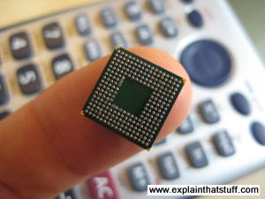
Photo: Computers that used to take up a huge room now fit comfortably on your finger!.
A computer is an electronic machine that processes information—in other words, an information processor: it takes in raw information (or data) at one end, stores it until it's ready to work on it, chews and crunches it for a bit, then spits out the results at the other end. All these processes have a name. Taking in information is called input, storing information is better known as memory (or storage), chewing information is also known as processing, and spitting out results is called output.
Imagine if a computer were a person. Suppose you have a friend who's really good at math. She is so good that everyone she knows posts their math problems to her. Each morning, she goes to her letterbox and finds a pile of new math problems waiting for her attention. She piles them up on her desk until she gets around to looking at them. Each afternoon, she takes a letter off the top of the pile, studies the problem, works out the solution, and scribbles the answer on the back. She puts this in an envelope addressed to the person who sent her the original problem and sticks it in her out tray, ready to post. Then she moves to the next letter in the pile. You can see that your friend is working just like a computer. Her letterbox is her input; the pile on her desk is her memory; her brain is the processor that works out the solutions to the problems; and the out tray on her desk is her output.
Once you understand that computers are about input, memory, processing, and output, all the junk on your desk makes a lot more sense:
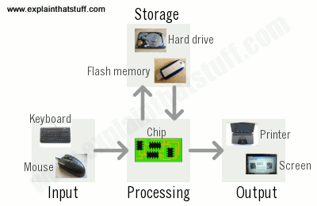
Artwork: A computer works by combining input, storage, processing, and output. All the main parts of a computer system are involved in one of these four processes.
- Input: Your keyboard and mouse, for example, are just input units—ways of getting information into your computer that it can process. If you use a microphone and voice recognition software, that's another form of input.
- Memory/storage: Your computer probably stores all your documents and files on a hard drive: a huge magnetic memory. But smaller, computer-based devices like digital cameras and cellphones use other kinds of storage such as flash memory cards.
- Processing: Your computer's processor (sometimes known as the central processing unit) is a microchip buried deep inside. It works amazingly hard and gets incredibly hot in the process. That's why your computer has a little fan blowing away—to stop its brain from overheating!
- Output: Your computer probably has an LCD screen capable of displaying high-resolution (very detailed) graphics, and probably also stereo loudspeakers. You may have an inkjet printer on your desk too to make a more permanent form of output.
Satellite:
A satellite doesn't necessarily have to be a tin can spinning through space. The word "satellite" is more general than that: it means a smaller, space-based object moving in a loop (an orbit) around a larger object. The Moon is a natural satellite of Earth, for example, because gravity locks it in orbit around our planet. The tin cans we think of as satellites are actually artificial (human-built) satellites that move in precisely calculated paths, circular or elliptical (oval), at various distances from Earth, usually well outside its atmosphere.
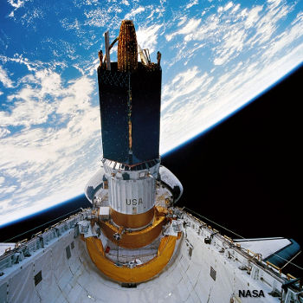
Photo: The Space Shuttle launches a communications satellite from its payload bay in 1995 by spinning it gyroscopically. You can see Earth just behind. Picture courtesy of NASA on the Commons.
The first satellite was developed by Arthur C. Clarke about 50 years ago. We put satellites in space to overcome the various limitations of Earth's geography—it helps us step outside our Earth-bound lives. If you want to make a phone call from the North Pole, you can fire a signal into space and back down again, using a communications satellite as a mirror to bounce the signal back to Earth and its destination. If you want to survey crops or ocean temperatures, you could do it from a plane, but a satellite can capture more data more quickly because it's higher up and further away. Similarly, if you want to drive somewhere you've never been before, you could study maps or ask random strangers for directions, or you could use signals from satellites to guide you instead. Satellites, in short, help us live within Earth's limits precisely because they themselves sit outside them.

What do satellites do for us?
We tend to group satellites either according to the jobs they do or the orbits they follow. These two things are, however, very closely related, because the job a satellite does usually determines both how far away from Earth it needs to be, how fast it has to move, and the orbit it has to follow. The three main uses of satellites are:
- Communications
- Photography, imaging, and scientific surveying
- Navigation

