Socio-Metric Technique: Meaning, Uses and Limitations

Meaning of Socio-Metric Technique:
Socio-metric technique or test as one of the non-testing devices was first developed by J.L. Moreno and Hellen Jennings sometimes around 1960. It is a means of presenting simply and graphically the structure of social relations, lines of communication and the patterns of friendship, attractions and rejection that exist at a given time among members of a particular group.
Through this technique the counsellor or the guidance personnel can measure acceptance or rejection frequently between the members of the group. It is commonly observed that some students always like to stay together, some students are more liked by all students, some students aren’t liked by anyone and so on. These social relationships existing among them influence all aspects of their development.
It is therefore necessary for the teacher to evaluate these social relationships that exist among the pupils or students. This socio-metric technique is a method of evaluating the social acceptance of individual students. It is grounded on individual student’s choices of friendship for some group situations or activity. In this technique one can know which student would be congenial for a working group or companions for certain work. In the playground, the teacher may ask the question to a student.
These are;
(i) Whom do you want to be your team leader?
(ii) Whom do you want to make friendship? etc.
The choice of students indicates what types of relationship they have with others.
The essential qualities or features of a socio-metric test are as follows:
(i) It is a simple and graphical presentation of data about the group.
(ii) It presents the structure of social relationship that exist among the members of the group.
(iii) It indicates the friendship pattern among group members.
(iv) It indicates the line of attraction and rejection among group members.
(v) It has always a time reference.
(vi) It indicates at the person most chosen as the leader and the person not chosen at all or the isolate.
The Techniques Followed:
(i) If the group is large divide the group into smaller subgroups consisting of ten members each.
(ii) The members of each group or sub-group may be numbered from one to ten.
(iii) Ask each member to write the name or the number of a student with whom he likes most to work, to play, or to sit etc.
He may be asked questions like this:
(a) Whom would you like to sit next to you in the class or in the bus while going out on a journey?
(b) With whom would you like to work in the science laboratory?
(c) Whom would you like to be your class monitor?
(d) With whom would you like to go home?
(e) Choices and preferences of group members can be plotted graphically with arrow marks. Marks will indicate single line or one way choice, preference, likings and acceptance while will indicate mutual choice, preference, likings, and acceptance. Each member of the group will be represented by a circle. You have now got a ‘socio-gram’.
(f) While interpreting the socio-gram, concentrate on one member at a time.
(g) The point of greatest concentration and constellation of arrow marks indicates highest number of choices and preferences. Such a member can be easily picked up as the leader.
(h) Usually close relations, neighbours and members having common interests choose each other. This should be kept in view while picking up the leader..
(i) A student who isn’t’ chosen by any other member of the group is called the isolate.
A member of the group may become isolate due to many factors such as the following:
1. He is a new member of the group.
2. He is shy and withdrawing in nature.
3. He doesn’t try to make friends.
4. He may belong either to a lower or to an upper socio-economic level.
There may be three points of greatest choices. This may indicate cliques or sharp division of the group.
It is graphically presented below:
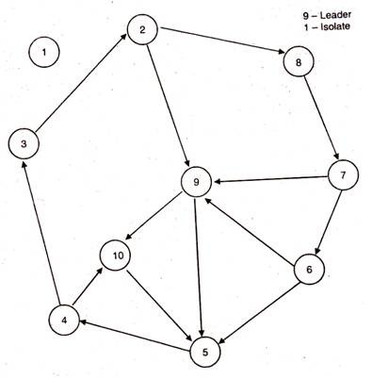
Uses of Socio-Metric Technique:
The Socio-metric technique has the following uses in the guidance programme:
(i) By studying the choice of students through socio-metric technique the teacher can determine the nature and degree of social relationship existing among the students.
(ii) It is useful in identifying those who are isolated, the one who is not preferred by any other individual.
(iii) It is also useful for identifying those who are liked by many others and who can be better leader of the group. By working with them guidance can be provided.
(iv) Socio-metric technique is more useful with small groups. The position or status of the individual is determined on the basis of some particular criterion.
(v) It is a simple, economical and natural method of observational and data collection.
(vi) Socio-metric methods are used whenever human actions like choosing, influencing, dominating and communicating in group situations are involved.
(vii) They can be employed in a wide variety of research in the laboratory as well as in the field.
(viii) They can be used to discover cheques in groups, communication and influence channels, patterns of cohesiveness and connectedness and so on.
Limitations of Socio-Metric Technique:
In spite of having the above merits or uses of this non-testing device, it is criticized in the following grounds:
(i) A data of socio-metric tests seem so different from other kind of data.
(ii) The investigators or counsellors find it difficult to think of socio-metric measurement of individuals.
(iii) The rating of one person by others is an old practice.
(iv) There are certain traits or qualities that are very difficult to be measured and if at all they are measured through observations or other tools the measurement may not be accurate and free from subjectivity.

