A guide to experimental design
Published on December 3, 2019 by Rebecca Bevans. Revised on August 4, 2020.
An experiment is a type of research method in which you manipulate one or more independent variables and measure their effect on one or more dependent variables. Experimental design means creating a set of procedures to test a hypothesis.
A good experimental design requires a strong understanding of the system you are studying. By first considering the variables and how they are related (Step 1), you can make predictions that are specific and testable (Step 2).
How widely and finely you vary your independent variable (Step 3) will determine the level of detail and the external validity of your results. Your decisions about randomization, experimental controls, and independent vs repeated-measures designs (Step 4) will determine the internal validity of your experiment.

Step 1: Define your research question and variables
You should begin with a specific research question in mind. You may need to spend time reading about your field of study to identify knowledge gaps and to find questions that interest you.
We will work with two research question examples throughout this guide, one from health sciences and one from ecology:

Example question 1: Phone use and sleep
You want to know how phone use before bedtime affects sleep patterns. Specifically, you ask how the number of minutes a person uses their phone before sleep affects the number of hours they sleep.

Example question 2: Temperature and soil respiration
You want to know how temperature affects soil respiration. Specifically, you ask how increased air temperature near the soil surface affects the amount of carbon dioxide (CO2) respired from the soil.
To translate your research question into an experimental hypothesis, you need to define the main variables and make predictions about how they are related.
Start by simply listing the independent and dependent variables.
Research question | Independent variable | Dependent variable
Phone use and sleep | Minutes of phone use before sleep | Hours of sleep per night
Temperature and soil respiration | Air temperature just above the soil surface | CO2 respired from soil
Then you need to think about possible confounding variables and consider how you might control for them in your experiment.
 | Confounding variable | How to control for it
Phone use and sleep | Natural variation in sleep patterns among individuals. | Control statistically: measure the average difference between sleep with phone use and sleep with phone use rather than the average amount of sleep per treatment group.
Temperature and soil respiration | Soil moisture also affects respiration, and moisture can decrease with increasing temperature. | Control experimentally: monitor soil moisture and add water to make sure that soil moisture is consistent across all treatment plots.
Finally, put these variables together into a diagram. Use arrows to show the possible relationships between variables and include signs to show the expected direction of the relationships.
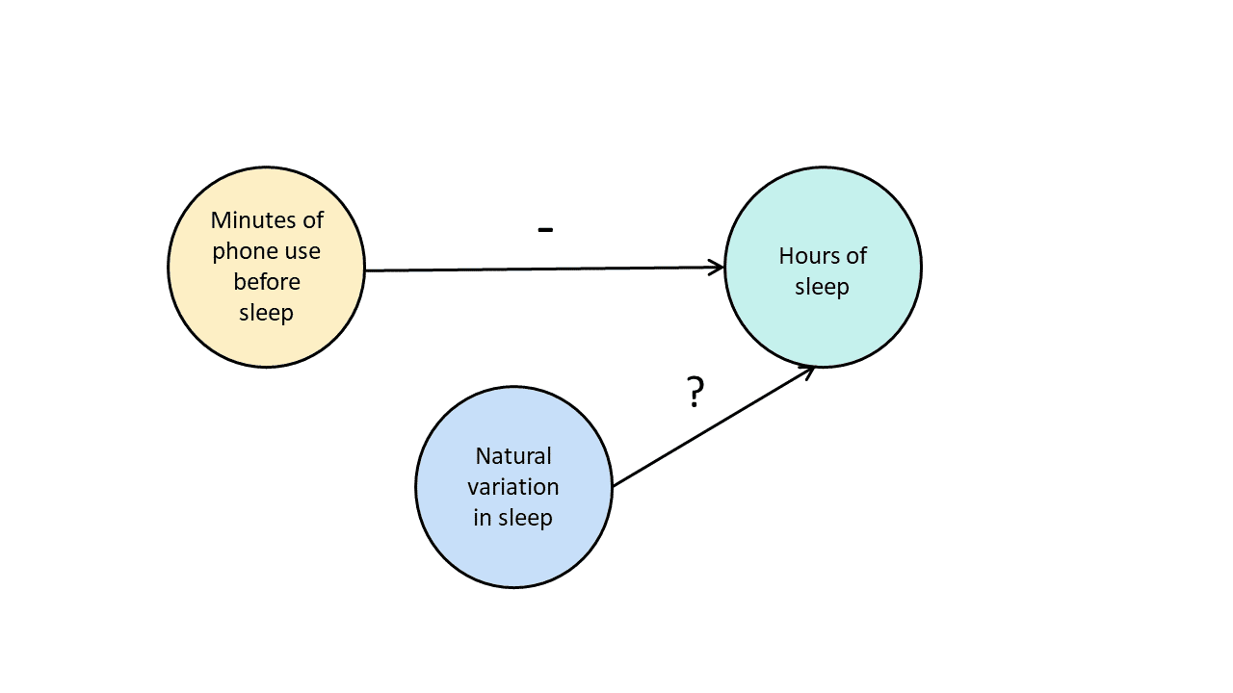
Here we predict that increasing phone use is negatively correlated with hours of sleep, and predict an unknown influence of natural variation on hours of sleep.
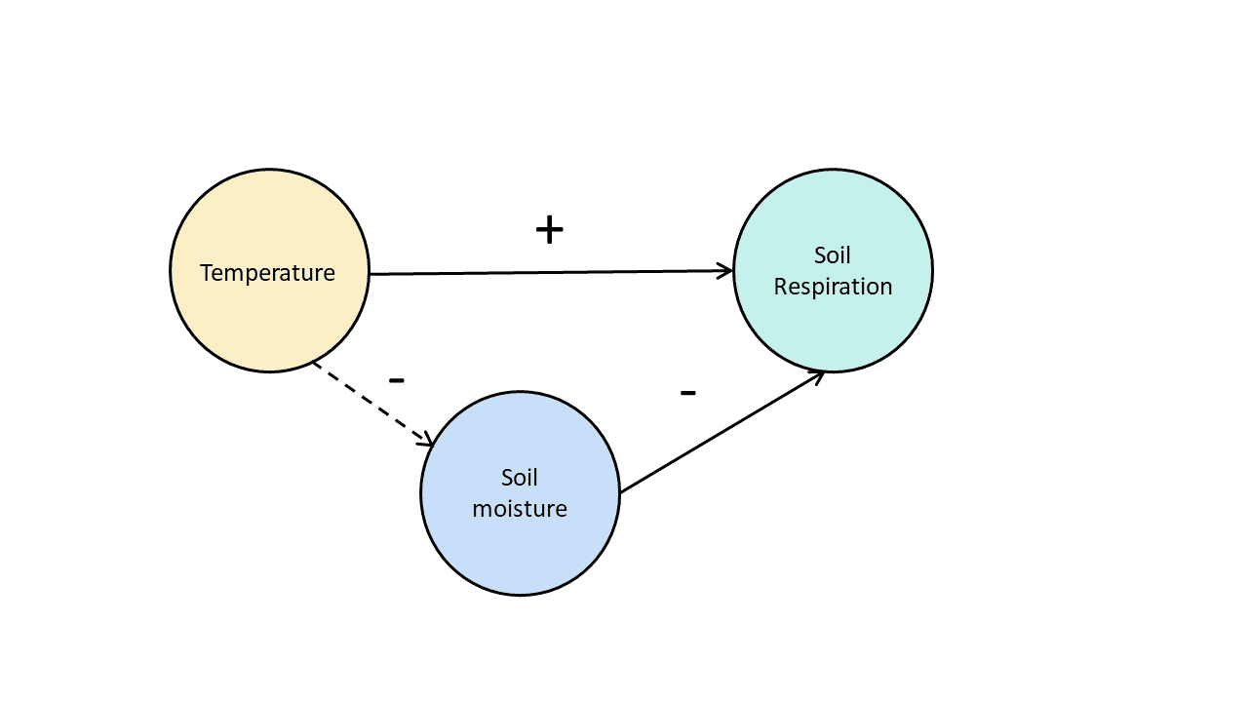
Here we predict a positive correlation between temperature and soil respiration and a negative correlation between temperature and soil moisture, and predict that decreasing soil moisture will lead to decreased soil respiration.

Step 2: Write your hypothesis
Now that you have a strong conceptual understanding of the system you are studying, you should be able to write a specific, testable hypothesis that addresses your research question.
 | Null (H₀) hypothesis | Alternate (H_{a}) hypothesis
Phone use and sleep | Phone use before sleep does not correlate with the amount of sleep a person gets. | Increasing phone use before sleep leads to a decrease in sleep.
Temperature and soil respiration | Air temperature does not correlate with soil respiration. | Increased air temperature leads to increased soil respiration.
The next steps will describe how to design a controlled experiment. In a controlled experiment, you must be able to:
- Systematically and precisely manipulate the independent variable(s).
- Precisely measure the dependent variable(s).
- Control any potential confounding variables.

Step 3: Design your experimental treatments
How you manipulate the independent variable can affect the experiment’s external validity – that is, the extent to which the results can be generalized and applied to the broader world.
First, you may need to decide how widely to vary your independent variable.

Soil-warming experiment
You can choose to increase air temperature:
- just slightly above the natural range for your study region.
- over a wider range of temperatures to mimic future warming.
- over an extreme range that is beyond any possible natural variation.
Second, you may need to choose how finely to vary your independent variable. Sometimes this choice is made for you by your experimental system, but often you will need to decide, and this will affect how much you can infer from your results.

Phone-use experiment
You can choose to treat phone use as:
- a categorical variable: either as binary (yes/no) or as levels of a factor (no phone use, low phone use, high phone use).
- a continuous variable (minutes of phone use measured every night).

Step 4: Assign your subjects to treatment groups
How you apply your experimental treatments to your test subjects is crucial for obtaining valid and reliable results.
First, you need to consider the study size: how many individuals will be included in the experiment? In general, the more subjects you include, the greater your experiment’s statistical power, which determines how much confidence you can have in your results.
Then you need to randomly assign your subjects to treatment groups. Each group receives a different level of the treatment (e.g. no phone use, low phone use, high phone use).
You should also include a control group, which receives no treatment. The control group tells us what would have happened to your test subjects without any experimental intervention.
When assigning your subjects to groups, there are two main choices you need to make:
- A completely randomized design vs a randomized block design.
- An independent measures design vs a repeated measures design.

Randomization
An experiment can be completely randomized or randomized within blocks (aka strata):
- In a completely randomized design, every subject is assigned to a treatment group at random.
- In a randomized block design (aka stratified random design), subjects are first grouped according to a characteristic they share, and then randomly assigned to treatments within those groups.
 | Completely randomized design | Randomized block design
Phone use and sleep | Subjects are all randomly assigned a level of phone use using a random number generator. | Subjects are first grouped by age, and then phone use treatments are randomly assigned within these groups.
Temperature and soil respiration | Warming treatments are assigned to soil plots at random by using a number generator to generate map coordinates within the study area. | Soils are first grouped by average rainfall, and then treatment plots are randomly assigned within these groups.
Sometimes randomization isn’t practical or ethical, so researchers create partially-random or even non-random designs. An experimental design where treatments aren’t randomly assigned is called a quasi-experimental design.
 | Independent measures design | Repeated measures design
Phone use and sleep | Subjects are randomly assigned a level of phone use (low, medium, or high) and follow that level of phone use throughout the experiment. | Subjects are assigned consecutively to low, medium, and high levels of phone use throughout the experiment, and the order in which they follow these treatments is randomized.
Temperature and soil respiration | Warming treatments are assigned to soil plots at random and the soils are kept at this temperature throughout the experiment. | Every plot receives each warming treatment (1, 3, 5, 8, and 10C above ambient temperatures) consecutively over the course of the experiment, and the order in which they receive these treatments is randomized.
Experiments are always context-dependent, and a good experimental design will take into account all of the unique considerations of your study system to produce information that is both valid and relevant to your research question.

