EXPERIMENT NO.2
Flow measurement with the help of venturi meter.
Theory:
Definition of venturi meter:
A venturi meter is a device used for measuring the rate of flow of a fluid flowing through a pipe.

Main parts of Venturi meter

The main parts of a venturi meter are:
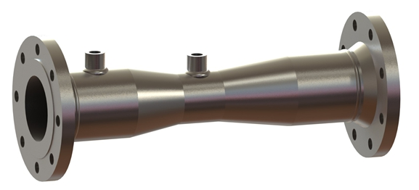
- A short converging part: It is that portion of the venturi where the fluid gets converges.
- Throat: It is the portion that lies in between the converging and diverging part of the venturi. The cross section of the throat is much less than the cross section of the converging and diverging parts. As the fluid enters in the throat, its velocity increases and pressure decreases.
- Diverging part: It is the portion of the venturi meter (venturi) where the fluid gets diverges.
Principle of Venturi meter:
- The working of venturi meter is based on the principle of Bernoulli’s equation.
- Bernoulli’s Statement: It states that in a steady, ideal flow of an incompressible fluid, the total energy at any point of the fluid is constant. The total energy consists of pressure energy, kinetic energy and potential energy or datum energy.
- Mathematically

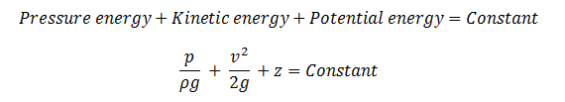

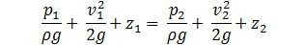

Apparatus:
Venturi meter fitted in a horizontal pipe line with means of varying flow rate, U tube different manometer
Procedure:

Calculation table:
Sr.no | H7(mm) | H8(mm) | Qact(lpm) | Qthr(mm) | %Error
1 | 140 | 74 | 10 | 9.34 | 6.6%
2 | 82 | 32 | 8.5 | 8.13 | 4.35%
3 | 159 | 110 | 8 | 8.05 | 0%
4 | 160 | 112 | 8 | 7.95 | 0.5%

Conclusions:

