Communication Channels
The channel, or medium, used to communicate a message affects how accurately the message will be received. Channels vary in their “information-richness.” Information-rich channels convey more nonverbal information. Research shows that effective managers tend to use more information-rich communication channels than less effective managers. Allen, D. G., & Griffeth, R. W. (1997).
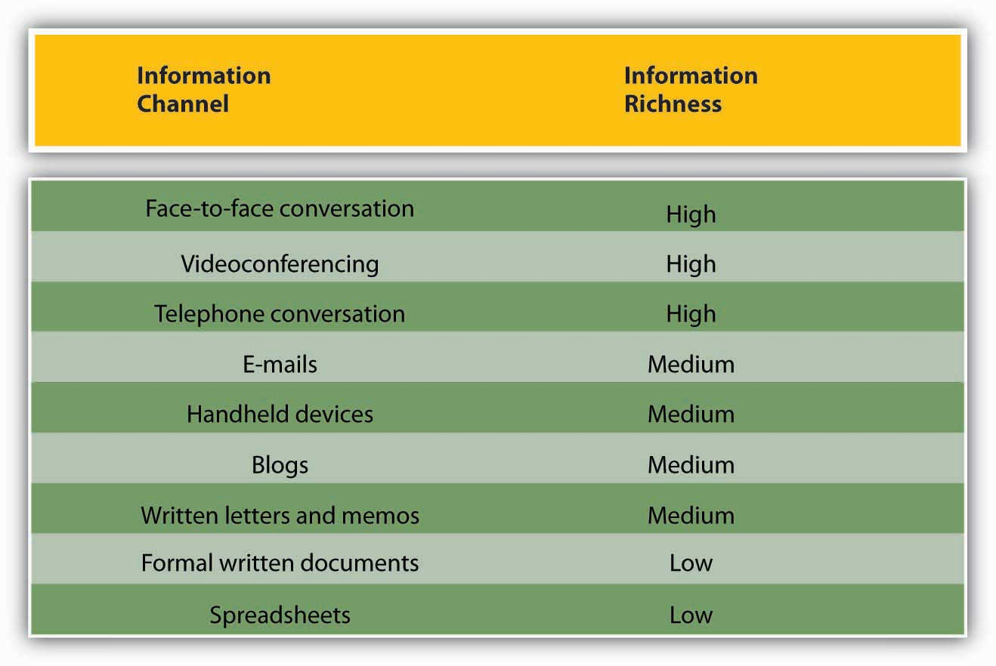
Face-to-Face or Personal Communication
Face-to-face or personal communication is one of the richest channels of communication that can be used within an organization. Physical presence, the tone of the speaker's voice and facial expressions help recipients of a message interpret that message as the speaker intends. This is the best channel to use for complex or emotionally charged messages, because it allows for interaction between speaker and recipients to clarify ambiguity.
Broadcast Media Communications
TV, radio and loud speakers all fall within the broadcast media communication channel. These types of media should be used when addressing a mass audience. Businesses seeking to notify customers of a new product may advertise or do promotions using a broadcast channel. Similarly, a CEO may do a global company address by having a television feed broadcast across global sites. When a message intended for a mass audience can be enhanced by being presented in a visual or auditory format, a broadcast channel should be used.
Mobile Communications Channels
A mobile communication channel should be used when a private or more complex message needs to be relayed to an individual or small group. A mobile channel allows for an interactive exchange and gives the recipient the added benefit of interpreting the speaker's tone along with the message.

Electronic Communications Channels
Electronic communication channels encompass email, Internet, intranet and social media platforms. This channel can be used for one-on-one, group or mass communication. It is a less personal method of communication but more efficient. When using this channel, care must be taken to craft messages with clarity and to avoid the use of sarcasm and innuendo unless the message specifically calls for it.
Written Methods of Communication
Written communication should be used when a message that does not require interaction needs to be communicated to an employee or group. Policies, letters, memos, manuals, notices and announcements are all messages that work well for this channel. Recipients may follow up through an electronic or face-to-face channel if questions arise about a written message

Information communication technologies
Information communication technologies (ICT) at present are influencing every aspect of human life. They are playing salient roles in work places, business, education, and entertainment. Moreover, many people recognize ICTs as catalysts for change; change in working conditions, handling and exchanging information, teaching methods, learning approaches, scientific research, and in accessing information communication technologies
E learning: is a learning program that makes use of an information network- such as the internet, an intranet (LAN) or extranet (WAN) whether wholly or in part, for course delivery, interaction and/or facilitation.
Web-based learning is a subset of e learning and refers to learning using an internet browser such as the model, blackboard or internet explorer (Tinio, 2002).
Blended Learning: refers to learning models that combines the face-to-face classroom practice with e-learning solutions. For example, a teacher may facilitate student learning in class contact and uses the model (modular object oriented dynamic learning environment) to facilitate out of class learning.
Constructivism: is a paradigm of learning that assumes learning as a process individuals ‘’construct’’ meaning or new knowledge based on their prior knowledge and experience (Johassen, 1991). Educators also call it the emerging pedagogy in contrast to the long existing behaviorism view of learning.
Learner- centered learning environment: is a learning environment that pays attention to knowledge, skills, attitudes, and beliefs that learners bring with them to the learning process where its impetus is derived from a paradigm of learning called constructivism.
Teleconferencing
1. Audio – Conferencing – It involves the live (real-time) exchange of voice messages over a telephone network when low – band width text and still images such as graphs, diagrams or picture can also be exchanged along with voice messages, then this type of conferencing is called audio-graphic. Non-moving visuals are added using a computer keyboard or by drawing / writing on graphics tablet or whiteboard.
2. Video – Conferencing –allows the exchange not just of voice and graphics but also of moving images. Video-Conferencing technology does not use telephone lines but either a satellite link or television network (broadcast / cable).
3. Web–Based Conferencing – Web-based conferencing as the name implies, involves the transmission of text and graphic, audio and visual media via the internet; it requires the use of a computer with a browser and communication can be both synchronous and asynchronous.
4. Open and Distance Learning – All these services availed through ICT plays a great role in teacher education. It allows higher participation and greater interaction. It also improves the quality of education by facilitating learning by doing, directed instruction, self-learning, problem solving, information seeking and analysis and critical thinking as well as the ability to communicate, collaborate and learn.

