WATER GAS SHIFT REACTION
Carbon oxide reacts with water and produces, via the reversible and exothermic reaction: , carbon dioxide with pure hydrogen. In recent years, this reaction has received considerable interest due to the possibility to reduce a large amount of carbon monoxide from reformed fuels (CO + H₂) into additional hydrogen production. This reaction is catalyzed with a large variety of metals and metal oxides like Fe [1–3], Cu [2, 4], Au [2, 5, 6], Ru [2, 7], and Pt [8, 9] and is often performed in two steps to achieve rates for commercial purposes. At lower temperature (150–250°C) the catalyst of choice is based on copper Cu-ZnO. The iron oxide-based catalysts, Fe₂O₃, are well known in high temperature water-gas shift reaction (350–450°C) and are generally doped with chromium oxide, Cr₂O₃, which prevents the sintering of iron oxide crystallites. Before the high temperature shift catalysts can be used, hematite must be converted to magnetite which is believed to be the active phase. This reduction is carried out with process gas mixtures of hydrogen, nitrogen, carbon oxide, carbon dioxide, and water vapour and is controlled to avoid further reduction of magnetite active material to lower oxides or to metallic iron species. Metallic iron is an active catalyst for the methanation of CO and the Fischer-Tropsch processes, which is undesirable here, since all generated hydrogen is consumed. To solve this problem, it is suitable to develop iron oxide stable catalysts that would be more difficult to reduce to metallic iron.
Júnior et al. [10] have indicated that the substitution of chromium by vanadium, in the iron oxide based water-gas shift reaction, produced directly the sought active phase. In a recent study, Martos and his coworkers [11] have replaced chromium by molybdenum in magnetite-based catalysts, by using the oxidation-precipitation and wet impregnation methods preparation and concluded that molybdenum increases thermal stability of the magnetite active phase and prevents metallic iron formation during the reaction. The oxidation-precipitation method allows obtaining the material directly in the active phase and molybdenum is incorporated into magnetite lattice. Boudjemaa et al. [3] have reported that magnesium could be a good candidate to replace chromium in iron-based catalysts since Mg-rich catalysts are more active than Cr-promoted ones. By adding MgO to Fe₂O₃ [12], it was found that the Fe₂O₃-MgO basic catalyst is 100 times more active than the acidic catalyst Fe₂O₃/SiO₂ and a direct relation between catalytic activity and acid-base properties of catalysts is established.
The catalytic conversion of carbon oxide and water to carbon dioxide and hydrogen via the water-gas shift reaction is established to take place principally through two main types of mechanisms, the regenerative mechanism or the associative mechanism. In the first mechanism the catalyst surface is successively oxidized by H₂O and reduced by CO [13]:
In turn, the associative mechanism supposes that the reactants CO and H₂O interact to form a reaction intermediate, such as an adsorbed formate adspecies, which then decomposes to CO₂ and H₂:
It was proposed in several researches that the formic acid species can be used as an intermediate to represent the formate group produced from the reaction between carbon oxide and water in the WGS reaction [2, 9, 13] on the following dehydrogenation process:
The decomposition of formic acid (reaction (3)) to the products of WGS reaction is catalyzed by metals and basic metal oxides.
In this work, we present the results of the effect of acid-base properties created by the support addition oxides on the catalytic activity of Fe₂O₃ in the water-gas shift reaction. An associative mechanistic of hydrogen production in the high temperature shift reaction was also developed on iron oxide catalyst.

2. Experimental

2.1. Materials Synthesis and Characterizations
30 wt% Fe₂O₃- systems, with M equal to Mg, Ti, or Si, were prepared by incipient wetness impregnation method. This method consists of adsorbing an adequate aqueous solution of iron nitrate salt Fe(NO₃)₃9 H₂O onto the selected support MgO, TiO₂, or SiO₂. The systems obtained are 30Fe-Mg, 30Fe-Ti, and 30Fe-Si. All these solids were calcined at 400°C.
The concentration of iron oxide in the solution was controlled to obtain the desired Fe content on MgO (5, 10, 20, and 30 wt%). It is about 5Fe-Mg, 10Fe-Mg, 20Fe-Mg, and 30Fe-Mg, respectively.
30Fe-Mg system was calcined for study needs at 200°C and 300°C. These systems are labeled 30Fe-Mg400, 30Fe-Mg300, and 30Fe-Mg200.
The elaborated solids were then characterized by means of techniques of analysis, X-ray powder diffraction, CO₂ and NH₃ adsorptions calorimetry, and the diffuse reflectance infrared Fourier transform spectroscopy. X-ray diffraction studies were obtained with a Philips PW 1050/81 automated powder goniometer, equipped with a diffracted-beam graphite monochromatic Cu (K_{α}) radiation. CO₂ and NH₃ adsorptions calorimetry was carried out at 80°C after activation under H₂ flow at 200°C. Differential heats of adsorption were measured in a heat flow Setaram HT microcalorimeter linked to a volumetric adsorption system. Successive small doses of CO₂ or NH₃ were sent over the catalytic surface. From the calorimetric and volumetric data, the differential heats of adsorption versus coverage and the corresponding isotherms are plotted. In situ diffuse reflectance infrared Fourier transform studies were performed on a Nicolet Magna IRTF spectrometer with OMNIC software. The reaction was performed in a high temperature Spectratech cell equipped with a ZnSe window. A sample was first treated in a flow of (~35 mL/min) H₂ at 400°C for 30 min (high-temperature treatment) before each experiment. After this treatment, the sample was cooled under helium and then put in contact with the reacting mixture CO + H₂O at increasing temperature from 25 to 450°C.

2.2. CO + H₂O Reaction
Catalytic properties of Fe-only and Fe-supported systems were examined in the reaction of the conversion of carbon oxide to carbon dioxide usually named WGSR between 350°C and 450°C. The reduction treatment was carried for all Fe-based catalysts with a mixture of H₂/N₂ at 450°C during 60 min with a heating rate of 5°Cmin⁻¹. The mixtures of reactant gases, H₂O/CO = 4.4 at a total flow-rate of 33 mL/min, and products were periodically analysed on line using a TCD chromatograph which contained two 4 m carbosieve B columns (1/8 inch, 100 to 200 mesh). Prior to analysis, the effluent was passed through a water-trap at 0°C in order to remove reaction water.

3. Results and Discussions

3.1. Fe-Cr Systems
Iron and chromium based catalysts, known generally as high temperature shift catalysts, are active within the temperature range of 350–450°C. Three methods of preparation of iron-chromium oxides, described obviously in [3], are chosen to study their catalytic activities in WGS reaction. The hydrogen produced via the CO + H₂O process at 450°C of the Fe-only and Fe-Cr synthesized under various preparation methods is presented in Figure 1. The samples were reduced in a mixture of H₂ + N₂ at 450°C during 60 min before the reaction. The Fe-Cr prepared by substituting Fe by Cr stays almost inactive for all the duration of the study, while Fe-Cr prepared by the coprecipitation technique provides the highest values of H₂ after 90 min of reaction time and Fe-Cr prepared via impregnation method exhibits an intermediate performance. In turn, the Fe-only catalyst presents very high initial activity which decreased significantly with the reaction time to values one more active than the promoted catalyst Fe-Cr prepared via impregnation method. This loss of activity and stability can be related to the sintering of the iron oxide phase. It has been proved that the addition of chromium oxide to Fe₂O₃ slows the deactivation of the iron oxide [14].
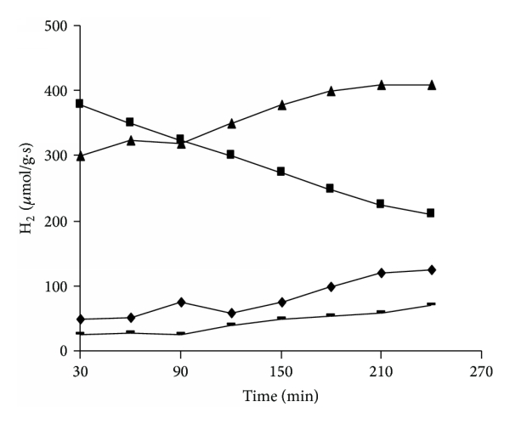
Figure 1
Hydrogen generation via WGSR of the calcined and reduced solids prepared by (-) substitution, (◆) impregnation, and (▲) coprecipitation methods. (■) corresponds to Fe₂O₃.

3.2. Fe-Mg Systems
The aim of this part of the study is to promote the iron oxide-based catalyst by replacement of the chromium oxide by MgO which can be apt to improve the catalytic activity of the intermediate active catalyst, in the occurrence Fe-Cr prepared via impregnation method (see Figure 1). Our intent here is for 5Fe-Mg, 10Fe-Mg, 20Fe-Mg, and 30Fe-Mg or 30Fe-Mg400, 30Fe-Mg300, and 30Fe-Mg200 catalysts. The WGS reaction results of Fe-Mg catalysts, expressed by the hydrogen production and the X-ray diffraction patterns of the magnesium promoted catalyst, are given in Figures 2 and 3, respectively.
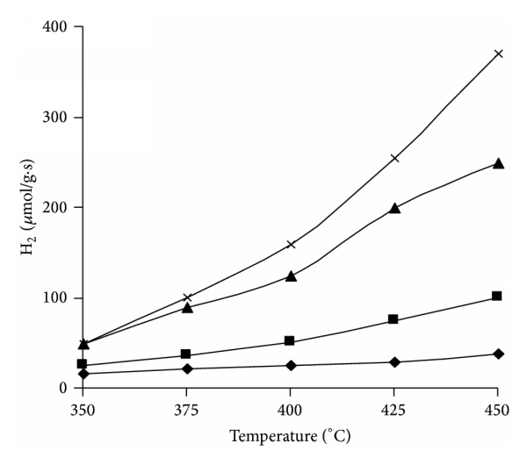
Figure 2
Temperature dependence of the H₂ generation from WGS reaction of the samples: (◆) 5Fe-Mg, (■) 10Fe-Mg, (▲) 20Fe-Mg, and (x) 30Fe-Mg after a reduction treatment at 450°C during 60 min. Reactant gas mixture, H₂O/CO = 4.4. Total flow-rate of 33 mL/min.
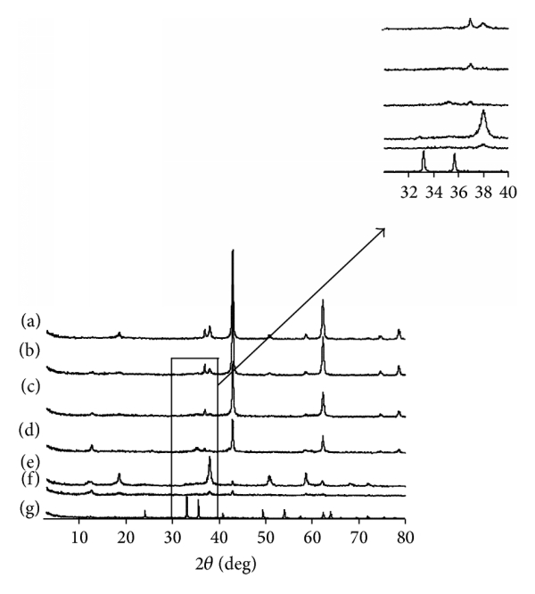
Figure 3
X-ray diffraction patterns of the magnesium promoted Fe-Mg catalysts. (a) 5Fe-Mg, (b) 10Fe-Mg, (c) 20Fe-Mg, (d) 30Fe-Mg400, (e) 30Fe-Mg300, (f) 30Fe-Mg200, and (g) Fe-only.
Figure 2 shows the effect of magnesium additives to iron oxide-based catalysts on the hydrogen production via the WGS reaction at the temperature range 350–450°C. The quantity of hydrogen produced increases significantly with the increase of iron oxide content in the following order 5Fe-Mg < 10Fe-Mg < 20Fe-Mg < 30Fe-Mg. The H₂ production is also found to increase with the rise of reaction temperature. We have reported in previous works [3, 15] that the sample 30Fe-Mg produced a spinel oxide phase of type MgFe₂O₄ together with a predominant MgO phase at a temperature of calcination of 400°C and presented excellent performance in the WGS reaction. Furthermore, we projected that a decrease in calcination temperature from 400 to 200°C would not produce the spinel oxide.
The X-ray diffractograms of pure and Fe-supported 5–30 wt% Fe-Mg solids calcined at 400°C and 30 wt% Fe-Mg calcined at 200, 300, and 400°C were studied and illustrated by Figure 3. The analysis of XRD patterns reveals that the Fe₂O₃ crystalline phase was detected in the unsupported solid. Iron oxide did not appear on the Fe-supported solids. By looking at 5–30 wt% Fe-Mg spectra, it appears clearly that the intensity of the principal ray assigned to the MgO crystalline phase decreases progressively when the iron oxide charge increases by 5 to 30 wt%. At a charge of 30 wt% Fe₂O₃ (spectrum d), the crystalline fraction of MgO is ostensibly changed by the formation of MgFe₂O₄ spinel phase [16]. For 30Fe-Mg300 and 30Fe-Mg200 solids a minor MgO phase was observed together with the predominant Mg(OH)₂ phase.

3.3. Fe-Supported Systems
By choosing MgO, TiO₂, and SiO₂ to support iron oxide in this section, it was expected that the large variety of acid-base strengths of MgO (basic support), TiO₂ (amphiprotic support), or SiO₂ (acidic support) important in determining catalytic activity could be realized. In a previous work [12], we have shown that the most active system is the catalyst containing MgO as a support. Fe₂O₃/MgO is 12 times more active than Fe₂O₃/TiO₂, 21 times more active than the unsupported catalyst, and 100 times more active than Fe₂O₃/SiO₂.
The X-ray crystalline phases of the elaborated Fe-only, 30Fe-Mg, 30Fe-Ti, and 30Fe-Si systems are given in Table 1 with the results of calorimetric and DRIFT measurements data. MgFe₂O₄ was identified with mainly MgO support phase in the 30Fe-Mg solid system. On the three other systems, iron was found at the Fe (3+) state in it α-Fe₂O₃ allotr

