Department of Chemistry and Biochemistry Biochemistry 3300
University of Lethbridge
III. Metabolism
- Glycolysis.

Major Pathways of Glucose Utilization
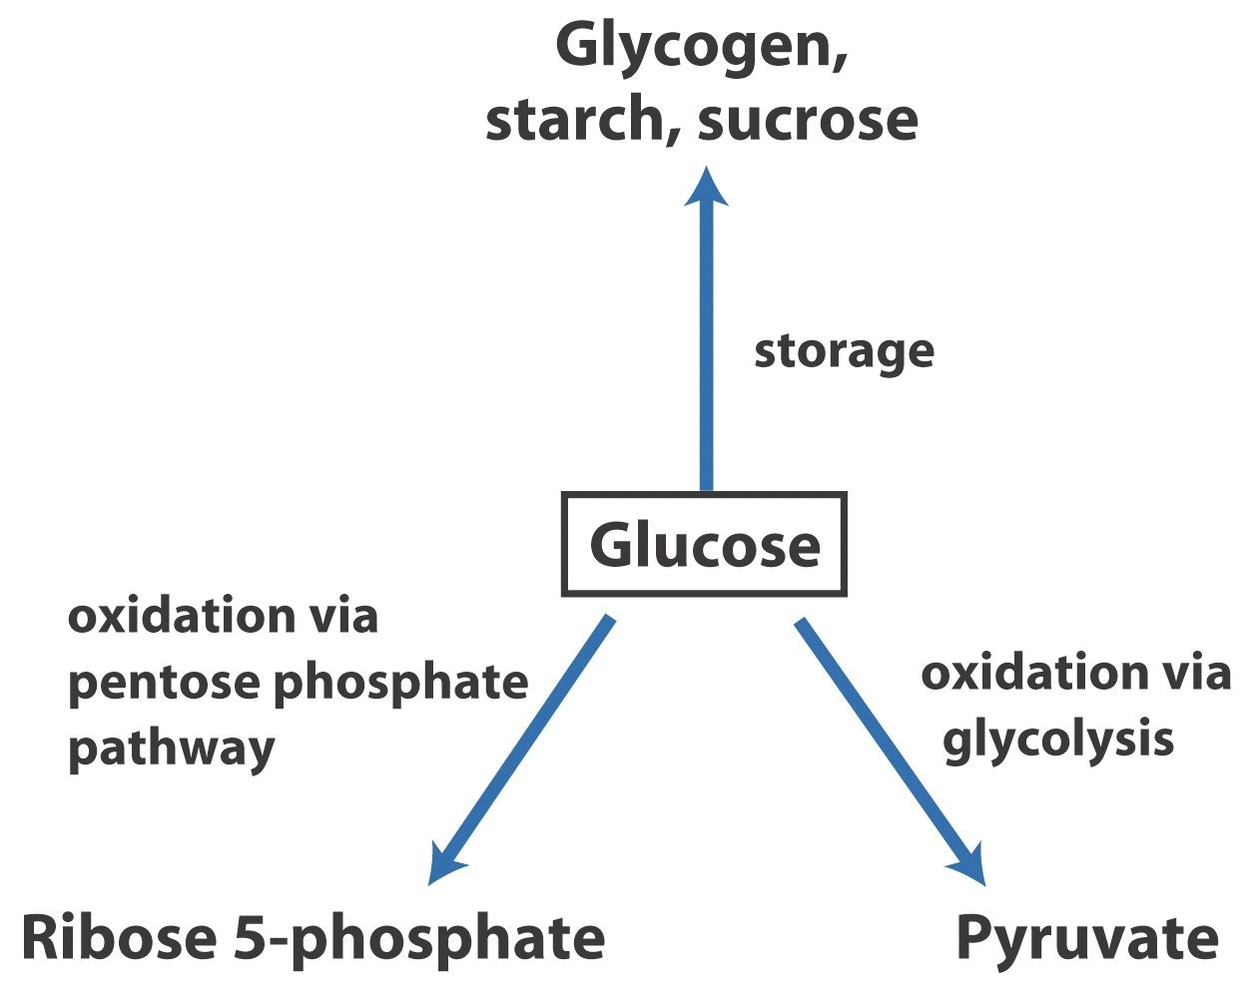
These three pathways are the most significant in terms of the amount of glucose that flows through them in most cells.

The Two Phases of Glycolysis
Breakdown of the glucose (6C) into two molecules of the pyruvate (3C) occurs in ten steps.
Ten steps of Glycolysis can be subdivided in two Phases:
- The Preparatory Phase (steps 1-5)
  - spend ATP
  - glucose → 2 glyceraldehyde-3-phosphate
- The Payoff Phase (steps 6-10)
  - generate ATP & NADH
  - 2 glyceraldehyde-3-phosphate → 2 pyruvate

Preparatory Phase of Glycolysis
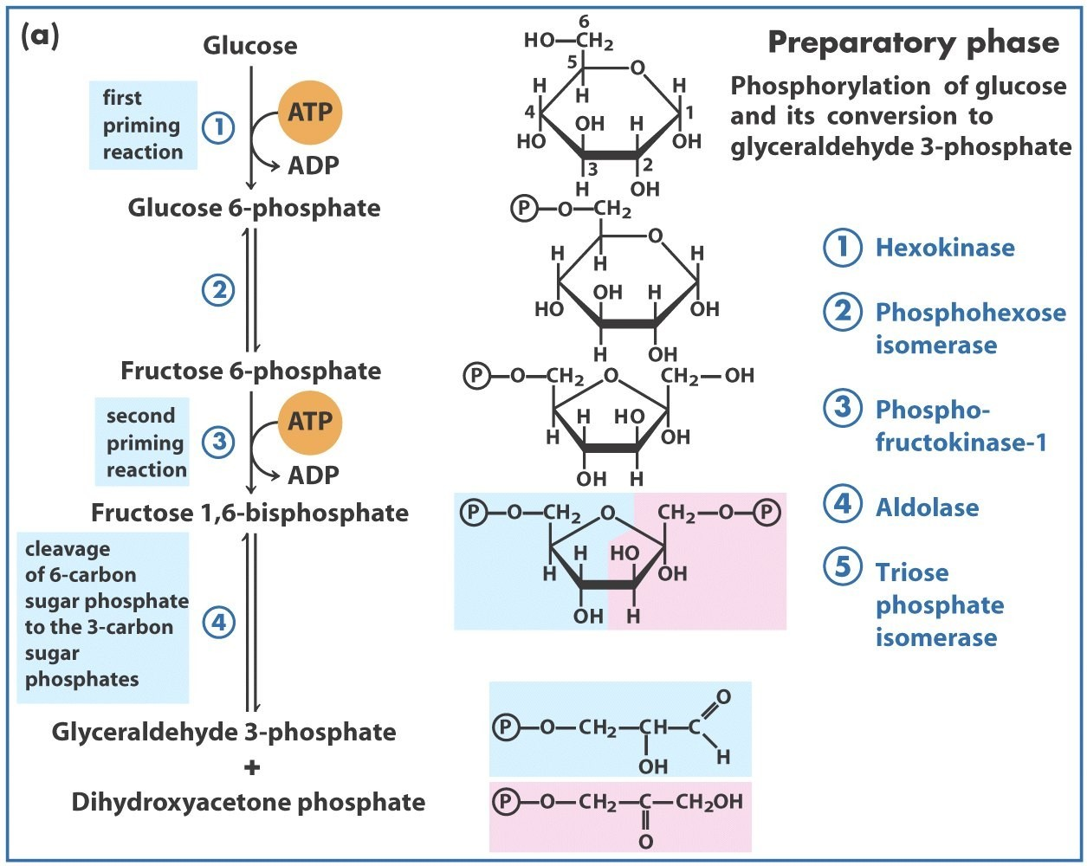
Enzymes
- 2 Kinases
- 2 Isomerases
- 1 Aldolase

Payoff Phases of Glycolysis
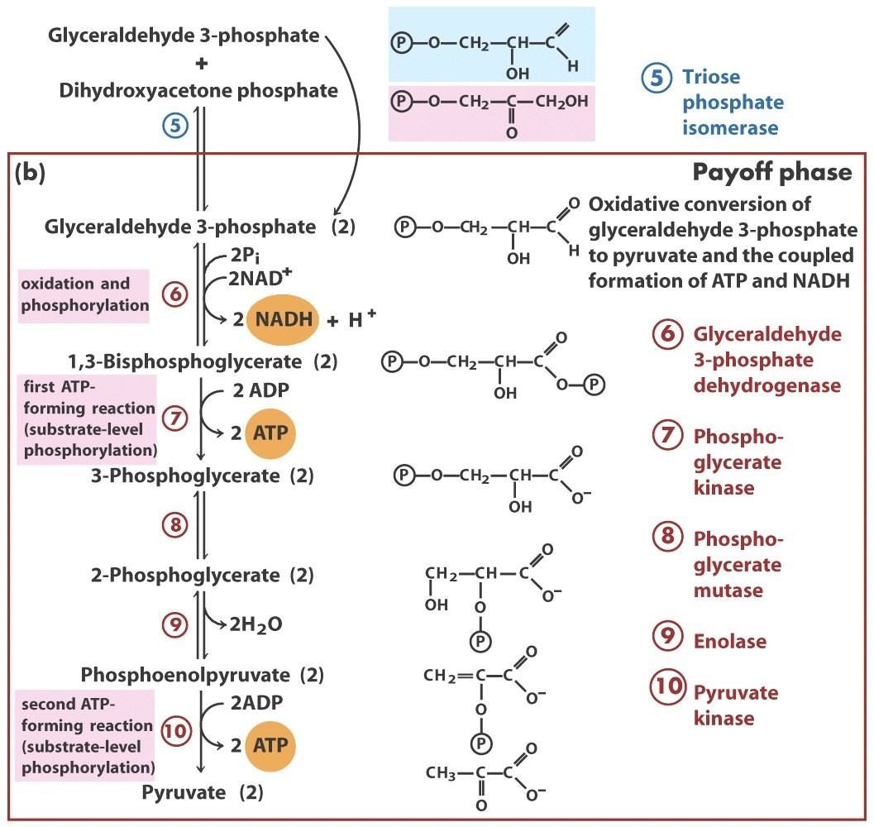
Enzymes
- 2 Kinases- 1 Mutase
- 1 Dehydrogenase
- 1 Enolase

Yield (in energy equivalents) per glucose

Chemical equation for glycolysis:

Glucose + 2NAD⁺ + 2ADP + 2P
i
→ 2 pyruvate + 2NADH + 2H⁺ + 2ATP + 2H O
2

Formation of 2x pyruvate, NADH and H⁺ (energy released):

Glucose + 2NAD⁺ → 2 pyruvate + 2NADH + 2H⁺ ∆G’ ^{O}= -146 kJ/mol
1

Formation of 2 ATP (energy cost):

2ADP + 2P → 2ATP + 2H O ∆G’ ^{O}= 61.0 kJ/mol
i 2 2
∆G’ ^{O}= ∆G’ ^{O} + ∆G’ ^{O} = -85 kJ/mol
S 1 2

A Historical Perspective
- 1854-1864: L. Pasteur establishes fermentation is caused by microorganisms.
- 1897: E. Buchner demonstrates cell-free yeast extracts carry out this process.
- 1905-1910: Arthur Harden and William Young discovered:
  - Inorganic phosphate is required for fermentation and is incorporated into fructose-1-6-bisphosphate
  - A cell-free yeast extract has a nondialyzable heat-labile fraction (zymase) and a dialyzable heat-stable fraction (cozymase).
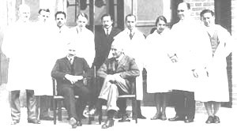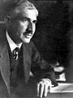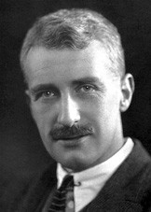
- By 1940: Elucidation of complete glycolytic pathway (Gustav Embden, Otto Meyerhof, and Jacob Parnas).
Otto Fritz Meyerhof & Archibald Vivian Hill The Nobel Prize in Physiology or Medicine 1922

Glycolysis
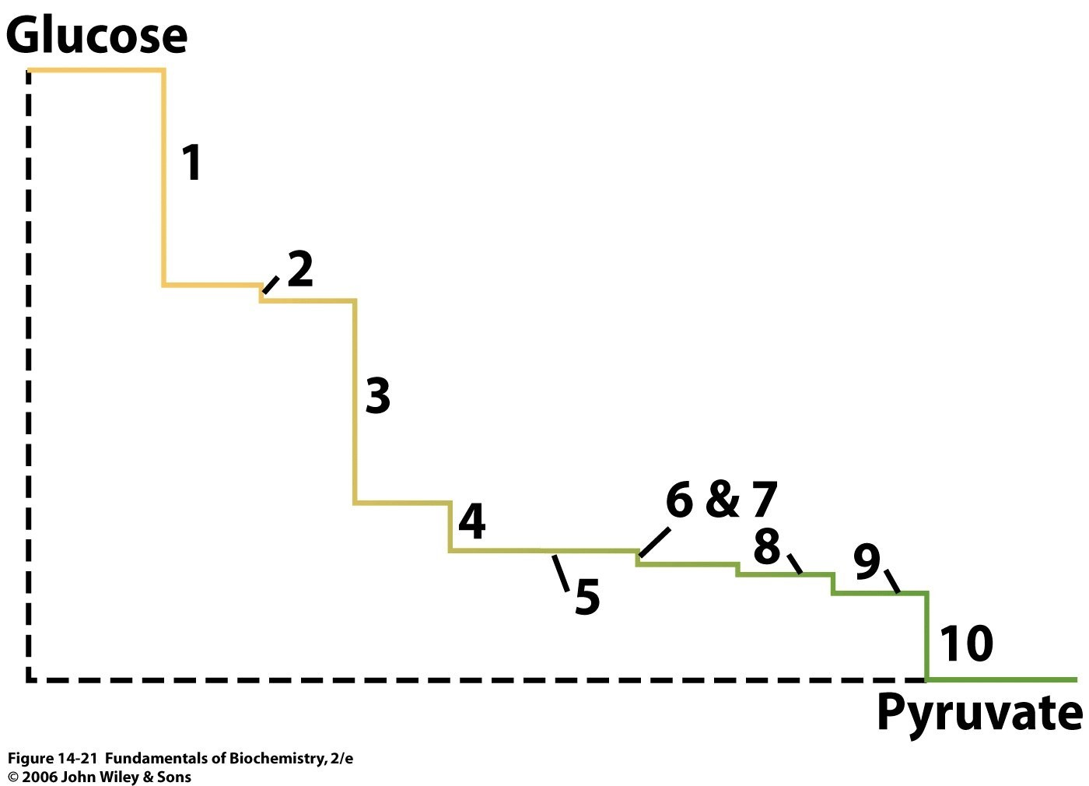
∆
G

(
k
J
/
m
o
l
)

u
n
d
e
r
c
e
l
l
u
l
a
r

c
o
n
d
i
t
i
o
n
s
Pathway coordinate

Hexokinase: First ATP Utilization
Reaction 1 : Transfer of a phosphoryl group from ATP to glucose to form glucose 6-phosphate (G6P)
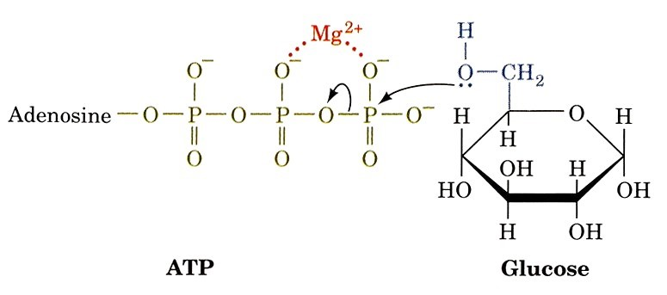
∆
G’
° = -16.7 kJ/mol
Irreversible under cellular conditions
due to large, negative

∆
G'

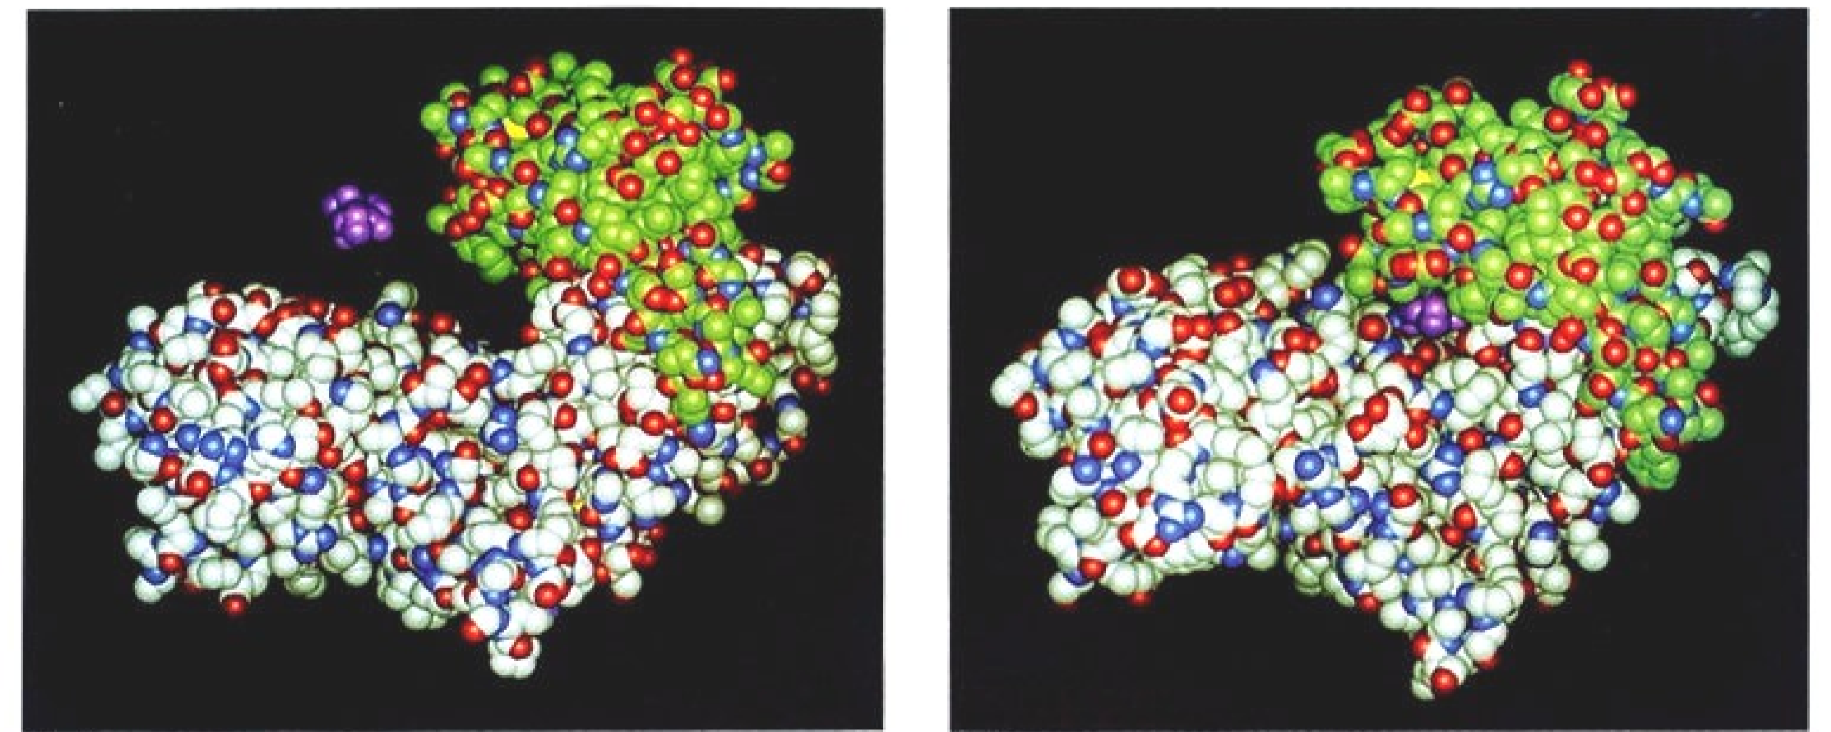
Hexokinase: First ATP Utilization
E + S
ES complex
The two domains (grey/green) swing together when bound to Pi
- excludes H₂O from active site (eg. electrostatic catalysis)

Phosphohexose Isomerase
Reaction 2: Phosphohexose isomerase catalyzes the conversion of G6P to F6P
(ie. aldose to ketose isomerisation)
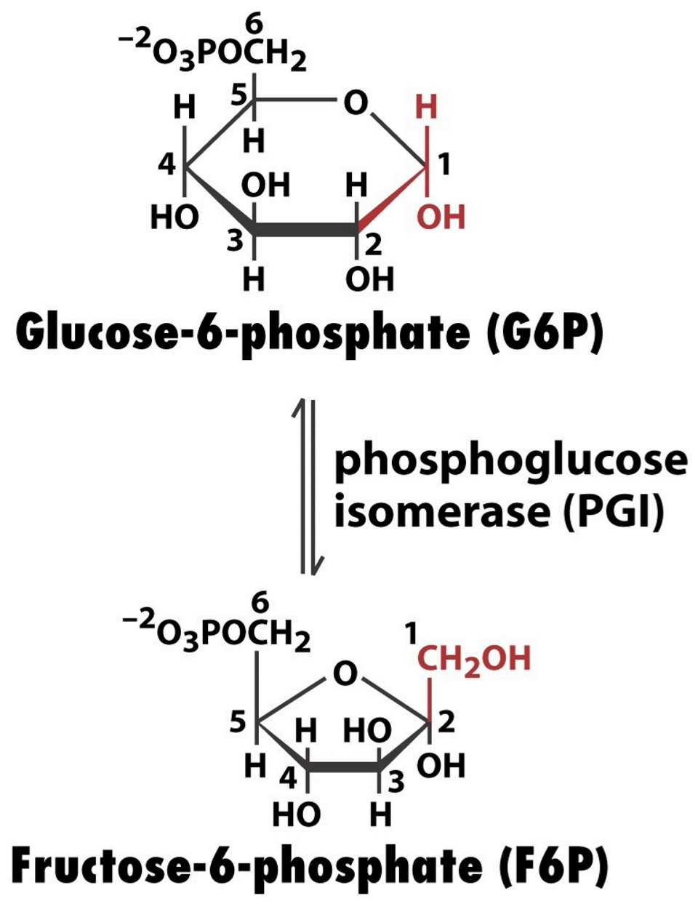
Isomerases and mutases
typically catalyze reactions with small ∆G'º (and ∆G')
∆G’° = 1.7 kJ/mol

Phosphohexose Isomerase
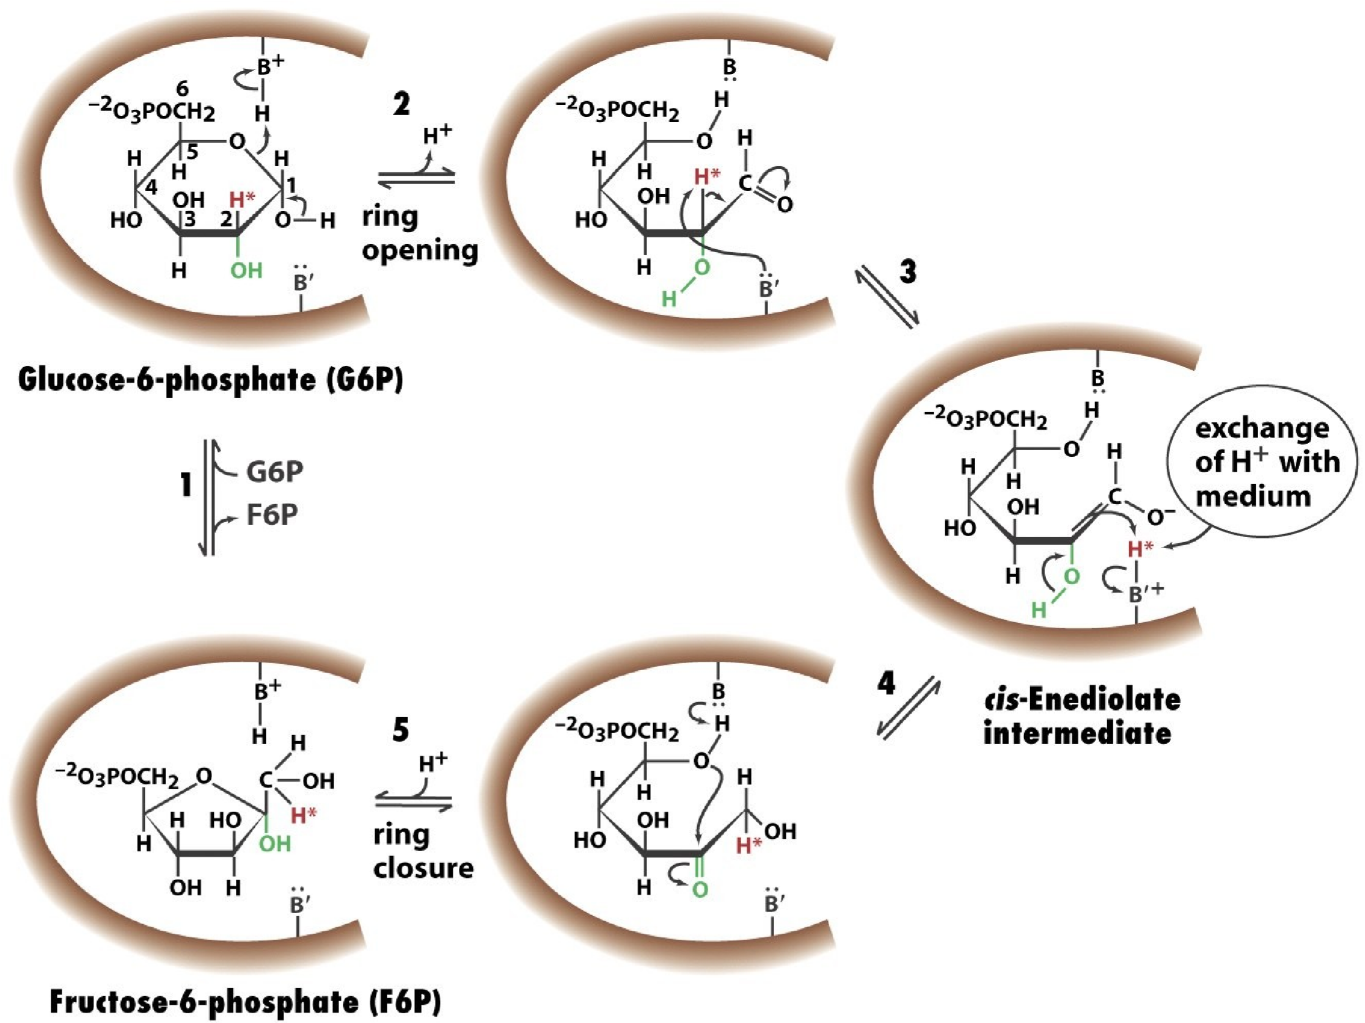
Overall reaction
involves multiple (4)
elementary steps
Acid-base catalysis

PFK-1: Second ATP Utilization
Reaction 3: Phosophofructokinase-1 (PFK-1) phosphorylates fructose-6-phosphate (F6P)
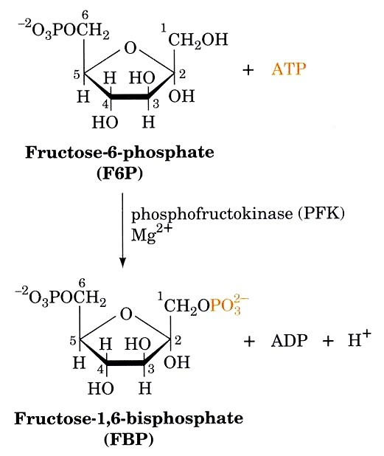
PFK-1 plays a central role in control of glycolysis as it catalyzes one of the pathway’s rate-determining reactions.
Irreversible under cellular conditions due to large, negative ∆G'
∆G’° = -14.2 kJ/mol

Aldolase
Reaction 4: Aldolase catalyzes cleavage of fructose-1,6-bisphosphate (FBP)
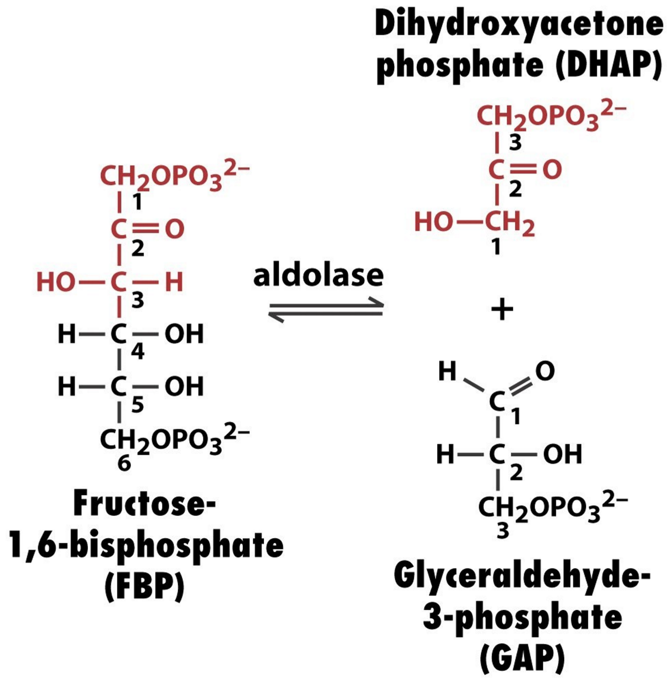
How is the large, unfavourable ∆G’° for this reaction overcome?
The [Product]/[Substrate] is kept very small
Enzymes operating far from their equilibrium state are regulatory targets
∆G’° = 23.8 kJ/mol

Retro Aldol Reaction
The aldolase mechanism is similar to the retro-aldol mechansim in organic chemistry
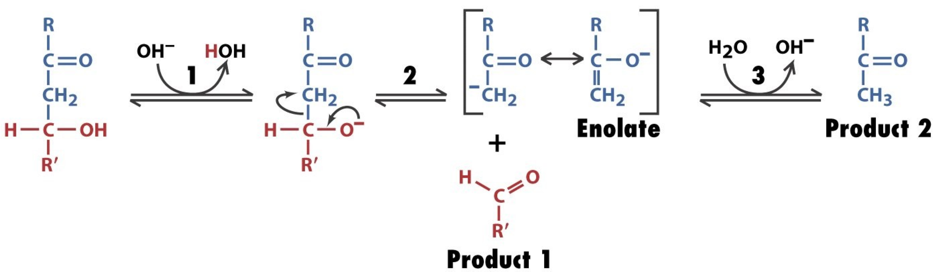
How could (and does) aldolase enhance the rate of this reaction?
Stabilize the carbanion !

(Class I) Aldolase Reaction Mechanism
Formation of a protonated Schiff's base (Lys 229) that stabilizes the carbanion/enamine
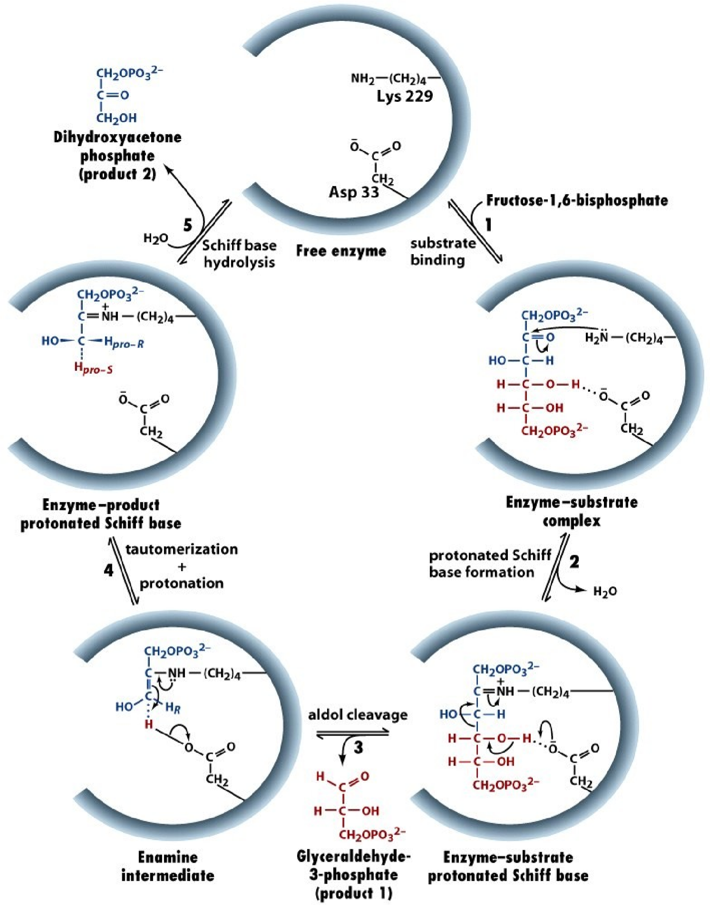
Class I Aldolase (Schiff's base mechanism)
Class II Aldolase (Metalloenzyme)

Triose Phosphate Isomerase
Reaction 5: Interconversion of the triose phosphates
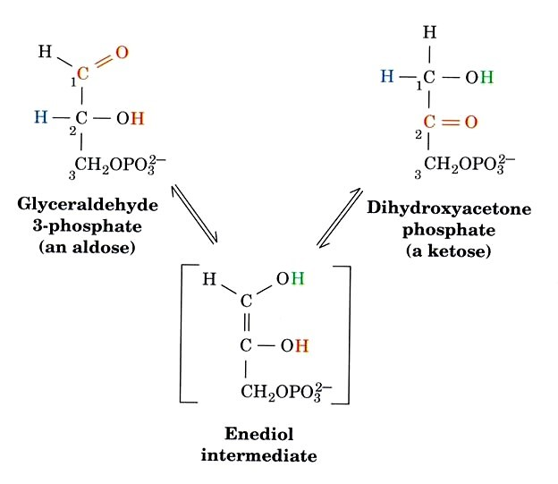
Only G3P continues along the glycolytic pathway. DHAP (dihydroxyacetonephosphate) is rapidly and reversible converted to G3P by TPI (aka TIM)
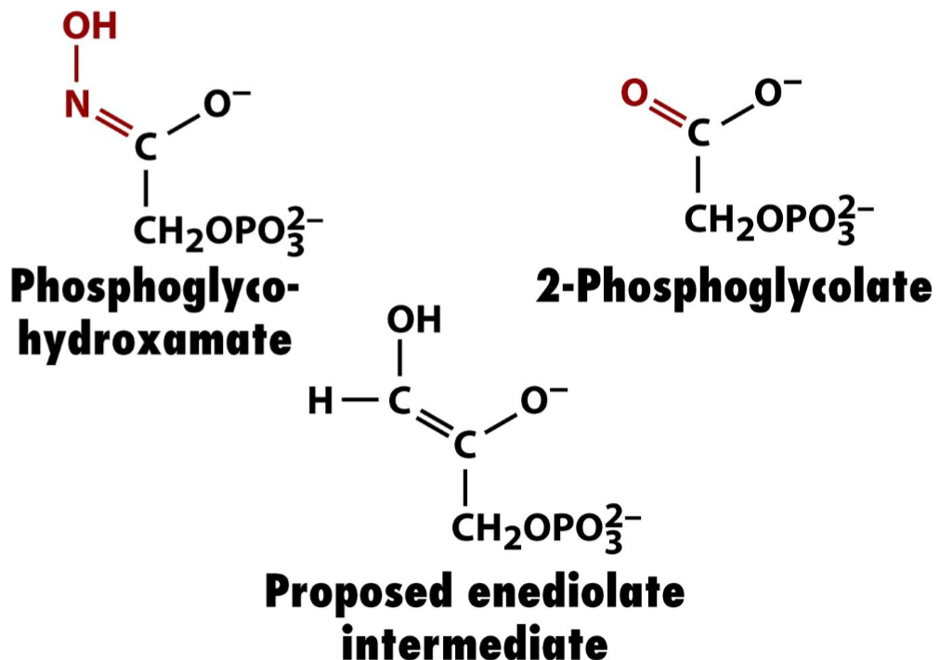
Inhibitors used to study
TPI mechanism
∆G’° = 7.5 kJ/mol

Triose Phosphate Isomerase
Ribbon diagram of TPI (TIM) in complex
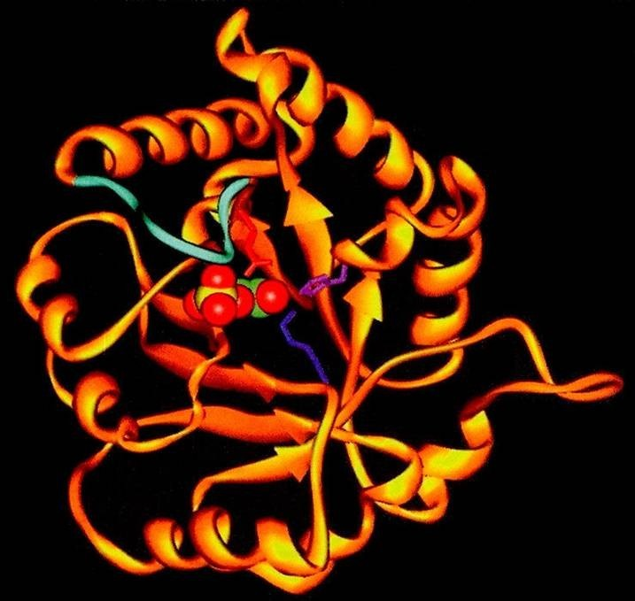
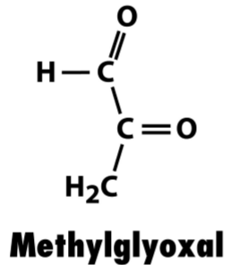
with its transition state analog 2-phosphoglycolate.
Flexible loop (light blue) makes a hydrogen bond with the phosphate group of the substrate.
Removal of loop (mutagenesis) does not impair substrate binding but reduces catalytic rate by 10⁵ fold.
stereoelectronic control (electrostatic catalysis)

Summary of Reaction 4 & 5
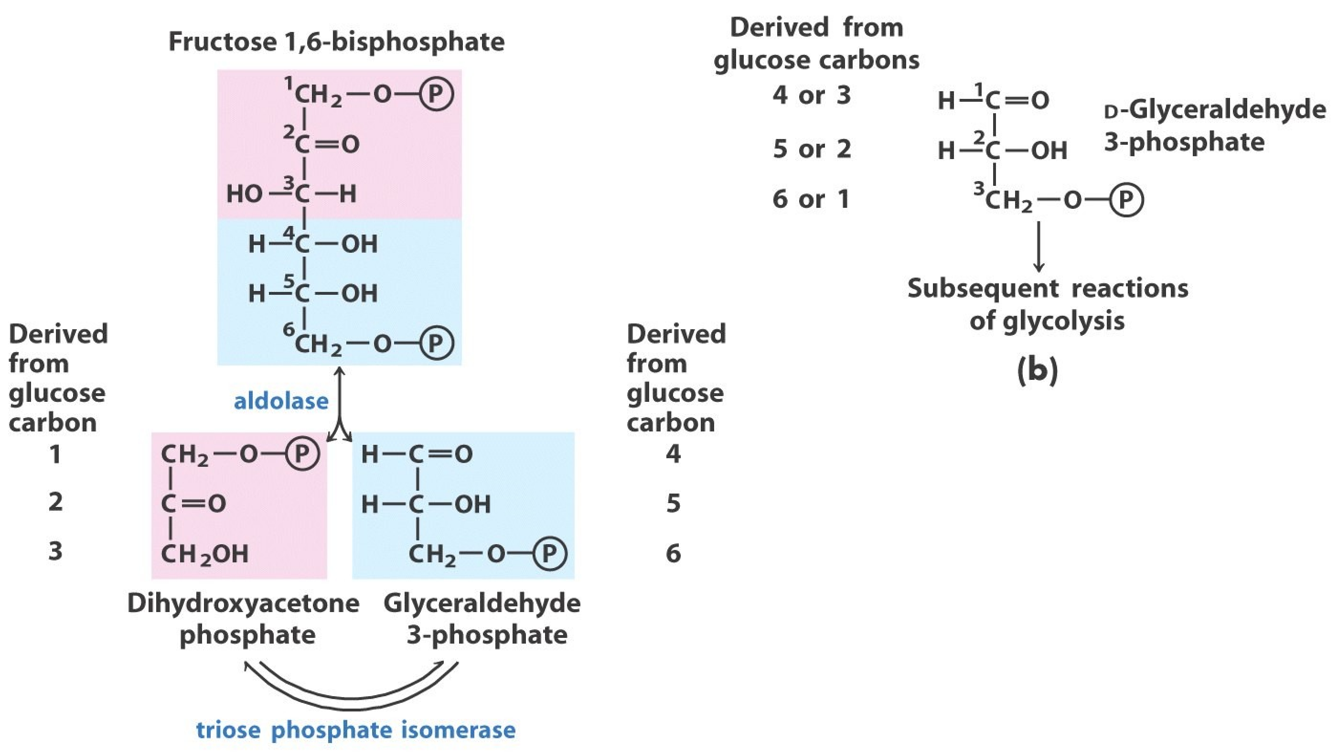
Fate of carbon atoms of glucose
in the formation of
glyceraldehyde-3-phosphate

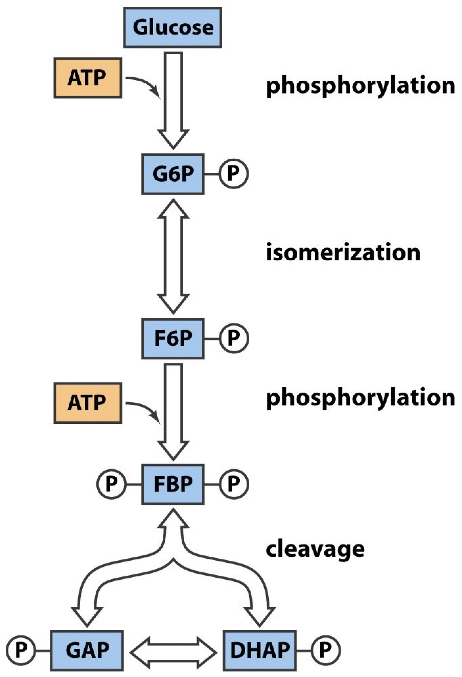
'Cartoon' summary of preparatory phase of glycolysis
Overall Reaction for Preparatory
Phase of Glycolysis
Glucose + 2 ATP
2 Glyceraldehyde-3-phosphate + 2 ADP

The Payoff Phase

Glyceraldehyde-3-Phosphate Dehydrogenase
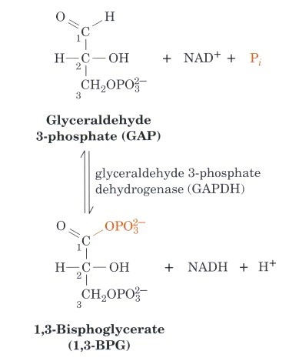
Reaction 6:
Glyceraldehyde-3-phosphate dehydrogenase forms the first “high-energy” intermediate.
Substrate Level Phosphorylation P_{i} is the substrate !!
High energy phosphodiester and NADH produced without expending ATP !!!
∆G’° = 6.3 kJ/mol

Glyceraldehyde 3-Phosphate Dehydrogenase Reaction Mechanism
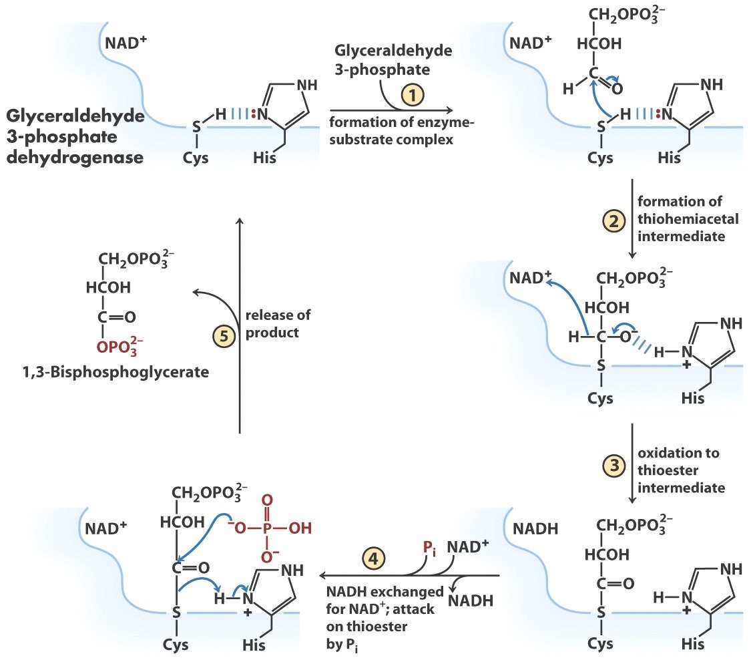
David Trentham
Mechanism

Glyceraldehyde 3-Phosphate Dehydrogenase (covalent intermediate)
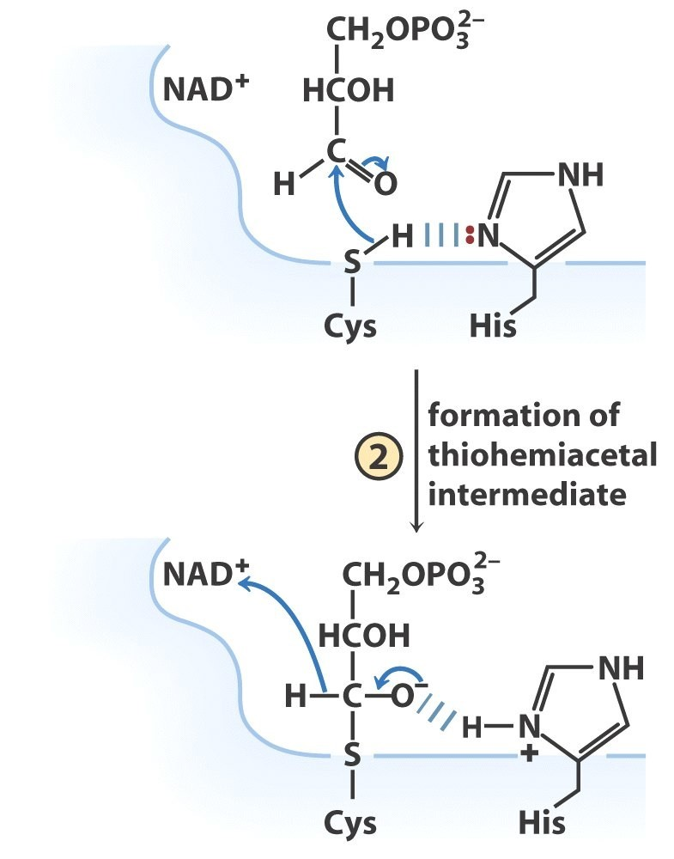
Covalent intermediate:
thiohemiacetals are higher energy compounds than hemiacetals

Glyceraldehyde 3-Phosphate Dehydrogenase (oxidation step)
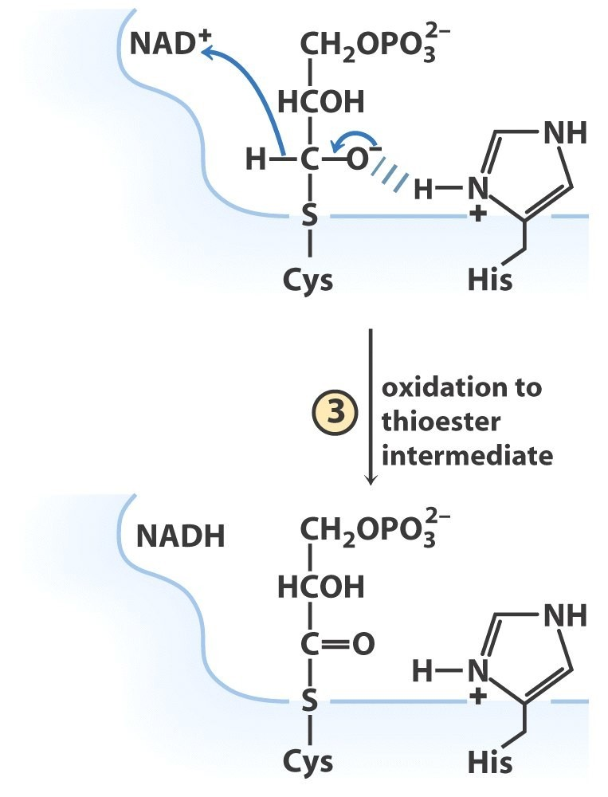
Bound NAD⁺ accepts electrons That are funnelled into oxidative phosphorylation

Glyceraldehyde 3-Phosphate Dehydrogenase (substrate level phosphorylation)
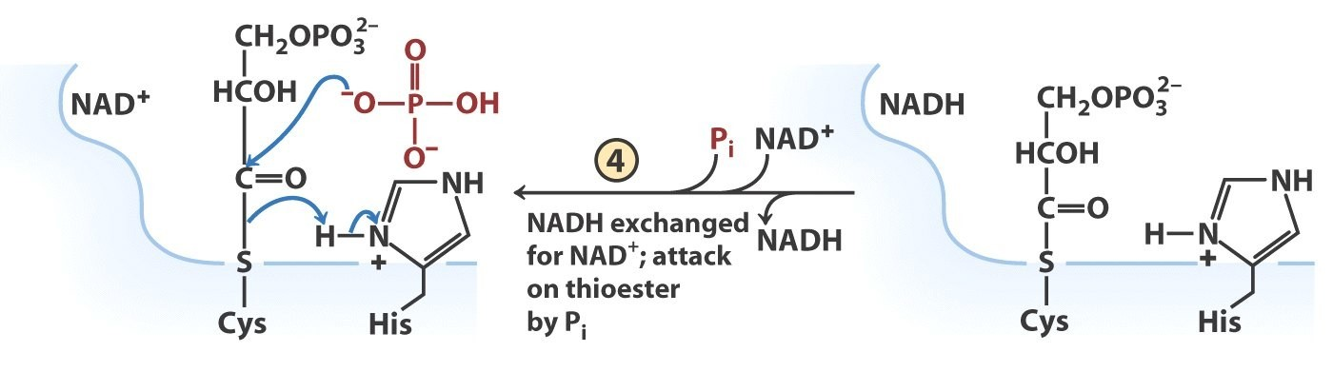
Thioester is cleaved by Pi producing a high energy compound:
1,3-bisphosphoglycerate

Glyceraldehyde 3-Phosphate Dehydrogenase (product release)
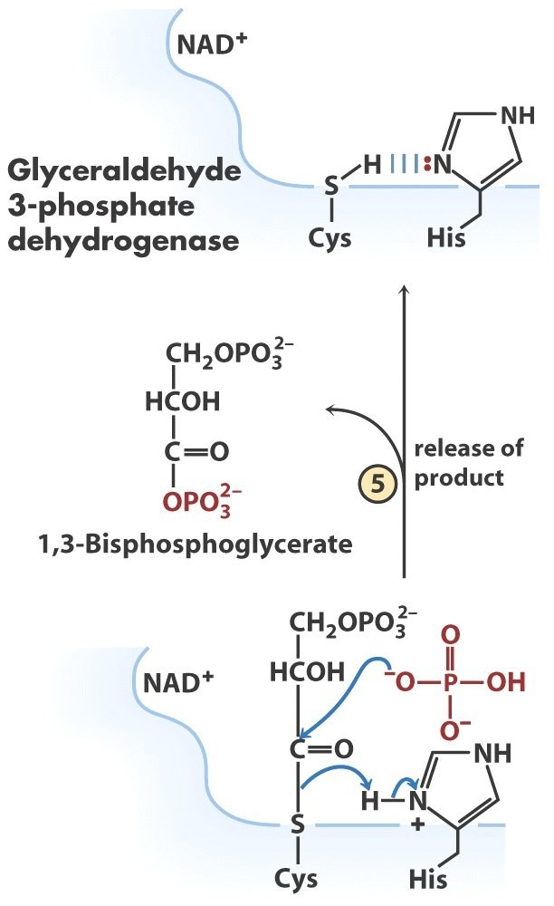

Glyceraldehyde-3-Phosphate Dehydrogenase
Mechanistic Studies:
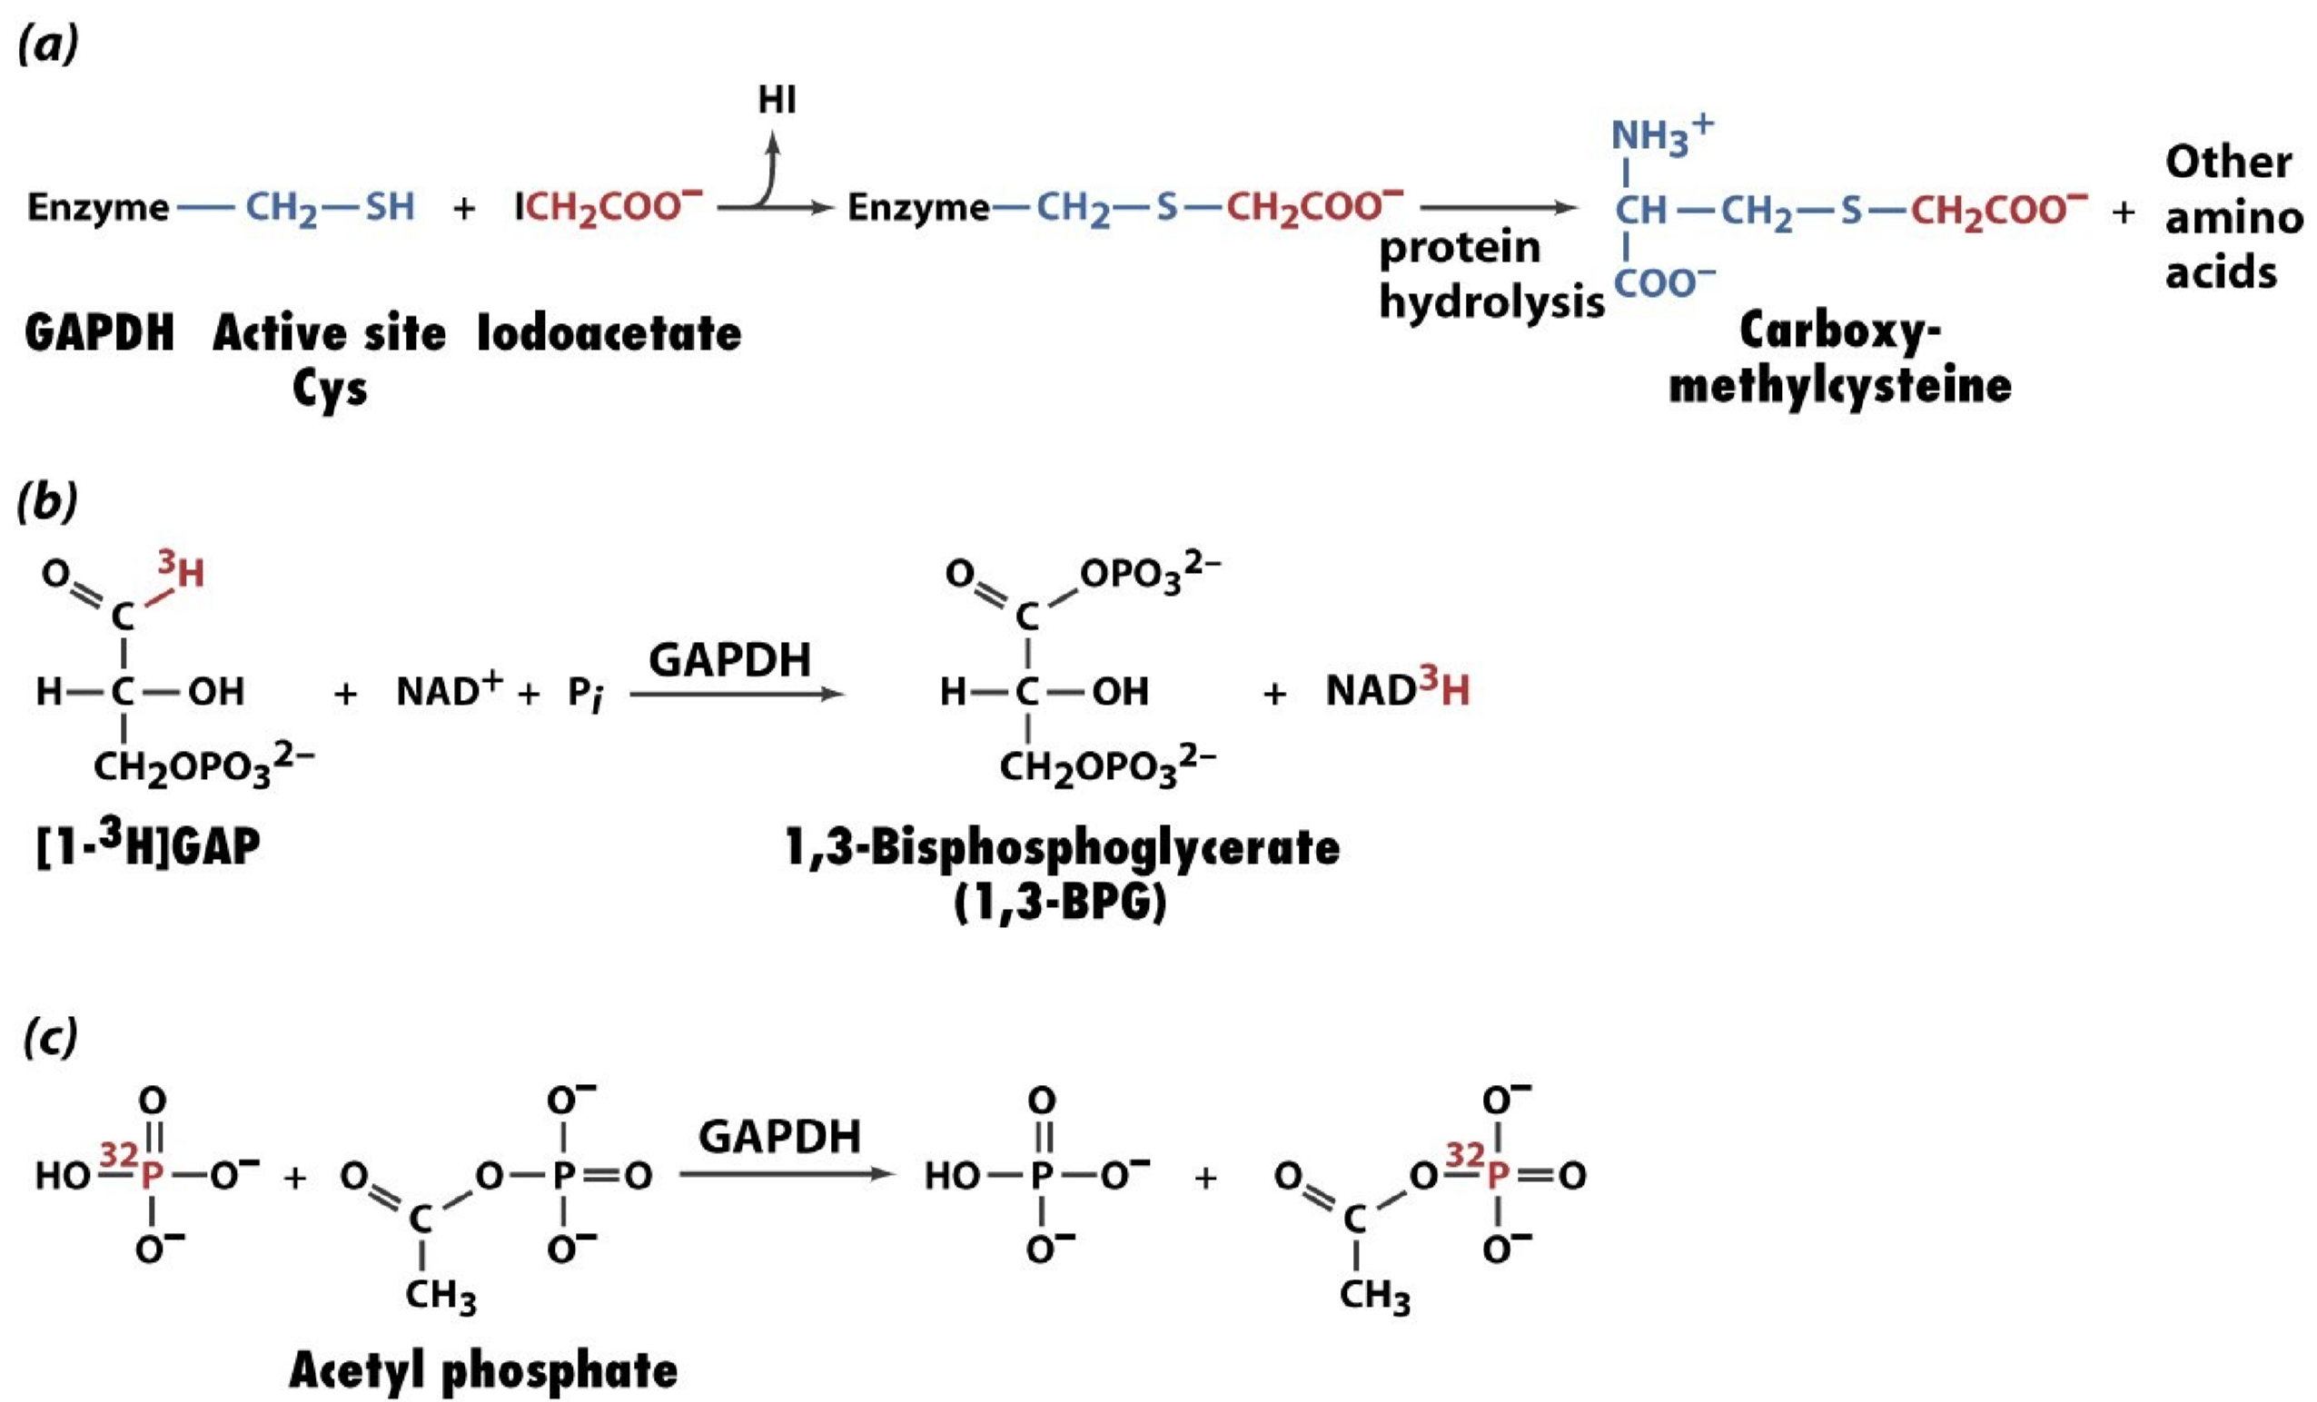
Iodoacetate inactivates enzyme by modification of active site cysteine
Aldehyde group provides H
+
for NAD
+
reduction
P
i
is substrate

Phosphoglycerate Kinase: First ATP Generation
Upon substrate binding, the two domains of PGK swing together, providing a waterfree environment (just like hexokinase)
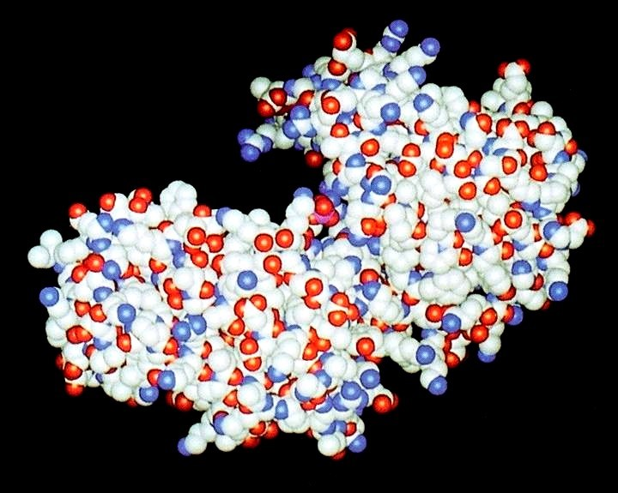
Glycolysis:
Two kinase enzymes (hexokinase and PGK) are homologs with different
substrate specificities

Phosphoglycerate Kinase:

First ATP Generation
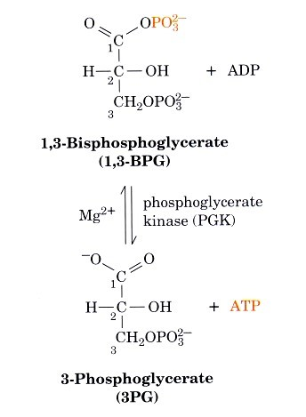
1,3-bisphosphoglycerate is a higher energy compound than ATP so the reaction has a large favourable free energy change

∆G’° = -18.5 kJ/mol
Mechanism of PGK reaction
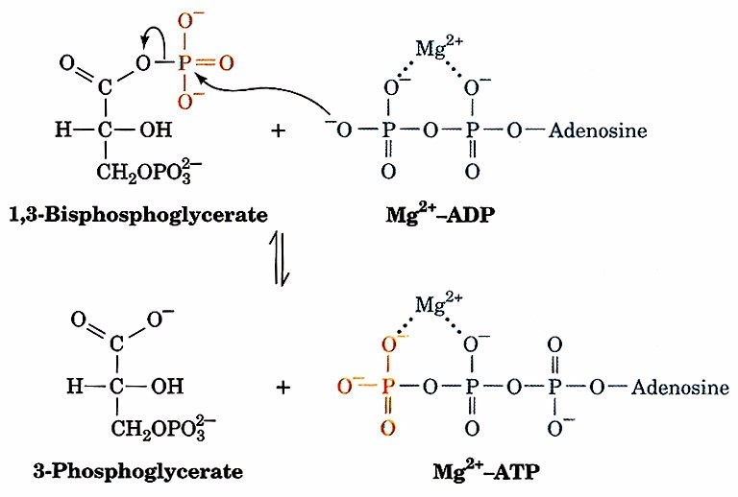
Phosphotransferase reaction similar to hexokinase (and PFK)

Energetics of the Glyceraldehyde-3-Phosphate Dehydrogenase:Phosphoglycerate Kinase Reaction Pair
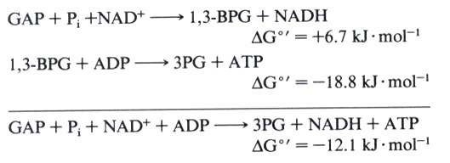
Coupling the two steps of the pathway:
Under standard condition: 1,3-BPG phosphotransfer drives the coupled reaction forming NADH and ATP.

Phosphoglycerate Mutase
Reaction 8: Catalyzes a reversible shift of the phosphoryl group between C-2 and C-3 of glycerate;
Mg²⁺ and 2,3-bisphosphoglycerate are essential.
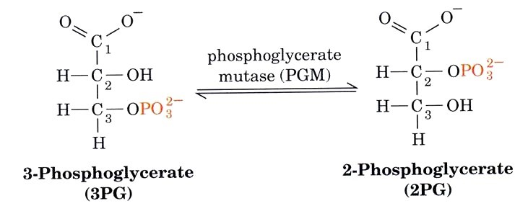
∆G’° = 4.4 kJ/mol

Reaction Mechanism of PGM
Catalytic amounts of 2,3-bisphosphoglycerate are required for enzymatic activity.
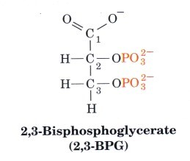
2,3-bisphosphoglycerate 'activates' PGM by phosphorylating active site histidine ie. Enzyme is inactive until phosphorylated

Reaction Mechanism of PGM
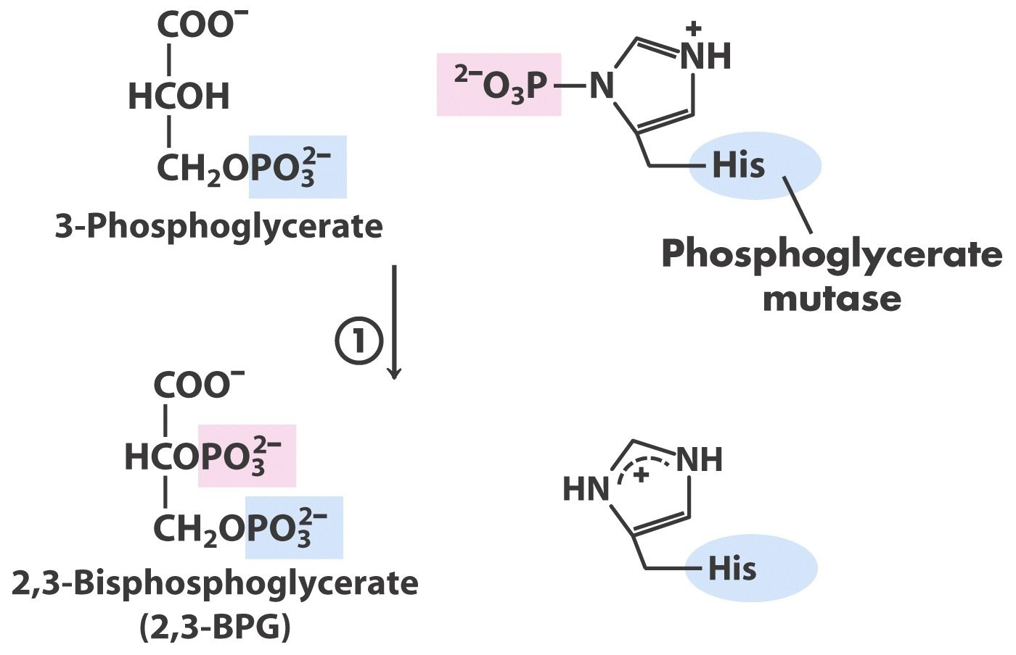
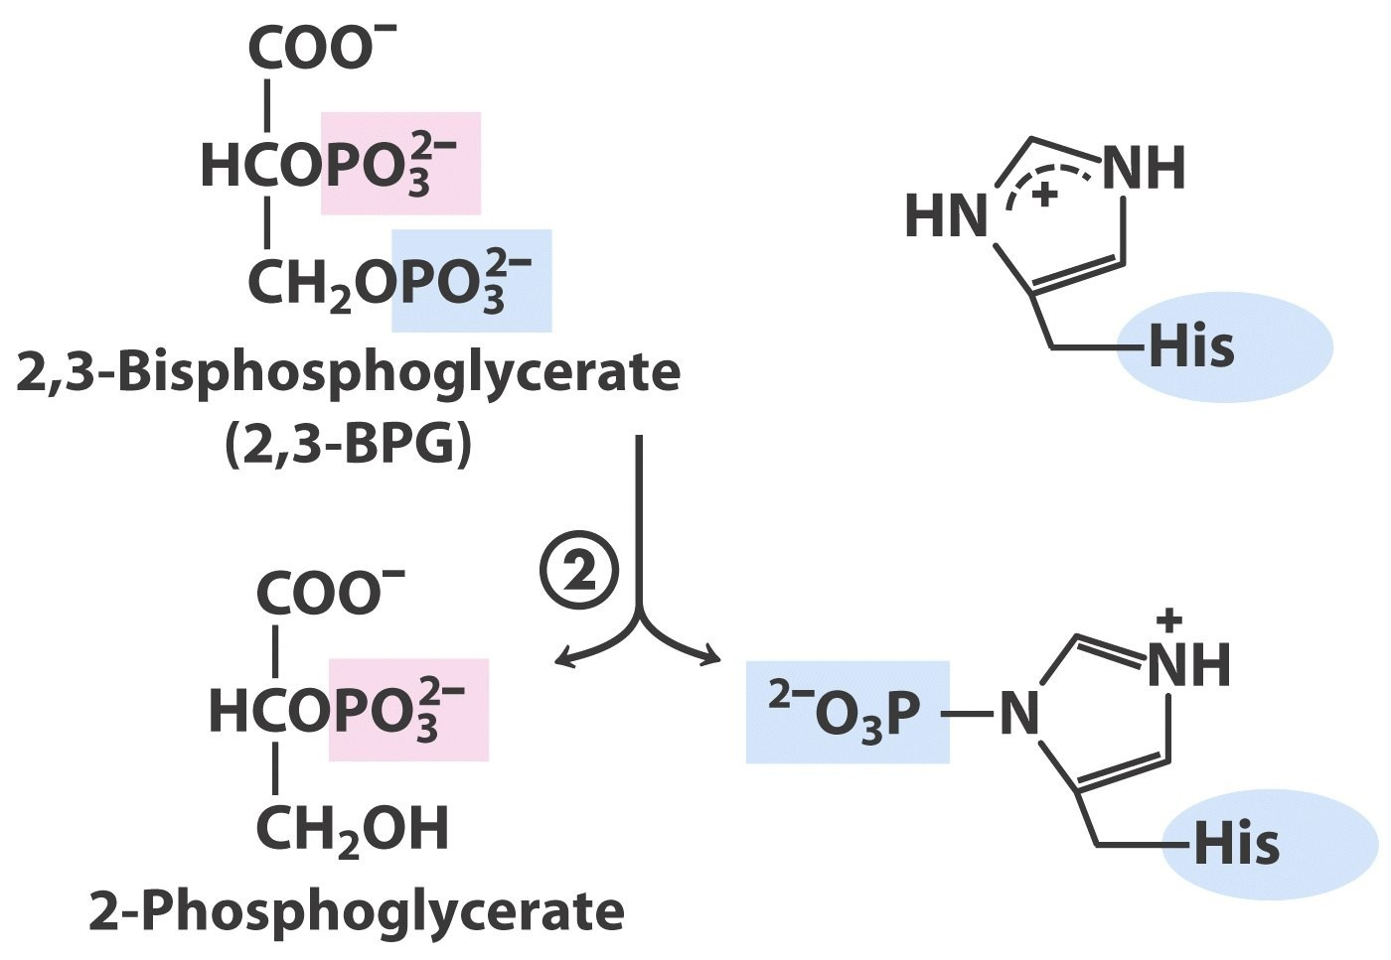
Step 1:
Phosphohistidine transfers phosphoryl to 3PG forming 2,3-BPG
Step 2:
2,3-BPG transfers phosphoryl (3C) to His forming 2BPG and phosphorylated His

Gycolysis Influences Oxygen Transport
2,3-BPG binds to deoxyhemoglobin and alters (decreases) oxygen binding affinity.
Erythrocytes synthesize and degrade 2,3-BPG using a 'detour' within the glycolytic pathway.
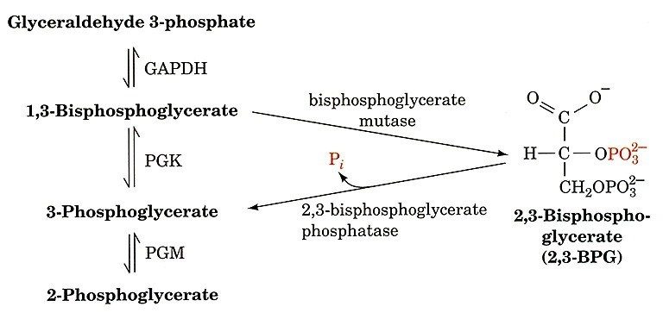
Requires two enzymes (only)
expressed in Erythrocytes

Gycolysis Influences Oxygen Transport
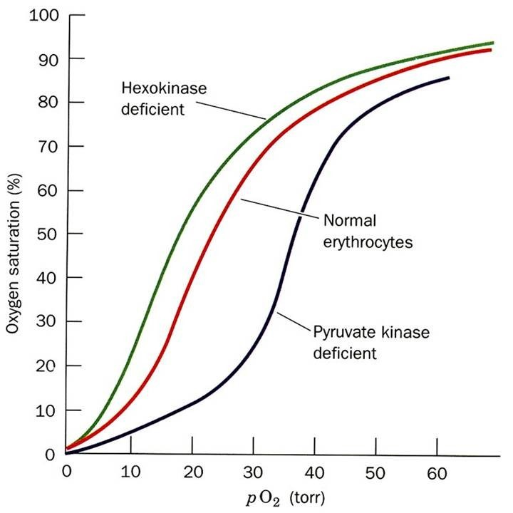
Lower [2,3-BPG] in erythrocytes resulting from hexokinase-deficiency results in increased hemoglobin oxygen affinity.
Higher [2,3-BPG] in erythrocytes resulting from PK-deficiency results in decreased hemoglobin oxygen affinity.

Enolase: Second “High Energy” Intermediate
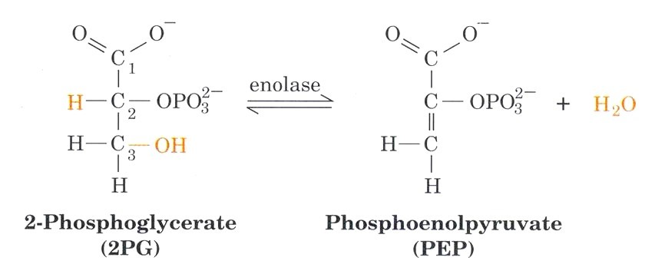

∆G’° = 7.5 kJ/mol

Enolase Reaction Mechanism
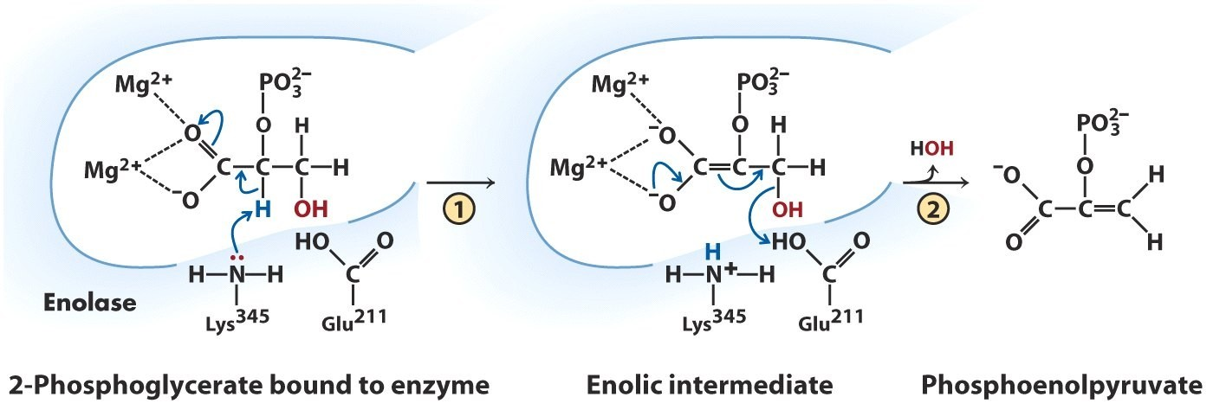
Can be inhibited by F⁻. Why? Overall reaction
F⁻ binds to strongly metals is a dehydration

Enolase Reaction Mechanism
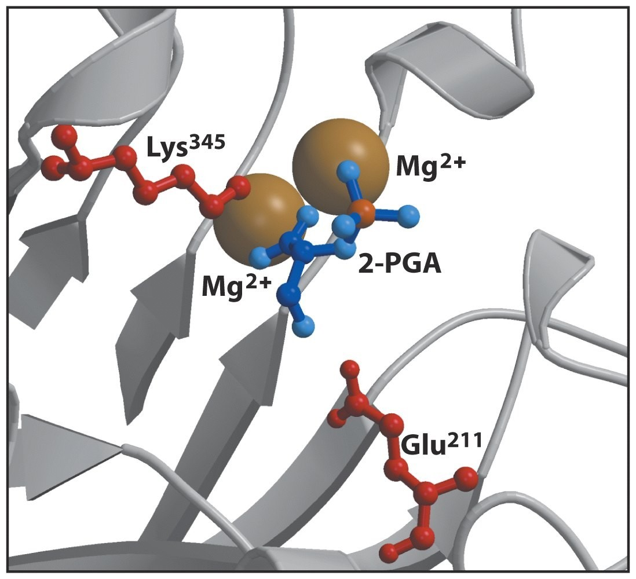
Structure of enolase catalytic center
(PDB ID 1ONE)
Pyruvate Kinase :

Second ATP Generation
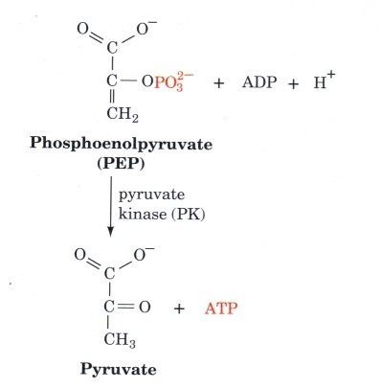
Not a homolog of other kinases in
glycolysis
Irreversible under cellular conditions due to large, negative ∆G'
∆G’° = -31.4 kJ/mol
Pyruvate Kinase :

Second ATP Generation
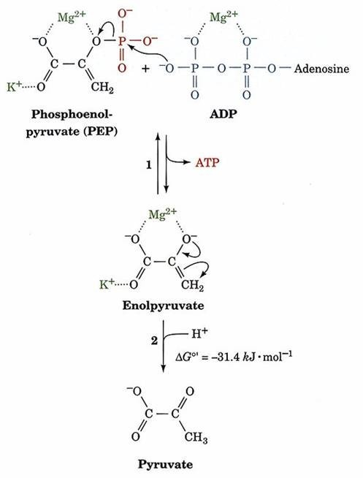
Phosphotransfer to ADP
Tautomerization of enolpyruvate to pyruvate.

The Payoff Phase
4 ATP
2 NADH
Overall: glycolysis
generates 2 ATP and
2 NADH

Summary of Enzyme Properties
Enzyme | EC Class | Mechanism | Intermediate | G'º | G' | Features
Hexokinase | Transferase | Phosphotransferase ATP → ADP | - | -17 | -27 | Costs ATP
G6P Isomerase | Isomerase | Aldose → Ketose | enol | 2 | -1
Phosphofructokinase | Transferase | Phosphotransferase ATP → ADP | - | -14 | -26 | Costs ADP
Aldolase | Lyase | Schiffs base | eneamine | 23 | -6 | 6C sugar → 2x 3C sugar
Triose Phosphate Isomerase | Isomerase | Ketose → Aldose | enol | 8 | 0
G3P Dehydrogenase | Oxidoreductase | NAD+ → NADH; SLP | thioester | 6 | 0 | 1,3-BPG ( Substrate level phosphorylation); NADH
Phosphoglycerate Kinase | Transferase | Phosphotransferase ADP → ATP | - | -18 | -1 | Generates ATP
Phosphoglycerate Mutase | Isomerase | Phosphate migration | 2,3-BPG | 4 | -1
Enolase | Lyase | Dehydration; Mg2+ | enediol | 8 | -2 | PEP
Pyruvate Kinase | Transferase | Phosphotransferase ADP → ATP | - | -31 | -14 | a-keto -CO2- ; generates ATP
Reactions with large G' tend to be regulatory targets (Red)

