https://aurora.dawn.com/news/1141398
Published in Jan-Feb 2016 Aurora magazine

Measuring radio – finally
Sami Qahar
Will RadioScore become a credible radio measurement tool?
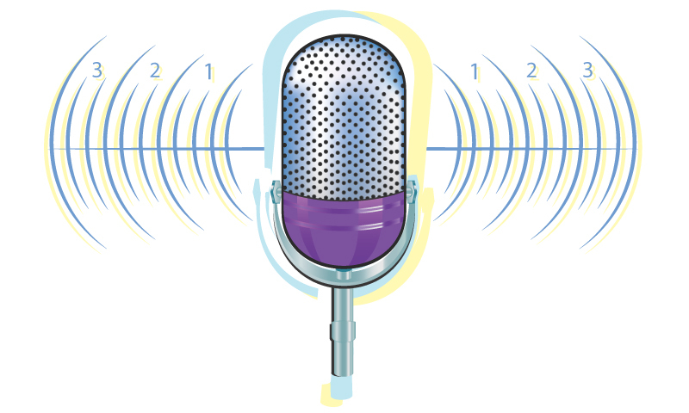
Illustration by Creative Unit.
Every other day, a new startup comes along in the business. New ambitions, new hopes, new dreams, yet few are able to turn their dreams into a reality and become a commercial success. My way of assessing the potential of a new venture is based on the uniqueness of the concept and the ability it has to win in a particular segment (be it the absence of a competitor or the will to tackle anything that comes in the way). If these two parameters are met, financials will follow, although it is not often that one sees them coming together nicely.
Raza Rahman Khan was happily working for Nestlé Pakistan, first in marketing and later in research, making him a familiar person in media and research circles in Lahore. Then in 2014, he took a leap of faith and launched RadioScore and introduced Radio Audience Measurement (RAM), a measurement tool that works on similar principles to the peoplemeter.
So what made Khan venture into this field?
“I needed to move on. I was tired of a routine job and I started looking around to see where the gaps in the market were. As a marketer, I spent a lot of money on radio, and when I used to ask my media agency for the ROI on that spend, I never received a satisfactory answer. So I decided to do something about it.”
He recalls attending a lecture given by Syed Babar Ali at LUMS, during which he said words to the effect that running one’s own business is innate and cannot be taught.
“That was the day I decided to take the risk. From then onwards, I was sure of what I wanted to do and I only had to figure out how to do it.”
In 2015, Pakistani brands invested Rs 2.3 billion on radio (Source: Aurora Fact File FY 2014-15); up 17% on the previous year, yet according to Khan, “despite the fact that we have more than 100 radio channels, there is no clarity on the money spent, and the convenient answer has always been that there is no rating system available. We want to eliminate this excuse and provide the industry with quantifiable parameters for their investment.”

RAM initially launched in Karachi and Lahore with a fairly limited panel size. They designed their own software to work with mobile phones (via an app) and create a daily log file which is then uploaded to RadioScore’s server via the unique ID of each panel member.

Having established what he wanted to do (the uniqueness of the idea), selling the idea proved relatively easy.
In 2015 Medialogic (the company that brought the peoplemeter to Pakistan) joined hands with RadioScore.
According to Khan, Salman Danish Naseer, CEO, Medialogic Pakistan, believes RadioScore to be the right fit for what Medialogic offers as a service.
“Medialogic provides the research assistance as well as sampling and recruitment advice to TV and RadioScore provides the same support for radio. The biggest synergy comes from the fact that RadioScore’s data is analysed by the same software we use, thus enabling media planners and clients to evaluate both mediums side by side.”
In essence this means that Medialogic is providing guidance on panel recruitment as well as management and operational support, and most importantly, access and data customisation to Kantar’s software, which will enable subscribers to simultaneously look at TV and radio data that is based on internationally recognised research methods. However, as Kantar is being used for the first time for radio in Pakistan, this is still a work in progress to exploit the full potential of their software.
RAM initially launched in Karachi and Lahore with a fairly limited panel size. They designed their own software to work with mobile phones (via an app) and create a daily log file which is then uploaded to RadioScore’s server via the unique ID of each panel member.
Companies like Coca Cola, Engro Foods, FM 106.2 and Nestlé were among the early subscribers and according to Tahir Hameed, Head of Media and Consumer Services at Nestlé Pakistan, “RadioScore has brought sense to radio planning. We can now plan according to programme ratings and listening behaviour. However, the coverage is still limited and we anticipate that with future expansion the value that RadioScore is bringing will increase accordingly.”
Khan is already on to expanding his panel size. In fact, Faisalabad, Islamabad and Rawalpindi have been added and in the third quarter of 2015, 300 car radios were installed with a RAM tracker, making the sample even more robust. As a result, in a year and a half, RAM’s sample size has increased six-fold, with geographical coverage across four cities. This is an aggressive expansion plan resulting in more radio channels coming on board; the total number at present is 26 and includes City FM89, Radio1 FM 91 and FM107.4. These and other radio stations are using the RAM data to chalk out their pricing strategy for their clients and media agencies. In addition, according to Khan, the major players “in telecom and banking are coming on board, while existing subscribers have renewed their contracts for the next year.”
Although RadioScore seems well on its way to becoming a meaningful radio measurement tool, challenges remain. Firstly many radio stations and advertisers remain wary of the accuracy of the data and the transparency of the collection method and recent events in 2015 relating to TV ratings has not helped their cause. To overcome this, the data collected by RadioScore is now audited by Optimised Global, acting as an independent auditing party. Secondly, radio accounts for only four percent of the total media spend in Pakistan, therefore for small advertisers the cost of data can work out higher than their actual media spend on radio. On the other hand, for the big spenders (telecoms, for example) the percentage of their radio spend is too small for them to worry about the ROI. In view of this Khan will have to work out pricing strategies that work for both the big and small radio advertiser.

