Topic : Mitochondria
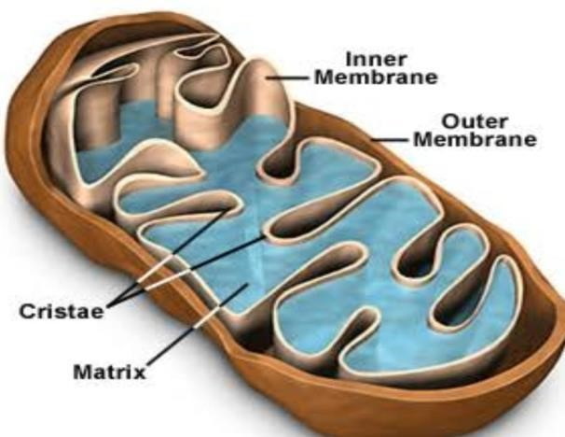
Cell:
What is cell?The world cell is derived from Latin word cella, meaning "small room"The cell is the basic structural, functional, and biological unit of all known organisms. A cell is the smallest unit of life. For example nerve cell ,muscle cell etc.Cells are often called the "building blocks of life". All cells are made from the same major classes of organic molecules: nucleic acids, proteins, carbohydrates, and lipids .
A plant cell contains a large, singular vacuole that is used for storage and maintaining the shape of the cell. In contrast, animal cells have many, smaller vacuoles. Plant cells have a cell wall, as well as a cell membrane. ... Animal cells simply have a cell membrane, but no cell wall. Additionally, animal cells also lack chloroplasts found in plant cells.
Structure of cell :
A cell consists of three parts: the cell membrane, the nucleus, and, between the two, the cytoplasm. Within the cytoplasm lie intricate arrangements of fine fibers and hundreds or even thousands of miniscule but distinct structures called organelles.For example .Golgi apparatus ,mitochondria ,nucleus,E.R ,chloroplasts, nucleus ,ribosomes etc.
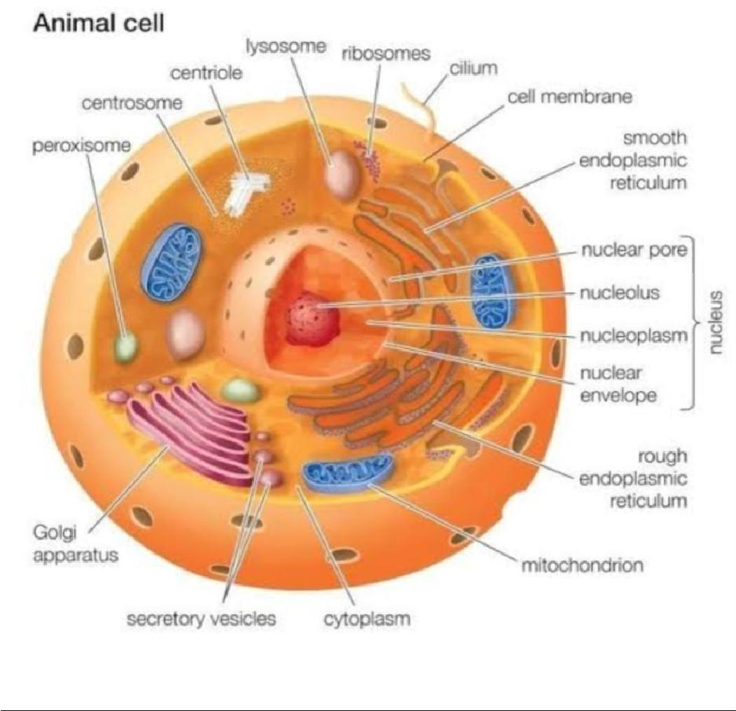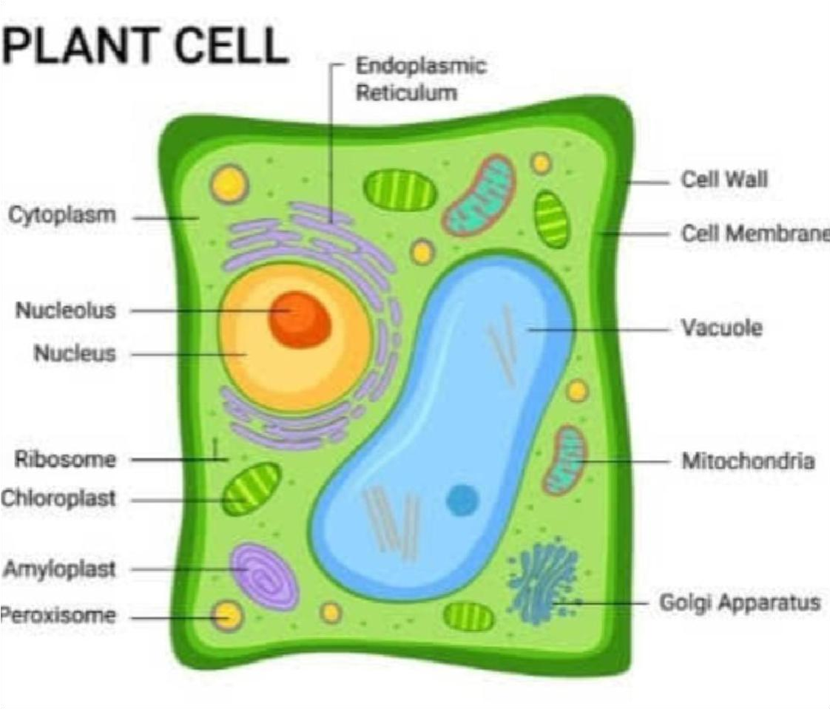
Organelles :
An organelle is a subcellular structure that has one or more specific jobs to perform in the cell, much like an organ does in the body. Among the more important cell organelles are the nuclei, which store genetic information.

MITOCHONDRIA
The word mitochondrion comes from the Greek , mitos, "thread", and , chondrion, "granule"[6] or "grain-like". Mitochondria generate most of the cell's supply of adenosine triphosphate (ATP), used as a source of chemical energy . A mitochondrion is thus termed the powerhouse of the cell.[8]Mitochondria are semi -autonomous membrane-bound cell organelles (mitochondrion, singular) that generate most of the chemical energy needed to power the cell's biochemical reactions. Chemical energy produced by the mitochondria is stored in a small molecule called adenosine triphosphate (ATP).The mitochondria are the main source of adenosine triphosphate (ATP), the energy-rich compound that drives fundamental cell functions.It is thought that mitochondria arose from once free-living bacteria that were
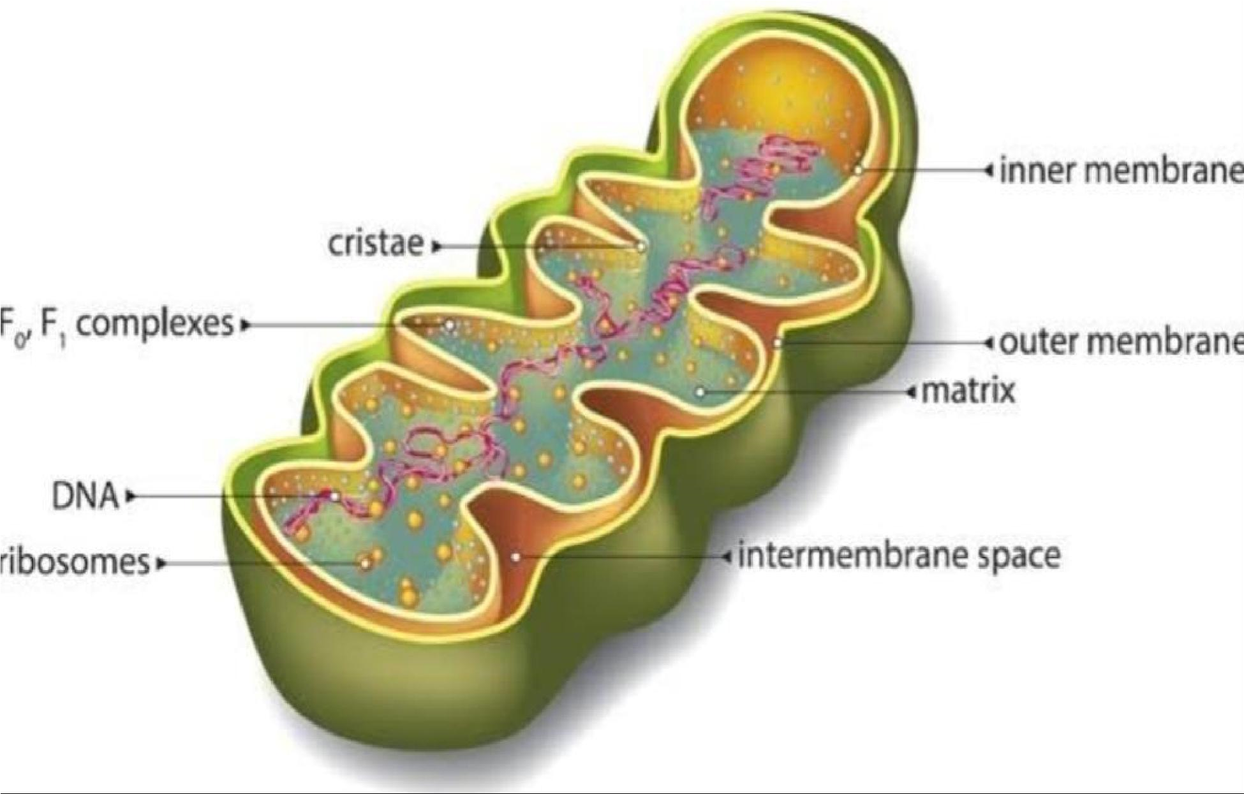
incorporated into cells.
Where are mitochondria found?
Mitochondria are found in all body cells, with the exception of a few. There are usually multiple mitochondria found in one cell, depending upon the function of that type of cell. Mitochondria are
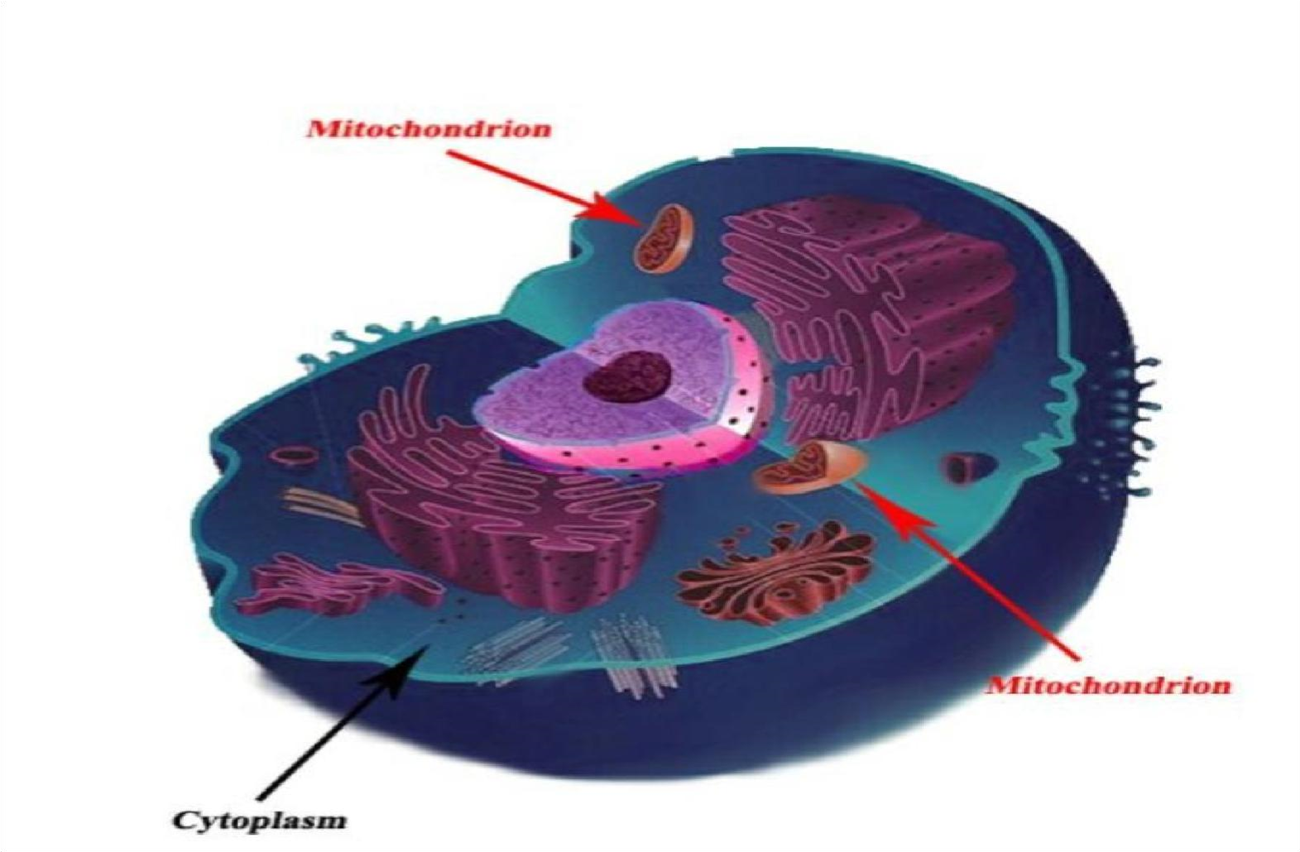
located in the cytoplasm of cells along with other organelles of the cell.
History of mitochondria:
The first observations of intracellular structures that probably represented mitochondria were published in the 1840s. In 1890, established them as cell organelles and called them "bioblasts".The term "mitochondria" was coined by Carl Benda in 1898.In 1939, experiments using minced muscle cells demonstrated that cellular respiration using one oxygen atom can form two adenosine triphosphate (ATP) molecules.The popular term "powerhouse of the cell" was coined by Philip Siekevitz in 1957.[
Structure of mitochondria :
They can differ widely from cell type to cell type.
Even within one type of tissue, the shape of the mitochondria can vary depending on their functional status.
Mitochondria are mobile, plastic organelles.
Mitochondria are typically round to oval in shape and range in size from 0.5 to 10 μm. In addition to producing energy, mitochondria store calcium for cell signaling activities, generate heat, and mediate cell growth and death. The number of mitochondria per cell varies widely; for example, in humans, erythrocytes (red blood cells) do not contain any mitochondria, whereas liver cells and muscle cells may contain hundreds or even thousands. The only eukaryotic organism known to lack mitochondria is the oxymonad Monocercomonoides species. Mitochondria are unlike other cellular
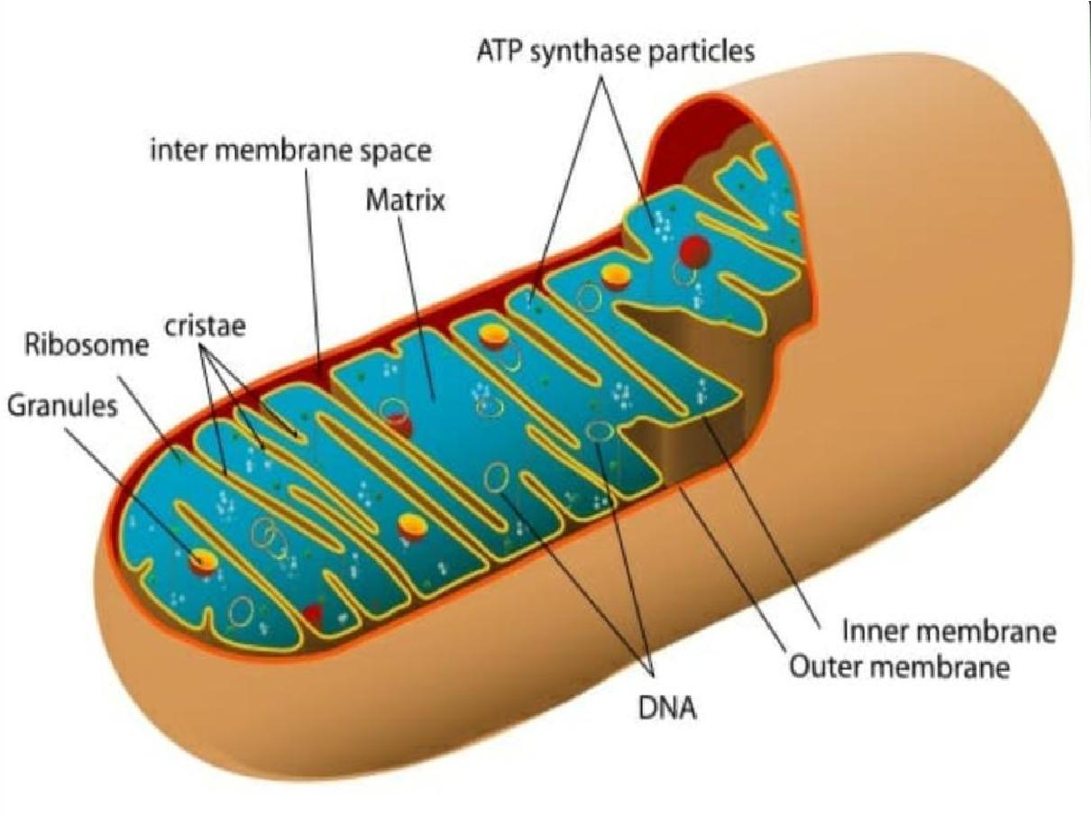
organelles in that they have two distinct membranes and a unique genome and reproduce by binary fission; these features indicate that mitochondria share an evolutionary past with prokaryotes (single-celled organisms).
MITOCHONDRIAhave two membranes, Outer membrane and inner membrane ..These membranes are made of phospholipid layers, just like the cell’s outer membrane.
Outer membrane :
The outer membrane covers the surface of the mitochondrionThe outer
mitochondrial membrane is freely permeable to small molecules and contains special channels capable of transporting large molecules. The outer membrane contains proteins known as porins, which allow movement
of ions into and out of the mitochondrion. Enzymes involved in the elongation of fatty acids and the oxidation of adrenaline can also be found on the outer membrane.
inner membrane is located within and has many folds called cristae. The inner membrane is far less permeable, allowing only very small molecules to cross into the gel-like matrix that makes up the organelle’s central mass. It is also where many other chemical reactions take place to carry out the mitochondria’s many functions increased surface area creates more space for more reactions to occur, and increases the mitochondria’s output.
Cristae:
The inner membrane contains a variety of enzymes. It contains ATP synthase which generates ATP in the matrix, and transport proteins that regulate the movement of metabolites into and out of the matrix.The inner membrane has many folds called cristae. The folds increase surface area of the membrane, which is important because the inner membrane holds the proteins involved in the electron transport chain. It is also where many other chemical reactions take place to carry out the mitochondria’s many functions. An increased surface area creates more space for more reactions to occur, and increases the mitochondria’s output.
Matrix:
The space between the outer and inner membranes is called the intermembrane space, and the space inside the inner membrane is called the matrix.which contains the enzymes of the Krebs (TCA)also known as the citric acid cyclce fatty acid cycles, alongsidedeoxyribonucleic acid ( DNA)of the mitochondrial genome , RNA, ribosomes and calcium granulesthe , which metabolizes nutrients into by-products the mitochondrion can use for energy production.
_
Mitochondrial DNA :
Although most of our DNA is kept in the nucleus of each cell, mitochondria have their own set of DNA. Interestingly, mitochondrial DNA (mtDNA) is more similar to bacterial DNA.The mtDNA holds the instructions for a number of proteins and other cellular support equipment across 37 genes.
The human genome stored in the nuclei of our cells contains around 3.3 billion base pairs, whereas mtDNA consists of less than 17,000.
During reproduction, half of a child’s DNA comes from their father and half from their mother. However, the child always receives their mtDNA from their mother. Because of this, mtDNA has proven very useful for tracing genetic lines.
For instance, mtDNA analyses have concluded that humans may have originated in Africa relatively recently, around 200,000 years ago, descended from a common ancestor, known as mitochondrial Eve.
Granules :
Matrix granules are particles containing phospholipids, proteins and calcium found in the mitochondria.
Twenty years ago, two hypotheses on their functions were introduced:
- the granules were considered as sinks for cations and that they regulated the concentrations of these ions (Peachey).
- they were considered to be precursors of the mitochondrial inner membrane (Barnard). In heart muscle in stimulating situations, the native matrix granules move towards the inner membrane and are incorporated in it. They appear to create contact sites between inner and outer mitochondrial membranes in which enzymes can function efficiently. ATP synthase Practical :
The function of ATP synthase is to synthesize ATP from ADP and inorganic phosphate (P_{i}) in the F₁ sector. This is possible due to energy derived from a gradient of protons which cross the inner mitochondrial membrane from the intermembrane space into the matrix through the
F_{o} portion of the enzyme.
Mitochondrial Ribosomes :
Mitochondrial ribosomes (mitoribosomes) perform protein synthesis inside mitochondria.
Evolution of Mitochondria :
Mitochondria are thought to have evolved from free-living bacteria that developed into a symbiotic relationship with a prokaryotic cell, providing it energy in return for a safe place to live. It eventually became an organelle, a specialized structure within the cell, the presence of
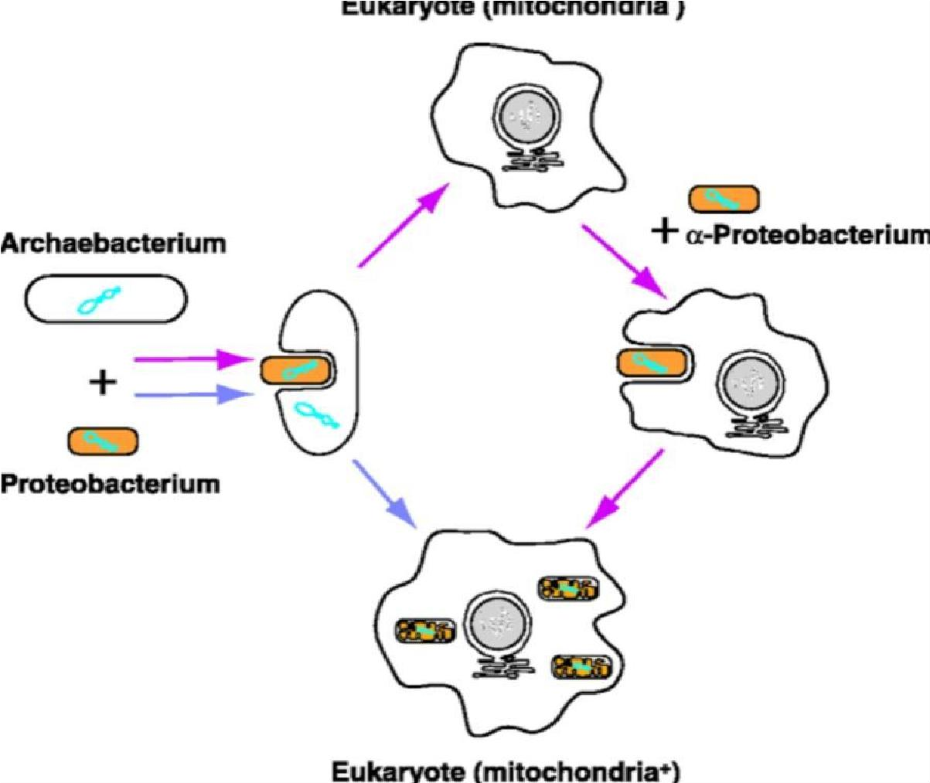
which are used to distinguish eukaryotic cells from prokaryotic cells. This occurred over a long process of millions of years, and now the mitochondria inside the cell cannot live separately from it. The idea that mitochondria evolved this way is called endosymbiotic theory.
Endosymbiotic theory has multiple forms of evidence. For example, mitochondria have their own DNA that is separate from the DNA in the cell’s nucleus. It is called mitochondrial DNA or mtDNA, and it is only passed down through females because sperm do not have mitochondria. You received your mtDNA from your mother, and you can only pass it on if you are a female who has a child. It is also circular, like bacterial DNA. Another form of evidence is the way new mitochondria are created in the cell. New mitochondria only arise from binary fission, or
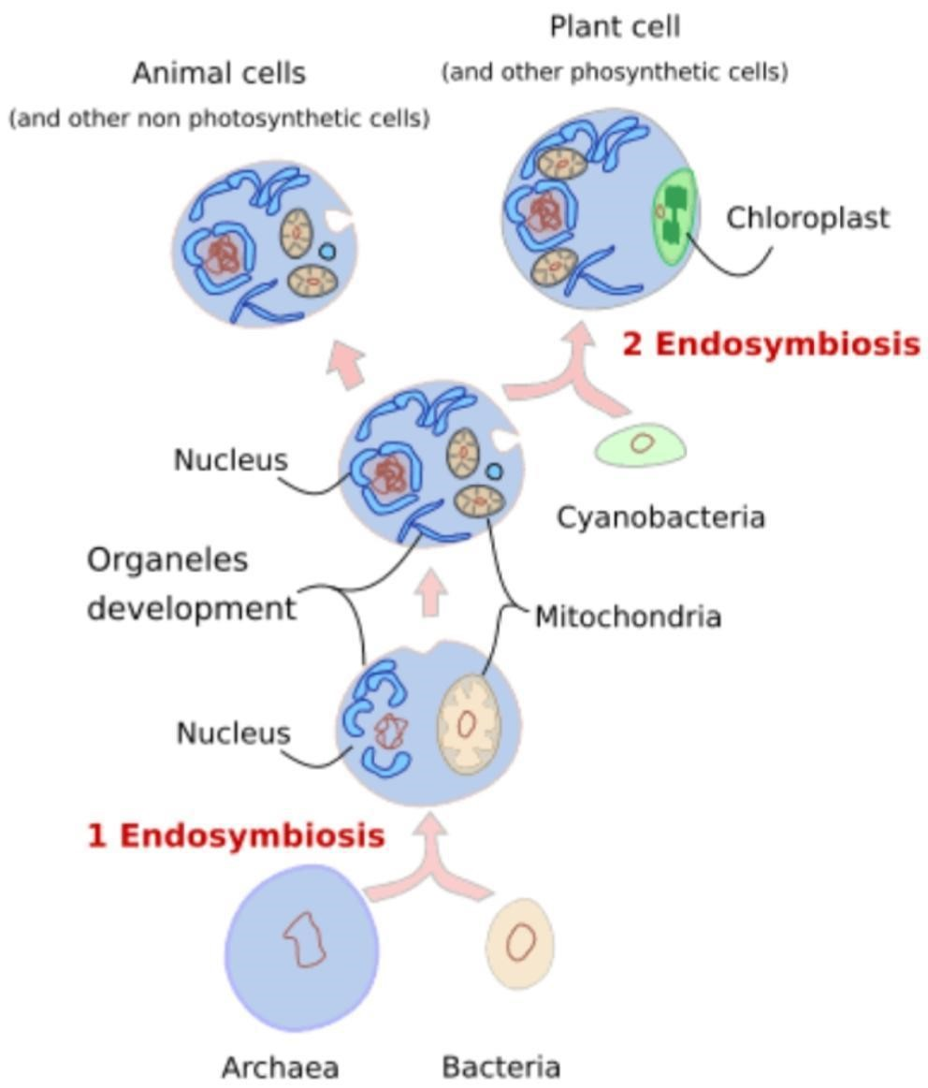
splitting, which is the same way that bacteria asexually reproduce. If all of the mitochondria are removed from a cell, it can’t make new ones because there are no existing mitochondria there to split. Also, the genome of mitochondria and Rickettsia bacteria (bacteria that can cause spotted fever and typhus) have been compared, and the sequence is so similar that it suggests that mitochondria are closely related to Rickettsia.
Chloroplasts, the organelles in plants where photosynthesis occurs, are also thought to have evolved from endosymbiotic bacteria for similar reasons: they have separate, circular DNA, a double membrane structure, and split through binary fission.
Amount of mitochondria in cell:
The amount of mitochondria in a cell depends on how much energy that cell needs to produce. Muscle cells, for example, have many mitochondria because they need to produce energy to move the body. Red blood cells, which carry oxygen to other cells, have none; they do not need to produce energy. The cells which are very metabolically active, such as hepatocytes, will have many mitochondria.
Function of mitochondria :
There are following functions of mitochondria…
ATP Production :Mitochondria, using oxygen available within the cell convert chemical energy from food in the cell to energy in a form usable to the host cell. ... NADH is then used by enzymes embedded in the mitochondrial inner membrane to generate adenosine triphosphate (ATP). In ATP the energy is stored in the form of chemical bonds.Mitochondria produce ATP through process of cellular respiration—specifically, aerobic respiration, which requires oxygen. The citric acid cycle, or Krebs cycle, takes place in tIhe mitochondria. This cycle involves the oxidation of pyruvate, which comes from glucose, to form the
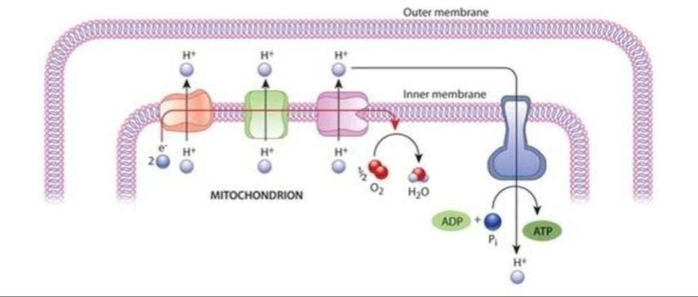
molecule acetyl-CoA. Acetyl-CoA is in turn oxidized and ATP is produced.
Oxidative phosphorylation:
The citric acid cycle reduces nicotinamide adenine dinucleotide (NAD⁺) to NADH. NADH is then used in the process of oxidative phosphorylation, which also takes place in the mitochondria. Electrons from NADH travel through protein complexes that are embedded in the inner membrane of the mitochondria. This set of proteins is called an electron transport chain. Energy from the electron transport chain is then used to transport proteins back across the membrane, which power ATP synthase to form ATP.
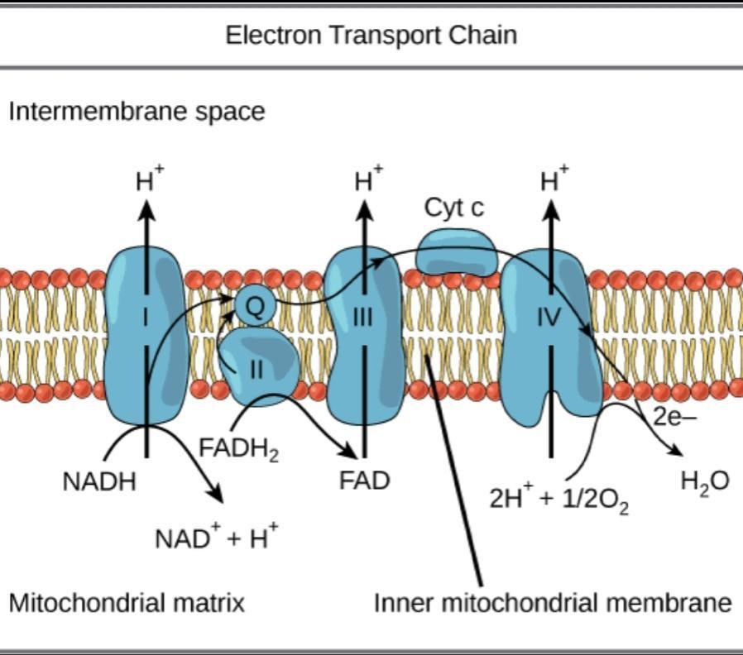
Storage of calcium :They can store calcium, which maintains homeostasis of calcium levels in the cell and maintain proper concentration of calcium ion within the compartment of cell
DNA and Inheritance:
Mitochondria replicate their DNA by a process called binary fission and can use this to make multiple copies in one mitochondrion.
Their DNA has maternal lineage which means their DNA is passed from mother to child with little change.
The mitochondria also help in building certain parts of blood and hormones like testosterone and estrogen.
The liver cells mitochondriahave enzymes that detoxify ammonia.
Mitochondria also generate heat .
Regulation of innate immunity
Innate immunity is the in-born system that recognizes and responds to infection by pathogens, providing immediate, non-specific defence. Mitochondrial antiviral signalling protein (MAVS) plays a key role in the innate response to viral infections, helping to induce antiviral and anti-inflammatory pathways.
Stem Cell Regulation
Mitochondria are thought to play crucial roles in the maintenance of pluripotency, differentiation, and reprogramming of induced pluripotent stem cells.
Program cell death :
Apoptosis is the highly controlled process of programmed cell death, which is used by multicellular organisms in a number of biological processes, including intrauterine development, mopping up damaged cells, and maintaining cell numbers. The production of apoptotic bodies which are engulfed by phagocytes can be activated by both an intrinsic and extrinsic pathway.
Control intrinsic pathway : Mitochondria control the intrinsic pathway, releasing proteins such as cytochrome c from their intermembrance space in response to cell stresses such as heat, infection, hypoxia, increased calcium and nutrient deprivation.
Disturbances to this regulation are associated with the development of diseases such as cancer, and tissue damage following stroke.
Regulation of metabolism:
Mitochondria have several critical roles in metabolism,¹⁴ even in organisms that live anaerobically and do not use their mitochondria for ATP synthesis.¹⁵ They are the central player in carbon metabolism. As well as their well-known catabolic role in oxidation of sugars
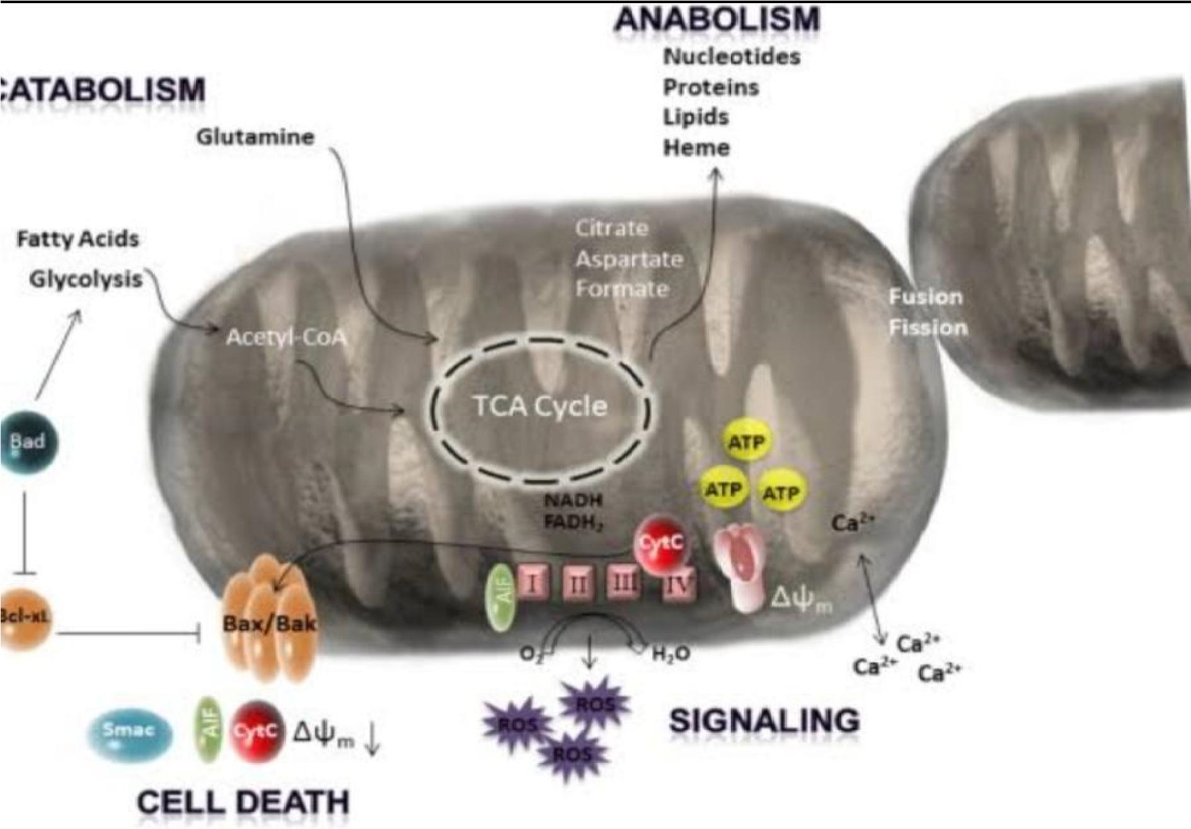
(pyruvate), fats (palmitoylcarnitine) and proteins (glutamine, glutamate, alanine, and so on), they have a critical anabolic role, providing the carbon skeletons for the biosynthesis of most biomolecules, particularly glucose, fatty acids and amino acids. They are a major player in 1carbon metabolism. They are central in nitrogen metabolism, metabolizing the glutamate used in transamination reactions and the glutamine used to shuttle nitrogen around the body, as well as the site of half of the reactions of the urea cycle. They are also essential in the synthesis of haem and iron-sulphur clusters.
Mitochondrial have mitochondrial DNA (mtDNA)
Mitochondria contain their own genetic material which is independent of cell of cell in which they are located .Mitochondrial DNA is maternally inherited at fertilization only nuclear DNA enters from sperm because although the egg contains mitochondria ,sperm cell do not .sperm are so tiny that mitochondria
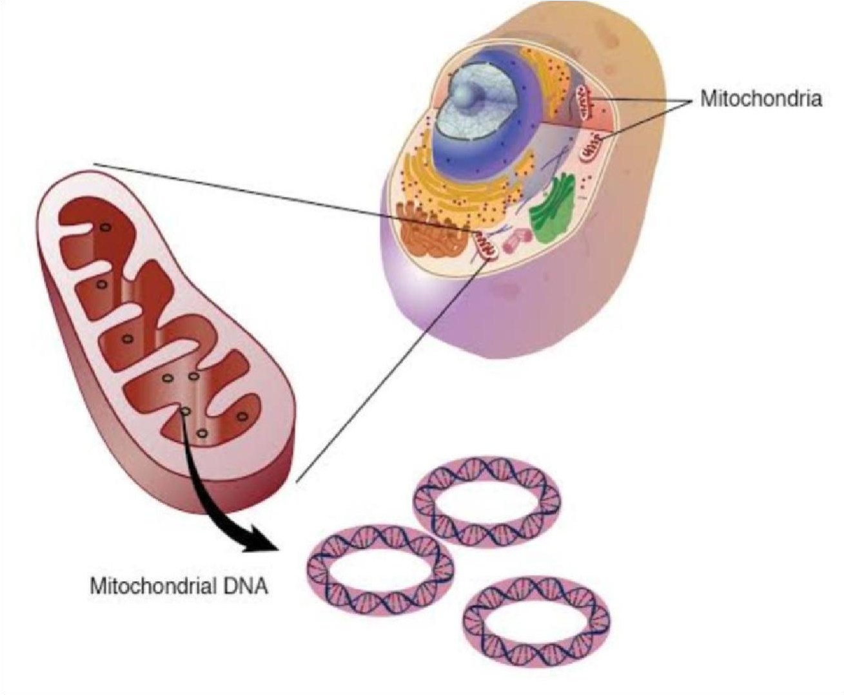
whould hamper their passage towards the egg
Mitochondrial disease :
Mitochondrial diseases are chronic (long-term), genetic, often inherited disorders that occur when mitochondria fail to produce enough energy for the body to function properly. (Inherited means the disorder was passed on from parents to children.) Mitochondrial diseases can be present at birth, but can also occur at any age.
Mitochondrial diseases can affect almost any part of the body, including the cells of the brain, nerves, muscles, kidneys, heart, liver, eyes, ears or pancreas.
Mitochondrial dysfunction occurs when the mitochondria don't work as well as they should due to another disease or condition. Many conditions can lead to secondary mitochondrial dysfunction and affect other diseases.
One in 5,000 individuals has a genetic mitochondrial disease. Each year, about 1,000 to 4,000 children in the United States are born with a mitochondrial disease. With the number and type of symptoms and organ systems involved, mitochondrial diseases are often mistaken for other, more common, diseases.
Causes of mitochondria disease :Mitochondria are the “power plants” of all the cells in the human body, producing the energy our bodies need to function. They are also involved in metabolism, helping our cells build, break down and recycle compounds they need.
In mitochondrial disorders, the mitochondria’s ability to do these jobs is impaired because of a genetic mutation — a “mistake” in the DNA. We all have two types of DNA in our bodies. The nuclear DNA (usually just called “DNA”) is found in the cell's nucleus and is inherited from both our mother and father. Mitochondria also have DNA, inherited from mothers. Because both types of DNA are responsible for the structure and function of the mitochondria, mutations in either can cause mitochondrial disorders. Mutations can be inherited from parents or can happen for the first time in a child (so-called de novo mutations).
Inherited mutations in the mitochondrial DNA come from the mother. Mutations in nuclear DNA usually are recessive, meaning that one copy of the mutation comes from each parent. In this case, the parents are just carriers and do not have mitochondrial disease themselves. This also explains why some people with a mitochondrial disorder have a family history of the disorder, while others are the only one in their family to be affected.
Environmental toxins can also trigger mitochondrial disease.
Symptoms of mitochondrial diseases:
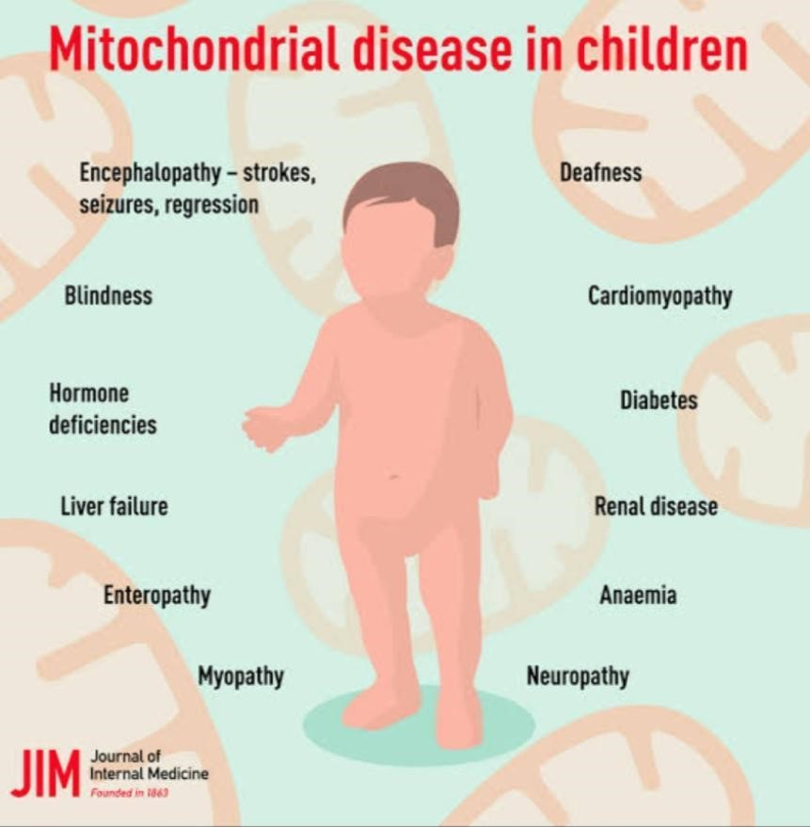
- Poor growth
- Loss of muscle coordination
- Muscle weakness
- Seizures
- Autism
- Problems with vision and/or hearing
- Developmental delay
- Learning disabilities
- Heart, liver, and/or kidney disease
EXAMPLES:
Mitochondrialmyopathies — a group of neuromuscular diseases caused by damage to the mitochondria.
Mitochondrial DNA (mtDNA) depletion syndromes (MDS) are a genetically and clinically heterogeneous group of autosomal recessive disorders that are characterized by a severe reduction in mtDNA content leading to impaired energy production in affected tissues and organs.
Kearns-Sayre syndrome (KSS),is a condition caused by defects in mitochondria , which are
structures within cells that use oxygen to convert the energy from food into a form cells can use. This process is called oxidative phosphorylation .
Leigh syndromeand MELAS are the most common mitochondrial myopathies. The
prognosis of Leigh syndrome is generally poor, with survival generally being a matter of months after disease onset.
__________________________________
MCQ 's related to topic :
1.The site of aerobic respiration in eukaryotic cells is___________
- Peroxisome
- Plastid
- Mitochondria
- Cilia
Answer: c
2.How do the small molecules pass through the outer membrane of mitochondria?
- ATP pump
- Carrier protein
- Channels
- Porins
Answer: d
3. Name the organelle which is used for aerobic respiration and ATP synthesis in Entamoeba histolytica.
- Hydrogenosome
- Mitochondria
- Mitosome
- Peroxisome
Answer: c
4. Which is a function of mitochondria?
a). Regulating metabolism
b). Producing ATP
c).Storing calcium
d). All of the above
Answer : d
5.Which is NOT a reason why mitochondria are thought to have evolved from free-living bacteria?
a) Mitochondria have their own DNA.
b).Mitochondria reproduce through binary fission.
c). Mitochondrial DNA is inherited matrilineally.
d). The genome is similar to that of bacterial DNA.
Answer :c
6.Where is the mitochondrial matrix located?
a). Within the inner membrane
b). Between the inner and outer membrane
c). Inside the mtDNA
d). In the intermembrane space
Answer : a
7.Example of autonomous organelles.
a).chloroplast
b).Mitochondria
c).Golgi apparatus
d).chloroplasts and mitochondria
Answer :b
8.which of the following cellular event is not directly involved with mitochondria . a).apoptosis
b).ATP synthesis
c).cell cycle
d).protein degradation
Answer: d
9.The inner membrane of the mitochondria is usually, highly convoluted forming a series of infolding known as
- thylakoids
- lamella
- cristae
- grana
Answer : cristae
10.Mitochondrial DNA is
- simple, double stranded linear DNA molecule
- simple, single stranded linear DNA molecule
- simple, single stranded circular DNA molecule
- simple, double stranded circular DNA molecule
Answer : d
11.The inner mitochondrial membrane has
  - NADH dehydrogenase complex
  - b-c1 complex
  - cytochrome oxidase complex
  - all of these
Answer : d
12.In mitochondria , cristae act as sites for
  - protein synthesis
  - phosphoryaltion of flavoproteins
  - breakdown of macromolecules
  - Oxidation reduction reaction
Answer :d
13.Mitochondrial inner membrane is rich in phospholipid
  - Cardiolipin
  - Phosphatidyl inositol
  - Phosphatidyl serine
  - Phosphatidyl choline
Answer : a
14.Which of the following is not a function of mitochondrion
  - electron transport cahin and associated ATP production
  - glycolysis and associated ATP production
  - Fatty acid breakdown
  - non-shivering thermogenesis
Answer :b
15.Cyanide is a mitochondria toxin the mechanism of action of cyanide is by inhibiting
a).NADH dehydrogenase
b).succinate dehydrogenase
c).cytochrome c oxidase
d).ATP synthase
Answer : c
------------------------------------------------

