4. Role of PPP’s in Education
Content
4.1. | Introduction to Public- Private Partnership  (PPP)
4.2. | Key characteristics of Public-Private Partnership
4.3. | Definition of Public-Private Partnership
4.4. | Parties involve in Public-Private Partnership
4.5. | Advantages of Public-Private Partnership
4.6. | Public-Private Partnership in Pakistan
4.7. | Management of Public-Private Partnership
4.8. | Role of Private-Public Partnership in Education  - Role of Government  - Role of Private sector  - Role of NGO’s/CSO’s
4.9. | Educational objectives of Public-Private Partnership
4.10. | Public-Private Partnership in Education
4.11. | Key challenges in structuring in Education with Private-public Partnership
4.12. | Key partners and scope of partnership in Education
4.13. | Issues and Problems with the PPP’s  - Insufficient of PPP implementation guidelines and challenge in managing KPI’s  - Maintenance approach and service delivery failure  - Asset risk and life cycle issue

Introduction to PPPs:
Public-Private Partnership (PPP) describes a government service or private business venture which is funded and operated through a partnership of government and one or more private sector companies. These schemes are sometimes referred to as PPP or P3.
PPP involves a contract between a public sector authority and a private party, in which the private party provides a public service or project and assumes substantial financial, technical and operational risk in the project the government may provide a capital subsidy in the form of a one-time grant, so as to make it more attractive to the private investors. In some other cases, the government may support the project by providing revenue subsidies, including tax breaks or by providing guaranteed annual revenues for a fixed period.

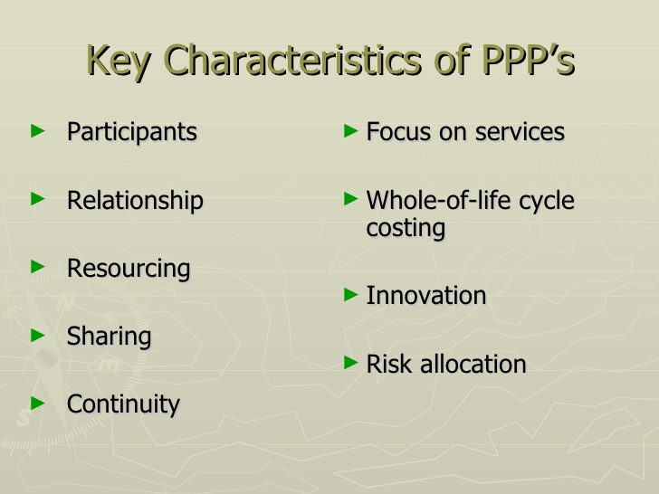

Definition:
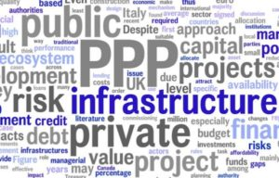

“Public-Private Partnership involves collaboration between a government agency and private-sector companies that can be used to finance, build, and operate projects, such as public transportation networks, parks and convention centers etc.”
According to Saves (2000):
“A PPP is defined as any arrangement between a government and the private sector in which partially or traditionally public activities are performed by the private sector.”
Parties involve in PPPs:
PPPs have been on the rise sometimes triggered by the government itself and sometimes by CSOs (Civil Society Organizations) and sometimes even by the local industry keen to improve the quality of HR (Human Resources).

Advantages of PPPs:
- Ensure the necessary investments into public sector and more effective public resources management.
- Ensure higher quality and timely provision of public services
- Mostly investment projects are implemented in due terms and do not impose unforeseen public sectors and extra expenditures.
- A private entity is granted the opportunity to obtain a long-term payment.
- Private sector expertise and experience are utilized in PPP projects implementation
- Appropriate PPP project risks allocation enables to reduce the risk management expenditures.

PPPs in Pakistan:

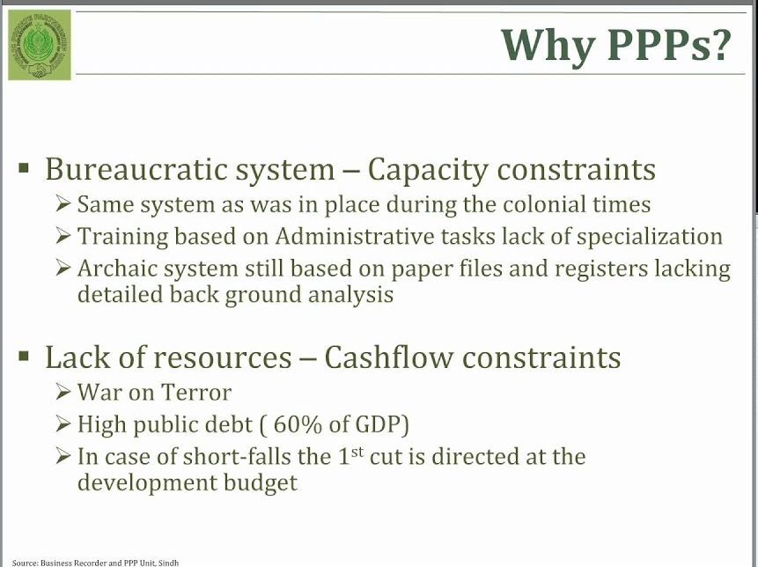

Management of PPP:
- Employ gets weekly report reminder.
- Progress, plans and problems form filled by everyone.
- Report with informative manager’s team dashboard compiled.
- Manager reviews each employee.
- Other can comment and like.

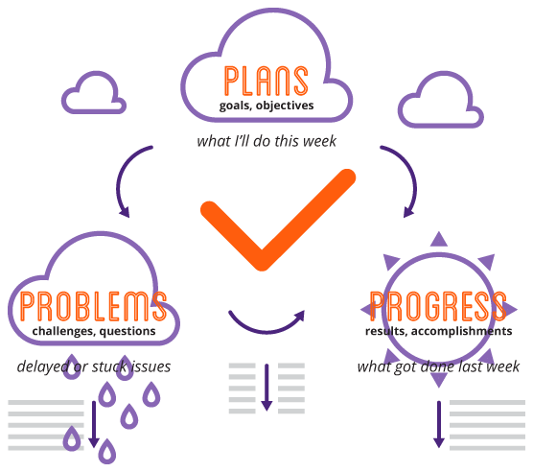

Role of PPPs in Education:
A collaboration of government and private sector companies, individuals or NGOs in the funding, management, operations to support education.
Collaboration at:
- Government owned institutions
- Community owned sites
- Private sector sites

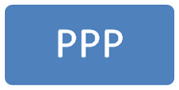

Government:
- Curriculum
- Teachers
- School Premise
- Public Education System
Private Sector:
- Resources
- Expertise
- Funding
- Parents
- Citizens
- Operations
NGOs / CSOs:
- Funding
- Resources
- Teacher training
- Policy implementation
- Management
- Capacity
Educational Objectives of 3P:
Various governments at the central, state and local level are exploring and implementing PPPs in education. Three primary objectives that governments are exploring these partnerships include:
- Increasing access to school
- Using underutilizes school infrastructure
- Improve the quality of Education
Some other objectives are as follows:
- Lift the quality of Education
- Increase choice for low-income parents
- Strengthen accountability in the government system

3P in Education:
The main rationale for developing public-private partnerships (PPPs) in education is to maximize the potential for expanding equitable access to schooling and for improving education outcomes, especially for marginalized groups. Different types of contracts can help to meet these two objectives in different socioeconomic and political contexts. Contracting is the process whereby a government procures education or education-related services of a defined quantity and quality at an agreed price from a specific provider. The agreement between the funder and the service provider is recorded in a contract and is valid for a specified period of time. Many forms of contracting are currently used in education around the world. A range of different services can be procured from the private sector governments buy the services involved in producing education (inputs), such as teacher training, management, curriculum design, or the use of a school facility from private organizations governments contract with private organizations to provide the process of education, for example, by managing and operating public schools.
Here we will see each type of education service:
- Management services
- Professional services
- Support services
- Operational services
- Education services
- Facility availability
- Facility availability and education services combined.

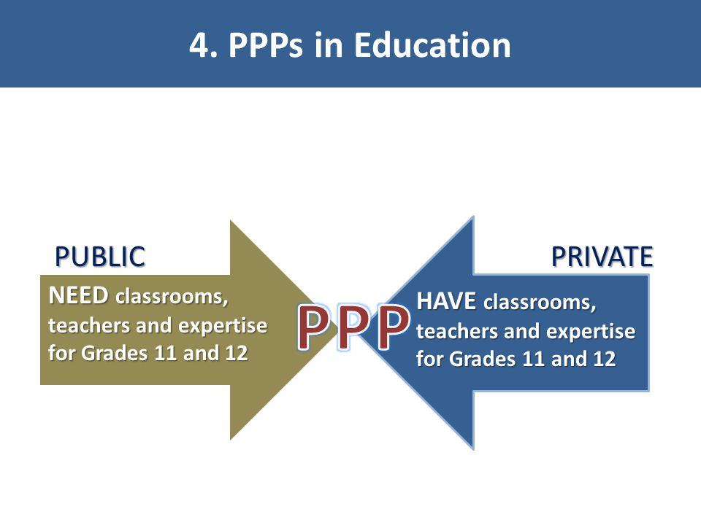

Key challenges in structuring Education with PPPs:
- Initial structure and prioritization of objectives:
- Government priorities
- Private participant priorities (price, demand stability, financial viability, performance target).
- The bidding processes.
- Capacity building.
- Regulatory and legal issues.
These challenges are the key challenges in structuring Education with PPP. These three challenges are related to buying, selling, forming, managing and monitoring.
It also involves the role of government, concerned private sector and public. If these three main parties are doing their work honestly and effectively then all the PPP system will work great.

Key partners and Scope of Partnership in Education:
PPP Partners

The Private Sector

The Government

Civil Society
Private Philanthropy
Bilateral & Multilateral
Educational

Issues and Problems with the PPPs:
Three major issues with PPP are as follows:
- Insufficient of PPP implementation guidelines and challenge in managing KPIs:
According to report, there was no clear framework for monitoring or performance auditing as well as the tendering mechanism, project financing and project implementation for PPP projects in Malaysia which may cause conformity issue pertaining to government’s objectives and the need statement of evaluation criteria.

- Maintenance Approach and Service Delivery Failure:
Most of PPP projects in Malaysia involved with public sector which the government must streamline the maintenance aspect in order to sustain the property value. Through Total Asset Management (TAM) manual revealed that the current practiced of government asset maintenance by most of government agency likely based on reactive maintenance through ad hoc without systematic planning and scheduled program. It has resulted many weaknesses such as improper planned maintenance, decreased the asset life cycle, uneconomic long-term cost, soften rectification work and increase agency workload. In order to improve the system and process of asset management strategy, the manual urged the government agency to measure and evaluate the asset service performance according to Agreed Service Levels (ASL), Key Performance Indicator (KPI) and any other related performance indicator.

- Asset Risk & Life Cycle Issues:
Assets were directly exposed with high attainment risk and could influence their performance in which several risks need to be foreseen in most PPP projects. For example, risks associated with design and construction, project commission and operation, technology and obsolescence, demand (or usage/volume), regulation, residual value and project finance. Therefore, the private sector should genuinely predict the risk because it was one of the fundamentals for PPP project requirement.
Some other issues are as follows:
- Risk sharing and management.
- Unsolicited projects.
- Certain sector-specific PPP issues in the transport, energy/power, communications, and water sectors.
- PPP projects by local governments.

