CHAPTER # 1
TYPES OF RESEARCH

RESEARCH
MEANING:
- the systematic investigation into and study of materials and sources in order to establish facts and reach new conclusions
- investigation,
- experimentation,
- testing,
- exploration,
- analysis,
- fact-finding,
- examination,
DEFINITION:
Research is careful and organized study or gathering of information about a specific topic.
- An example of research is a project where scientists try to find a cure for AIDS.
- An example of research is the information a high school student tracks down information for a school report.

ORIGIN:
Middle French recerche from recercher, to travel through, survey
  - to do research; make researches
  - to do research on or in; investigate thoroughly

Research = Re + Search. That is search after search and search. Why? The purpose of such repeated search is to thoroughly understand the problem or issue or phenomenon and find the apt and effective solution to the problem or strategy to deal with the issue or the phenomenon. Such solution or strategy adds to our stock of knowledge in dealing with the problem or the issue.

In common parlance, research refers to a search for knowledge. Research simply put, is an endeavour to discover answers to problems (intellectual and practical) through the application of scientific method. The Webster’s International Dictionary gives a very inclusive definition of research as
“as careful, critical inquiry or examination
in seeking facts or principles,
diligent investigation in order to ascertain something".
The 20th Century Chamber Dictionary defines research as:
a careful search or systematic investigation
towards increasing the sum of knowledge.

Research is essentially a systematic enquiry seeking facts through objective, verifiable methods in order to discover the relationship among them and to deduce from them broad principles or laws. Research is really a method of critical thinking. It comprises defining and redefining problems, formulating hypothesis or suggested solutions, collecting, organizing and evaluating data, making deductions and making conclusions and at last, carefully testing the conclusions to determine whether they fit the formulated hypothesis. Thus the term 'Research* refers to a critical, careful and exhaustive investigation or inquiry or experimentation or examination having as its aim the revision of accepted conclusions, in the light of newly discovered facts.

Research is the power of suspending judgment, with patience, of mediating with pleasures of assessing with caution, of correcting with readiness and of arranging thought with scrupulous pain, according to Francis Bacon.

Francis G, Cornell defines research as,
"the activity of collecting information in an orderly and systematic fashion".

D. Slesinger and D. Stephenspn in the Encyclopedia of Social Sciences define research as
"the manipulation of things, concepts or
symbols for the purpose of generalising to extend,
correct or verify knowledge, whether that
knowledge aids in construction of
theory or in the practice of an art".
John W. Best defines Research,
"as the systematic and objective analysis and recording of controlled observations that may lead to the developments of generalisations,
principles, or theories,, resulting in prediction
and possibly ultimate control of events".

CHARACTERISTICS FEATURES:
Definitions of this sort are rather abstract. So a summary of some of the characteristics of research may help to clarify the spirit, meaning, and methodology of research. The summary of characteristic features of research follows:
- Research is directed toward the solution of a problem.
- Research is highly purposive,
- Research involves the quest for answers to unsolved problems.
- Research is characterised by patient and unhurried activity.
- Research is logical and objective.
- Research is carefully recorded and reported.
- Research emphasises the development of generalisation of principles or theories that will help in predicting future occurrences.
- Research is based upon observable experience or empirical evidence.
- Research generally involves a hypothesis or set of hypotheses concerning explanation of a phenomenon.
- Research demands accurate observation and description.
- Research involves gathering new data from primary or first hand sources, or using existing data for a new purpose.
- Research activities are more often characterised by carefully designed procedures, always applying rigorous analysis.
- Research requires expertise i.e. skill necessary to carry out investigation, search the related literature and to understand and analyse the data gathered.
- Research applies every possible test to validate the procedures employed, the data collected and the conclusions reached.
- Researchers are not only scholarly and imaginative, but also have highest integrity and patience.

Research is thus the process of a systematic and in-depth study or search of any particular topic, subject or area of investigation, involving collection, compilation, presentation and interpretation of relevant details or data. It is a careful search or inquiry into any subject matter, which is an endeavour to discover to find out valuable facts which would be useful for solving problems or improving existing solutions to problems. The research that involves scientific analysis would result in the formulation of new theories, the discovery of new techniques, modification of old concepts or a knocking-off an existing theory, concept or technique.

Madhavi Shah writes; Research is a word which frightens a lot of people. It need not. As a matter of fact, it is essentially a state of mind - a friendly, welcoming attitude towards change. Research for practical people as teachers, supervisors, etc should arise out of the desire to do things better.

Research is defined as a careful consideration of study regarding a particular concern or a problem using scientific methods. According to the American sociologist Earl Robert Babbie, “Research is a systematic inquiry to describe, explain, predict and control the observed phenomenon. Research involves inductive and deductive methods.”
Inductive research methods are used to analyze the observed phenomenon whereas, deductive methods are used to verify the observed phenomenon. Inductive approaches are associated with qualitative research and deductive methods are more commonly associated with quantitative research.
One of the most important aspects of research is the statistics associated with it, conclusion or result. It is about the “thought” that goes behind the research. Research is conducted with a purpose to understand:
- What do organizations or businesses really want to find out?
- What are the processes that need to be followed to chase the idea?
- What are the arguments that need to be built around a concept?
- What is the evidence that will be required that people believe in the idea or concept?

TYPES OF RESEARCH:
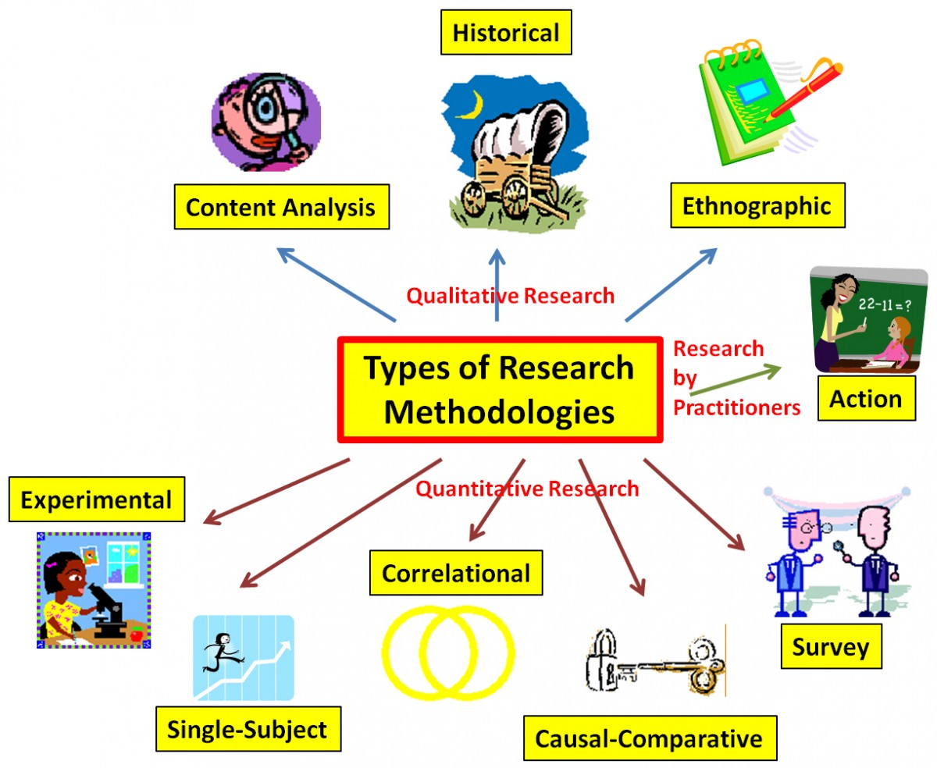
The research is broadly classified into two main classes:
1. Fundamental or basic research and
2. Applied research.
Basic and applied researches are generally of two kinds: normal research and revolutionary research. In any particular field, normal research is performed in accordance with a set of rules, concepts and procedures called a paradigm, which is well accepted by the scientists working in that field. In addition, the basic and applied researches can be quantitative or qualitative or even both (mixed research).
Following are the types of research:
Basic Research:
Basic research is mostly conducted to enhance knowledge. It covers fundamental aspects of research. The main motivation of this research is knowledge expansion. It is a non-commercial research and doesn’t facilitate in creating or inventing anything.
For example,
- an experiment is a good example of basic research.
- Seeks generalization
- Aims at basic processes
- Attempts to explain why things happen
- Tries to get all the facts
- Reports in technical language of the topic

Applied Research:
Applied research focuses on analyzing and solving real-life problems. This type of research refers to the study that helps solve practical problems using scientific methods. This research plays an important role in solving issues that impact the overall well-being of humans.
For example,
- finding a specific cure for a disease. Studies individual or specific cases without the objective to generalize
- Aims at any variable which makes the desired difference
- Tries to say how things can be changed
- Tries to correct the facts which are problematic
- Reports in common language
Qualitative Research:
Qualitative research is a process that is about inquiry, that helps in-depth understanding of the problems or issues in their natural settings. This is a non- statistical research method.
Qualitative research is heavily dependent on the experience of the researchers and the questions used to probe the sample. The sample size is usually restricted to 6-10 people in a sample. Open-ended questions are asked in a manner that one question leads to another. The purpose of asking open-ended questions is to gather as much information as possible from the sample.
Following are the methods used for qualitative research:
- One-to-one interview
- Focus groups
- Ethnographic Research
- Content/ Text Analysis
- Case study research

Quantitative Research:
Qualitative research is a structured way of collecting data and analyzing it to draw conclusions. Unlike qualitative research, this research method uses a computational, statistical and similar method to collect and analyze data. Quantitative data is all about numbers.
Quantitative research involves a larger population as more number of people means more data. In this manner, more data can be analyzed to obtain accurate results. This type of research method uses close-ended questions because, in quantitative research, the researchers are typically looking at measuring the extent and gathering foolproof statistical data.
Online surveys, questionnaires, and polls are preferable data collection tools used in quantitative research. There are various methods of deploying surveys or questionnaires. In recent times online surveys and questionnaires have gained popularity. Survey respondents can receive these surveys on mobile phones, emails or can simply use the internet to access surveys or questionnaires.
Other types of research
Problem Oriented Research:
As the name suggests, problem-oriented research is conducted to understand the exact nature of the problem to find out relevant solutions. The term “problem” refers to having issues or two thoughts while making any decisions.
For e.g Revenue of a car company has decreased by 12% in the last year. The following could be the probable causes: There is no optimum production, poor quality of a product, no advertising, economic conditions etc.
Problem Solving Research:
This type of research is conducted by companies to understand and resolve their own problems. The problem-solving research uses applied research to find solutions to the existing problems.
Exploratory Research
Exploratory research might involve a literature search or conducting focus group interviews. The exploration of new phenomena in this way may help the researcher’s need for better understanding, may test the feasibility of a more extensive study, or determine the best methods to be used in a subsequent study. For these reasons, exploratory research is broad in focus and rarely provides definite answers to specific research issues.
The objective of exploratory research is to identify key issues and key variables.
Descriptive research
The descriptive research is directed toward studying “what” and how many off this “what”. Thus, it is directed toward answering questions such as, “What is this?”.
Explanatory research
- Its primary goal is to understand or to explain relationships.
- It uses correlations to study relationships between dimensions or characteristics off individuals, groups, situations, or events.
- Explanatory research explains (How the parts of a phenomenon are related to each other).
- Explanatory research asks the “Why” question.
Longitudinal Research
Research carried out longitudinally involves data collection at multiple points in time. Longitudinal studies may take the form of:
- Trend study- looks at population characteristics over time, e.g. organizational absenteeism rates during the course of a year
- Cohort study- traces a sub-population over time, e.g. absenteeism rates for the sales department;
- Panel study- traces the same sample over time, e.g. graduate career tracks over the period 1990 – 2000 for the same starting cohort.
While longitudinal studies will often be more time consuming and expensive than cross-sectional studies, they are more likely to identify causal relationships between variables.
Cross-sectional Research
One-shot or cross-sectional studies are those in which data is gathered once, during a period of days, weeks or months. Many cross-sectional studies are exploratory or descriptive in purpose. They are designed to look at how things are now, without any sense of whether there is a history or trend at work.
Action research
- Fact findings to improve the quality of action in the social world
Policy-Oriented Research
- Reports employing this type of research focus on the question ‘How can problem ‘X’ be solved or prevented ?’
Classification research
- It aims at categorization of units in to groups
- To demonstrate differences
- To explain relationships
Comparative research
- To identify similarities and differences between units at all levels
Causal research
- It aims at establishing cause and effect relationship among variable
Theory-testing research
- It aims at testing validity of a unit
Theory-building research
- To establish and formulate the theory
To understand the characteristic of research design using research purpose here is a comparative analysis:
 | Exploratory Research | Descriptive Research | Explanatory Research
Research approach used | Unstructured | Structured | Highly structured
Research conducted through | Asking research questions | Asking research questions | By using research hypotheses.
When is it conducted? | Early stages of decision making | Later stages of decision making | Later stages of decision making

DIFFERENCE BETWEEN RESEARCH METHOD AND METHODOLOGY:
Method is simply a research tool, a component of research – say for example, a qualitative method such as interviews. Methodology is the justification for using a particular research method.
So if for example, you want to understand the motivations and perceptions of a group of bloggers then you would most likely choose a qualitative, method as opposed to a quantitative one.
But as Clough and Nutbrown explain their book, decisions such as whether to interview, how many participants to interview and so on, “are often based on values and assumptions which influence the study, and as such therefore need to be fully interrogated in order to clarify the research decisions which are made.”
BASIS OF COMPARISON | RESEARCH METHOD | RESEARCH METHODOLOGY
Meaning | Research Method implies the methods employed by the researcher to conduct research. | Research methodology signifies way to efficiently solving research problems.
What is it? | Behavior and instrument used in the selection and construction of the research technique. | Science of understanding, how research is performed methodically.
Encompasses | Carrying out experiment, test, surveys and so on. | Study different techniques which can be utilized in the performance of experiment, test, surveys etc.
Comprise of | Different investigation techniques. | Entire strategy towards achievement of objective.
Objective | To discover solution to research problem. | To apply correct procedures so as to determine solutions.

OBJECTIVES OF RESEARCH:
The purpose of research is to discover answers to questions through the application of scientific procedures. The main aim of research is to find out the truth which is hidden and which has not been discovered as yet. Though each research study has its own specific purpose, we may think of research objectives as falling into a number of following broad groupings:
- To gain familiarity with a phenomenon or to achieve new insights into it (studies with this object in view are termed as exploratory or formulative research studies);
- To portray accurately the characteristics of a particular individual, situation or a group(studies with this object in view are known as descriptive research studies);
- To determine the frequency with which something occurs or with which it is associated with something else (studies with this object in view are known as diagnostic research studies);
- To test a hypothesis of a causal relationship between variables (such studies are known as hypothesis-testing research studies).

CONCLUSION:
The scope of research methodology is wider than that of research method, as the latter is the part of the former. For understanding the research problem thoroughly, the researcher should know the research methodology along with the methods.
In a nutshell, research method refers to the technique which can be adopted to explore the nature of the world that surrounds us. On the contrary, research methodology is the foundation, which helps us to understand the determinants influencing the effectiveness of the methods applied.

