Phrase: Definition, Types & Examples

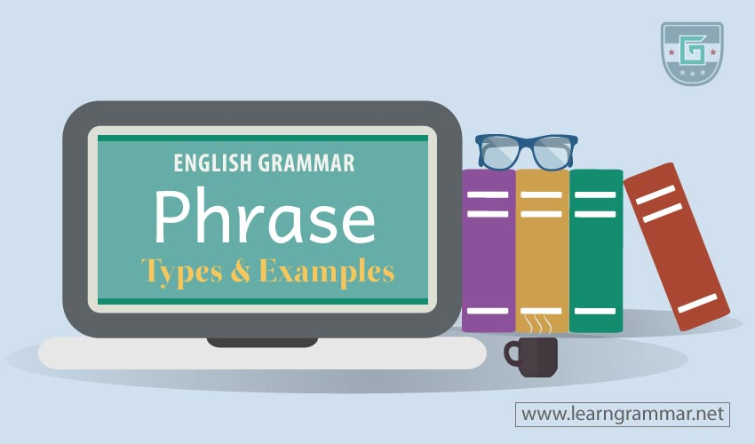
Phrase and clause are the most important elements of English grammar. Phrase and clause cover everything a sentence has. Clauses are the center of sentences and phrases strengthen the sentences to become meaningful. If the clauses are the pillars of a building, the phrases are the bricks. A phrase usually is always present within a clause, but a phrase cannot have a clause in it.

The basic difference between a clause and a phrase is that a clause must have a finite verb and a phrase must not.
A phrase, therefore, is a group of words which has no finite verb in it and acts to complete the sentence for making it meaningful.
“A phrase is a small group of words that form a meaningful unit within a clause.”-Oxford Dictionary
“In linguistic analysis, a phrase is a group of words (or possibly a single word) that functions as a constituent in the syntax of a sentence, a single unit within agrammatical hierarchy.”- Osborne, Timothy, Michael Putnam, and Thomas Gross (2011)

Types of Phrases
The phrases are generally of six types.
- Noun Phrase
- Adjective Phrase
- Adverbial Phrase
- Prepositional Phrase
- Conjunctional Phrase
- Interjectional Phrase

Noun Phrase
A noun phrase is usually assembled centering a single noun and works as a subject, an object or a complement in the sentence.
Example:
- I like to swing the bat hard when I am at the crease. (An object)
- Reading novels is a good habit. (A subject)
- The probability of happening that match is not much. (A subject)
- We are sorry for her departure.

Adjective Phrase
An adjective phrase is comprised of an adjective and works as a single adjective in the sentence.
Example:
- Alex is a well-behaved man.
- He is a man of friendly nature.
- Julie is a woman of gorgeous style.
- She leads a very interesting life.
- A lot of people do not sleep at night.

Adverbial Phrase
An adverbial phrase modifies the verb or the adjective and works as an adverb in the sentence.
Example:
- The horse runs at a good speed.
- I was in a hurry then.
- I ran as fast as possible.
- He works very slowly.

Prepositional Phrase
A prepositional phrase always begins with a preposition and connects nouns.
Example:
- He sacrificed his life for the sake of his country.
- In the end, we all have to die.
- He is on the way.
- By working aimlessly, you will not get success.
- In spite of working hard, he was insulted by his boss.
Note: Prepositional phrases include all other types of phrases.

Conjunctional Phrase
A conjunctional phrase works as a conjunction in the sentence.
Example:
- As soon as you got in, he went out.
- We have to work hard so that we can win the next match.
- I will attend the ceremony provided that you come.
- John started working early in order that he could finish early.

Interjectional Phrase
Interjections that have more than one words are called the interjectional phrases.
Example:
- What a pity! He is dead.
- What a pleasure! I won the first prize.
- Oh please! Don’t say that again.

