TOPIC: DNA Structure and Composition
DNA:
DEFINITION:
‘’Deoxyribonucleic acid (DNA) is a molecule that contains the biological instructions that make each species unique. DNA, along with the instructions it contains, is passed from adult organisms to their offspring during reproduction’’

Example of DNA in real life:
- Identity Confirmation. DNA is being used to determine the identification of a person. ...
- Biological Parents. ...
- Prevention of Diseases or Illnesses. ...
- Forensic Science. ...
- Criminal Investigation. ...
- Ancestry and Family History. ...
- Health Report. ...
- Agriculture.

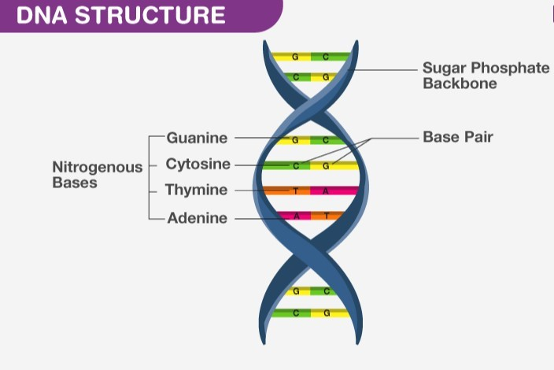

DNA discovery:
DNA was first observed by a German biochemist named Frederich Miescher in 1869. But for many years, researchers did not realize the importance of this molecule. It was not until 1953 that James Watson, Francis Crick, Maurice Wilkins and Rosalind Franklin figured out the structure of DNA — a double helix — which they realized could carry biological information.
Watson, Crick and Wilkins were awarded the Nobel Prize in Medicine in 1962 "for their discoveries concerning the molecular structure of nucleic acids and its significance for information transfer in living material." Franklin was not included in the award, although her work was integral to the research. [Related: Unraveling the Human Genome: 6 Molecular Milestones]

ROLE OF SCIENTIST IN THE STUDY OF DNA:

Scientists James Watson and Francis Crick were famously the first to work out the structure of
DNA, and Rosalind Franklin and Maurice Wilkins are often credited for capturing the images
of the molecule that made this possible. But several other scientists who played a pivotal role in one of the most important scientific discoveries of the century are far less known – and deserve celebration.
In the autumn of 1947, Creeth and his PhD supervisors published the third of three papers from researchers at what became the University of Nottingham, which completed the evidence needed to show how the DNA molecule is held together. By proving that DNA contained the molecular glue known as hydrogen bonds, they made it possible for Watson and Crick to work out the molecule must take the shape of two strands held together in a double-helix structure. This discovery, six years after Creeth’s work, enabled the creation of genetic science as we know it today.
Creeth even produced his rough own model for DNA, formed of two chains held together by the bonds between its building blocks – not too dissimilar from the actual structure. Unfortunately, his discoveries seem to have missed almost everybody’s radar. So 70 years on, Nottingham has celebrated the discovery of hydrogen bonds in DNA with a special conference held in the building where the discovery was made and a dedicated plaque at the entrance.

Structure of DNA

DNA Structure:
The DNA structure can be thought of like a twisted ladder. This structure is described as a double-helix, as illustrated in the figure above. It is a nucleic acid, and all nucleic acids are made up of nucleotides. The DNA molecule is composed of units called nucleotides, and each nucleotide is composed of three different components, such as sugar, phosphate groups, and nitrogen bases.
The basic building blocks of DNA are nucleotides, which are composed of a sugar group, a phosphate group, and a nitrogen base. The sugar and phosphate groups link the nucleotides together to form each strand of DNA. Adenine (A), Thymine (T), Guanine (G) and Cytosine (C) are four types of nitrogen bases.
These 4 Nitrogenous bases pair together in the following way: A with T, and C with G. These base pairs are essential for the DNA’s double helix structure, which resembles a twisted ladder.
The order of the nitrogenous bases determines the genetic code or the DNA’s instructions.

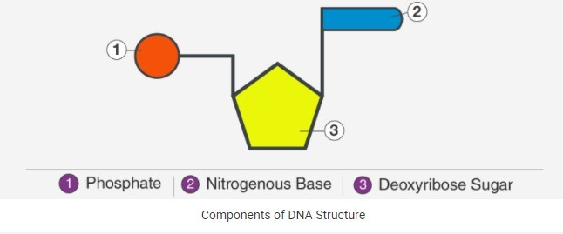

Among the three components of DNA structure, sugar is the one which forms the backbone of the DNA molecule. It is also called deoxyribose. The nitrogenous bases of the opposite strands form hydrogen bonds, forming a ladder-like structure.

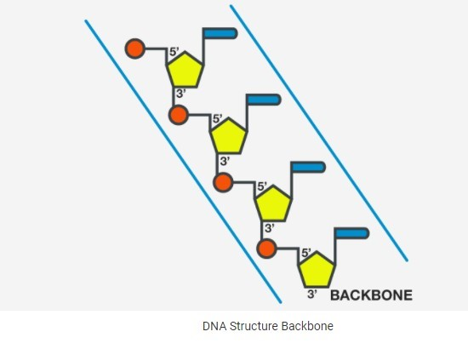
The DNA molecule consists of 4 nitrogen bases, namely adenine (A), thymine (T), cytosine (C) and Guanine (G) which ultimately forms the structure of a nucleotide. The A and G are purines and the C and T are pyrimidines.
The two strands of DNA run in opposite directions. These strands are held together by the hydrogen bond that is present between the two complementary bases. The strands are helically twisted, where each strand forms a right-handed coil and ten nucleotides make up a single turn.
The pitch of each helix is 3.4 nm. Hence, the distance between two consecutive base pairs (i.e., hydrogen-bonded bases of the opposite strands) is 0.34 nm.

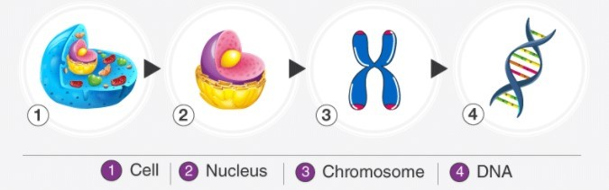

The DNA coils up, forming chromosomes, and each chromosome has a single molecule of DNA in it. Overall, human beings have around twenty-three pairs of chromosomes in the nucleus of cells. DNA also plays an essential role in the process of cell division.

DNA Function:
DNA is the genetic material which carries all the hereditary information. Genes are the small segments of DNA, consisting mostly of 250 – 2 million base pairs. A gene code for a polypeptide molecule, where three nitrogenous bases sequence stands for one amino acid.
Polypeptide chains are further folded in secondary, tertiary and quaternary structure to form different proteins. As every organism contains many genes in their DNA, different types of proteins can be formed. Proteins are the main functional and structural molecules in most of the organisms. Apart from storing genetic information, DNA is involved in:
- Replication process: Transferring the genetic information from one cell to its daughters and from one generation to the next and equal distribution of DNA during the cell division
- Mutations: The changes which occur in the DNA sequences
- Transcription
- Cellular Metabolism
- DNA Fingerprinting
- Gene Therapy

The Watson and Crick Double Helix Model of DNA:

The structure of DNA was first deduced by J.D. Watson and F.H. Crick in 1953. On the basis of Chargaff’s data, Wilkin’s and Franklin’s X-ray diffraction findings and inferences from their own model buildings, Watson and Crick proposed that DNA exists as a double helix in which the two polynucleotide chains are coiled about one another in a spiral.
Each polynucleotide chain consists of a sequence of nucleotides linked together by phosphodiester bonds, forming adjacent deoxyribose moieties. The two polynucleotide strands are held together in their helical configuration by hydrogen bonding between bases in opposing strands, the resulting base pairs being stacked between the two chains perpendicular to the axis of the molecule like the steps of a spiral ladder.

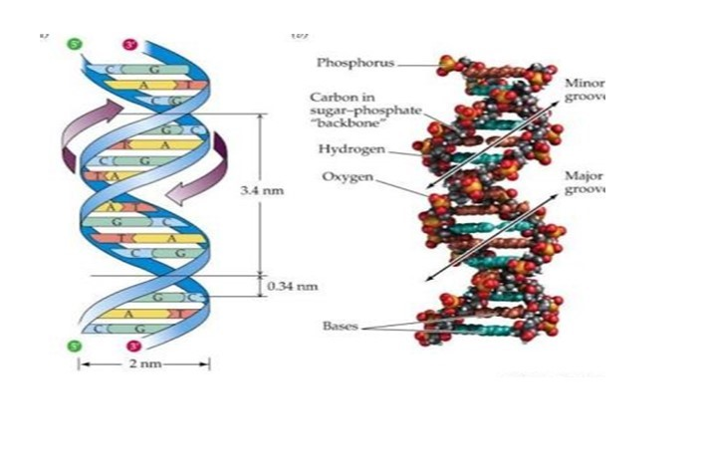

The base pairing is specific, adenine is always paired with thymine, and guanine is always paired with cytosine. Thus, all base- pairs consist of one purine and one pyrimidine. The specificity of base pairing results from the hydrogen bonding capacities of the bases, in their normal configurations.
In their most common structural configurations, adenine and thymine form two hydrogen bonds and guanine and cytosine form three hydrogen bonds. Analogous hydrogen bonding between cytosine and adenine, for example is not generally possible.
Once the sequence of bases in one strand of a DNA double helix is known, the sequence of bases in the other strand is also automatically known because of the specific base pairing. The two strands of a double helix are thus said to be complementary (not identical); it is this property, complementarity of the two strands, that makes DNA uniquely suited to store and transmit genetic information.
The base pairs in DNA are stacked 3.4A° apart with 10 base pairs per turn (360°) of the double helix. The sugar- phosphate backbones of the two complementary strands are antiparallel; that is they have opposite chemical polarity.
As one moves unidirectional along a DNA double helix, the phosphodiester bonds in one strand go from a 3′ carbon of one nucleotide to a 5′ carbon of the adjacent nucleotide while those in the complementary strand go from a 5′ carbon to 3′ carbon

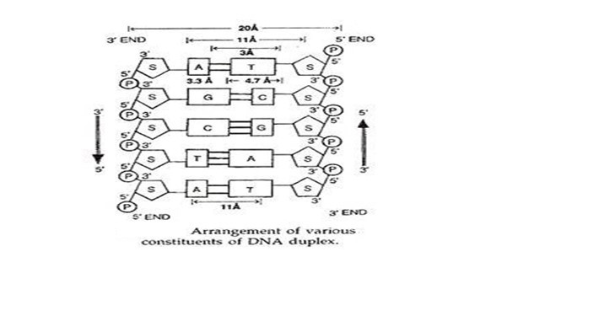

Evidences in Support of Double Helical Structure of DNA:
The double helical structure of DNA given by Waston and Crick is supported by the following evidences.
- M. H.F. Wilkins and his colleagues studied DNA by X-ray crystallography and supported its double helical structure.
- Kornberg and his associates tried to synthesize DNA in a medium free of DNA in the presence of enzyme DNA polymerase and nucleotides, the building blocks of DNA. They found that in a DNA- free medium with all necessary compounds DNA synthesis does not occur. Only when some DNA was added as a primer to the same medium did DNA synthesis start.

Composition of DNA:

1. Phosphoric acid (H₃PO₄) has three reactive (-OH) groups of which two are involved in forming the sugar phosphate backbone of DNA.

2. Pentose sugar:
DNA contains 2′-deoxy-D-ribose (or simply deoxyribose) which is the reason for the name deoxyribose nucleic acid.
3. Organic:
The organic base s are heterocyclic compounds containing nitrogen in their rings; hence they are also called nitrogenous bases.DNA ordinarily contains four different bases called adenirie
(A), guanine (G), thymine (T) and cytosine (C).
These four bases are grouped into two classes on the basis of their chemical structure:

(1) Pyrimidine (T and C) and
(2) purine (A, G).

In DNA four different nucleosides are found. These are:
- deoxycytidine
- deoxythy- midine,
- deoxyadenosine
- Deoxyguanosine.
Similarly four nucleotides in DNA are:
1) Deoxycytidylic acid or detox- ycytidylate,
2) Deoxythymidylic acid or deoxythymid
3) Deoxyadenylic acid or deoxyadenylate
4) Deoxyguanylic acid or deoxyguanylate.

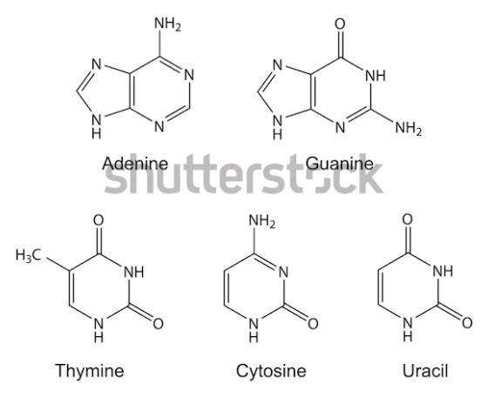
When the composition of DNA from many different organisms were analysed by E. Chargaff and coworkers (1950), it was observed that (i) regardless of the source, the purine and pyrimidine components occur in equal amounts in a molecule, (ii) The amount of adenine (A) is equivalent to the amount of thymine (T) and of cytosine (C) is equivalent to that of guanine (G) and (iii) the base ratio A+T/G+C is constant for a particular species

The A, B, and Z form of DNA:
The vast majority of the DNA molecules present in the aqueous protoplasms of living cells almost certainly exist in the Watson-Crick double helix form described above. This is called the B-form of DNA and shows right-handed coiling. It contains 10.4 base pairs per turn (instead of the 10 mentioned above). Dehydrated DNA occurs in the A-form which is also a right handed helix, but it has 11 base pairs per turn.
Certain DNA sequences occur in Z-form, which shows left-handed coiling, contains 12 base pairs per turn. In Z-DNA, the sugar-phosphate backbone follows a zig-zagged path giving it the name Z-DNA or Z-form.
Specific segments of a DNA molecule can undergo conformational changes from B-form to Zform and vice-versa; these changes may be brought about by some specific regulatory proteins. The Z-form DNA is postulated to play a role in gene regulation.
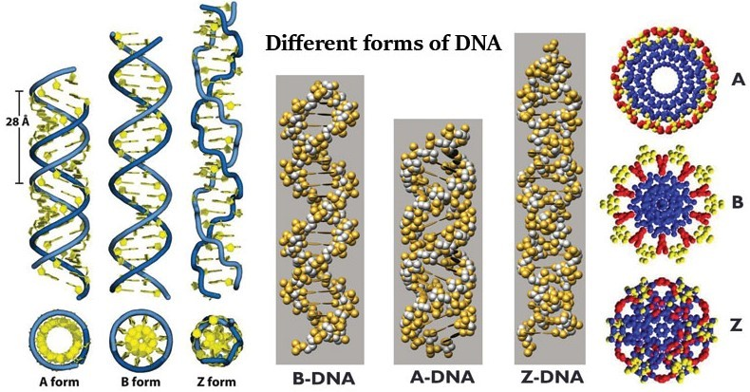

DNA Replication:
DNA replication is an important process that occurs during cell division. It is also known as semi-conservative replication, during which DNA makes a copy of itself.

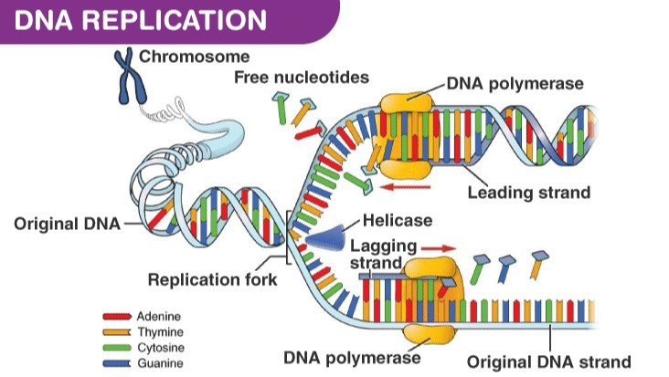
Chargaff’s Rule:
Erwin Chargaff, a biochemist, discovered that the number of nitrogenous bases in the DNA was present in equal quantities. The amount of A is equal to T, whereas the amount of C is equal to G.
A=T; C=G
In other words, the DNA of any cell from any organism should have a 1:1 ratio of purine and pyrimidine bases.
DNA replication takes place in three stages:

Step 1: Initiation
The replication of DNA begins at a point known as the origin of replication. The two DNA strands are separated by the DNA helicase. This forms the replication fork.

Step 2: Elongation
DNA polymerase III reads the nucleotides on the template strand and makes a new strand by adding complementary nucleotides one after the other. For e.g. if it reads an Adenine on the template strand, it will add a Thymine on the complementary strand.
While adding nucleotides to the lagging strand, gaps are formed between the strands. These gaps are known as Okazaki fragments. These gaps or nicks are sealed by ligase.

Step 3: Termination
The termination sequence present opposite to the origin of replication terminates the replication process. The TUS protein (terminus utilization substance) binds to terminator sequence and halts DNA polymerase movement. It induces termination.

SELF MADE MCQ’S:

1) Which shows the correct complementary base pairing for DNA?

A) C-A, T-G
- A-G, C-T
- C-G, U-A
- T-A, G-C

2) Adenine bonds with _____________
- Guanine
- Thymine
- Cytosine
- Adenine

3) Considering the Deoxyribonucleic Acid (DNA) structure, the inside basis of the double helix is made up

A) Nitrogen
B) Oxygen
- phosphorus
- magnesium

4) The Deoxyribonucleic Acid (DNA) structure was proposed in
A) 1949
B) 1963
C) 1958
D) 1953

5) The scientists who proposed the Deoxyribonucleic Acid (DNA) structures are
A) Francis crick and James Watson
B) James crick and Francis Watson
C) Marie curie and Niels Bohr
D) Nikola tesla and Marie curie

6) The first X-ray diffraction patterns of DNA were taken in 1938 by

A) William Asbury
B) Rosalind Franklin
C) Francis H. Crick
D) Linus Pauling

7) What dose structure of DNA resemble?

A) A Triple Chain
B) A Twisted Ladder
C) Blueprints
D) A Twisted Ball

8) It is easy to break the bond between A and T than in between G and C.

A) True
B) False

9) What stores the genetic information in DNA?
A) Sugar
B) Phosphate
C) Nitrogenous base
D) Polymerase

10) Which form of DNA is described by Watson - Crick Model?
A) B-DNA
B) Quadraplex DNA
C) A-DNA
D) Z-DNA

THE END

