Say this City has Ten Million Souls by Wystan Hugh Auden 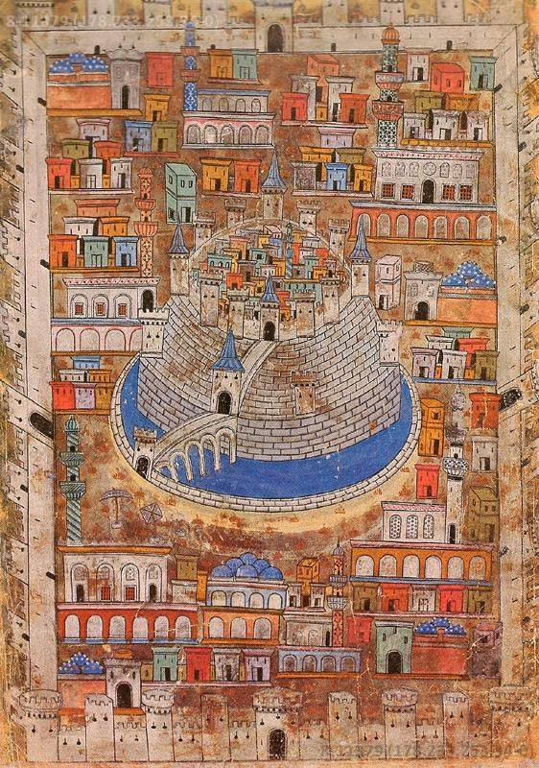
Say this City has Ten Million Souls,
Some are living in mansions, some are living in holes:
Yet there’s no place for us, my dear, yet there’s no place for us.
Once we had a country and we thought it fair,
Look in the atlas and you’ll find it there:
We cannot go there now, my dear, we cannot go there now.
In the village churchyard there grows an old yew,
Every spring it blossoms anew;
Old passports can’t do that, my dear, old passports can’t do that.
The consul banged the table and said:
‘If you’ve got no passport, you’re officially dead’;
But we are still alive, my dear, but we are still alive.
Went to a committee; they offered me a chair;
Asked me politely to return next year:
But where shall we go today, my dear, but where shall we go today?
Came to a public meeting; the speaker got up and said:
‘If we let them in, they will steal our daily bread’;
He was talking of you and me, my dear, he was talking of you and me.
Thought I heard the thunder rumbling in the sky;
It was Hitler over Europe, saying: ‘They must die’;
We were in his mind, my dear, we were in his mind.
Saw a poodle in a jacket fastened with a pin,
Saw a door opened and a cat let in:
But they weren’t German Jews, my dear, but they weren’t German Jews.
Went down the harbour and stood upon the quay,
Saw the fish swimming as if they were free:
Only ten feet away, my dear, only ten feet away.
Walked through a wood, saw the birds in the trees;
They had no politicians and sang at their ease:
They weren’t the human race, my dear, they weren’t the human race.
Dreamed I saw a building with a thousand floors,
A thousand windows and a thousand doors;
Not one of them was ours, my dear, not one of them was ours.
Stood on a great plain in the falling snow;
Ten thousand soldiers marched to and fro:
Looking for you and me, my dear, looking for you and me.

CRITICAL APPRECIATION OF THE POEM
The present poem is a satire on political and religious discrimination. The pot describes the pathetic condition of the outsiders to a country. In this view, such immigrants lead a life below animal level.
In this poem the poet gives a picture of America where class distinction exists completely. There are people who live in lofty and high buildings and there are other people who live in holes. But there is no room for those who come to this country from other countries for protection and shelter. The poet recalls there pathetic manner that one they had a country of their own. It existed in the ‘atlas’ of the world. It was very dear to them. But now they cannot go back to that country. He remembers the different scenes of his country. In the village of his country, life was very simple and pure. They grew a yew tree in the grave yard which blossomed in every spring. But they cannot go back to see that tree and they have built up an atmosphere of hatred and distrust against them.
The old passports are a hindrance in their going back. The old passports do not let them establish their lost identity. The poet is very sad at the inhuman treatment which he meets at the hands of passport officials. He is told that without a passport, he is officially dead. He feels as if he had no entity. He is not allowed to go back to his country on an expired passport. He feels that he is still alive but the officials of the embassy treat him dead.
The poet narrates and incident of maltreatment which he suffers at the hands of the officials of the embassy. They offer the poet chair but ask him to come to them next year. The poet has gone there to settle the case of his citizenship. The pot is wonderstruck at his decision. He asks where he should spend his next year. This problem is faced by every immigrant. The immigrants are treated with hostility. It is feared that they will snatch the bread of the local people. A sort of general hatred exists against them. The politicians, the thinkers and the press are against them. The poet goes to the sea port and sees the fish swimming freely in the water. He sees the birds in the trees, which enjoy more freedom than human beings. Perhaps, they enjoy this freedom because they have no politicians in them. They are fortunate because they are not human beings.
The poet laments that there are very high buildings in America. They have ‘a thousand windows and thousand doors’. But it is pity that none of them is meant for immigrants. On the other hand, they are suspected as an enemy to the country by thousand soldiers who are deputed to check their identity. They are likely to be killed by these soldiers. The poet has been successful in painting the miserable plight of immigrants and refugees in this poem. The refugees suffer physically as well as emotionally. They are isolated and alienated from the main lot. The point of the poem is that man is imprisoned in a thousand shackles of race, nationality and passports. Human life falls beneath the animal level.
EXERCISE
Point out the typically urban elements of this poem.
The present poem is a satire on political and religious discrimination. The pot describes the pathetic condition of the outsiders to a country. In this view, such immigrants lead a life below animal level.
In order to describe hatred and alienation for the refugees the poet has selected an urban scene. The homeless Jews have tried to seek refuge in a bid city of America where ten million souls live. The city has thousands of houses with numberless doors and the Jews are not allowed to enter in any one of these houses. Such as selfish and cruel attitude is found only in big cities.
It is also in big cities that people keep pet dogs and cats and pay more attention to them than human beings. There are many things in the poem which relate to the city life. The poet talks about ten million souls and we know that one can live only in the city. Also the words like ‘passport. Chair, table, committee, are related to urban life. The poet goes to the office of the embassy; the Consul gives him a chair but does not solve the problem. The poet talks about the public meeting where the speaker is seen talking. The poet mentions about Hitler and Europe. He talks about a poodle in a jacket, harbor, politicians, soldiers and thousand windows and doors.
CREATIVE EXERCISE
1. Write a note on the problems of refugees and especially that of the Muslims.
2. Do you find any elements of pathos in this poem?
3. Write a note on the title of the poem.
Quotations and references for this poem
1) Who is free? The man who masters his own self.

