Topic: Nucleus:
Content:
- History
- Structure
- Nuclear envelope
- Nuclear pores
- Nuclear bodies
- Nuclear lamina
- Nucleolus
- Chromosomes
- Function
- Nuclei per cell
- Evolution

Nucleus:
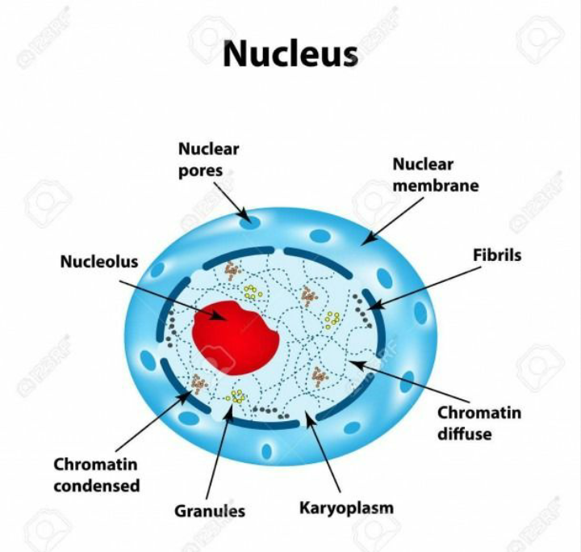
In cell biology, the nucleus (pl. nuclei; from Latin nucleus or nuculeus, meaning kernel or seed) is a membrane-bound organelle found in eukaryotic cells. Eukaryotes usually have a single nucleus, but a few cell types, such as mammalian red blood cells, have no nuclei, and a few others including osteoclasts have many. The main structures making up the nucleus are the nuclear envelope, a double membrane that encloses the entire organelle and isolates its contents from the cellular cytoplasm; and the nuclear matrix (which includes the nuclear lamina), a network within the nucleus that adds mechanical support, much like the cytoskeleton supports the cell as a whole.
The cell nucleus contains all of the cell's genome, except for a small fraction of mitochondrial DNA, organized as multiple long linear DNA molecules in a complex with a large variety of proteins, such as histones, to form chromosomes. The genes within these chromosomes are structured in such a way to promote cell function. The nucleus maintains the integrity of genes and controls the activities of the cell by regulating gene expression—the nucleus is, therefore, the control center of the cell.
Because the nuclear envelope is impermeable to large molecules, nuclear pores are required to regulate nuclear transport of molecules across the envelope. The pores cross both nuclear membranes, providing a channel through which larger molecules must be actively transported by carrier proteins while allowing free movement of small molecules and ions. Movement of large molecules such as proteins and RNA through the pores is required for both gene expression and the maintenance of chromosomes.
Although the interior of the nucleus does not contain any membrane-bound subcompartments, its contents are not uniform, and a number of nuclear bodies exist, made up of unique proteins, RNA molecules, and particular parts of the chromosomes. The best-known of these is the nucleolus, which is mainly involved in the assembly of ribosomes. After being produced in the nucleolus, ribosomes are exported to the cytoplasm where they translate mRNA
History:
Oldest known depiction of cells and their nuclei by Antonie van Leeuwenhoek, 1719
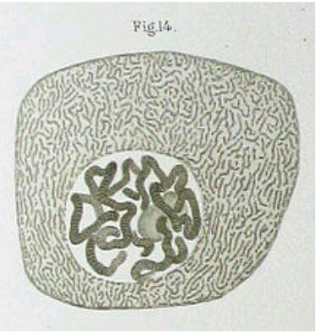
Drawing of a Chironomus salivary gland cell published by Walther Flemming in 1882. The nucleus contains polytene chromosomes.
The nucleus was the first organelle to be discovered. What is most likely the oldest preserved drawing dates back to the early microscopist Antonie van Leeuwenhoek (1632–1723). He observed a "lumen", the nucleus, in the red blood cells of salmon.Unlike mammalian red blood cells, those of other vertebrates still contain nuclei.
The nucleus was also described by Franz Bauer in 1804 and in more detail in 1831 by Scottish botanist Robert Brown in a talk at the Linnean Society of London. Brown was studying orchids under the microscope when he observed an opaque area, which he called the "areola" or "nucleus", in the cells of the flower's outer layer.
He did not suggest a potential function. In 1838, Matthias Schleiden proposed that the nucleus plays a role in generating cells, thus he introduced the name "cytoblast" ("cell builder"). He believed that he had observed new cells assembling around "cytoblasts". Franz Meyen was a strong opponent of this view, having already described cells multiplying by division and believing that many cells would have no nuclei. The idea that cells can be generated de novo, by the "cytoblast" or otherwise, contradicted work by Robert Remak (1852) and Rudolf Virchow (1855) who decisively propagated the new paradigm that cells are generated solely by cells ("Omnis cellula e cellula"). The function of the nucleus remained unclear.
Between 1877 and 1878, Oscar Hertwig published several studies on the fertilization of sea urchin eggs, showing that the nucleus of the sperm enters the oocyte and fuses with its nucleus. This was the first time it was suggested that an individual develops from a (single) nucleated cell. This was in contradiction to Ernst Haeckel's theory that the complete phylogeny of a species would be repeated during embryonic development, including generation of the first nucleated cell from a "monerula", a structureless mass of primordial protoplasm ("Urschleim"). Therefore, the necessity of the sperm nucleus for fertilization was discussed for quite some time. However, Hertwig confirmed his observation in other animal groups, including amphibians and molluscs. Eduard Strasburger produced the same results for plants in 1884. This paved the way to assign the nucleus an important role in heredity. In 1873, August Weismann postulated the equivalence of the maternal and paternal germ cells for heredity. The function of the nucleus as carrier of genetic information became clear only later, after mitosis was discovered and the Mendelian rules were rediscovered at the beginning of the 20th century; the chromosome theory of heredity was therefore developed
Structures:
Nuclear envelope and pores:

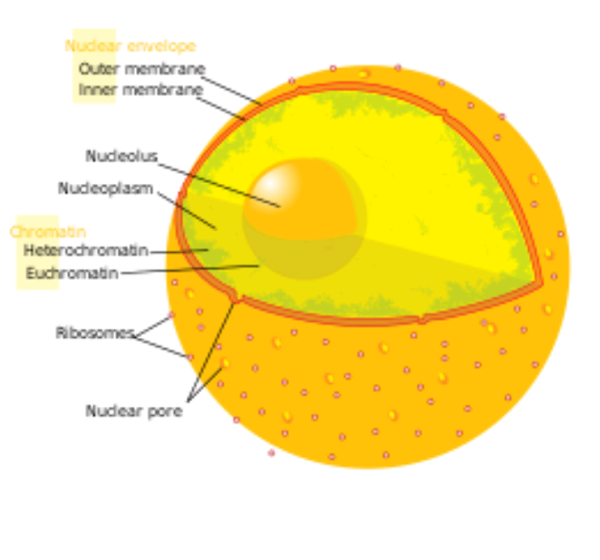
The eukaryotic cell nucleus. Visible in this diagram are the ribosome-studded double membranes of the nuclear envelope, the DNA (complexed as chromatin), and the nucleolus. Within the cell nucleus is a viscous liquid called nucleoplasm, similar to the cytoplasm found outside the nucleus.

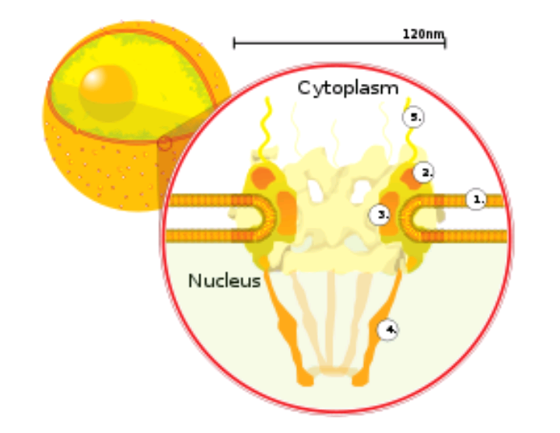
A cross section of a nuclear pore on the surface of the nuclear envelope (1). Other diagram labels show (2)the outer ring,(3) spokes,(4) basket,(5) filaments.
The nuclear envelope, otherwise known as nuclear membrane, consists of two cellular membranes, an inner and an outer membrane, arranged parallel to one another and separated by 10 to 50 nanometres (nm). The nuclear envelope completely encloses the nucleus and separates the cell's genetic material from the surrounding cytoplasm, serving as a barrier to prevent macromolecules from diffusing freely between the nucleoplasm and the cytoplasm. The outer nuclear membrane is continuous with the membrane of the rough endoplasmic reticulum (RER), and is similarly studded with ribosomes. The space between the membranes is called the perinuclear space and is continuous with the RER lumen
Nuclear pore:
Nuclear pores, which provide aqueous channels through the envelope, are composed of multiple proteins, collectively referred to as nucleoporins. The pores are about 60–80 million daltons in molecular weight and consist of around 50 (in yeast) to several hundred proteins (in vertebrates). The pores are 100 nm in total diameter; however, the gap through which molecules freely diffuse is only about 9 nm wide, due to the presence of regulatory systems within the center of the pore. This size selectively allows the passage of small water-soluble molecules while preventing larger molecules, such as nucleic acids and larger proteins, from inappropriately entering or exiting the nucleus. These large molecules must be actively transported into the nucleus instead. The nucleus of a typical mammalian cell will have about 3000 to 4000 pores throughout its envelope, each of which contains an eightfold-symmetric ring-shaped structure at a position where the inner and outer membranes fuse. Attached to the ring is a structure called the nuclear basket that extends into the nucleoplasm, and a series of filamentous extensions that reach into the cytoplasm. Both structures serve to mediate binding to nuclear transport proteins.
Nuclear lamina:
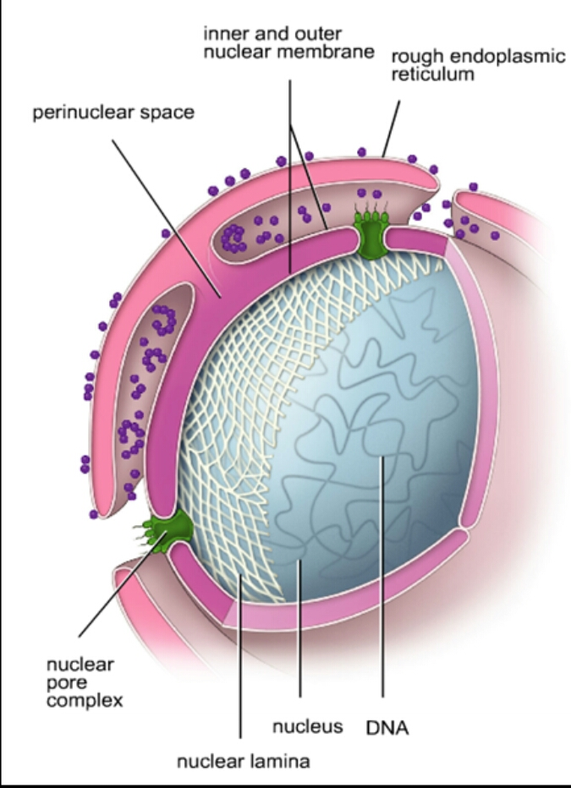
In animal cells, two networks of intermediate filaments provide the nucleus with mechanical support: The nuclear lamina forms an organized meshwork on the internal face of the envelope, while less organized support is provided on the cytosolic face of the envelope. Both systems provide structural support for the nuclear envelope and anchoring sites for chromosomes and nuclear pores.
The nuclear lamina is composed mostly of lamin proteins. Like all proteins, lamins are synthesized in the cytoplasm and later transported to the nucleus interior, where they are assembled before being incorporated into the existing network of nuclear lamina. Lamins found on the cytosolic face of the membrane, such as emerin and nesprin, bind to the cytoskeleton to provide structural support. Lamins are also found inside the nucleoplasm where they form another regular structure, known as the nucleoplasmic veil, that is visible using fluorescence microscopy. The actual function of the veil is not clear, although it is excluded from the nucleolus and is present during interphase. Lamin structures that make up the veil, such as LEM3, bind chromatin and disrupting their structure inhibits transcription of protein-coding genes.
Like the components of other intermediate filaments, the lamin monomer contains an alpha-helical domain used by two monomers to coil around each other, forming a dimer structure called a coiled coil. Two of these dimer structures then join side by side, in an antiparallel arrangement, to form a tetramer called a protofilament. Eight of these protofilaments form a lateral arrangement that is twisted to form a ropelike filament. These filaments can be assembled or disassembled in a dynamic manner, meaning that changes in the length of the filament depend on the competing rates of filament addition and removal.
Mutations in lamin genes leading to defects in filament assembly cause a group of rare genetic disorders known as laminopathies. The most notable laminopathy is the family of diseases known as progeria, which causes the appearance of premature aging in its sufferers. The exact mechanism by which the associated biochemical changes give rise to the aged phenotype is not well understood
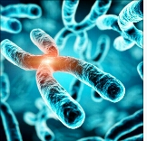
Chromosomes:

A mouse fibroblast nucleus in which DNA is stained blue. The distinct chromosome territories of chromosome 2 (red) and chromosome 9 (green) are stained with fluorescent in situ hybridization.
The cell nucleus contains the majority of the cell's genetic material in the form of multiple linear DNA molecules organized into structures called chromosomes. Each human cell contains roughly two meters of DNA. During most of the cell cycle these are organized in a DNA-protein complex known as chromatin, and during cell division the chromatin can be seen to form the well-defined chromosomes familiar from a karyotype. A small fraction of the cell's genes are located instead in the mitochondria.
Antibodies to certain types of chromatin organization, in particular, nucleosomes, have been associated with a number of autoimmune diseases, such as systemic lupus erythematosus. These are known as anti-nuclear antibodies (ANA) and have also been observed in concert with multiple sclerosis as part of general immune system dysfunction.
Nucleolus:
An electron micrograph of a cell nucleus, showing the darkly stained nucleolus
The nucleolus is the largest of the discrete densely stained, membraneless structures known as nuclear bodies found in the nucleus. It forms around tandem repeats of rDNA, DNA coding for ribosomal RNA (rRNA). These regions are called nucleolar organizer regions (NOR). The main roles of the nucleolus are to synthesize rRNA and assemble ribosomes. The structural cohesion of the nucleolus depends on its activity, as ribosomal assembly in the nucleolus results in the transient association of nucleolar components, facilitating further ribosomal assembly, and hence further association. This model is supported by observations that inactivation of rDNA results in intermingling of nucleolar structures.
In the first step of ribosome assembly, a protein called RNA polymerase I transcribes rDNA, which forms a large pre-rRNA precursor. This is cleaved into the subunits 5.8S, 18S, and 28S rRNA. The transcription, post-transcriptional processing, and assembly of rRNA occurs in the nucleolus, aided by small nucleolar RNA (snoRNA) molecules, some of which are derived from spliced introns from messenger RNAs encoding genes related to ribosomal function. The assembled ribosomal subunits are the largest structures passed through the nuclear pores.
When observed under the electron microscope, the nucleolus can be seen to consist of three distinguishable regions: the innermost fibrillar centers (FCs), surrounded by the dense fibrillar component (DFC) (that contains fibrillarin and nucleolin), which in turn is bordered by the granular component (GC) (that contains the protein nucleophosmin). Transcription of the rDNA occurs either in the FC or at the FC-DFC boundary, and, therefore, when rDNA transcription in the cell is increased, more FCs are detected. Most of the cleavage and modification of rRNAs occurs in the DFC, while the latter steps involving protein assembly onto the ribosomal subunits occur in the GC

Function:

The nucleus provides a site for genetic transcription that is segregated from the location of translation in the cytoplasm, allowing levels of gene regulation that are not available to prokaryotes. The main function of the cell nucleus is to control gene expression and mediate the replication of DNA during the cell cycle.
The nucleus is an organelle found in eukaryotic cells. Inside its fully enclosed nuclear membrane, it contains the majority of the cell's genetic material. This material is organized as DNA molecules, along with a variety of proteins, to form chromosomes
Cell compartmentalization:
The nuclear envelope allows the nucleus to control its contents, and separate them from the rest of the cytoplasm where necessary. This is important for controlling processes on either side of the nuclear membrane. In most cases where a cytoplasmic process needs to be restricted, a key participant is removed to the nucleus, where it interacts with transcription factors to downregulate the production of certain enzymes in the pathway. This regulatory mechanism occurs in the case of glycolysis, a cellular pathway for breaking down glucose to produce energy. Hexokinase is an enzyme responsible for the first the step of glycolysis, forming glucose-6-phosphate from glucose. At high concentrations of fructose-6-phosphate, a molecule made later from glucose-6-phosphate, a regulator protein removes hexokinase to the nucleus, where it forms a transcriptional repressor complex with nuclear proteins to reduce the amount of the expression of genes involved in glycolysis.
The compartmentalization allows the cell to prevent translation of unspliced mRNA. Eukaryotic mRNA contains introns that must be removed before being translated to produce functional proteins. The splicing is done inside the nucleus before the mRNA can be accessed by ribosomes for translation. Without the nucleus, ribosomes would translate newly transcribed (unprocessed) mRNA, resulting in malformed and nonfunctional proteins.
Replication:
The main function of the cell nucleus is to control gene expression and mediate the replication of DNA during the cell cycle. It has been found that replication happens in a localised way in the cell nucleus. In the S phase of interphase of the cell cycle; replication takes place. Contrary to the traditional view of moving replication forks along stagnant DNA, a concept of replication factories emerged, which means replication forks are concentrated towards some immobilised 'factory' regions through which the template DNA strands pass like conveyor belts.
- Gene expression
- Processing of pre-mRNA
- Dynamics and regulation
- Nuclear transport
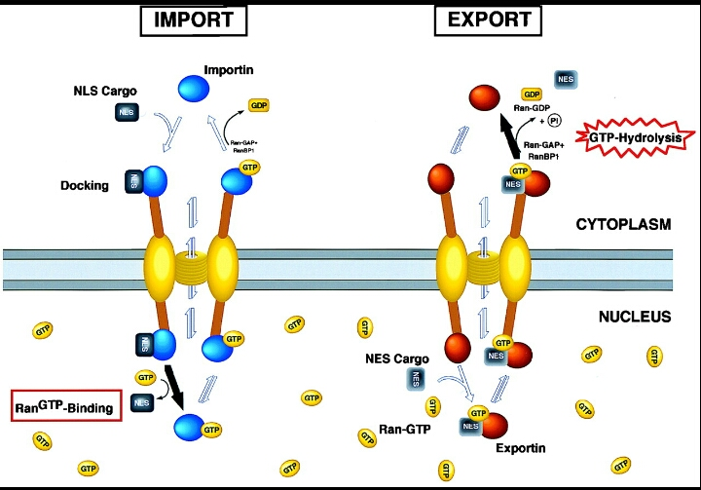
Nuclear transport:

Macromolecules, such as RNA and proteins, are actively transported across the nuclear membrane in a process called the Ran-GTP nuclear transport cycle.
The entry and exit of large molecules from the nucleus is tightly controlled by the nuclear pore complexes. Although small molecules can enter the nucleus without regulation, macromolecules such as RNA and proteins require association karyopherins called importins to enter the nucleus and exportins to exit. "Cargo" proteins that must be translocated from the cytoplasm to the nucleus contain short amino acid sequences known as nuclear localization signals, which are bound by importins, while those transported from the nucleus to the cytoplasm carry nuclear export signals bound by exportins. The ability of importins and exportins to transport their cargo is regulated by GTPases, enzymes that hydrolyze the molecule guanosine triphosphate (GTP) to release energy. The key GTPase in nuclear transport is Ran, which can bind either GTP or GDP (guanosine diphosphate), depending on whether it is located in the nucleus or the cytoplasm. Whereas importins depend on RanGTP to dissociate from their cargo, exportins require RanGTP in order to bind to their cargo.
Nuclear import depends on the importin binding its cargo in the cytoplasm and carrying it through the nuclear pore into the nucleus. Inside the nucleus, RanGTP acts to separate the cargo from the importin, allowing the importin to exit the nucleus and be reused. Nuclear export is similar, as the exportin binds the cargo inside the nucleus in a process facilitated by RanGTP, exits through the nuclear pore, and separates from its cargo in the cytoplasm.

Nuclei per cell:
Most eukaryotic cell types usually have a single nucleus, but some have no nuclei, while others have several. This can result from normal development, as in the maturation of mammalian red blood cells, or from faulty cell division.
Anucleated cells:

Human red blood cells, like those of other mammals, lack nuclei. This occurs as a normal part of the cells' development.
An anucleated cell contains no nucleus and is, therefore, incapable of dividing to produce daughter cells. The best-known anucleated cell is the mammalian red blood cell, or erythrocyte, which also lacks other organelles such as mitochondria, and serves primarily as a transport vessel to ferry oxygen from the lungs to the body's tissues. Erythrocytes mature through erythropoiesis in the bone marrow, where they lose their nuclei, organelles, and ribosomes. The nucleus is expelled during the process of differentiation from an erythroblast to a reticulocyte, which is the immediate precursor of the mature erythrocyte. The presence of mutagens may induce the release of some immature "micronucleated" erythrocytes into the bloodstream. Anucleated cells can also arise from flawed cell division in which one daughter lacks a nucleus and the other has two nuclei.
Multinucleated cells:
Multinucleated cells contain multiple nuclei. Most acantharean species of protozoa and some fungi in mycorrhizae have naturally multinucleated cells. Other examples include the intestinal parasites in the genus Giardia, which have two nuclei per cell. In humans, skeletal muscle cells, called myocytes and syncytium, become multinucleated during development; the resulting arrangement of nuclei near the periphery of the cells allows maximal intracellular space for myofibrils. Other multinucleate cells in the human are osteoclasts a type of bone cell. Multinucleated and binucleated cells can also be abnormal in humans; for example, cells arising from the fusion of monocytes and macrophages, known as giant multinucleated cells, sometimes accompany inflammation and are also implicated in tumor formation.
A number of dinoflagellates are known to have two nuclei. Unlike other multinucleated cells these nuclei contain two distinct lineages of DNA: one from the dinoflagellate and the other from a symbiotic diatom.
Evolution:
As the major defining characteristic of the eukaryotic cell, the nucleus' evolutionary origin has been the subject of much speculation. Four major hypotheses have been proposed to explain the existence of the nucleus, although none have yet earned widespread support.
The first model known as the "syntrophic model" proposes that a symbiotic relationship between the archaea and bacteria created the nucleus-containing eukaryotic cell. (Organisms of the Archaea and Bacteria domain have no cell nucleus.) It is hypothesized that the symbiosis originated when ancient archaea, similar to modern methanogenic archaea, invaded and lived within bacteria similar to modern myxobacteria, eventually forming the early nucleus. This theory is analogous to the accepted theory for the origin of eukaryotic mitochondria and chloroplasts, which are thought to have developed from a similar endosymbiotic relationship between proto-eukaryotes and aerobic bacteria. The archaeal origin of the nucleus is supported by observations that archaea and eukarya have similar genes for certain proteins, including histones. Observations that myxobacteria are motile, can form multicellular complexes, and possess kinases and G proteins similar to eukarya, support a bacterial origin for the eukaryotic cell.
A second model proposes that proto-eukaryotic cells evolved from bacteria without an endosymbiotic stage. This model is based on the existence of modern planctomycetes bacteria that possess a nuclear structure with primitive pores and other compartmentalized membrane structures. A similar proposal states that a eukaryote-like cell, the chronocyte, evolved first and phagocytosed archaea and bacteria to generate the nucleus and the eukaryotic cell.
The most controversial model, known as viral eukaryogenesis, posits that the membrane-bound nucleus, along with other eukaryotic features, originated from the infection of a prokaryote by a virus. The suggestion is based on similarities between eukaryotes and viruses such as linear DNA strands, mRNA capping, and tight binding to proteins (analogizing histones to viral envelopes). One version of the proposal suggests that the nucleus evolved in concert with phagocytosis to form an early cellular "predator". Another variant proposes that eukaryotes originated from early archaea infected by poxviruses, on the basis of observed similarity between the DNA polymerases in modern poxviruses and eukaryotes. It has been suggested that the unresolved question of the evolution of sex could be related to the viral eukaryogenesis hypothesis.
A more recent proposal, the exomembrane hypothesis, suggests that the nucleus instead originated from a single ancestral cell that evolved a second exterior cell membrane; the interior membrane enclosing the original cell then became the nuclear membrane and evolved increasingly elaborate pore structures for passage of internally synthesized cellular components such as ribosomal subunits.

Multiple choice question:
1 which organelle provide site for getenic transcription
- Mitochondria
- Golgibodies
- Cell wall
- nucleus
2 Nuclear pore is a large of
- Lipids
- Protein
- Carbohydrate
- Salt
3 Nuclear pore regulates transportation of molecules between the
- Mitochondria and nucleus
- Endoplasmreticulm and nucleus
- Nucleus and cytoplasm
- Cytoplasm and golgicomplex
4 nuclear organizer region is found in
- Nuclear matrix
- Nucleolus
- Nuclear lamina
- Nuclear pores
5 nuclear membrane is in continuous connection with
- SER
- RER
- Golgicomplex
- lysosomes
6 the number of nuclear pores depends on the
- Size of cell
- Transcriptional activity of cell
- DNA content of cell
- All of these
7 nuclei was first discovered by
- Stasburger
- Fonatana
- Robert brown
- Robert koch
8 the most important function of nuclear envelope is to
- Regulate nucleo cytoplasm traffic
- Protect genetic material
- Prevent the entrance of active ribosomes into nucleus
- synthesis rRNAs
9 central commanding center of the cell
- Nucleus
- Mitochondria
- ER
- ribosomes
10 function of nucleoli is
- Synthesis of SER
- Synthesis of RER
- Synthesis of ribosomal RNA
- transport of chemicals

