Topic:
DNA as genetic material

Discovery of DNA
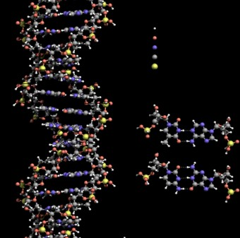
Scientists had narrowed down that the genetic material was on chromosomes in the nucleus of a cell. However, the exact molecule was discovered only much later.
Let’s take a look at the series of experiments that scientists undertook that brought us closer to the discovery of DNA.

Frederick Griffith
While working with Streptococcus pneumoniae (the bacterium that causes pneumonia) in 1928, Frederick Griffith observed a miraculous transformation in this bacterium. When you grow this bacterium on a culture plate, some produce shiny colonies (denoted as ‘S’) and some produce rough colonies (denoted as ‘R’).
The S strain bacteria have a polysaccharide coat which gives rise to smooth, shiny colonies. The R strain lacks this coat and hence, it gives rough colonies. Also, the S strain is virulent and causes pneumonia; while the R strain is non-virulent. He performed the following experiment with these strains and saw different observations.
- S strain → Inject into mice → Mice develop pneumonia and die.
- R strain → Inject into mice → Mice live.
- Heat-killed S strain → Inject into mice → Mice live. (Griffith found that heating kills the bacteria).
- Heat-killed S strain + R strain → Inject into mice → Mice die.

- Observations – Not only did the mice injected with the heat-killed S strain + R strain die, but Griffith also recovered live S strain bacteria from these dead mice.
- Conclusions – He concluded that this was because the R strain had somehow been ‘transformed’ by the heat-killed S strain. This he argued was due to the transfer of a ‘transforming principle‘ from the S strain to the R strain, which made the R strain virulent. Although significant, his observations did not identify the biochemical nature of the transforming principle.

Griffith's experiment, reported in 1928 by Frederick Griffith was the first experiment suggesting that bacteria are capable of transferring genetic information through a process known as transformation. Griffith's findings were followed by research in the late 1930s and early 40s that isolated DNA as the material that communicated this genetic information.

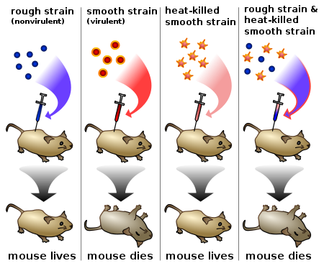

Griffith's experiment discovering the "transforming principle" in pneumococcus bacteria.
Pneumonia was a serious cause of death in the wake of the post-WWI Spanish influenza pandemic, and Griffith was studying the possibility of creating a vaccine. Griffith used two strains of pneumococcus (Streptococcus pneumoniae) bacteria which infect mice – a type III-S (smooth) which was virulent, and a type II-R (rough) strain which was nonvirulent. The III-S strain synthesized a polysaccharide capsule that protected itself from the host's immune system, resulting in the death of the host, while the II-R strain did not have that protective capsule and was defeated by the host's immune system. A German bacteriologist, Fred Neufeld, had discovered the three pneumococcal types (Types I, II, and III) and discovered the quellung reaction to identify them in vitro. Until Griffith's experiment, bacteriologists believed that the types were fixed and unchangeable, from one generation to another.
In this experiment, bacteria from the III-S strain were killed by heat, and their remains were added to II-R strain bacteria. While neither alone harmed the mice, the combination was able to kill its host. Griffith was also able to isolate both live II-R and live III-S strains of pneumococcus from the blood of these dead mice. Griffith concluded that the type II-R had been "transformed" into the lethal III-S strain by a "transforming principle" that was somehow part of the dead III-S strain bacteria.
Today, we know that the "transforming principle" Griffith observed was the DNA of the III-s strain bacteria. While the bacteria had been killed, the DNA had survived the heating process and was taken up by the II-R strain bacteria. The III-S strain DNA contains the genes that form the smooth protective polysaccharide capsule. Equipped with this gene, the former II-R strain bacteria were now protected from the host's immune system and could kill the host. The exact nature of the transforming principle (DNA) was verified in the experiments done by Avery, McLeod and McCarty and by Hershey and Chase.

Oswald Avery, Colin MacLeod & Maclym McCarty
The Avery–MacLeod–McCarty experiment was an experimental demonstration, reported in 1944 by Oswald Avery, Colin MacLeod, and Maclyn McCarty, that DNA is the substance that causes bacterial transformation, in an era when it had been widely believed that it was proteins that served the function of carrying genetic information. It was the culmination of research in the 1930s and early 20th century at the Rockefeller Institute for Medical Research to purify and characterize the "transforming principle" responsible for the transformation phenomenon first described in Griffith's experiment of 1928: killed streptococcus pneumoniae of the virulent strain type III-S, when injected along with living but non-virulent type II-R pneumococci, resulted in a deadly infection of type III-S pneumococci. In their paper "Studies on the Chemical Nature of the Substance Inducing Transformation of Pneumococcal Types: Induction of Transformation by a Desoxyribonucleic Acid Fraction Isolated from Pneumococcus Type III", published in the February 1944 issue of the Journal of Experimental Medicine, Avery and his colleagues suggest that DNA, rather than protein as widely believed at the time, may be the hereditary material of bacteria, and could be analogous to genes and/or viruses in higher organisms.
With the development of serological typing, medical researchers were able to sort bacteria into different strains, or types. When a person or test animal (e.g., a mouse) is inoculated with a particular type, an immune response ensues, generating antibodies that react specifically with antigens on the bacteria. Blood serum containing the antibodies can then be extracted and applied to cultured bacteria. The antibodies will react with other bacteria of the same type as the original inoculation. Fred Neufeld, a German bacteriologist, had discovered the pneumococcal types and serological typing; until Frederick Griffith's studies bacteriologists believed that the types were fixed and unchangeable from one generation to the next.
Griffith's experiment, reported in 1928, identified that some "transforming principle" in pneumococcal bacteria could transform them from one type to another. Griffith, a British medical officer, had spent years applying serological typing to cases of pneumonia, a frequently fatal disease in the early 20th century. He found that multiple types—some virulent and some non-virulent—were often present over the course of a clinical case of pneumonia, and thought that one type might change into another. In testing that possibility, he found that transformation could occur when dead bacteria of a virulent type and live bacteria of a non-virulent type were both injected in mice: the mice would develop a fatal infection (normally only caused by live bacteria of the virulent type) and die, and virulent bacteria could be isolated from such infected mice.
The findings of Griffith's experiment were soon confirmed, first by Fred Neufeld at the Koch Institute and by Martin Henry Dawson at the Rockefeller Institute A series of Rockefeller Institute researchers continued to study transformation in the years that followed. With Richard H.P. Sia, Dawson developed a method of transforming bacteria in vitro (rather than in vivo as Griffith had done After Dawson's departure in 1930, James Alloway took up the attempt to extend Griffith's findings, resulting in the extraction of aqueous solutions of the transforming principle by 1933. Colin MacLeod worked to purify such solutions from 1934 to 1937, and the work was continued in 1940 and completed by Maclyn McCarty.

Avery, MacLeod, and McCarty, together set out to determine the biochemical nature of the ‘transforming principle’ identified by Griffith. These people purified DNA, RNA, and proteins from the heat-killed S strain and determined which macromolecule converted the R strain into the S strain.
- Experiment – They first treated the heat-killed S strain with proteases to break down proteins. Subsequently, they treated it with RNAses and then DNAses to break down RNA and DNA, respectively.
- Observations – Both protease and RNAse treatments did not affect the transformation of the R strain into the virulent one. Finally, treatment with DNAses inhibited the transformation of the R strain.
- Conclusions – They concluded that the genetic material is not protein or RNA, but it is DNA. However, this discovery was not accepted by all biologists.

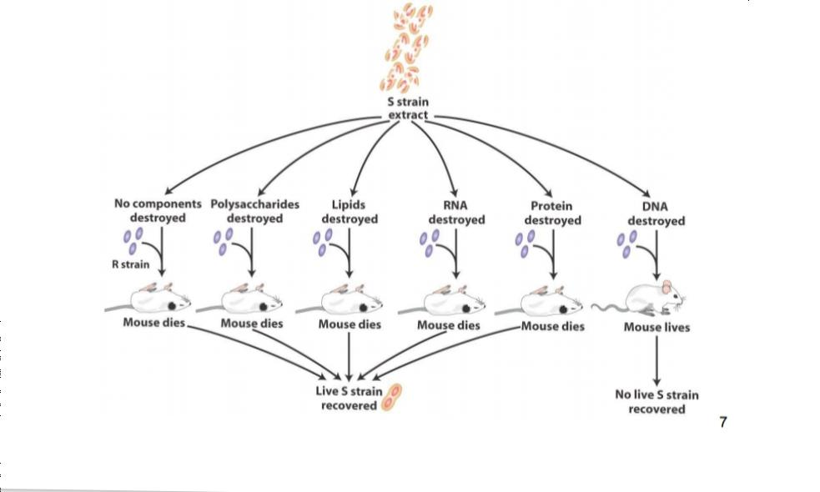

Alfred Hershey & Martha Chase

Much earlier, scientists believed that the genetic material was protein. In 1952, Hershey & Chase were the ones to conclusively prove that DNA is the genetic material. They worked with bacteriophages – viruses that infect bacteria.
Hershey and Chase were also able to prove that the DNA from the phage is inserted into the bacteria shortly after the virus attaches to its host. Using a high-speed blender they were able to force the bacteriophages from the bacterial cells after adsorption. The lack of ³²P-labeled DNA remaining in the solution after the bacteriophages had been allowed to adsorb to the bacteria showed that the phage DNA was transferred into the bacterial cell. The presence of almost all the radioactive ³⁵S in the solution showed that the protein coat that protects the DNA before adsorption stayed outside the cell.
Hershey and Chase concluded that DNA, not protein, was the genetic material. They determined that a protective protein coat was formed around the bacteriophage, but that the internal DNA is what conferred its ability to produce progeny inside a bacterium. They showed that, in growth, protein has no function, while DNA has some function. They determined this from the amount of radioactive material remaining outside of the cell. Only 20% of the ³²P remained outside the cell, demonstrating that it was incorporated with DNA in the cell's genetic material. All of the ³⁵S in the protein coats remained outside the cell, showing it was not incorporated into the cell, and that protein is not the genetic material.
Hershey and Chase's experiment concluded that little sulfur-containing material entered the bacterial cell. However no specific conclusions can be made regarding whether material that is sulfur-free enters the bacterial cell after phage adsorption. Further research was necessary to conclude that it was solely bacteriophages' DNA that entered the cell and not a combination of protein and DNA where the protein did not contain any sulfur.

Hersey & Chase used bacteriophages to experiment as follows:
- Labelling – Some viruses were grown on a medium containing radioactive phosphorus and some on a medium with radioactive sulfur.
- Viruses – grown on radioactive phosphorus have radioactive DNA but not protein since DNA contains phosphorus but protein does not. Contrarily, viruses grown on radioactive sulfur have radioactive protein but not DNA since DNA does not contain sulfur.
- Infection – The radioactive phages were then allowed to infect the bacteria – E. coli.
- Blending and Centrifugation – As the infection progressed, the viral coats were removed from the bacteria by blending. Then, centrifugation was used to separate the viral particles from the bacteria.

Observations – Bacteria infected with viruses that have radioactive DNA, were radioactive, while bacteria infected with viruses that have radioactive protein, were not radioactive.
Conclusions – This experiment conclusively showed that DNA is the genetic material transferred from virus to bacteria, and not protein.
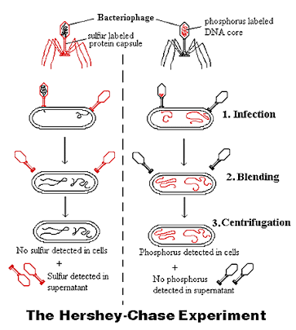

Properties Of Genetic Material
For a molecule to act as the genetic material, it should have the following characteristics:
- Be capable of replication i.e. create its own replica.
- It should be stable, structurally and chemically.
- It must have the scope for slow changes (mutations) to evolve.
- Be expressed in the form of ‘Mendelian Characters’.
Although DNA is the genetic material in most organisms, in some viruses, RNA is the genetic material. In fact, according to studies, RNA was the first genetic material. But, since RNA is unstable, DNA evolved from RNA with chemical modifications, making it more stable and more fit to carry genetic information.

Multiple Choice Questions

Q. Frederick Griffith's experiment involving Streptococcus pneumonia lead to the discovery of ___ .

- DNA as genetic material
- RNA as genetic material
- Protein as genetic material
- Transforming principle

- Q. What were the main criteria taken under consideration for the experiment by Hershey and Chase ?

- DNA contains phosphorus, protein contains sulfur
- Protein contains phosphorus, DNA contains sulfur
- Both DNA and protein contains phosphorus and not sulfur
- Both DNA and protein contains sulfur and not phosphorus

Q. Definite results proving DNA to be genetic material was given by___.

- Frederick Griffith
- Hershey and Chase
- Avery, MacLeod, MacCarty
- Meselson and Stahl

Q. Recently scientists have developed a procedure in which protoplast of E. Coli could be directly infected by the phage DNA. This process is termed as___.

- Transformation
- Transduction
- Transfection
- Mutation

Q. Frederick Griffith infected mice with a combination of dead R and S live bacterial strains. What was the out come and why did it occur?

- The mice will live. Transformation was not required.
- The mice will die. Transformation of genetic material from R to S was required.
- The mice will live. Transformation of genetic material from S to R was required.
- The mice will die. Transformation was not required.

- Q. In his transformation experiments, what did Griffith observe?

- Mutant mice were resistant to bacterial infections.
- Mixing a heat-killed pathogenic strain of bacteria with a living nonpathogenic strain can convert some of the living cells into the pathogenic form.
- Mixing a heat-killed nonpathogenic strain of bacteria with a living pathogenic strain makes the pathogenic strain nonpathogenic.
- Infecting mice with nonpathogenic strains of bacteria makes them resistant to pathogenic strains.

- Q. Which of the following investigators was/were responsible for the following discovery?
- Chemicals from heat-killed S cells were purified. The chemicals were tested for the ability to transform live R cells. The transforming agent was found to be DNA.

- Frederick Griffith
- Alfred Hershey and Martha Chase
- Oswald Avery, Maclyn McCarty, and Colin MacLeod
- Erwin Chargaff

- Q. When T2 phages infect bacteria and make more viruses in the presence of radioactive sulfur, what is the result?

- The viral DNA will be radioactive.
- The viral proteins will be radioactive.
- The bacterial DNA will be radioactive.
- both A and B

- Q. Hershey & Chase used radioactive _______ to label the DNA core of the bacteriophage.

- Phosphorus
- Sulfur
- Nitrogen
- Carbon

- Q. Which of the following investigators demonstrated that DNA could direct the replication of a virus, thus providing evidence that DNA is the genetic material?

- Watson and Crick
- Avery, McCarty and MacLeod
- Beadle and Tatum
- Hershey and Chase

