EXPERIMENT NO.5
Determine the coefficient of contraction C_{c,Cv,Cc} factor in flow through orifice.
Theory:
Discharge C_{c,} Cd, Cv:
An orifice is an opening in the wall of the tank, while a mouth is a short pipe fitted in the same opening. Orifice is used for discharge measurement. The jet approaching the orifice continues beyond the orifice till the streamline becomes parallel. This section is the jet approaching the orifice, continue to coverage beyond parallel. This section of the jet approaching the orifice continue to coverage beyond the orifice till the streamlines become parallel. This section of jet is then a section of minimum area and is known as vena contract. If Vc is the true horizontal velocity at the vena contract, then the properties of jet trajectory give the following relationship:
Orifice tube:
The discharge coefficient – Cc,Cv,Cd -varies considerably with changes in area ratio and the Reynolds number. A discharge coefficient c_{d} = 0.60 may be taken as standard, but the value varies noticeably at low values of the Reynolds number. ... For an area ratio of 0.5 the head loss is about 70 - 75% of the orifice differential.

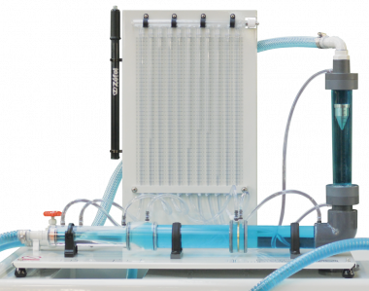

Apparatus:
Supply tank with overflow arrangement and provision of fitting of orifice or mouth piece installed in the vertical plane of the tank side, scale and sliding apparatus with hook gauge, orifice 10 mm dia.
Procedure:
- Note down the relevant dimensions as area of collecting tank and supply tank.
- Attach an orifice and note down its diameter.
- The apparatus is leveled.
- The water supply was admitted to the supply tank and conditions are allowed to steady, to give a constant head.
- The lowest point of the orifice is used as the datum for the measurement of h and y.
- The discharge flowing through the jet was recorded together with the water level in the supply tank.
- A series of reading of dimensions x and y was taken along the trajectory of the jet.
- The procedure is repeated by means of flow control valve.

Sr.no | Static head(H) | Velocity head(H) | Cc | Cv | Cd=Cc*Cd
1
2
3
4
Calculation table:

Conclusions:

